Epi Info™ 7 User Guide

Version 3
3/21/2016

User Guide Chapters
Chapter Number | Title
1 | Introduction
2 | Form Designer
3 | Check Code
4 | Enter
5 | Web Survey
6 | Companion for Android
7 | Data Packager
8 | Visual Dashboard
9 | Classic Analysis
10 | Maps
11 | Nutritional Anthropometry
12 | StatCalc
13 | Command Reference
14 | Functions and Operators
15 | Glossary
16 | Appendix

- Introduction to Epi Info™ 7

Using Epi Info™

Epi Info™ 7 is a series of tools designed to help public health professionals conduct outbreak investigations, manage surveillance databases, and perform statistical analyses. The software enables epidemiologists and other public health and medical professionals to createa questionnaire , customize the data entry process, and enter and analyze data. The program is free and publicly available for download at the Epi Info™ website (http://wwwn.cdc.gov/epiinfo/). The software runs on Microsoft Windows operating systems. Download and installation information is located in the appendix of this guide.

Tools

Epi Info™ 7 is comprised of four main tools used to collect, analyze, or visualize data:
- Create Forms – Create a questionnaire using one or more forms to collect and view data.
- Enter Data – Enter data and view existing records.
- Analyze Data (Classic and Visual Dashboard) – Manage data, run statistical analyses, and generate lists, tables, graphs, and charts.
- Create Maps – Create maps from map server, KLM files, or shape files.
Available utilities include:
- StatCalc – Compute statistics from summary data.
- Help – Find online and offline resources: including a “discussion forum” and “help desk” information.
- Options – Configure default settings on the following tabs: general, language, analysis, plug-ins, and web survey.
Epi Info™ 7 comes with several fully functional sample projects that can be used as templates when designing forms. The Nutrition project (nutrition.prj) contains the functionality of NutStat also found in previous version of Epi Info™. It contains several nutritional anthropometry functions that can be used to collect, analyze, and graph child growth data. Other sample projects contain various forms that demonstrate the potential use of Epi Info 7™ in public health data collection and outbreak investigations.

Conventions Used in the User Guide

This following table identifies typographic conventions used in this document.
Convention | Description
Boldface type | Emphasizes heading levels, column headings, and the following text when writing procedures:  - Names of options and elements that appear on screens if the option or element is involved in an action  - Keys on the keyboard  - User input for procedures  - Definitions
Italic type | Accentuates words or phrases that have special meaning or that are being defined.
Courier New | Used for code samples.
Hyperlink or URL | Hyperlinks and URLs are highlighted in blue and may be underlined.
File > Print | Used to identify menu choice and command selection.

Syntax Notations

The following conventions/rules apply to this document.
Syntax | Explanation
ALL CAPITALS | Epi Info 7™ commands and reserved words are shown in all capital letters.
<parameter> | Information to be supplied to a command or function. Parameters are enclosed with less-than and greater-than symbols. Each parameter is described following the statement of syntax for the command. Parameters are required by the command unless they are enclosed in braces { }. Do not include the < > or { } symbols in the code.
[<variable(s)>] | Brackets [ ] around a parameter indicate the possibility of more than one parameter.
{<parameter>} | Braces { } around a parameter indicate an optional parameter. Do not include the < > or { } symbols in the code.
| | The pipe symbol '|' denotes a choice and is usually used with optional parameters. An example is seen in the ROUTEOUT command.  ROUTEOUT <filename> {REPLACE | APPEND}
* | An asterisk in the beginning of a line of code, as shown in some code examples, indicates a comment. Comments are skipped when a program is run. An asterisk also serves as “all” when coding in Classic Analysis.
" " | Quotation marks must surround all text values.  DIALOG "Notice: Date of birth is invalid."

System Requirements
These requirements apply to versions available for download up to and including Epi Info™ 7.1.1.14.
- Microsoft Windows XP or above
- Microsoft .NET Framework 4.0 or above
- Recommended – 1 GHz processor
- Recommended – 256 MB RAM

DOWNLOAD NOTES
Epi Info™ 7 is available for download in two different formats, as a setup or zip file. The following explains what scenarios may be best suited for each format.
Setup (.exe file) Installation
- Traditional setup mechanism that deploys Epi Info™ 7 (If applicable, the location is subject to an organization’s IT policy).
- Allows network administrators to centrally manage and push Epi Info™ 7, including updates and patches, to users using Microsoft System Center Configuration Manager.
- Ensures that the desktop configuration matches the software’s minimum requirements.
- Precompiles and registers Epi Info™ 7 components on the computer, boosting the speed of certain components.
- Requires administrative or elevated privileges during installation.
- Recommended for centrally managed IT environments.

ZIP (.zip file) Installation
- Can be downloaded to most computers and run without requiring administrative or elevated privileges.
- Can be extracted to and run from any folder for which the user has read/write/execute privileges (including thumb drives).
- Assumes that the computer already has Microsoft .NET 4.0 and other prerequisites installed.
- Recommended for disconnected laptops and other emergency use if IT support or infrastructure is unavailable.

Navigate Epi Info™ 7

Epi Info™ 7 tools can be accessed through the main menu. Open the main menu by double-clicking the Epi Info™ icon on the desktop.
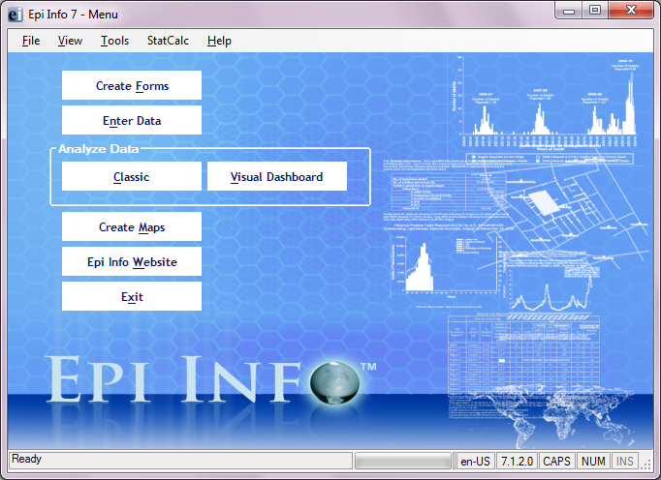
Figure 7.1: Epi Info™ Main Menu
- The navigation menu, located at the top of the Epi Info™ main menu, allows access to tools and setting customization.
- File allows you to exit Epi Info™ 7.
- View offers two display options.
  - Status Bar displays several items at the bottom of the screen, including the program version number. The version number will vary based on the version downloaded from the Epi Info™ website. Versions of Epi Info™ may also display the release date.
  - Epi Info™ Logs keep a record of certain program errors and activities.
- Tools allows access to Create Forms, Enter Data, Analyze Data (Classic and Visual Dashboard), and Create Maps.
    - Options enable you to set default options. Detailed descriptions of these options are located in the appendix.
      - General – includes those for the background image and default data formats.
      - Language – allows file translation into multiple languages. For additional information on language options, reference the Translation section of the user guide.
      - Analysis – provides for options on the display of Boolean values, HTML output, and statistical functions.
      - Plug-ins – allows the user to import data sources and custom designed dashboard gadgets.
      - Date\Time –allows the user to set formats for date, time, and date and time as a single unit (Note: not available in all versions of Epi Info™).
      - Web Survey – enables the user to identify an endpoint address and set various survey protocols. For additional information on web survey options, reference the Web Survey section of the user guide.
- StatCalc is a statistical calculator used to compute statistics from summary data. It is frequently used to calculate sample size, chi square test, relative risks, and odds ratios.
- Help provides access to the Epi Info™ User Guide, online help videos, an Epi Info™ discussion forum, and instructions on how to contact the help desk.
- Menu options are located on the left side of the screen. These options allow easy access to the most used tools: Create Forms, Enter Data, Analyze Data: Classic and Visual Dashboard, Create Maps, Epi Info Website, and the Exit button.

Note: Internet access is required to visit the Epi Info™ website.

- The status bar at the bottom of the Epi Info™ 7 main menu screen contains important information about the application including:
  - Application status or error messages - If the application is ready to start and no errors have been encountered, Ready is displayed. The status bar may be hidden and can be displayed by clicking on View > Status Bar from the navigation menu at the top of the screen.
  - Windows language and region setting.
  - Application version number.
  - Version release date (not displayed in all versions of Epi Info™).
  - Keyboard status: CAPS, NUM, INS. These buttons will become active if the respective keys on the keyboard are toggled on.

Tech Support and Contact Information

The Epi Info™ Help Desk offers free technical support to all Epi Info™ users from 8 a.m. to 6 p.m. Eastern Standard Time (EST), Monday through Friday.
Epi Info Help Desk: (404) 498-6190
Epi Info Email: epiinfo@cdc.gov

Website
The latest version of the Epi Info™ software, tutorials, and translations can be downloaded from the Epi Info™ website ( http://www.cdc.gov/epiinfo). Epi Info™ download and installation instructions are located in the appendix.
Epi Info™ Community Questions and Answers
The Epi Info™ User Community Questions and Answers website provides a resource for you to research answers to questions others have asked or to post your own questions. Join the community at the Epi Info™ community website (https://epiinfo.atlassian.net/wiki/questions).

- Form Designer

Introduction

In Epi Info™ 7, the Form Designer and the Enter modules work together to design the data entry process and collect data. Form Designer is the tool used to design the survey, questionnaire, or form, tailor the data entry process, and specify the tab sequence. It is where you customize any data validation you want to occur when the form receives data in the Enter tool.
Data collection in Epi Info™ 7 is organized by projects. Each project can have one or many forms which can have one or many pages. On each page, one or many data entry fields are added which collect individual data elements.
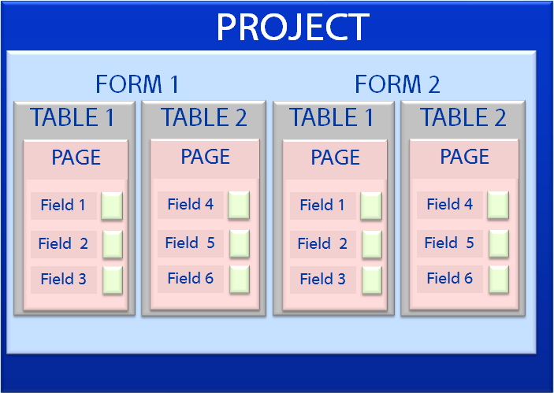
Figure 7.2: Project Organization
Fields added to a page can be any of a variety of field types corresponding to the type of data needed and the kinds of analyses that can be anticipated. Field types range from simple labels, text, numeric, and date fields to more advanced fields like drop-down lists, data grids, and command buttons. A list of the available field types is shown in Figure 2.21.
Epi Info™ 7 normally uses the Microsoft Access database format. If no changes are made to the default settings when new projects are created, data are stored in the project’s MS Access data file having an “.mdb” extension. If you have access to a Microsoft SQL Server database, Epi Info™ 7 can natively use this format for data storage, instead of the MS Access format. Epi Info™ 7 handles all of the database management aspects such as the table creation, managing keys, relationships, and other information storage details. Since the process of designing the form also defines the database, the Form Designer can be regarded as a type of database design environment.

Navigate the Form Designer Workspace

To open Form Designer, click Create Forms from the Epi Info™ 7 - Menu, or select Tools > Create Forms from the toolbar.
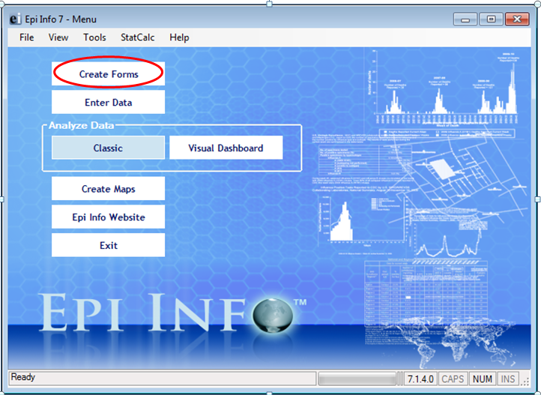
Figure 7.3: Create Forms Menu Option
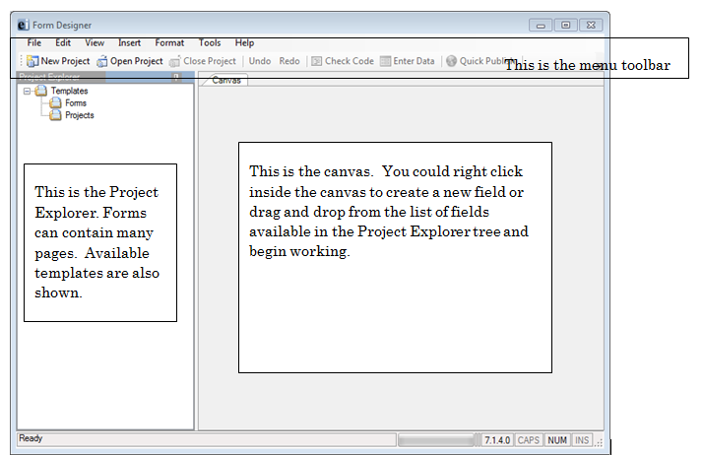

Figure 7.4 Form Designer (No Active Project)
- The Menu toolbar provides an easy way to access your projects and gives you tools to edit your forms, manage your project and customize your Canvas.
- The Project Explorer is located on the left of the screen and allows you to add pages, fields, and templates to a form. Each category can be collapsed or expanded by clicking their respective – or + buttons next to the category name.
- The blank page to the right of the Project Explorer is the Canvas where the form is designed. Each field is defined and edited using its Field Definition dialog box. You can customize the work space by selecting fonts, colors, and grid options.

Open a Recent Project
Epi Info™ 7 is packaged with many sample projects, templates, and examples to use for helping to showcase its many features and functions. The Sample project is one that contains several forms already prepared with instructional data collected. Many of these forms and their associated data are used in schools of public health for teaching Epi Info™ and the science of epidemiology and statistics important to public health research and epidemiologic investigations.
To open a recent project, from the Form Designer menu, select File > Recent Projects.
A list of recently opened projects is shown in the menu. Even though this may be the first time opening Form Designer, the Sample project is shown in the list to get you started.
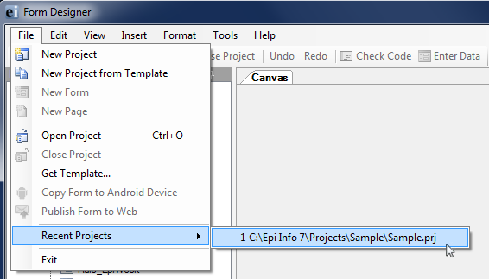
Figure 7.5: Opening a Recent Project

After selecting the Sample project, Form Designer opens to the first page of the first form – ADD Full.
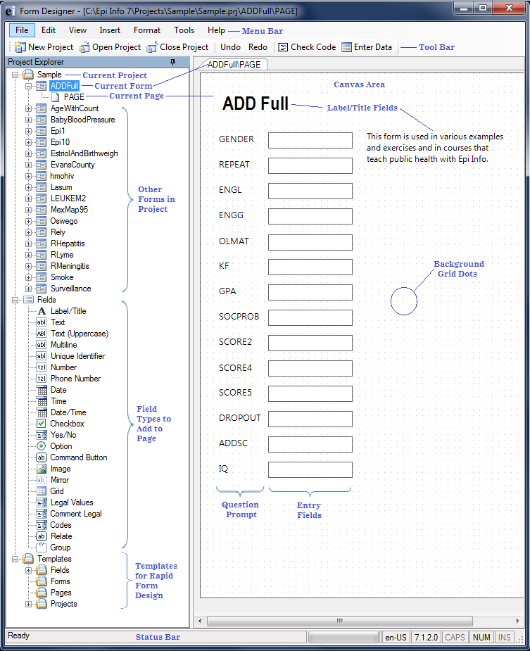
Figure 7.6: Form Designer First Page of Project

Create a New Blank Project and Form
Every Epi Info™ 7 project could contain two files; the database file and a project file (.prj) that is contained in a project folder. The project file holds the information about the location and format of the database, and whatever connection information might be required, such as a user name and password. If you choose to use the Microsoft Access format for your database, your project may also have the database file (.mdb) inside the project folder. The database file can also be saved to another location as needed. Projects that use a SQL Server database will only have the .prj file since the database is located on the server.
To create a new project and form, follow the steps below:
- From the Epi Info main menu, select Create Forms or select Tools > Create Forms from the toolbar. The Form Designer window opens.
- Click the New Project button in the toolbar or select File > New Project. The New Project window opens.
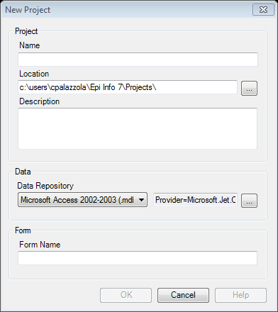
Figure 7.7: New Project dialog box
- Enter a Project Name. Project names cannot contain spaces, or most non-alphanumeric characters, although underscores are permitted.
- Set the desired project location by typing it into the Location field, or clicking the browse button. The default location for projects is the \Epi Info 7\Projects folder.
- Provide a description of the project. (Optional)
- Select the database format from the Data Repository drop-down list. The default option is Microsoft Access 2000-2003. However, SQL Server is also available. To use the SQL Server option, you need to have access to a SQL Server database.
- If you selected Microsoft SQL Server for the Data Repository, then click the browse button to the right to enter the connection information for the SQL Server database. Contact your SQL Server database administrator for the required information requested in this dialog box.
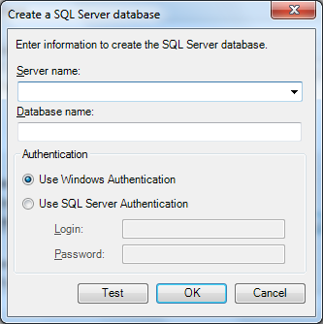
Figure 7.8: SQL Server Database dialog box
- Click OK.
- Tab to, or select the Form Name field.
- Enter a Form Name.
- Use only letters, numbers, and underscores.
- Do not start a form name with a number.
- Do not use any spaces.
- Click OK. A new blank canvas appears with the new form name and page on the tab at the top left of the canvas.

Before You Begin
Decide on a Naming Convention for Field Names
Before beginning to design your form it is helpful to have a standard way to name the data fields. While Epi Info™ will attempt to suggest a field name based on the question or prompt, in many cases these suggestions are too lengthy or cumbersome. Having a standard naming convention to assign to fields as they are added to the form will make later analyses much easier. The following suggestions may help:
- Keep field names short.
- Capitalize words within field names to help improve their readability.
For example, "PatientLastName" is easier to read than "patientlastname".
- Use a prefix to keep associated fields together in alphabetized lists.

Customize the Form Designer
One of the most helpful things you can do before beginning to develop your questionnaire or survey form is to decide on the layout and overall look of the form.
Aspects to consider include the following:
- What Font do you want the Questions and Entry Fields to have? You may want to set the Default Prompt and Input Fonts. You specify the fonts in Format>Set Default Prompt Font and Set Default Input Font.
- How far apart should fields be spaced? You may want to adjust the settings for the grid. The grid square size and other grid settings are set in Format > Grid Settings.
- Will the form need to be printed? If so, what size paper will likely be used? You may want to use a corresponding page size when designing the form. You specify the page size in Format > Page Setup.
- What page orientation should be used, Portrait or Landscape? The answer to this may depend on what devices and platform will be used for data entry. If the form will be published to a website or uploaded to a mobile device, consider a smaller page size and an appropriate page orientation. The page orientation is set in Format > Page Setup.
- Would you prefer the Question or Prompt to appear above the Input Field or to the left of the Input Field? You set the question and input field positioning in Format > Page Setup and select Vertical or Horizontal.
- What screen resolution will likely be used for data entry? If the anticipated screen resolution is less than your usually setting, you may consider reducing your resolution while designing the form so the layout of your fields will be consistent when viewed in the Enter tool.
While you can change these format settings at any time during the form design, if these questions are considered earlier, there may be less rework required to make the form presentable than if these settings are changed after fields are added to the pages.

Set a Default Prompt or Input Field Font

Set the character font to be used as fields are added to the form using the Format menu.

Default Prompt Font
- Format > Set Default Prompt Font. The Font dialog box appears.
- Select a font, font style, and sizes.
- Click OK.

Default Input Font
  - Format > Set Default Input Font.
  - Select a font, font style, and sizes.
  - Click OK.

Change Grid Settings
Use the Format settings to customize the Form Designer canvas.
- From the Form Designer toolbar, select Format. The drop-down menu opens allowing you to customize your canvas.
- Select Format > Grid Settings to open the grid settings dialog box.
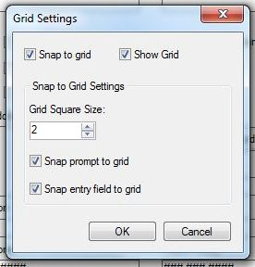
Figure 7.9: Grid Settings
- Check the Snap to Grid box to force fields in the form to snap to the grid nearest the field edge.
- Check the Show Grid box to see the grid as the canvas background.
- Use the up and down arrows in the Grid Square Size field to alter the displayed width between grid lines.
- Select the Snap prompt to grid or Snap entry field to grid check boxes depending on the snapping effect you want to use.
- Click OK. The Form Designer page appears with new settings.

Set the Page Size, Orientation, and Default Prompt Alignment
The Page Size, Orientation, and Default Prompt Alignment are set using the Page Setup dialog.
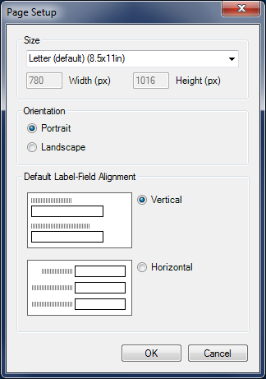
Figure 7.10: Page Setup
- On the Form Designer menu, select Format > Page Setup.
- Set the page size to be any of the pre-configured sizes listed in the Size drop-down list or use a Custom Size and specify the Width and Height in pixels.
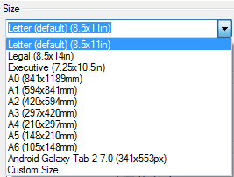
Figure 7.11: Page Size Setup
- Set the preferred page orientation – Portrait or Landscape.
- Portrait orientation is good for data entry forms that need to be printed and when the data entry is done from printed forms that have a portrait orientation. Portrait orientation may also be preferred for forms uploaded to small mobile devices such as smart phones or tablets.
- Landscape orientation is better for forms intended to be published to a website for entry using an Internet browser on a desktop or laptop computer.
Set the default alignment to be vertical so the field is below the prompt and left aligned, or horizontal where the field is to the right of the prompt on the same row.
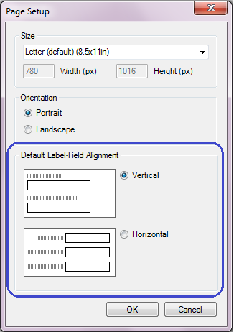
Figure 7.12: Page Setup dialog showing Default Label-Field Alignment

Insert a Background Image or Color
- From the Form Designer toolbar, select Format > Background. The Background dialog box opens.
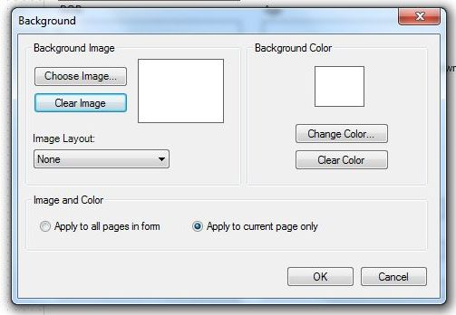
Figure 7.13: Background Format
- To set a background image, use the Background Image section of the dialog, click Choose Image. The Background Image box opens.
- Locate the image file. Click Open. The selected image appears in the Background Image dialog box. Image formats include bitmap (.bmp), picture (.ico), and JPEG (.jpg).
- Use the Image Layout drop-down list to customize the image on the screen (None, Tile, Center, and Stretch).
- From the Image and Color section, use the option buttons to Apply to all pages or Apply to the current page only.
- Click OK. The image appears in the form.
- To remove the image, select Clear Image from the Background Image box.
- To set a background color, click Change Color. The Color dialog box opens.
- Select a background color from the palette or select Define Custom Colors to enter a more specific color request.
- Click OK. The selected color previews in the background box.
- From the Image and Color section, use the option buttons to Apply to all pages or Apply to the current page only.
- Click OK. The color appears in the form as a background.
- To remove the color, select Clear Color from the Background Color box.

Create a New Project from a Project Template
Another way to create a new project is to use a pre-defined project template. This option creates the project with all of the forms, pages, fields, and Check Code that are specified in the project template. Epi Info™ 7 comes with a number of sample project templates to demonstrate its many features. These templates are located in the Project Explorer under Templates > Projects.
To use an existing project template, follow the steps below:
- Select File > New Project from Template. The New Project from Template window opens listing the available project templates.
- Select the desired project template.
- Confirm the name and location of the new project, and the data format as shown in the window and make changes as needed.
- Click OK. The Form Designer will begin constructing the forms and fields and after a few moments, the first page of the project opens in the canvas.

Create a New Form in an Existing Project
- Select File > New Form or right click on the project folder in the Project Explorer and select Add Form. The form dialog box opens.
- Type a Form Name.
- Click OK. The new form appears in the Project Explorer, and the first page appears in the canvas area.

Open an Existing Project
There are two ways to open an existing project.
If the project you want to open is one of the four most recent projects opened, select File > Recent Projects and select the project from the list.
Otherwise, follow these steps:
Click the Open Project button from the toolbar or select File > Open Project. The Open dialog appears
  - Select a project file (.prj) from the Epi Info™ Projects folder.
Note: Epi Info™ will only display files in the Epi Info Project File format (*.prj).
  - Click Open. The project appears on the canvas.

Close Project
    - Click the Close Project button from the toolbar or select File > Close Project.
    - The project closes.
Note: Epi Info™ automatically saves all changes to the project.
There is no save function in Form Designer.

Add or Insert a Page

Add a Page
The Add Page function will add a blank page at the end of the form. To add a page, right click on the form in the Project Explorer and select Add Page from context menu or select Insert > Page > Add Page from the toolbar.
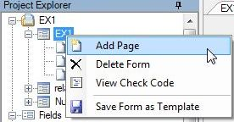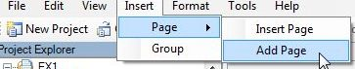
Figure 7.14: Add a Page
Enter a page name in the Set Page Name dialog box and click OK. The blank page appears on the canvas and in the Project Explorer at the end of the form.
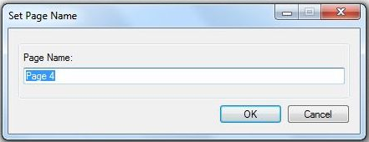
Figure 7.15: Set Page Name

Insert Page
The Insert Page function will add a blank page immediately before the current page displayed on the canvas. To insert a page, right click on the desired page in the Project Explorer and select Insert Page from the context menu or select Insert > Page > Insert Page from the toolbar
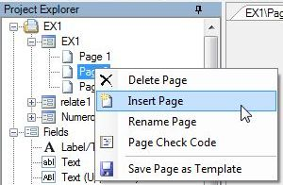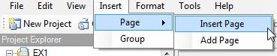
Figure 7.16: Insert Page

The new page appears on the canvas and in the Project Explorer immediately before the current page.

Name a Page
    - Right click on a page in the Project Explorer. Select Rename Page from the context menu.
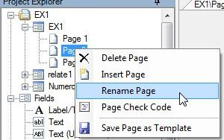
Figure 7.17: Rename Page
    - The Page Name dialog box opens. Enter a name in the Page Name field.
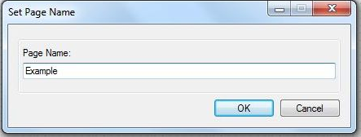
Figure 7.18: Set Page Name
    - Click OK. The page name appears in the list of pages.

Delete a Page
From the Project Explorer, right click on the page you want to delete and select Delete Page or select Edit > Delete Page from the toolbar.
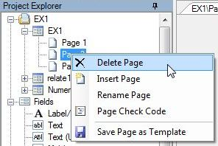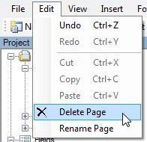
Figure 7.19: Delete Page
Note: If there is only one page to the form, then you cannot delete the only page.
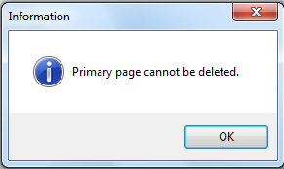
Figure 7.20: Primary Page cannot be Deleted
Otherwise, a dialog box opens prompting you to confirm deletion. Click Yes. The page is deleted.
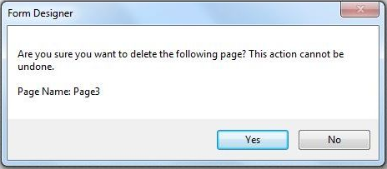
Figure 7.21: Delete Page Confirmation dialog box

Undo / Redo
Most actions performed on the canvas, such as moving fields, copying and pasting fields, and changing field alignment, are recorded in the memory of the tool. This allows you to undo any of those actions.
Click Undo from the toolbar or Ctrl + Z to undo the most recent action in the list. Form Designer begins recording actions when it is opened. Therefore, you can undo all actions from the most recent to the first action performed since opening Form Designer.
Click Redo from the toolbar or Ctrl + Y to redo the most recent action undone. As with Undo, the Form Designer remembers the actions retracted by clicking Undo. Therefore you can Click Redo repeatedly to reinstate the actions retracted by Undo, up to the first time Undo was clicked.
Form Designer only remembers actions in the Redo list that were undone by clicking Undo. As soon as you make any other changes directly to the canvas, other than clicking Undo, then the Redo list is discarded. Redo can only reinstate actions that were undone—it cannot be used to repeat actions made directly to the canvas.

Check Code
Epi Info™ allows the creator of the questionnaire or survey to guide the data entry process to produce range checking, automatic skip patterns and coding of variables. This is accomplished using Check Code. Many other more complex functions are possible such as mathematical or logical operations, checking the value of a field against the value of one or more other fields, and displaying helpful dialogs or custom error messages. Click the Check Code button to open the Check Code Editor. For information about the Check Code Editor, refer to the Check Code section of the user guide.

Enter Data
The Enter tool is used to enter data into the data entry forms in Epi Info™ 7. Click the Enter Data button to open the current form in the Enter tool. Only independent, stand-alone forms or Parent level forms can be opened in Enter. If the form is a Related Form—as in a child form related to another parent form—then you cannot open the Related Form by clicking the Enter Data button. You must open the top-most parent form first, and then use the parent form’s relate button to access the child form. This is required in order to keep the record hierarchy according to the related table relationship.
If a form does not yet contain a data table, Epi Info™ will prompt you to create a data table in this step. For information regarding the Enter tool, refer to the Enter Data section of the user guide.

Fields

A Field is sometimes called a data entry field or input field. The field is usually where the answers to the questions are entered, although Epi Info™ 7 has a few field types that don’t receive any data such as Label Fields and Command Buttons.
Fields usually contain a question or prompt or some text describing the data that will be collected. In Epi Info™ 7, different fields are provided to collect different types of information. A list of available fields is shown in the Project Explorer under the Fields category or when you right click on the Canvas and select New Field.
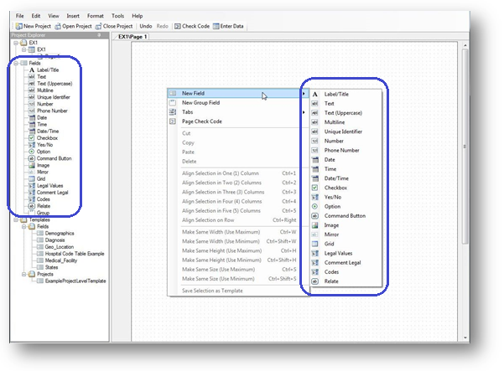
Figure 7.22: New Field context menu

Field Attributes
Fields have properties or attributes that help control how or if they receive data. Each field type has a set of available field attributes; however, some options may not be shown or may be disabled (grayed out) depending on the field type selected.
- Required field attribute makes a field mandatory in data entry. If a page contains fields marked with the Required attribute, the Enter tool will not allow record navigation or the saving of a partially completed record until a value is supplied in all Required fields.
Use With Caution! The Required attribute can potentially cause gridlock if, for any reason, the required information is not available at the time of data entry.
It is best to use this attribute sparingly to avoid this situation.
Additionally, Check Code can be used to set or unset a field’s required status. For more information on this feature, refer to the topics in the Check Code Command Reference on the SET-REQUIRED and SET-NOT-REQUIRED commands.
- Read Only – prevents data entry into the field. This attribute is used for fields that hold calculated or prepopulated values that should not be edited. The cursor cannot be placed in the field and therefore no data entry can occur. Also, since the cursor cannot enter a field with this attribute, Check Code written for this field will not have a chance to run.
The Read Only attribute is useful for calculated fields that will not be changed directly. Read Only cannot be used in combination with the Required attribute because those attributes are mutually exclusive.
- Retain Image Size – used only for image fields, this attribute maintains the size of the original image and does not alter the size to fit the image box in the form.
- Range – enables a valid range with lower and upper limit fields. Only Number and Date field types can have range values. If a value is entered that is less than the lower limit or greater than the upper limit, you will get a warning message. Missing values are accepted unless the field’s Required attribute is checked.
- Repeat Last – causes the field to be automatically populated with the last value displayed for that field. This may speed up data entry for fields that often have a value the same as the last record entered. For example, if entering many records from a given clinic, then a “Clinic Name” field could have the Repeat Last attribute checked so it will be automatically filled in from the clinic name used in the last record.
- Pattern – the format that a response must be entered in the field.
- Prompt Font -- the font for the text entered in the Question or Prompt text box.
- Field Font -- the font for the data entered into the field.
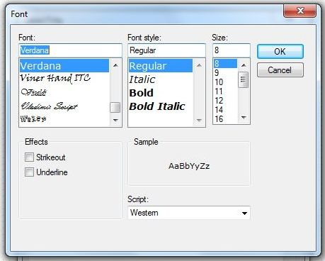
Figure 7.23: Font dialog box

Field Type | Required | Read Only | Retain Image Size | Range | Repeat Last | Pattern | Web Survey Compatible | Companion for Mobile Compatible
Label/Title |  |  |  |  |  |  | X | X
Text | X | X |  |  | X |  | X | X
Test (Uppercase) | X | X |  |  | X |  |  | X
Multiline | X | X |  |  | X |  | X | X
Unique Identifier
Number | X | X |  | X | X | X | X | X
Phone Number | X | X |  |  | X | X
Date | X | X |  | X | X |  | X | X
Time | X | X |  |  | X |  | X | X
Date-Time | X | X |  |  | X
Checkbox |  | X |  |  | X |  | X | X
Yes-No | X | X |  |  | X |  | X | X
Option |  |  |  |  |  |  | X | X
Command Button |  |  |  |  |  |  |  | X
Image |  |  | X |  |  |  |  | X
Mirror
Grids
Legal Values | X | X |  |  | X |  | X | X
Comment Legal | X | X |  |  | X |  | X | X
Codes | X | X |  |  | X
Relate
Group |  |  |  |  |  |  | X | X

Figure 7.24: Field Attributes

Add a New Field
Click and drag the type of field you want to add from the Project Explorer to the approximate location on the canvas.
Alternatively, right click on the canvas in the approximate location you want to add a field and select the field type from the New Field context menu.
A Field Definition dialog box appears. The contents of the Field Definition dialog depend on the type of field being added.

Label/Title
The Label/Title field allows you to have a title on the form or to give instructions or other information. Since this field type does not allow any data entry, it does not have Check Code, and is not searchable. The following figure is an example of a Label/Title field in Enter (circled in blue) based on the FoodHistory form of the sample EColi project.
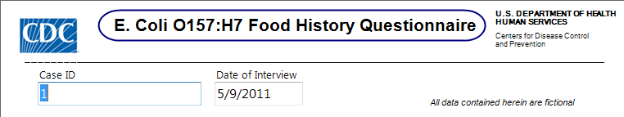
Figure 7.25: Label/Title Field
To complete the Label/Title Field Definition dialog:
- Enter the Question or Prompt. The text entered in this field will display on the canvas.
- Click in the Field Name text box. Epi Info automatically suggests a field name based on the Question or Prompt, however, it is very important that field names be short, intuitive, and usable. The field name is used for data validation in Check Code and when doing analyses. Field names cannot start with a number or contain any spaces or non-alphanumeric characters (except the underscore character “_” is permitted).
Note: It is best to simplify the field name at this time. Field names cannot be changed after data collection starts.
- Click the Font button to adjust the Question or Prompt font settings. Titles typically are configured with larger font or bolder text.
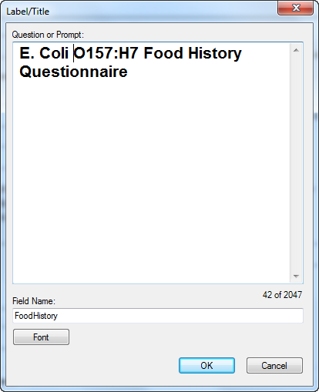
Figure 7.26: Label/Title Field Definition dialog box
- Click OK. The Label/Title appears on the canvas.

Text Field
The Text field is one of the most generic and common data entry fields used to capture text type data—letters, numbers, and symbols. Text fields hold up to 255 characters in a single line. You can restrict the number of characters entered by specifying a maximum field size. Text fields are often used for short questions such as name, address, occupation. The following figure provides an example of how a Text field appears in Enter (circled in blue) based on the FoodHistory form of the EColi project.
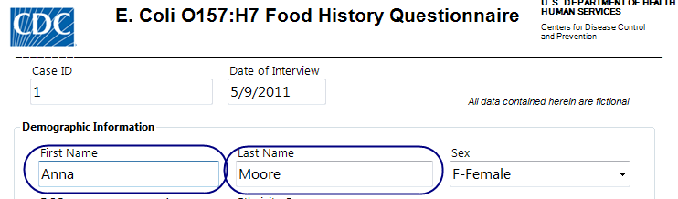
Figure 7.27: Text field
To complete the Text Field Definition dialog box:
- Enter the Question or Prompt. The text entered in this field will display on the canvas and prompt the user to enter a response.
- Click in the Field Name text box or press the tab key. Epi Info automatically suggests a field name based on the Question or Prompt, however, it is very important that field names be short, intuitive, and usable. The field name is used for data validation in Check Code and when doing analyses. Field names cannot start with a number or contain any spaces or non-alphanumeric characters (except the underscore character “_” is permitted).
Note: It is best to simplify the field name at this time. Field names cannot be changed after data collection starts.
- Optionally, you can limit how long the value can be typed into this field by specifying the maximum number of characters using a number (e.g. 10 for ten characters). If the maximum number of characters box is left blank, text fields can accept up to 255 characters.
Note: Entering a maximum number of characters is optional.
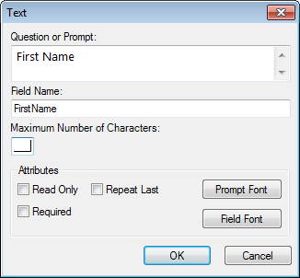
Figure 7.28: Text Field Definition dialog box
- Click OK. The Text field appears on the canvas.

Text Uppercase
The Text Uppercase field is used to help standardize the data entered. All letters typed in this field are automatically in ALL CAPS. This field draws emphasis to the information collected on the form. This field type is not supported on web surveys. The following figure provides an example of how a Text Uppercase field appears in Enter (circled in blue) based on the Surveillance form of the Sample project.
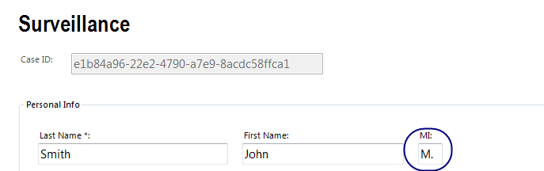
Figure 7.29: Text (Uppercase) field
To complete the Text Uppercase Field Definition dialog box:
- Enter the Question or Prompt. The text entered in this field will display on the canvas and prompt the user to enter a response.
- Click in the Field Name text box or press the tab key. Epi Info automatically suggests a field name based on the Question or Prompt, however, it is very important that field names be short, intuitive, and usable. The field name is used for data validation in Check Code and when doing analyses. Field names cannot start with a number or contain any spaces or non-alphanumeric characters (except the underscore character “_” is permitted).
Note: It is best to simplify the field name at this time. Field names cannot be changed after data collection starts.
- Optionally, you can limit how long the value can be typed into this field by specifying the maximum number of characters using a number (e.g. 10 for ten characters). If the maximum number of characters box is left blank, text fields can accept up to 255 characters.
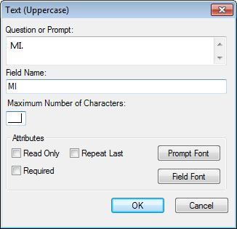
Figure 7.30: Text (Uppercase) Field Definition dialog box
- Click OK. The Text Uppercase field appears on the canvas.

Multiline
The Multiline field is similar to the Text field but allows for several lines of text. This field type allows you to enter a large amount of text based on the question or prompt. The benefit of using this type of field is that a Multiline field can hold up to 1 gigabyte of data or approximately two million characters. However, you can’t specify the maximum number of characters that can be entered into a Multiline field the way you can with a Text field. Also, some analyses are more difficult with Multiline data. For example, you can't sort data based on values in a Multiline field, so if sorting is important for your work, may be better to use another type of field. Multiline fields are most useful when capturing lengthy narratives and wordy, free-form, and descriptive data. The following figure provides an example of how a Multiline field appears in Enter (circled in blue) based on the Surveillance form of the Sample project.
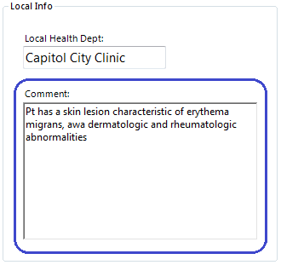
Figure 7.31: Multiline field
To add a Multiline field:
- Open the Multiline Field Definition dialog box.
- Enter the Question or Prompt. The text entered in this field will display on the canvas and prompt the user to enter a response.
- Click in the Field Name text box or press the tab key. Epi Info automatically suggests a field name based on the Question or Prompt, however, it is very important that field names be short, intuitive, and usable. The field name is used for data validation in Check Code and when doing analyses. Field names cannot start with a number or contain any spaces or non-alphanumeric characters (except the underscore character “_” is permitted).
Note: It is best to simplify the field name at this time. Field names cannot be changed after data collection starts.
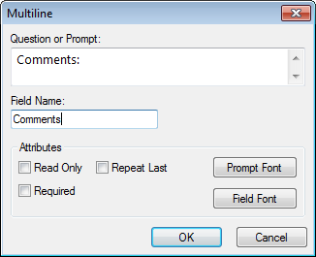
Figure 7.32: Multiline Field Definition dialog box
- Click OK. The Multiline field appears on the canvas.

Number
The Number field only accepts numeric values. Letters and most symbols cannot be entered into this type of field, however the negative sign (-) and the decimal point (.) are allowed. Number fields can have a valid upper and lower range. For numbers that must have a specific number of decimals, you can specify a required pattern. For example, if your data requires two decimal places, your number field could have the pattern “##.##” which would allow a number between -9.99 to 99.99.
Note: The negative sign takes one of the pattern spaces.
Therefore, the number “-7” entered into a field with this pattern would appear as “-7.00”, whereas the number “5” would appear as “05.00”. The leading zeros are not included in calculations, analyses, or output. The following figure provides an example of how a Number field appears in Enter (circled in blue) based on the FoodHistory form of the EColi project.
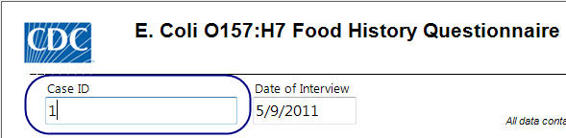
Figure 7.33: Number field
To add a Number field:
- Open the Number Field Definition dialog box.
- Enter the Question or Prompt. The text entered in this field will display on the canvas and prompt the user to enter a response.
- Click in the Field Name text box or press the tab key. Epi Info automatically suggests a field name based on the Question or Prompt, however, it is very important that field names be short, intuitive, and usable. The field name is used for data validation in Check Code and when doing analyses. Field names cannot start with a number or contain any spaces or non-alphanumeric characters (except the underscore character “_” is permitted).
Note: It is best to simplify the field name at this time. Field names cannot be changed after data collection starts.
- Optionally, select a pattern from the Pattern drop-down list (optional). You can also create a new pattern by typing in the desired pattern using the # symbol and the decimal point as needed. The default setting is None.
- To limit the range of responses, check the Range checkbox (optional). Type a lower and upper limit in the Lower and Upper fields.
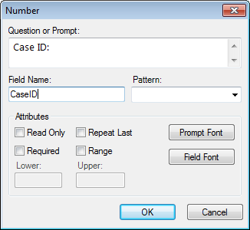
Figure 7.34: Number Field Definition dialog box
- Click OK. The Number field appears on the canvas.

Phone Number
The Phone Number field is similar to a number field, but with a pre-defined list of common phone number patterns. As with the Number field, letters and most symbols are not allowed. This field type is not supported on Web Survey. The following figure provides an example of how a Phone Number field appears in Enter (circled in blue) based on the Case Report form of the Lyme project.
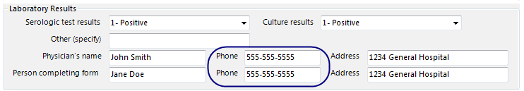
Figure 7.35: Phone Number field
To add a Phone Number field:
- Open the Phone Number Field Definition dialog box.
- Enter the Question or Prompt. The text entered in this field will display on the canvas and prompt the user to enter a response.
- Click in the Field Name text box or press the tab key. Epi Info automatically suggests a field name based on the Question or Prompt, however, it is very important that field names be short, intuitive, and usable. The field name is used for data validation in Check Code and when doing analyses. Field names cannot start with a number or contain any spaces or non-alphanumeric characters (except the underscore character “_” is permitted).
Note: It is best to simplify the field name at this time. Field names cannot be changed after data collection starts.
- Optionally, select a pattern from the Pattern drop-down list. The default setting is None.
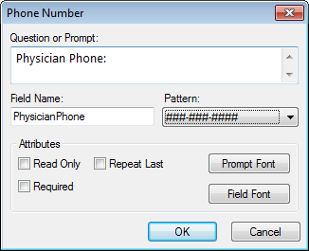
Figure 7.36: Phone Number Field Definition dialog box
- Click OK. The Phone Number field appears on the canvas.

Date
The Date field is used to enter a date. The date pattern for data entry is determined by the computer’s regional settings where the pattern can be modified. The date pattern cannot be changed within Epi Info™ 7. The following figure provides an example of how Date fields appear in Enter (circled in blue) based on the FoodHistory form of the EColi project.
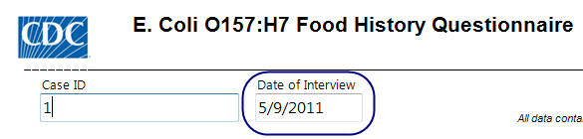
Figure 7.37: Date field
To add a Date field:
- Open the Date Field Definition dialog box.
- Enter the Question or Prompt. The text entered in this field will display on the canvas and prompt the user to enter a response.
- Click in the Field Name text box or press the tab key. Epi Info automatically suggests a field name based on the Question or Prompt, however, it is very important that field names be short, intuitive, and usable. The field name is used for data validation in Check Code and when doing analyses. Field names cannot start with a number or contain any spaces or non-alphanumeric characters (except the underscore character “_” is permitted).
Note: It is best to simplify the field name at this time. Field names cannot be changed after data collection starts.
- To limit the range of responses, check the Range checkbox (optional). Enter a lower and upper date range into the Lower and Upper fields or select a date using the date calendar by clicking on the calendar icon.
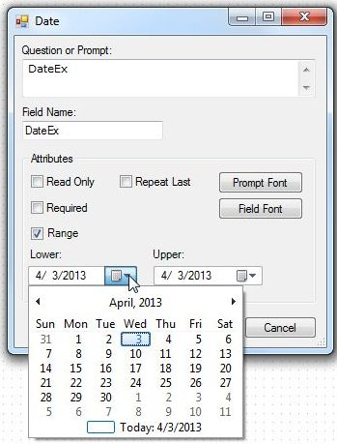
Figure 7.38: Date Field Definition dialog box
- Click OK. The Date field appears on the canvas.

Time
The Time field is used to collect time data in the form of hours, minutes, seconds, and AM or PM. The time pattern for data entry is determined by the computer’s regional settings where the pattern can be modified. The time pattern cannot be changed within Epi Info™ 7.
To add a Time field:
- Open the Time Field Definition dialog box.
- Enter the Question or Prompt. The text entered in this field will display on the canvas and prompt the user to enter a response.
- Click in the Field Name text box or press the tab key. Epi Info automatically suggests a field name based on the Question or Prompt, however, it is very important that field names be short, intuitive, and usable. The field name is used for data validation in Check Code and when doing analyses. Field names cannot start with a number or contain any spaces or non-alphanumeric characters (except the underscore character “_” is permitted).
Note: It is best to simplify the field name at this time. Field names cannot be changed after data collection starts.
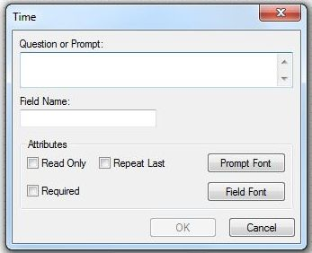
Figure 7.39: Time Field Definition dialog box
- Click OK. The Time field appears on the canvas.

Date-Time
The Date-Time field is used to collect data representing the exact date and time of a given moment. It is like a date field combined with a time field. The Date-Time pattern for data entry is determined by the computer’s regional settings where the pattern can be changed, if needed. The date-time pattern cannot be changed within Epi Info™ 7. This field type is not supported on Web Survey. The following figure provides an example of how a Date-Time field appears in Enter (circled in blue) based on the Oswego form of the Sample project.

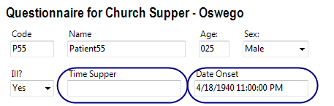
Figure 7.40: Date-Time field
To add a Date-Time field:
- Open the Date-Time Field Definition dialog box.
- Enter the Question or Prompt. The text entered in this field will display on the canvas and prompt the user to enter a response.
- Click in the Field Name text box or press the tab key. Epi Info automatically suggests a field name based on the Question or Prompt, however, it is very important that field names be short, intuitive, and usable. The field name is used for data validation in Check Code and when doing analyses. Field names cannot start with a number or contain any spaces or non-alphanumeric characters (except the underscore character “_” is permitted).
Note: It is best to simplify the field name at this time. Field names cannot be changed after data collection starts.
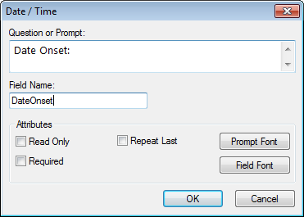

Figure 7.41: Date-Time Field Definition dialog box
- Click OK. The Date-Time field appears on the canvas.

Checkbox
The Checkbox field allows you to collect data by checking or unchecking a box. Multiple checkboxes can be used to quickly enter responses that are consistent in the study (e.g. symptoms or foods eaten). Checkbox fields collect binary data such as 0 or 1, True or False, Yes or No. The response is stored in the database as a 1 or 0 where 1 equals Yes and 0 equals No. When writing Check Code, use (+) and (–) to indicate yes and no, respectively. Unlike the Yes-No field type, Checkbox fields do not contain missing values, so all checkbox fields are considered to be “No” until they are checked during data entry or assigned a “Yes” value in Check Code. Since checkbox fields can only be either Yes or No, these fields cannot be required fields. The following figure provides an example of how Checkbox fields appear in Enter (circled in blue) based on the FoodHistory form of the EColi project.
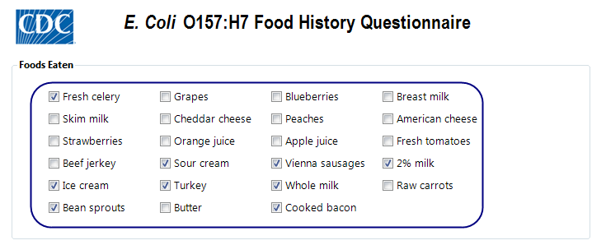
Figure 7.42: Checkbox field
To add a Checkbox field:
- Open the Checkbox Field Definition dialog box.
- Enter the Question or Prompt. The text entered in this field will display on the canvas and prompt the user to enter a response.
- Click in the Field Name text box or press the tab key. Epi Info automatically suggests a field name based on the Question or Prompt, however, it is very important that field names be short, intuitive, and usable. The field name is used for data validation in Check Code and when doing analyses. Field names cannot start with a number or contain any spaces or non-alphanumeric characters (except the underscore character “_” is permitted).
Note: It is best to simplify the field name at this time. Field names cannot be changed after data collection starts.
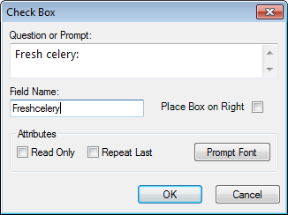
Figure 7.43: Check Box Field Definition dialog box
- Click OK. The Checkbox field appears on the canvas.

Yes-No
The Yes-No field is used to collect data with only a Yes or No answer. The field appears as a drop-down list on the canvas. The answer is stored in a database as a 1 or 0 where 1 = Yes and 0 = No. When writing Check Code, use (+) and (–) to indicate yes and no, respectively. Until this field is answered one way or the other, the field’s value is considered to be missing. In Check Code, the missing condition is indicated by the (.) operator. The following figure provides an example of how a Yes-No field appears in Enter (circled in blue) based on the FoodHistory form of the EColi project.
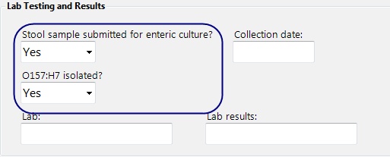
Figure 7.44: Yes-No field

In the Enter module and in the output of analyses, the values for Yes-No fields can be displayed in a variety of ways, or customized for a specific purpose such as in translation to another language. Regardless of how the data are displayed, the values in the database and in exported output are still only 1 or 0.

Yes-No fields can display their data as:
Yes | No | Missing
True | False | Unknown
(+) | (-) | (.)
<custom setting> | <custom setting> | <custom setting>
To add a Yes-No field:
- Open the Yes-No Field Definition dialog box.
- Enter the Question or Prompt. The text entered in this field will display on the canvas and prompt the user to enter a response.
- Click in the Field Name text box or press the tab key. Epi Info automatically suggests a field name based on the Question or Prompt, however, it is very important that field names be short, intuitive, and usable. The field name is used for data validation in Check Code and when doing analyses. Field names cannot start with a number or contain any spaces or non-alphanumeric characters (except the underscore character “_” is permitted).
Note: It is best to simplify the field name at this time. Field names cannot be changed after data collection starts.
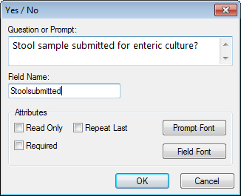
Figure 7.45: Yes-No Field Definition dialog box
- Click OK. The Yes-No field appears on the canvas.

Option
The Option field creates a group box containing mutually exclusive option buttons, also known as radio buttons. These are used for fields requiring one and only one answer. When a choice is made, any other selection within the group is cleared. In the database, the values are stored as a zero-based array. The first option is 0, the second is 1, the third is 2, and so on. The image below shows an example of two option fields. Since the options are mutually exclusive, in the first example you can’t select both options “Have your cake” and “Eat your cake”. You may select only one or the other. The field name for this example option field is “HaveOrEatCake”. Since the first option is selected, the field “HaveOrEatCake” has the value of zero (0). In the next example, the field name is “TrafficLightColor”. Since the selected color is the third option, the value of “TrafficLightColor” is two (2).
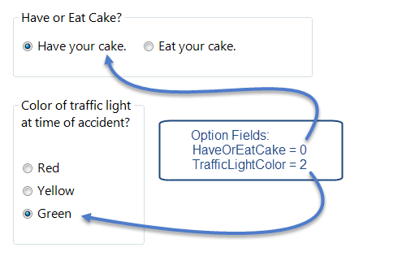
Figure 7.46: Option Field
To add an Option field:
- Open the Option Field Definition dialog box.
- Enter the Question or Prompt. The text entered in this field will display on the canvas and prompt the user to enter a response.
- Click in the Field Name text box or press the tab key. Epi Info automatically suggests a field name based on the Question or Prompt, however, it is very important that field names be short, intuitive, and usable. The field name is used for data validation in Check Code and when doing analyses. Field names cannot start with a number or contain any spaces or non-alphanumeric characters (except the underscore character “_” is permitted).
Note: It is best to simplify the field name at this time. Field names cannot be changed after data collection starts.
- Select Vertical or Horizontal from the List options vertically or horizontally field to choose how the options are displayed in the Option field.
- In the Start listing options on the left or right field, select Left or Right to choose where the options are listed.
- In the Attributes field, select Right or Left to determine how the radio buttons are aligned with the option text.
- Select the Number of Choices in the Attributes field. You can have a maximum of 16 options. The number of options selected corresponds to the number of rows listed under Option Definition.
- Enter the option name in each row of the Option Definition section.

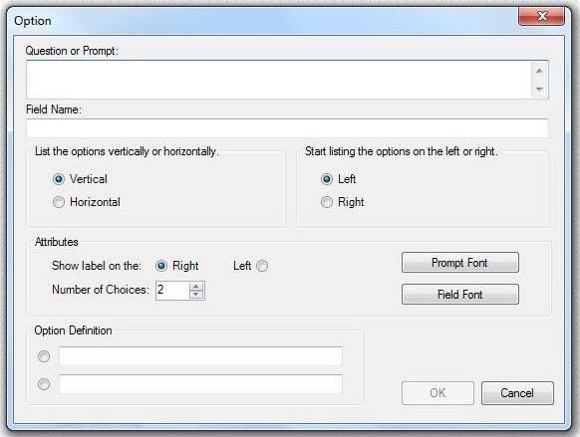
Figure 7.47: Option Field Definition dialog box
- Click OK. The Option field appears on the canvas.

Command Button
The Command Button creates a clickable button on the form and is used to run a specific block of Check Code. Below are a few examples of the possible applications of a Command Button and the Check Code behind the button:
- Compare the values of fields and perform automatic calculations
- Raise a message for information or to alert the data entry person to invalid data
- Capture longitude and latitude coordinates from an address field
- Run a prewritten program in Classic Analysis
- Open the Visual Dashboard with a saved canvas
- Open other programs outside of Epi Info™ 7 such as Microsoft Excel or Outlook.
The Command Button field is not supported on Web Survey. The following figure provides an example of how a Command Button appears in Enter (circled in blue) based on the FoodHistory form of the EColi project.

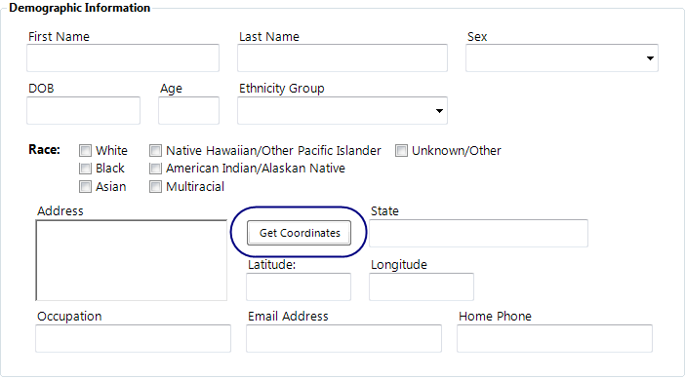
Figure 7.48: Command Button
To add a Command Button field:
- Open the Command Button Field Definition dialog box.
- Enter the Question or Prompt. The text entered in this field will display on the canvas and prompt the user to enter a response.
- Click in the Field Name text box or press the tab key. Epi Info automatically suggests a field name based on the Question or Prompt, however, it is very important that field names be short, intuitive, and usable. The field name is used for data validation in Check Code and when doing analyses. Field names cannot start with a number or contain any spaces or non-alphanumeric characters (except the underscore character “_” is permitted).
Note: It is best to simplify the field name at this time. Field names cannot be changed after data collection starts.
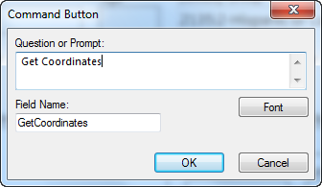
Figure 7.49: Command Button Field Definition dialog box
- Click OK. The Command Button field appears on the canvas.

Image
The Image field allows an image to be inserted in the record. Examples of items that could be included as an image might be the patient’s photo, an image of a wound, rash or insect bite, a bacteria culture dish, or the barcode of a sample vial. This is especially useful when the data collection device has a built in camera such as a tablet computer and smart phone.
If the image is not collected from a built in camera, clicking in this field will display the Open dialog to browse for an image file. The accepted image file types are: Portable Network Graphics (.PNG), Graphics Interchange Format (.GIF), Joint Photographic Expert Group (.JPG or .JPEG), and Windows Bitmap Format (.BMP). This field type is not supported on Web Survey.
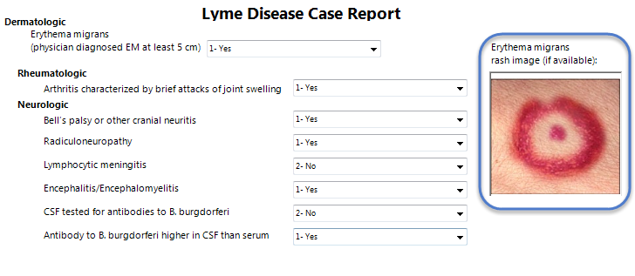
Figure 7.50: Image field

To add an Image field:
- Open the Image Field Definition dialog box.
- Enter the Question or Prompt. The text entered in this field will display on the canvas and prompt the user to enter a response.
- Click in the Field Name text box or press the tab key. Epi Info automatically suggests a field name based on the Question or Prompt, however, it is very important that field names be short, intuitive, and usable. The field name is used for data validation in Check Code and when doing analyses. Field names cannot start with a number or contain any spaces or non-alphanumeric characters (except the underscore character “_” is permitted).
Note: It is best to simplify the field name at this time. Field names cannot be changed after data collection starts.
- By default, Epi Info™ expands/contracts the image to fit in the size of the Image field. Check the Retain Image Size checkbox to disable this function and have the image inserted in the field without modification.
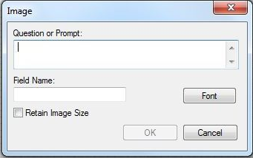
Figure 7.51: Image Field Definition dialog box
- Click OK. The Image field appears on the canvas.

Mirror
The Mirror field shows data in a field on another page. It does not actually store data of its own. It only shows data from another field. This is useful when the same information needs to be displayed on multiple pages in a form. Since this field type does not allow any data entry, it does not have a column in the database, Check Code cannot be run on this field, and Mirror fields are not searchable. This field type is not supported on Web Survey.
Mirror fields also have the following attributes:
- Mirror fields are Read Only.
- When the source field receives data through data entry or when it is assigned a value in Check Code, the value of that field will be reflected in the Mirror field.
- Mirror fields can be copied and pasted to subsequent pages while in the Form Designer. However, since they are Read Only, their contents cannot be copied when running the form in the Enter tool.
- Command buttons cannot be selected as source fields to mirror.
The following figure is an example showing three mirror fields on Page 2 of a form that reflect the data entered into Page 1 of the form. The mirror fields on Page 2 are circled in blue.
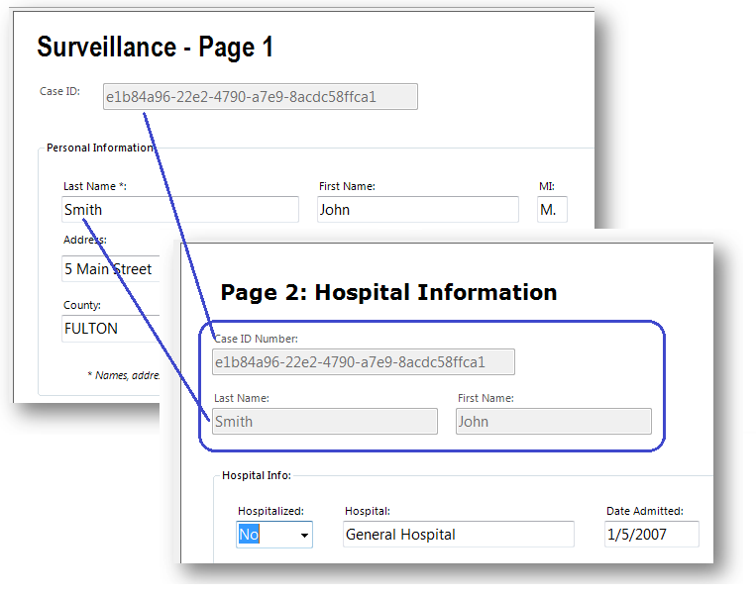

Figure 7.52: Mirror fields reflecting data entered on Page 1
To add a Mirror field:
- Open the Mirror Field Definition dialog box.
- Enter the Question or Prompt. The text entered in this field will display on the canvas and prompt the user to enter a response.
- Click in the Field Name text box or press the tab key. Epi Info automatically suggests a field name based on the Question or Prompt, however, it is very important that field names be short, intuitive, and usable. The field name is used for hiding or unhiding mirror fields in Check Code and other commands. Field names cannot start with a number or contain any spaces or non-alphanumeric characters (except the underscore character “_” is permitted).
Note: It is best to simplify the field name at this time. Field names cannot be changed after data collection starts.
- Click the Assigned Variable drop-down list in the Attributes Group to show a list of variables that can be mirrored.
- Select the variable to be mirrored.
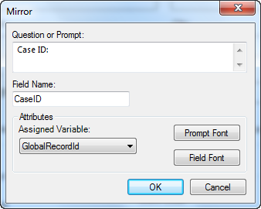
Figure 7.53: Mirror Field Definition dialog box
- Click OK. The Mirror field appears on the canvas.

Grid
The Grid field allows users to enter data in the form of a spreadsheet on the page. This allows for simple and effective data entry for multiple data points.
When you create a Grid field, you specify each column for the grid, the type of data for the column, its size and properties.
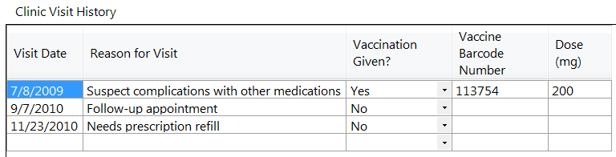
Figure 7.54a: Grid Field
Before deciding to use a Grid field on your form, please also know the following limitations with Grid fields:
- Not all field types are supported as grid columns. Text, Number, Date, Time, Date-Time, Phone Number, Checkbox, Yes-No, Legal Value, and Comment Legal field types are supported.
- Grid fields do not support Check Code. This means that the many things that Check Code can offer, such as automatic calculations, skip patterns, enabling/disabling of fields, or other data entry validation, are not available to Grid fields.
- Grid column tab order cannot be changed. Pressing the tab key moves the cursor to the next field from left to right. Pressing the Enter key moves the cursor within the same column, but down to the next row.
- Grid fields are not supported on Web Survey.
To add a Grid field:
- Open the Grids Field Definition dialog box.
- Enter the Question or Prompt. The text entered in this field will display on the canvas and prompt the user to enter a response.
- Click in the Field Name text box or press the tab key. Epi Info automatically suggests a field name based on the Question or Prompt, however, it is very important that field names be short, intuitive, and usable. The field name is used for data validation in Check Code and when doing analyses. Field names cannot start with a number or contain any spaces or non-alphanumeric characters (except the underscore character “_” is permitted).
Note: It is best to simplify the field name at this time. Field names cannot be changed after data collection starts.
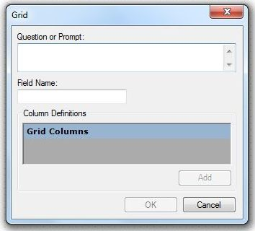
Figure 7.55: Grids Field Definition dialog box
After setting the Question or Prompt for the Grid field and setting it’s Field Name, the Add button is enabled.
- Click the Add button.
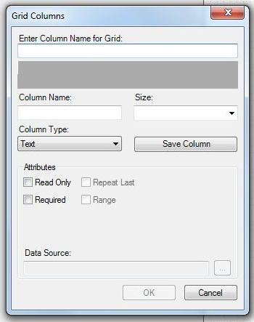
Figure 7.56: Grid Columns
- Type the column heading into the Enter Column Name for Grid textbox. This text will display as the column heading on the form.
- Press Tab or click in the Column Name textbox. Epi Info automatically suggests a column name based on the Enter Column name for Grid field, however, it is very important that column names be short, intuitive, and usable. The column name cannot start with a number or contain any spaces or non-alphanumeric characters (except the underscore character “_” is permitted).
Note: It is best to simplify the column name at this time. Column names cannot be changed after data collection starts.
- Select the column size from the Size drop-down list. This determines the amount of characters that can be placed in that column’s cells. This setting only applies to Text type columns.
- Select the column format from the Column Type drop-down list. Available formats are:
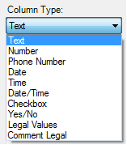
Figure 7.57: Grid Column Types
- After selecting a Legal Values or Comment Legal column type, click the browse button next to the Data Source field and complete the steps outlined in the Legal Values and Comment Legal field sections below.
- Click Save Column to add the column to the grid.
- Repeat steps 5-10 until all desired columns have been added.
- Click OK. The Grid field appears on the canvas.

Legal Values
A Legal Values field creates a drop-down list of choices on the field. The responses listed in the drop-down are the only choices available to the respondent and cannot be altered. The following figure provides an example of how Legal Value fields appear in Enter (circled in blue) based on the Surveillance form of the Sample project.

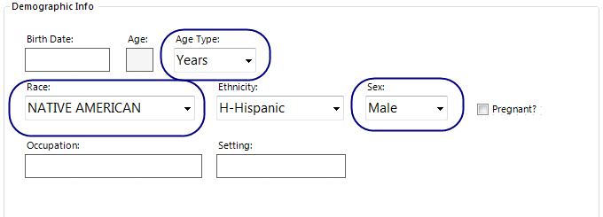
Figure 7.58: Legal Values field
To add a Legal Values field:
- Open the Legal Values Field Definition dialog box.
- Enter the Question or Prompt. The text entered in this field will display on the canvas and prompt the user to enter a response.
- Click in the Field Name text box or press the tab key. Epi Info automatically suggests a field name based on the Question or Prompt, however, it is very important that field names be short, intuitive, and usable. The field name is used for data validation in Check Code and when doing analyses. Field names cannot start with a number or contain any spaces or non-alphanumeric characters (except the underscore character “_” is permitted).
Note: It is best to simplify the field name at this time. Field names cannot be changed after data collection starts.
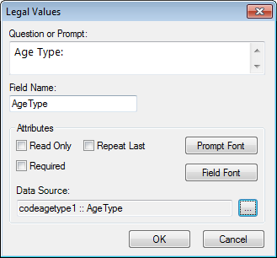
Figure 7.59: Legal Values Field Definition dialog box
- Click the Browse button to the right of the Data Source textbox.
- Click Create New to enter the available answers for the question.
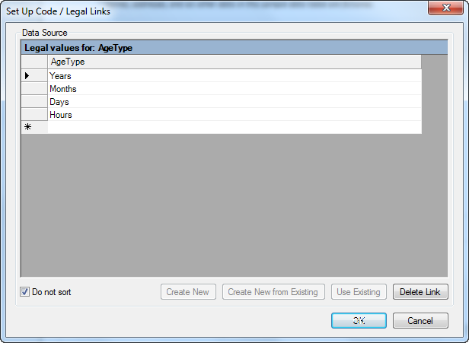
Figure 7.60: Set Up Code / Legal Links
- Enter the first value (e.g. Years). Press Enter or Tab to advance to the next value.
- Enter additional values until all necessary items are added to the drop-down list.
- Values will appear in alphabetical order unless you select Do Not Sort. This feature displays values in the order in which they were entered.
- Click OK.
- Existing tables can also be used to create legal values.
  - Click Create New from existing (takes a copy of selected table, changes to the original table will not affect the new table) or Use Existing (establishes a connection between the selected table and the new table, any changes made to the original table will modify the new table)
  - Select a table from the drop-down list.
  - Click OK.
- From the Field Definition box, click OK. The new field appears in the form as a drop-down list of values.

Comment Legal
Comment Legal fields are similar to Legal Values. They are text fields with character(s) typed in front of the text (with a hyphen). During data entry, the character and the text (e.g., M-Male) are displayed. However, only the character value is stored in the table (e.g., M). In the Classic Analysis and Visual Dashboard tools, statistics can be calculated if all values are numeric. The following figure provides an example of how a Comment Legal field appears in Enter (circled in blue) based on the CaseReport form of the Lyme project.
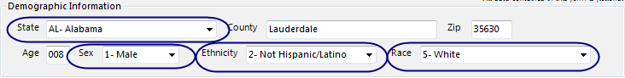
Figure 7.61: Comment Legal field
To add a Comment Legal field:
- Open the Comment Legal Values Field Definition dialog box.
- Enter the Question or Prompt. The text entered in this field will display on the canvas and prompt the user to enter a response.
- Click in the Field Name text box or press the tab key. Epi Info automatically suggests a field name based on the Question or Prompt, however, it is very important that field names be short, intuitive, and usable. The field name is used for data validation in Check Code and when doing analyses. Field names cannot start with a number or contain any spaces or non-alphanumeric characters (except the underscore character “_” is permitted).
Note: It is best to simplify the field name at this time. Field names cannot be changed after data collection starts.
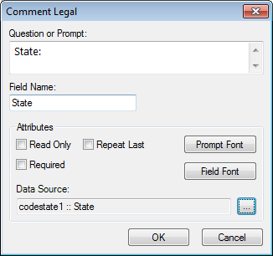
Figure 7.62: Comment Legal Field Definition dialog box
- Click the browse button to the right of the Data Source textbox.
- Click Create New to enter the available answers for the question.
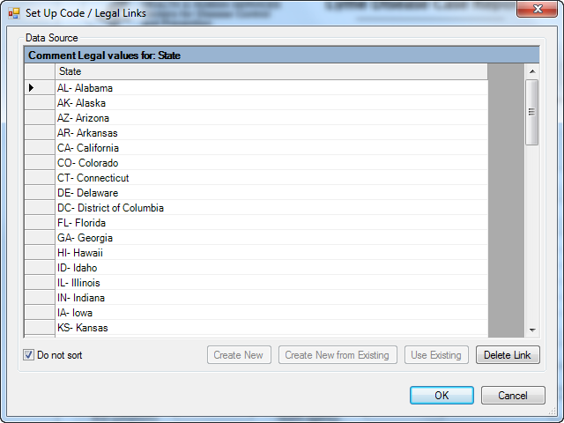
Figure 7.63: Set Up Code / Legal Links
- Enter the first value using the form code-hyphen-comment as in "M-Male" where "M" is the code and "Male" is the comment. Press Enter or Tab to advance to the next value.
- Enter additional values using the same code-hyphen-comment format until all necessary items are added to the drop-down list.
- Values will appear in alphabetical order unless you select Do Not Sort which will display values in the order in which they are entered.
- Click OK.
- Existing tables can also be used to create comment legal fields.
  - Click Create New from existing (takes a copy of selected table, changes to the original table will not affect the new table) or Use Existing (establishes a connection between the field and the existing table. Any changes made to the original table will be seen in all fields that use this table as the source.
  - Select a table from the drop-down list.
  - Click OK.
- From the Field Definition box, click OK. The new field appears in the form as a drop-down list of values.

Codes
A Codes field designates the available options on a form based on the user’s response to a question. Based on the value selected from a drop-down list, other field(s) are populated with predetermined values. At least two fields must exist; one which holds the selection code, and another to receive the value of the code. The first field holds the selection code in a drop-down list while subsequent fields are Read Only and are populated based on the values in the code table. The Codes field allows for more efficient data entry by the user. This field type is not supported on Web Survey. The following figure provides an example of how a Codes field appears in Enter (circled in blue) based on the Surveillance form of the Sample project.
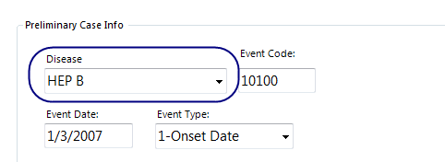
Figure 7.64: Codes field

Create a New Code Table
- Open the Codes Field Definition dialog box.
- Enter the Question or Prompt. The text entered in this field will display on the canvas and prompt the user to enter a response.
- Click in the Field Name text box or press the tab key. Epi Info automatically suggests a field name based on the Question or Prompt, however, it is very important that field names be short, intuitive, and usable. The field name is used for data validation in Check Code and when doing analyses. Field names cannot start with a number or contain any spaces or non-alphanumeric characters (except the underscore character “_” is permitted).
Note: It is best to simplify the field name at this time. Field names cannot be changed after data collection starts.
- Select the field(s) to be linked from the Select field(s) to be linked section. To select multiple fields, hold down the CTRL key and click each field.
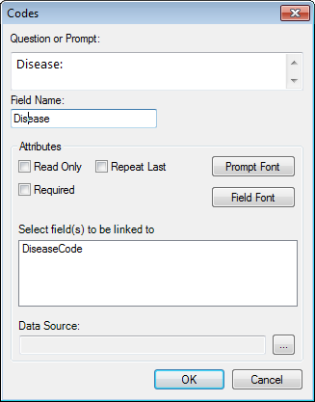
Figure 7.65: Codes Field Definition dialog box
- Click on the Data Source Browse button. 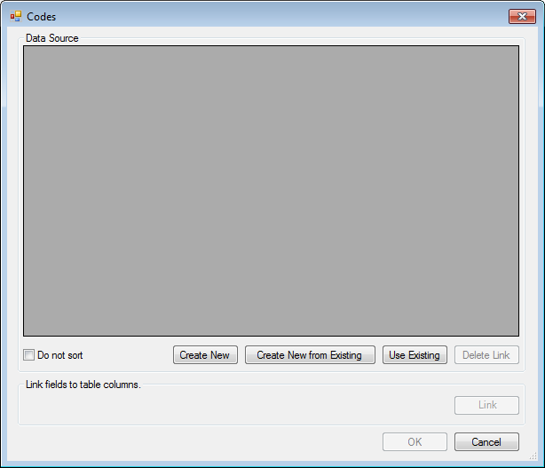
Figure 7.64 b:Create New Code table

- Click Create New. A spreadsheet opens for you to enter the values for the Codes field and Linked fields.
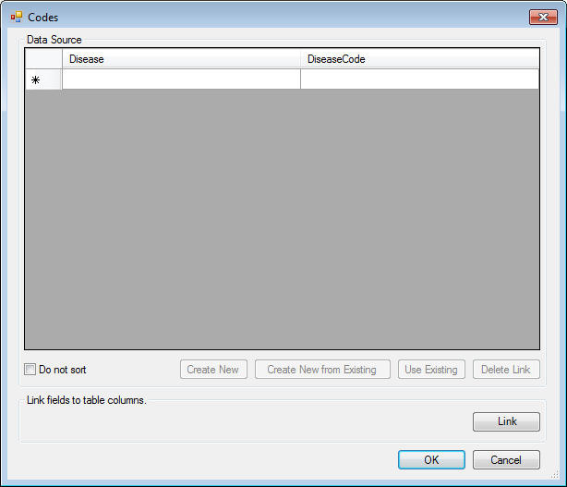
Figure 7.66: Codes Data Source Blank
- The left-most column displays the selection field(s) chosen in the Fields Definition dialog box.
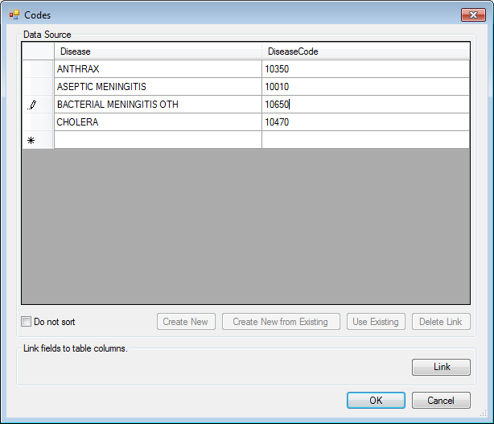
Figure 7.67: Codes Data Source Complete
- Each column to the right lists the field(s) to receive the codes based on the value of the selection field.
- Enter the codes for each field.
- Press the Tab key to move to the next field, or to the next row if at the end of a row.
- Click OK to accept the codes for each field.
- Existing tables can also be used to create code tables.
  - Click Create New from Existing (takes a copy of the selected table, changes to the original table will not affect the new table) or Use Existing (establishes a connection between the selected table and the new table, any changes made to the original table will modify the new table)
  - Select a table from the drop-down list.
  - Click OK.
- Click OK to close the Field Definition dialog box and place the fields in the form.
- To test the code table, open the Enter tool and verify that both fields populate based on the drop-down list selection.

Create Cascading Drop-Down Fields
Cascading Drop-Down fields are essentially two or more Code, Legal Value, or Comment Legal fields linked together in such a way as to filter each subsequent field based on the value selected in prior fields. In the example described below, the drop-down field for State, filters the drop-down field, County, to show only those counties that exist in the selected State. When County is selected, the drop-down field for Hospital is shown with only the hospitals located in the selected county.
In order to create Cascading Drop-Down fields, you need to have a table completed with all values for the linked fields that can be imported into Epi Info™ 7. The Excel spreadsheet shown below, named ‘codeHospital’, is an example of such a table. When importing this table into your Epi Info™ 7 project, the table name must contain the prefix “code”, as in this example, “codeHospital”.
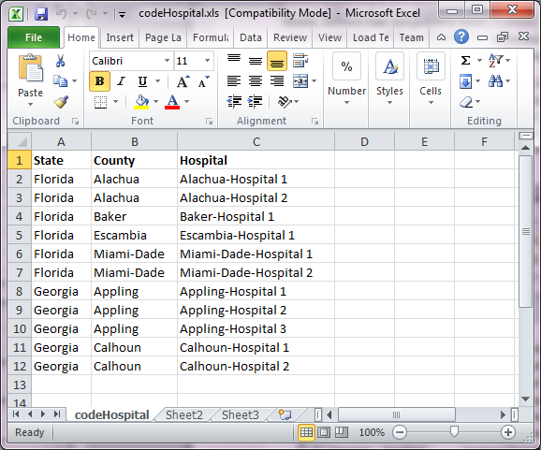
Figure 7.68: Cascading Drop-down Fields

To add Cascading Drop-down fields, complete the following steps:
  - Add the first Codes field to the page, but don’t link the field to other fields, yet. You will do this in later steps. For this example, we named the field StateName.
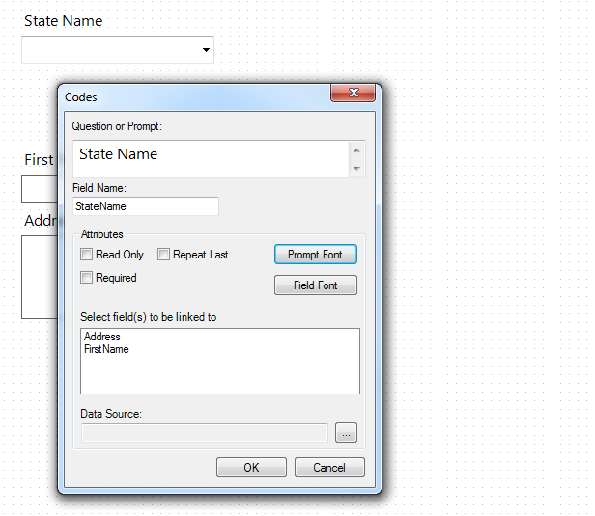
Figure 7.69: Adding Codes to Cascading Drop-down Fields
  - Add another Codes field to the page. Again, don’t link the field to other fields, yet. In this example, we named the second field County. Repeat this step for all but the last field in your cascading sequence. In this example, we have only three fields to link, so the next field will be our last.
  - Add the last field in our cascading sequence. The last field should be a type other than a Codes field, such as Legal Value or Comment Legal. Since no other fields will be linked to this last field, you don’t want to use a Codes field. In our example, we have two Codes fields named ‘StateName’ and ‘County’, and one Legal Value field named ‘Hospital’.
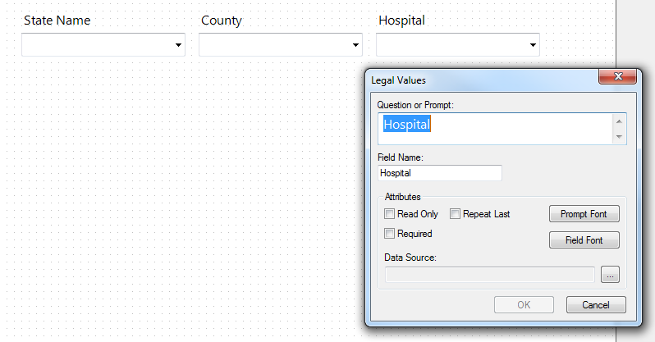
Figure 7.70: Adding Legal Values to Cascading Drop-down Fields
- If using a Legal Value or Comment Legal field for the last field, click the browse button to the right of Data Source. The Set Up Code / Legal Links dialog opens.
- Click Use Existing. The Open Form – Select a Table dialog box opens.
- Select the code table that was imported and click OK. In this example, we selected the codeHospital table.
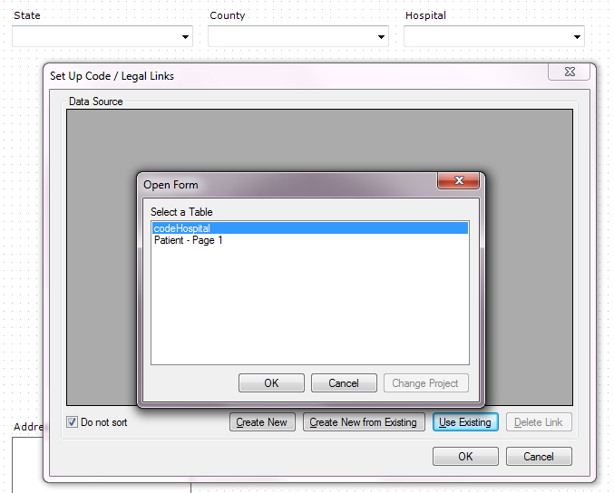
Figure 7.71: Open Form Dialog Box
- Click OK. The Select a field dialog opens showing the columns in the codeHospital table that can be linked.

- Select the appropriate field. Because we are linking the Hospital field, we selected Hospital in this example.
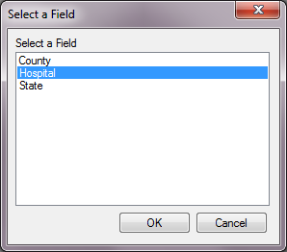
Figure 7.72: Selecting a Field
- Click OK on the Select a Field dialog. The Set Up Code / Legal Links data source table shows the values from the Hospital column in table.
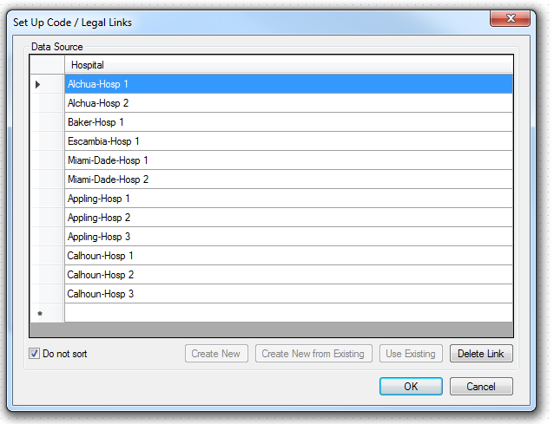
Figure 7.73a: Data Source shows values for Hospital
- Click OK on the Set Up Code / Legal Links dialog box.
- Click OK on the field definition dialog. The next steps are to link the fields to the remaining Codes fields.
- Open the properties for the first Codes field added above. (Right click the field and select Properties.) Our first field was ‘StateName’ and we want to link this field to the County field so when the State Name is selected, only the corresponding counties are shown in the County field.
- In the Select Fields to be Linked box, select the field you want to be filtered. Since, in our example, we want the County field to be filtered based on the selection made for State, we should select County here.
- Click the Browse button to the right of Data Source. The Codes dialog opens.
- Click Use Existing. The Select a Table dialog box opens.
- Select the same code table used to link the last field. In our example, codeHospital is the code table we are using.
- Click Link. The Match Fields dialog box opens. This is where we match the fields in our cascading sequence to the columns in the code table.
- Select the column to be linked to the first Codes field. Since our first field is StateName, we selected the column from our imported table named ‘State’.
- In the Link Associated Fields group, select the Form Field to be linked. For our example we want County to be linked to State, so we selected County.
- In the Table Fields drop-down, select the corresponding column in the code table.
- Click Link. The association to the linked field appears in the Linked Fields box.
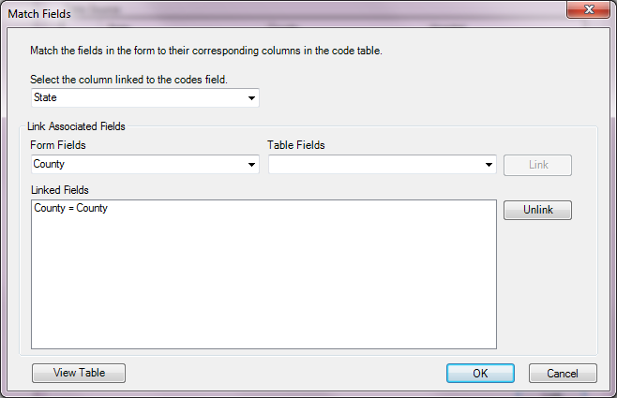
Figure 7.74: Match Fields Dialog Box

- Click OK to close the Match Fields dialog.
- Repeat the steps 12 through 21 for each remaining Codes field in the cascading sequence. For each, specify the next field in the cascading sequence and link it to the corresponding field in the code table. In our example, County is the only remaining Codes field to be linked and this field will be linked to Hospital.
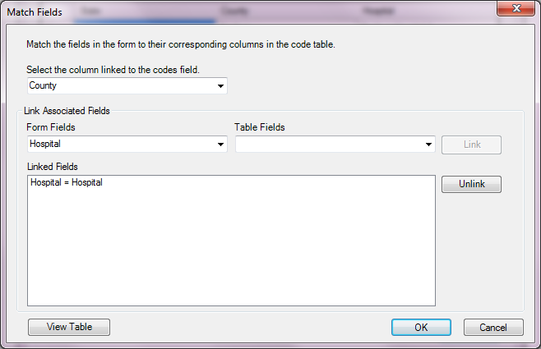
Figure 7.75: Linked Fields
This completes the process to create a series of cascading drop-down fields. When the form is opened in Enter, the selection made in the first field in the cascading sequence will filter the values shown in the next field in the sequence. In our example, when Florida is selected for State Name, the list shown for County only includes the values Alchua, Baker, Escambia, and Miami-Dade.
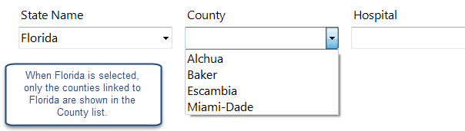
Figure 7.74: State Name field now filters the values shown for the County field

The StateName codes field filters the County codes field because of they way they are linked and because Alchua, Baker, Escambia, and Miami-Dade are the only counties on the same rows as Florida in the codeHospital table.
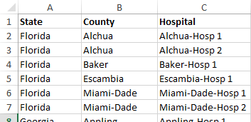
Figure 7.765: The codeHosptal table imported from Excel.
Likewise, when the county Alchua is selected, only the values Alchua-Hosp1 and Alchua-Hosp2 are shown in the Hospital legal values field.

Relate
Related forms are relationships between the main or parent form with sub or child forms. They are used to establish a one-to-one or one-to-many relationship between parent form records and child form records. For example, a survey may have a form devoted to patient information. This may be related to a form to record the many hospital visits that each patient may have. Related forms are linked to a parent form automatically by unique keys generated by Epi Info™ 7. In Enter, the related form is opened by clicking a Related Form Button. When a Related Form Button is selected, it will open the first page of the related form. Using Check Code, the Relate Button can be made conditionally accessible (e.g., to show a special form for a particular disease). This field type is not supported on Web Survey or on the Companion for Android application. The following figure is an example of how a Relate field appears in Enter (circled in blue) based on the Surveillance form of the Sample project.
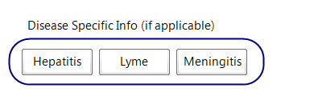
Figure 7.77: Relate field
To add a Relate field:
- Open the Relate Field Definition dialog box.
- Enter the Question or Prompt. The text entered in this field will display on the canvas and prompt the user to enter a response.
- Click in the Field Name text box or press the tab key. Epi Info automatically suggests a field name based on the Question or Prompt, however, it is very important that field names be short, intuitive, and usable. The field name is used for data validation in Check Code and when doing analyses. Field names cannot start with a number or contain any spaces or non-alphanumeric characters (except the underscore character “_” is permitted).
Note: It is best to simplify the field name at this time. Field names cannot be changed after data collection starts.
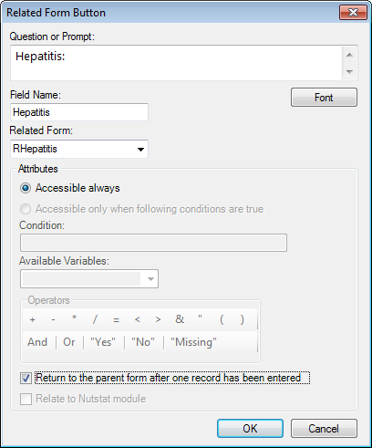
Figure 7.78: Relate Form Button Field Definition dialog box
- From the Related Form drop-down list, select Create new form to create a new form or select an existing form.
- The dialog box will show the Accessible always button selected. This option cannot be modified. The Accessible only when following conditions are true selection is not available in this version of Epi Info™ 7.
- Accessible always will create a related button in the form that is active at all times during data entry.
- Accessible only when following conditions are true will be available in a future Epi Info™ release. However, a conditional statement can be created using Check Code (see Check Code). Check Code can be associated with the button to create a condition statement.
- Select ‘Return to the parent form after one record has been entered’ to allow only one record to be entered in the related form for each record in the parent form. In Enter, after a record is saved in the related form, you are returned to the parent form. If multiple entries are desired, then leave this option unselected.
- Click OK. The Related Form button appears on the canvas.

Group
A Group field is a way to group together one or more fields on a page for visual and practical purposes. Visually, a group helps to tie similar fields together into a common category. Grouped fields also provide organization and structure to the form. A background color can be added to a group to enhance its appearance. You can nest groups and arrange them so they overlap specific fields for situations where you need a Venn style “diagram” on your form.
Group fields also have several practical purposes. In Classic Analysis and the Visual Dashboard, you can run statistics on individual fields, but if the fields are contained within a group, then you can use the group field and the statistics will be done on each field within the group.
Similarly, several Check Code commands can be run on all fields within a group by using just the group name, rather than using each field name individually. This makes commands such as Enable, Disable, Clear, Highlight, Set-Required, Set-Not-Required, among others, much easier for you to write.
Fields contained within the Group box are automatically members of the Group field. To remove a field from a group, simply drag the field outside of the boundaries of the group box. Likewise, dragging the group box itself will move all the fields within the group. When the group box is released, any additional fields within the boundaries of the group box are automatically members of the group field for analyses and Check Code execution.
The following figure provides an example of how Group field (circled in blue) appear in Enter.
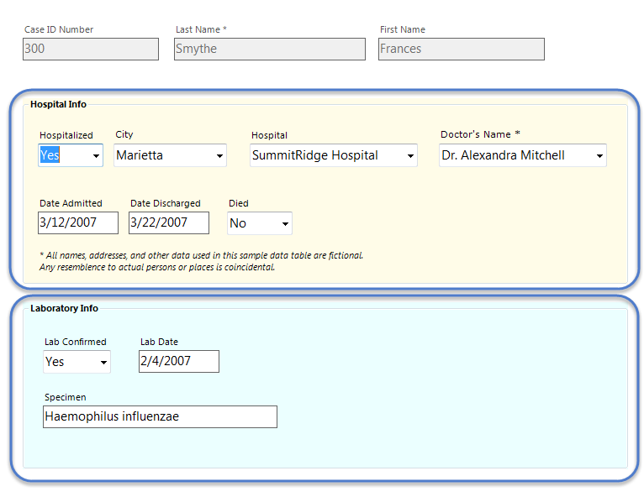
Figure 7.79: Group field

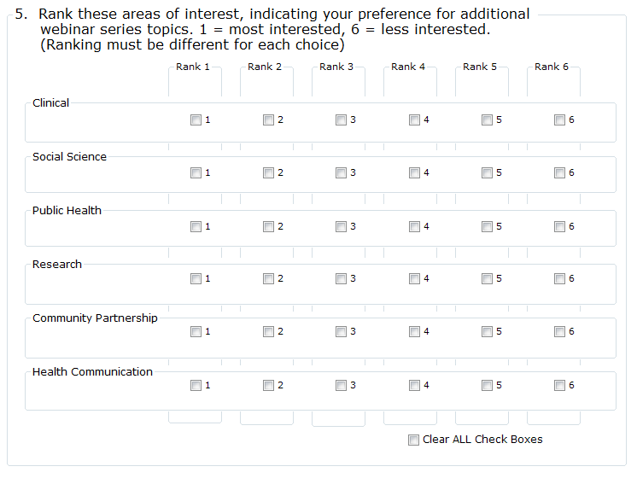
Figure 7.80: Nested Venn-style Group fields

To create a Group field:
- Click and drag a rectangle around the fields to be grouped. Each field in the selection appears highlighted with a rectangle.
- From the Form Designer toolbar, select Insert > Group or right click on a blank part of the canvas and select New Group Field from context menu. The Group Properties dialog box appears.
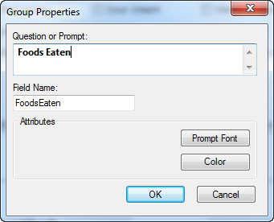
Figure 7.81: Group Field Properties
- Enter the Question or Prompt. The text entered in this field will display on the canvas and prompt the user to enter a response.
- Click in the Field Name text box or press the tab key. Epi Info automatically suggests a field name based on the Question or Prompt, however, it is very important that field names be short, intuitive, and usable. The field name is used for data validation in Check Code and when doing analyses. Field names cannot start with a number or contain any spaces or non-alphanumeric characters (except the underscore character “_” is permitted).
Note: It is best to simplify the field name at this time. Field names cannot be changed after data collection starts.
- Click OK to create the group. The fields appear in the group box.
- Move the group by clicking and holding the group name with the mouse.
- Resize the group box by moving the cursor over the group and adjust the box dimensions by clicking and dragging the corner boxes to the desired dimensions. If the new size includes additional fields, they become members of the group.
- Fields in the group are rearranged in the same process as on the Form Designer canvas. Click on the field and drag the field to the desired location.

Edit an Existing Field
Right click on the field and select Properties from the context menu. The Field Definition dialog box appears. Make the necessary changes and click OK.
Edit a Field Name
Field Names are critically important to Epi Info™ 7 projects because they are the basis for everything from database management, to data validation, and analysis. Because field names are such an integral part of Epi Info™ 7 projects, field names cannot be changed after the data table has been created to begin collecting data—even when testing the form with test data.
Therefore, it is very important to establish a concise and usable naming convention for your field names when beginning to design your data entry form. Although Epi Info automatically suggests a field name based on the Question or Prompt, it does so by concatenating the first several words together, stripping spaces and invalid symbols. This can be convenient when the question is only a few short words, but if the prompts to your questions frequently begin with similar phrases such as “Please enter the …?” or “What is the …?”, then the suggested field names will also have the same ambiguous start creating a very challenging and tedious experience searching for a specific field when writing Check Code or using Analysis and the Visual Dashboard.
For these reasons, is very important that field names be short, intuitive, and usable. Field names cannot start with a number or contain any spaces or non-alphanumeric characters (except the underscore character “_” is permitted).
The field name cannot be changed after the data table is created. When testing a form in Enter, the data table is initially created. If the data table has no data or only test data that can be discarded, you can delete the data table in order to change the field name. Refer to the topic ‘Delete an Existing Data Table Without Deleting the Form’ for more information.
Invalid Field Names
Since field names cannot start with a number, if your question or prompt begins with a number, Epi Info’s suggested field name will begin with a leading letter “N” before the number.
Field names cannot have spaces or non-alphanumeric characters other than the underscore.
Since fields are referenced by their field name in the database, the field name must be unique—it cannot already exist as the name of another field in your form.
Finally, Epi Info needs to reserve some words for internal use and to avoid conflicts related to database interaction. For a complete list of reserved words, please see the appendix
If your desired field name is invalid for any of the reasons mentioned above, it will appear in red font and the OK button will be disabled. To avoid this, modify the field name slightly, perhaps add a suffix or prefix to make it an acceptable name. Then click OK.

Delete a Field
- Right click on the field. The context menu opens.
- Click Delete. The field is removed from the form.
Warning: The field and any data previously collected are deleted from the form and database. Deletions occur immediately. There is no prompt to verify the deletion before it occurs, and the only way to recover the field is by using the “undo” feature, however, “undo” will not recover deleted data.

Copy, Cut, and Paste Fields
- Click and drag a rectangle around the fields to be copied or cut.
- From the Form Designer toolbar, select Edit > Copy or Cut from the drop-down list.
- Click in the new section of the form or select a new page in the project.
- Select Edit > Paste. The copied fields appear in the form.
When pasting fields, Epi Info automatically suggests a field name based on the name of the original field. To ensure the field name is unique, Epi Info appends a number. For example, if the field name of a field being copied is “Age”, then the pasted field is automatically named “Age1”. Copying and pasting this field again will result in a third field named “Age11”. The similarity of these names may lead to confusion and sometimes errors when used in Check Code and in analyses. Therefore it is important to change the field name as described in the next step.
- For each field pasted, do the following:
  - Right click the new field’s question or prompt and select Properties from the context menu.
  - Click in the Field Name text. Change the field name making it more clear and intuitive for the instance of the new field.
  - Field names cannot start with a number or contain any spaces or non-alphanumeric characters (except the underscore character “_” is permitted).
Note: Field names cannot be changed after a data table has been created (data collection has started).
Note: You can also right click on the field and use the context menu to copy or cut the field. Also, you can right click the canvas and use the context menu to paste a field from the clipboard.

Align Fields
There are several ways to align fields in Form Designer. Aligning fields in a consistent format allows you to make the form appear more professional. The process of aligning fields begins with selecting the desired fields to be aligned.
- Click and drag a rectangle around the fields to be aligned.
  - To align the fields vertically, select Format > Alignment > As Stack.
  - To align the fields horizontally, select Format > Alignment > As Table.
  - For additional options, right click on the canvas to display the possible alignment configurations.
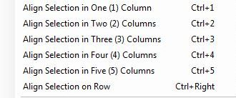
Figure 7.82: Field Alignment Options
- The options appear as follows:
    - Align Selection in Column(s) – aligns all fields vertically in the number of columns indicated (similar to Format > Alignment > As Stack).
    - Align Selection on Row – aligns all fields horizontally (similar to Format > Alignment > As Table).

Set Field Size
There are several field sizing options available in Form Designer. Making field sizes consistent will allow you to make the form appear more professional. The process of standardizing the field size begins with selecting the desired fields.
- Click and drag a rectangle around the fields to be re-sized.
- Right click on the canvas to display the possible sizing configurations.
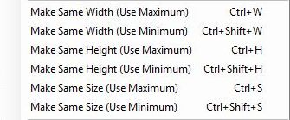
Figure 7.83: Adjust Field Size
- The options appear as follows:
- Make Same Width (Use Maximum) – Adjusts selected fields’ width to match the widest field of the selection
- Make Same Width (Use Minimum) – Adjusts selected fields’ width to match the narrowest field of the selection
- Make Same Height (Use Maximum) – Adjusts selected fields’ height to match the tallest field of the selection
- Make Same Height (Use Minimum) – Adjusts selected fields’ height to match the shortest field of the selection
- Make Same Size (Use Maximum) – Adjusts selected fields’ height and width to match the largest field of the selection
- Make Same Size (Use Minimum) – Adjusts selected fields’ height and width to match the smallest field of the selection

Manually Set Field Size
- Hover your mouse over the field to display the field’s frame and sizing handles.
- Hover the mouse over one of the sizing handles to see the mouse change to an arrow cursor.
- Click and drag a sizing handle to stretch the field to the needed size.
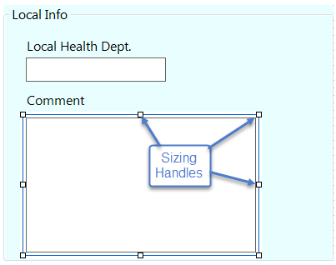
Figure 7.84: Manually Adjust Field Size

Manually Set Field Position
In certain cases, the field alignment or positioning will need to be adjusted manually. In Epi Info, the field and prompt can move together or separately. This is especially helpful if using a right-to-left language where the question or prompt should be to the right of the entry field.
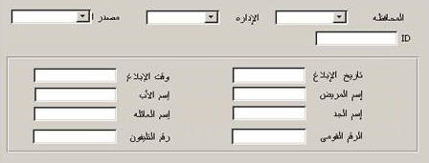
Figure 7.85: Manually Adjust Field Position
The following example is based on a form containing a Label/Title field and a Text field.
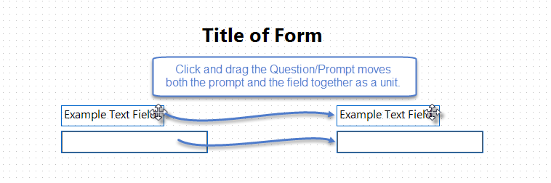
Figure 7.86: Prompt and Entry Field Selection
- To move a field and question together, click and drag the field’s prompt.
- To move the field and prompt separately, click and drag the entry field, not the prompt, as shown below.
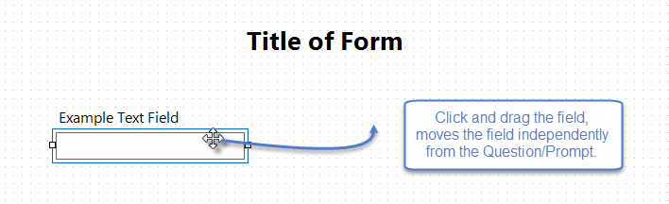
Figure 7.87: Select Entry Field
- Release the entry field at the desired location.
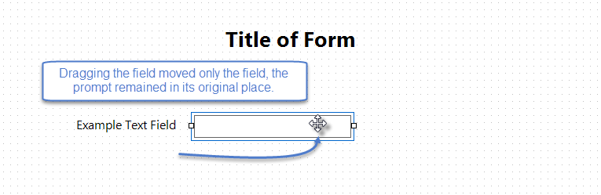
Figure 7.88: Adjust Entry Field Location
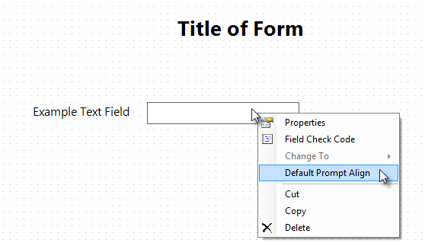
Figure 7.89: Default Prompt Alignment
- To restore the original field and prompt alignment according to the default configuration, right click on the field or prompt and select Default Prompt Align.
- To set the default prompt alignment, select Format > Page Setup from the Form Designer menu bar. Set the default alignment to be vertical so the field is below the prompt and left aligned, or horizontal where the field is to the right of the prompt on the same row.
Figure 7.90: Page Setup dialog showing Default Label-Field Alignment

Tab Order

In the Enter module, during data entry, pressing tab or enter will move the cursor to the next field. Tab Order is the order or sequence that the cursor moves from field to field. Initially, the tab order is determined by the order in which the fields are added to the form. In many cases, as fields are moved around the page, added from a template, or pasted from somewhere else, the tab sequence may become disorganized. There are other situations in which you may prefer the tab order to move in a custom way, such as down a column of questions, or maybe from right to left across the page.
The proper tab order will make entering data more user friendly and efficient. Additionally, the tab order will determine how fields are displayed on a mobile device.
To show the tab order, right click on the canvas and select Tabs > Show Tab Order. The tab order number for each field is shown in a rectangle near the entry field. Red rectangles indicate the field is a Read Only field or one that cannot receive the cursor, such as Label/Title fields. Group fields also do not receive the cursor, but a tab number is reserved for the group, even though the tab order number for a Group box is not shown.
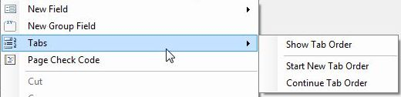
Figure 7.91: Show Tab Order

Start New Tab Order
Right click the canvas and select Tabs > Start New Tab Order from the context menu. Selecting this function will automatically set the tab order according to each field’s position from left to right, then top to bottom.

Customize the Tab Order
You can customize the tab order to meet the needs of your questionnaire. This process begins by showing the tab order on the canvas. The example below demonstrates how to adjust the tab order in the Food History form of the EColi project located in the Projects folder.
Right click the canvas and select Tabs > Show Tab Order from the context menu to show the current order of field entry.
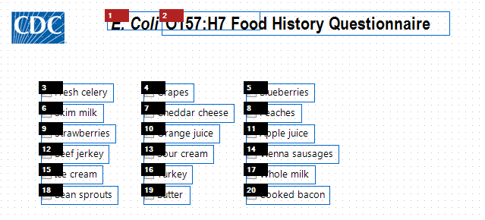
Figure 7.92: Show Tab Order
In the example shown in the figure above, the sequence will move the cursor from left to right, row by row.
Suppose you wanted to have the order run down the first column, from ‘Fresh celery’ to ‘Bean sprouts’, then over to the ‘Grapes’ in the second column. There are a couple of methods to do this.
Customize Tab Order using the Mouse
- With the Tab Order showing, hover the mouse pointer over the field you want to be the first field in the sequence. In this example, we want to start the sequence with ‘Fresh celery’ at tab order 3. A prompt appears showing the options available to reset the tab order.
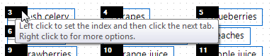
Figure 7.93: Tab Order Prompt

- Click on the tab order number to set the index. In this example, we click the number 3 in order to set the index at 3.
- Click on the tab order number for the next field you want to follow the index field. In our example, the field below ‘Fresh celery’ is ‘Skim milk’, currently tab order 6. When we click on the number 6, the number changes to follow our index field and becomes 4 (one more than 3—our index).
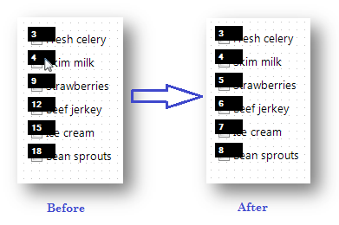
Figure 7.94: Tab Order Adjusted Manually – Before and After
- Click each successive field’s tab order box in the desired flow and the numbers are updated sequentially. In our example, we clicked on the tab order boxes 9, 12, 15, and 18 to set the order to be 5 through 8 consecutively.
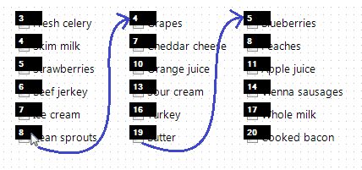
Figure 7.95: Additional Tab Order Options
- After clicking the tab number at the bottom of the first column, move the mouse up to the first field of the second column to continue the sequence. Continue clicking each successive tab order number until you are finished. Click anywhere on the canvas to hide the tab order numbers.

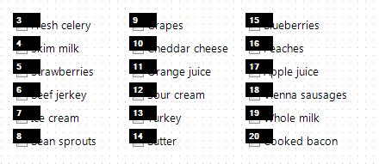

Figure 7.96: Additional Tab Order Options

Customize Tab Order using ‘Continue Tab Order’
The Continue Tab Order feature sequentially renumbers the tab order for a selected set of fields based on the current index value. As an example, the figure below shows the original tab order in the Food History form of the EColi project located in the Projects folder.
Figure 7.97: Customize Tab Order

In order to have the order run down the first column, from ‘Fresh celery’ to ‘Bean sprouts’, then over to ‘Grapes’ in the second column using the Continue Tab Order option, follow these steps:
- Click and drag a rectangle around the first column of fields. This will select just those fields.
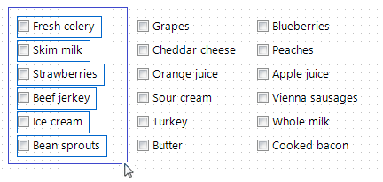
Figure 7.98: Click and Drag Column of Fields for Tab Order
- Right click the canvas and select Tabs > Start New Tab Order. This will reorder only the selected fields beginning with the first tab order number.
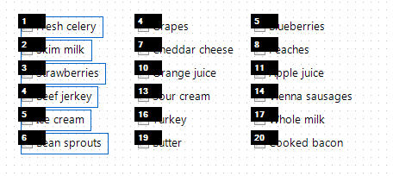
Figure 7.99: Start New Tab Order
- Click and drag a rectangle around the second column of fields to select them.
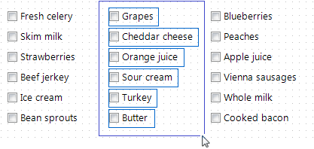
Figure 7.100: Grouping Tab Order
- Right click on the canvas and select Tabs > Continue Tab Order. This will reorder the second column of fields continuing from the last Tab Order Number used in the previous action.
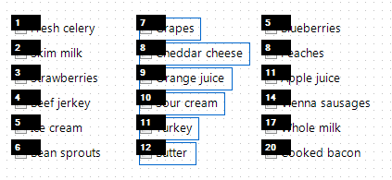
Figure 7.101: Continue Tab Order
- Repeat steps 3 and 4 until all fields’ Tab Order are renumbered as needed.

Disable Tab
The Disable Tab feature makes the field essentially a Read-Only field that does not receive the cursor. In the example shown in the figures that follow, the Age field is calculated in Check Code based on the value entered for Birth Date. Therefore, the designer of this form wants the cursor to skip over the Age field by disabling its tab.
- Right click the canvas and select Tabs > Show Tab Order from the context menu.
- Right click on the desired field’s tab order box and select Disable Tab.
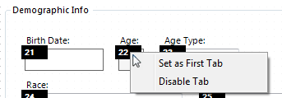
Figure 7.102: Disable Tab
After disabling the Tab for a field, the tab order box becomes red to indicate that it is no longer a field that will receive the cursor. Pressing the tab key will bypass any disabled tabs.
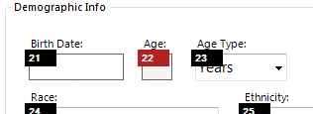
Figure 7.103: Bypassing Disabled Tabs

Note: Check Code only runs when the cursor enters a field. If a field’s tab order is disabled, Check Code will not run for that field.

Templates

Templates are a time-saving feature that allows you to save all or part of your project to be reused in other projects and shared with other Epi Info™ 7 users without sharing data collected with the project. For example, you might want to save certain fields for use on forms you will create later, as opposed to having to create those same fields over and over ( e.g. case demographic information). Saving fields for later use could also be a good way to have a library of fields already built and ready to go in case of a public health emergency. Templates are saved to the Epi Info™ Templates folder using the Extensible Markup Language (XML) format. There are four types of templates: Field, Page, Form, and Project.
Epi Info™ 7 is packaged with a number of project and field level templates that demonstrate many of the various field types and features of Epi Info™ 7 including some Check Code examples. These are listed in the Project Explorer under the Templates category.
One of the best ways to see how Epi Info can be used is to create a project using these templates and examine how they were done. A new project can be created from one of the sample Project Templates in the Form Designer when you open it for the first time.
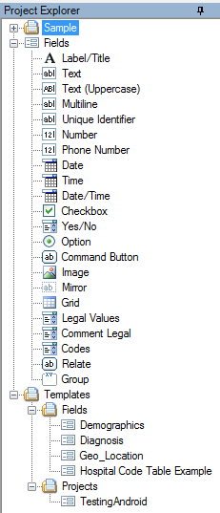
Figure 7.104: Project Explorer Template

Project Templates
Since Epi Info™ 7 Projects contain one or more forms, and each form has one or more pages with fields, Project Templates contain an example of all of the above including any Check Code that may have been saved with the template. Project templates are an effective and convenient way to share projects between colleagues without including collected data.

Create a New Project From Template
A list of demonstration templates are located in the Project Explorer under Templates > Projects. Use one of them to create a new project.
- Double-click the template of choice or select File > New Project from Template. The New Project from Template dialog opens.
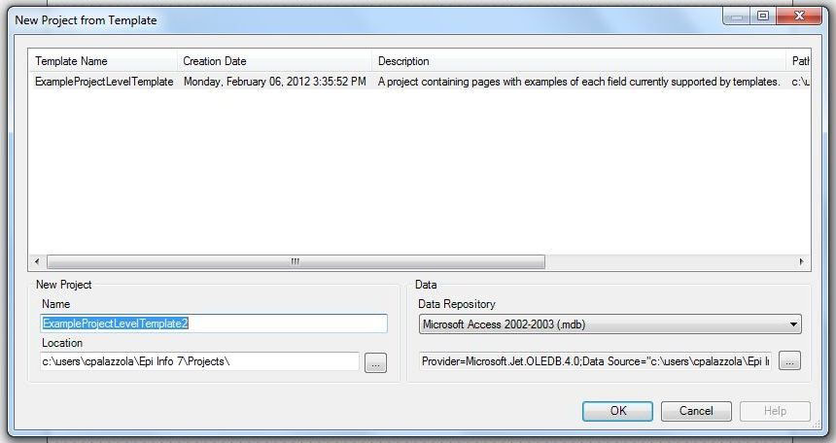
Figure 7.103: New Project from Template
- Select a template from the list. The Name and Data Repository used when the template was created is automatically populated in their respective fields.
- Edit the Project Name, if necessary (optional).
- The default location for the project is the Projects folder within the Epi Info™ 7 folder. Specify another location, if necessary (optional).
- Select the database format from the Data Repository drop-down list. The default option is Microsoft Access 2000-2003, however SQL Server is also available. To use the SQL Server option, you need to have access to a SQL Server database.
- If you selected Microsoft SQL Server for the Data Repository, then click the browse button (…) to the right of the Data Repository field to enter the connection information for the SQL Server database. Contact your SQL Server database administrator for the required information requested in this dialog.
Figure 7.1054: SQL Server Database Dialog Box

- Click OK. The Form Designer creates the project and after a few moments, the new project appears with the first form’s initial page shown on the canvas.
For additional information on creating new projects, refer to the topic Create a New Blank Project and Form.

Create a New Template from a Project
There are two options to create a project template that includes all the forms, pages, fields, and Check Code in the current project – Save Project as Template, which allows you to specify a template name and description, and Quick Save Project as Template which automatically names the template based on the project name and the current date and time. Both options save the template in the same way, but Quick Save does not allow for a custom name and description.
- In the Project Explorer, right click on the project name. The project name is the top most item in the Project Explorer.
- From the drop-down list, select Save Project as Template or Quick Save Project as Template. If Quick Save Project as Template is selected, the template is immediately saved to the Templates > Projects folder with the name of the project and a timestamp.
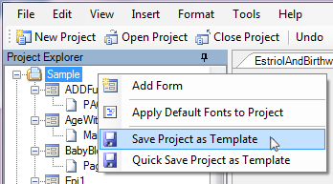
Figure 7.1065: Save Project as Template

- If the ‘Save Project as Template’ option is selected, a dialog appears to allow you to add a Template Name and an optional Description.
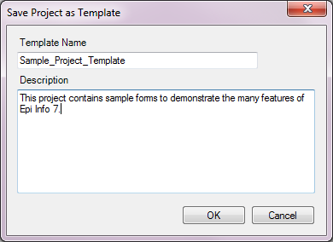
Figure 7.1076: Save Project as Template Description
- Click OK. The template is saved to the Templates > Projects folder.
- To retrieve the template to send to someone, locate the template in the Project Explorer.
- Right click the template name and select Open Containing Folder. This opens the folder in Windows Explorer. From Windows Explorer, you can copy and paste the XML template file into an email or save it to a shared network location for others to use.
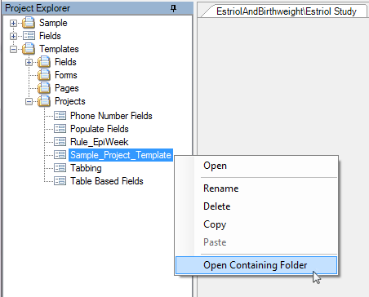
Figure 7.1087: Open Containing Folder

Get Template
If you receive a template from a colleague, an easy way to copy the template to the correct location within Epi Info™ 7 is to use the Get Template feature.
- From the Form Designer menu, select File > Get Template… The Open dialog appears.
- Locate the template file.
- Click Open. The template is saved to the corresponding Epi Info 7 > Templates folder according to the type of template. If the template is a Project template, then the New Project from Template dialog opens.
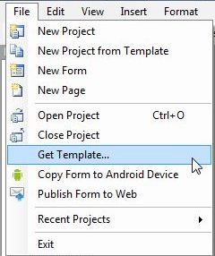
Figure 7.1098: Get Templates

Form and Page Templates
Form and Page templates are created and used in similar ways. The difference is in the item selected when right clicking to get the context menu. Also, form templates can be used to create a single form project, whereas a page template can only be added to a form in an exising project.

Create a Form Template
If you want the template to include all the pages and associated Check Code for a given form then right click the form name in the Project Explorer and select Save Form as Template. In the example shown below, the form ‘Surveillance’ along with its three pages, ‘Person’, ‘Hospital Info’, and ‘Case Report’, will be included in the template along with all associated Check Code.
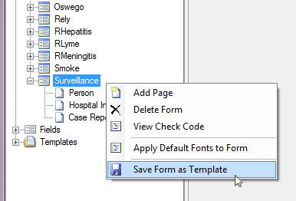
Figure 7.1109: Save Form as Template

Create a Page Template
If you want the template to include the contents of a specific page, and the Check Code for the fields on that page, then right click the page name in the Project Explorer and select Save Page as Template. In this example, only the selected page ‘Hospital Info’ and its Check Code will be in the template.
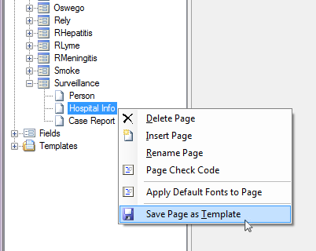
Figure 7.111: Save Page as Template
The Add Template dialog appears for you to enter a Template Name.

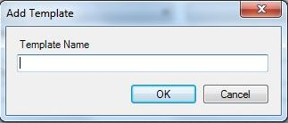
Figure 7.112: Add Template dialog box
Click OK. The page template is created and saved to the respective folder under Templates in the Project Explorer.

How to Use Form and Page Templates
Form and Page Templates are very similar in the way they are used. In order to use either template, there must be an existing Project already open in the Form Designer. The difference is that a Form Template contains the instructions to create a set of pages, each with one or more fields and Check Code, if any. A Page Template has only the page layout information and instructions to create the fields on a single page along with Check Code, if any.
Since all field names and page names must be unique within a given form, a new form created from a Form Template requires very little additional work to make the form usable after it is created from a Form Template.
A Page Template, on the other hand, can be used repeatedly on a given form. Because of this, during the process of creating the new page from a Page Template, if any field names already exist for the form, Epi Info™ 7 automatically appends a number to new field name from the template. Epi Info™ 7 does this to avoid having any duplicate field names. Unfortunately, this has the side effect of potentially breaking the Check Code that may exist for that page template. The field names within the Check Code are not synchronized. Therefore, the Check Code must be manually updated with the new field names.
To use a Form or Page Template, follow these steps:
- With a project open in Form Designer, locate the template in the Project Explorer – Templates > Forms for form templates, or Templates > Pages for a page template.
- If you cannot find the template you need, but you know it is saved somewhere, use the File > Get Template… feature to browse for the template.
- Click and Drag the template to the canvas. Epi Info™ 7 will create the new form or page and place it in the Project Explorer.
- If a page template was used, to change the page order, clicking and drag the page in the Project Explorer to the appropriate position.

Field Templates
Field templates allow for easy and concise duplication and sharing of fields and enable consistent collection of routine information. When a survey needs to have several questions asked in the same way, as in a Likert scale, it is easiest to set up one or two or a few of these questions, save them as a field template, then add additional sets of questions to the form from the template. This method only requires updating the prompt and field name properties of the new fields.
Each field template includes the field definition and attributes for one or more fields, along with any Check Code written for the selected fields. A list of demonstration field templates are available in the Project Explorer under Templates > Fields.

How to Create a Field Template
A convenient way to reuse a field or set of fields along with their Check Code or to share fields with a colleague, is to create a Field Template. To do this, follow these steps:
- Select the fields to add to the template by drawing a rectangle around them. To do that, click and drag the mouse from the top left of the desired fields diagonally down to the lower right until all needed fields are contained in the blue box.
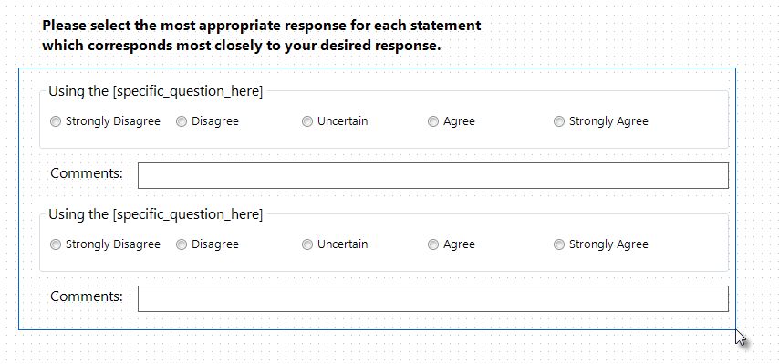
Figure 7.113: Drag a rectangle to Select Fields
- Release the mouse button and the selected fields will remain highlighted.
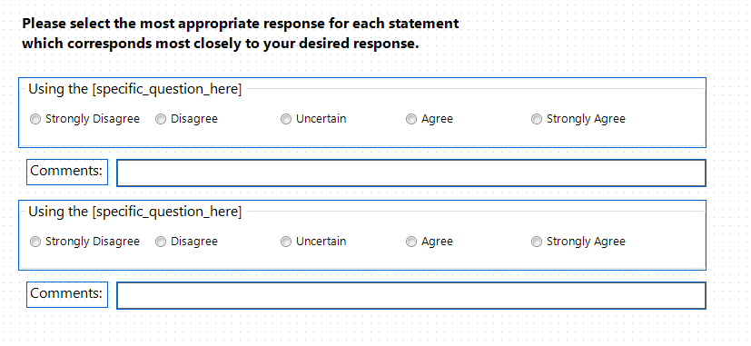
Figure 7.114: Selected Fields appear with blue border
- Right click on a blank area of the canvas. Select Save Selection as Template from the context menu.
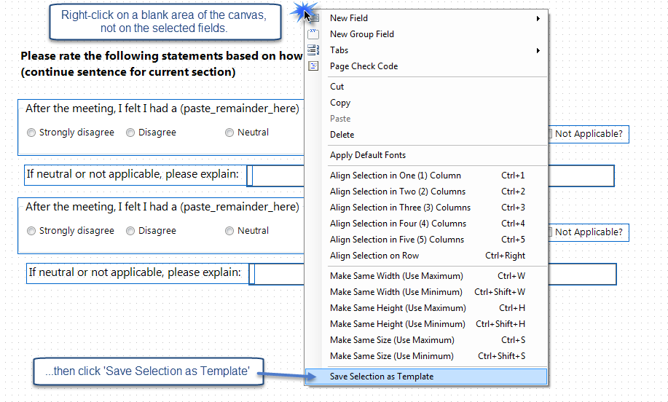
Figure 7.115: Create New Field Template
Note: Right clicking on a field or field group will not display the proper menu options to create a field template. Right click on a blank portion of the canvas only.

- Enter a Template Name in the Add Template dialog box.
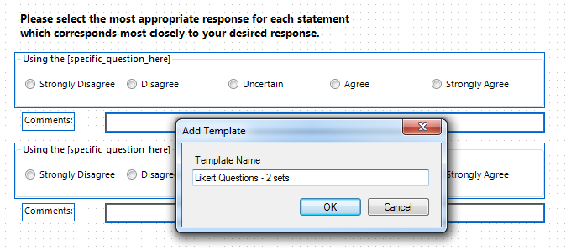
Figure 7.116: Field Template Name
- Click OK. The field template appears under Templates > Fields in the Project Explorer.

Using Field Templates
To use a Field Template to create a new set of fields, follow these steps:
- Locate the Field Template in the Project Explorer.
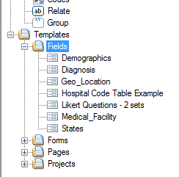
Figure 7.117: Field Template drop-down list
- If you cannot find the template you need, but you know it is saved somewhere, use the File > Get Template… feature to browse for the template.
- Click and drag the desired template from the Project Explorer onto the page in the appropriate location. As you drag the template over the canvas, you will see a blue rectangle showing the approximate footprint that the fields will occupy when created.
- Drop the template where new field(s) should be placed. When the template is released, Epi Info™ 7 will create the new fields and copy the associated Check Code into the Check Code Editor.
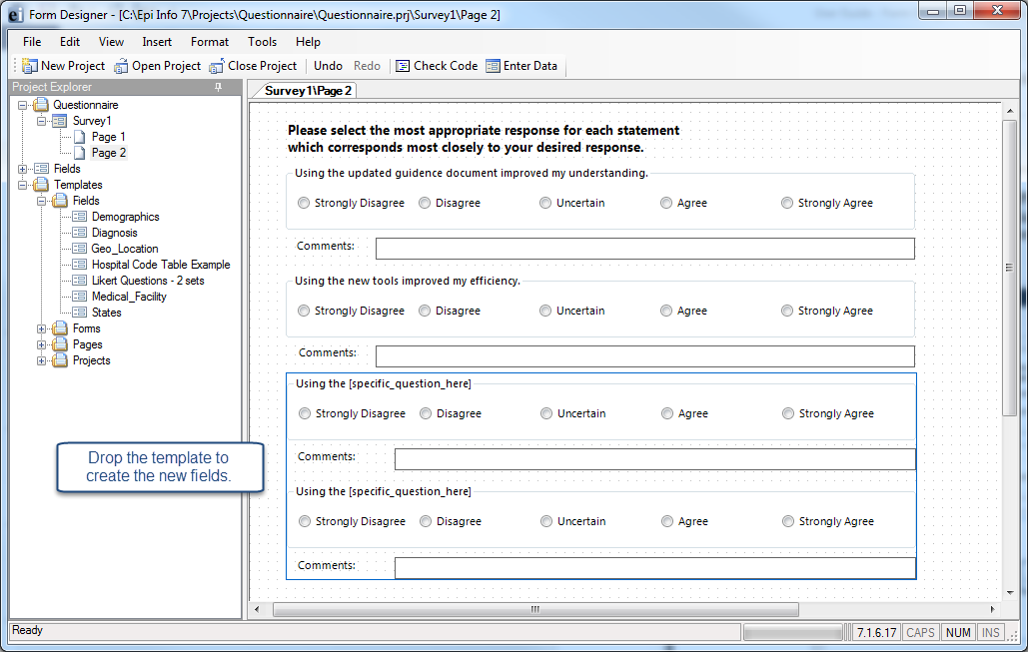

Figure 7.118: Drag Field Template to Canvas
Epi Info™ 7 creates fields from Field Templates using the field name specified in the template UNLESS a field by that name already exists on the form, perhaps on another page. To avoid duplicate field names within a given form, Epi Info™ 7 automatically appends a number to the field name of any field that already exists in the same Epi Info Form. Unfortunately, this has the side effect of potentially breaking the Check Code that may exist for the new fields. The field names within the Check Code are not synchronized. Therefore, the Check Code must be manually updated with any new field names.

- For each new field created from the template, right click the field and select Properties. The Field Property dialog box for the selected field opens. Notice the Field Name.
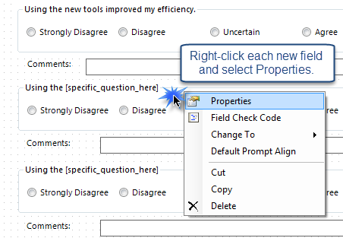
Figure 7.119: Open the Properties for new fields.
- If a data table has not been created for the form, edit the Field Name and other properties as needed.
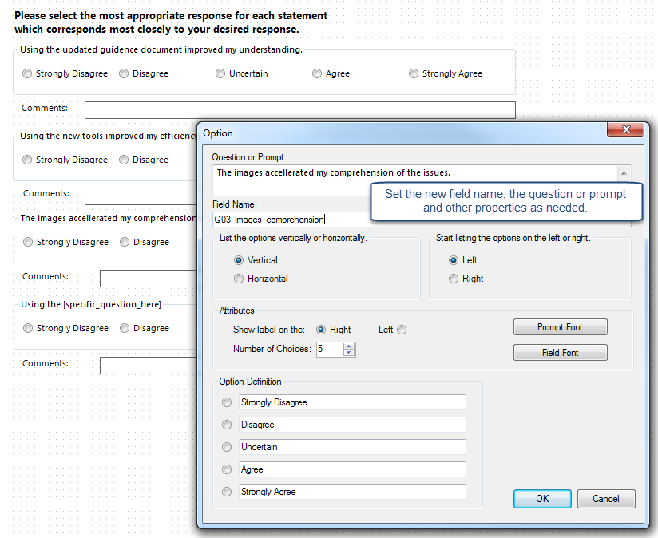
Figure 7.120: Customize the new fields’ names, question, and properties.

Sample Field Templates for Demonstration
There are several field templates that are packaged with Epi Info™ 7 for demonstration purposes. While these fields could be used “As Is” for data collection, these field templates and the Check Code they contain are meant to illustrate the features and functions of Epi Info™ 7.

Demographics
The demographics template has common fields used to for patient information. Some of the fields originate from the Public Health Information Network (PHIN) vocabulary set such as Sex and Ethnicity Group.
Field Types Illustrated:

- Text
- Comment Legal Drop Down
- Phone Number
- Checkbox
- Group
- Number
- Multiline
- Command Button

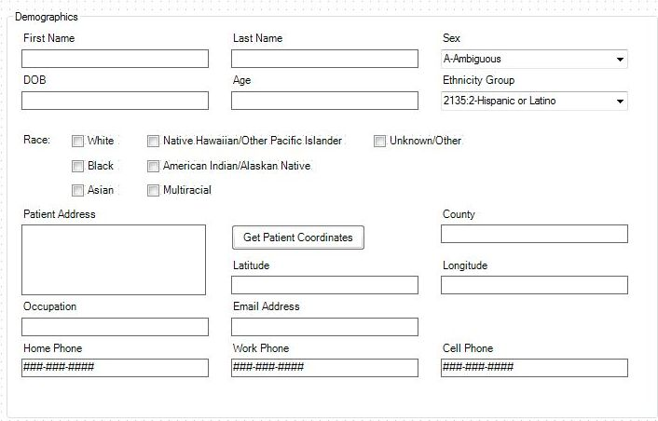
Figure 7.121: Demographics Field Template

Diagnosis
The diagnosis template contains multiple Yes-No fields related to common patient diagnoses. The template also includes text fields for collecting additional information.
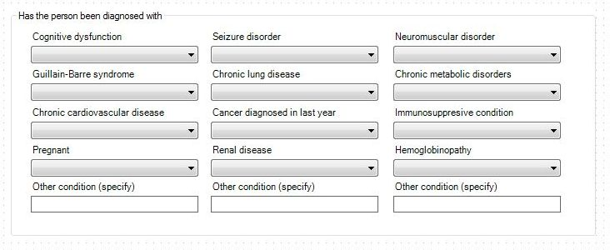
Figure 7.122: Diagnosis Field Template

Geo-location
The geo-location field template contains fields for Address, Latitude, and Longitude. It also has a command button, Get Coordinates for which Check Code was written using the GEOCODE command. This command uses a geolocation service to populate the Latitude and Longitude fields with coordinates based on the information entered into the Address field. These coordinates can then be used in mapping functions in the Epi Info™ Maps tool.
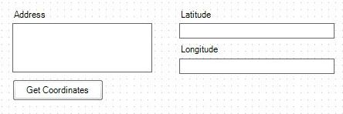
Figure 7.123: Geo_Location Field Template

Medical Facility
The Medical Facility template contains fields commonly used to collect medical facility information.
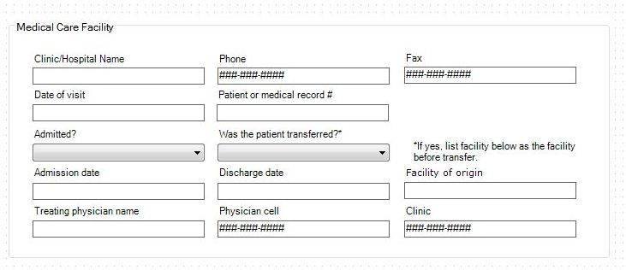
Figure 7.124: Medical Facility Field Template

States
The States field template is an example of a comment legal field. Comment legal fields store only the code or abbreviation in the database, but the full description is shown in the drop-down list. The data source for this field includes all state and territory names and abbreviations for the United States of America in sorted order (alphabetical).
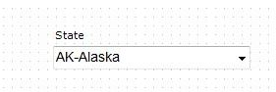
Figure 7.125: States Field Template

Additional Functionality in Form Designer

Insert a Line
It is sometimes helpful to add a horizontal line between groups of fields to give a visual separation between sections of the page. A line can be created using the Label/Title field.
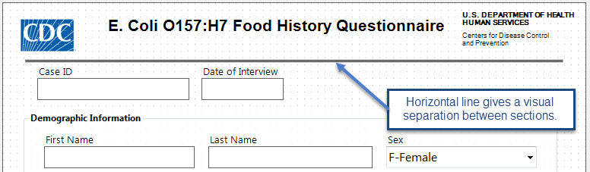Figure 7.126: Horizontal Line Functionality
To create a line on your page, follow these steps:
- Right click on the canvas where you want to add a line. Select New Field > Label/Title.
- In the Question or Prompt field, hold the SHIFT key and type an underscore to create a line.
- Click the Font button. The Font dialog box opens.
- Select a font size and bold.
- Click OK.
- Create a Field Name for the label field.
- Click OK. The line appears in the form.
- The line can be resized, moved, copied and pasted as needed.

Upgrade Project
To use a project from a previous version of Epi Info™ in Epi Info™ 7, the project must be upgraded to the proper format. The upgrade project tool allows users to browse and identify previous projects and upgrade the projects for use in Epi Info™ 7. Select Tools > Upgrade Project > Epi Info 3.5x (.MDB).
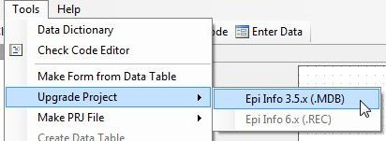
Figure 7.127: Upgrade Project
Browse and select the desired project. Click Open. The project is upgraded to Epi Info™ 7 and is available for use.

Make a Project File (PRJ)
Occasionally, you may receive an Epi Info™ 7 database--either the Access .MDB file or the location of the database on a SQL Server. If this database is by itself, and if you do not have the corresponding Project File (.prj), then Epi Info™ 7 will not be able to work with it until you create a new Project File.
To create a new Project File for a given Epi Info™ 7 database, follow these steps:
  - From the Form Designer Tools menu, select Make PRJ File.
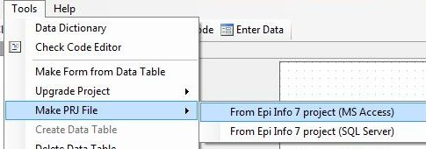
Figure 7.128: Make PRJ file
  - If the database you are attempting to use is a Microsoft Access database, .MDB, then select From Epi Info™ 7 project (MS Access).
For a SQL Server database, select From Epi Info™ 7 project (SQL Server).
  - For Access files, browse for the desired MDB file and click Open. A new project file is created from the source MDB. The original MDB is not changed so it can be opened in the older version after the migraion, however, any changes made to that original database will not be in the new upgraded version.
  - For SQL Server databases, you will be asked for the connection information for the SQL Server. See your SQL Server Database Administrator for the necessary connection information.

Delete an Existing Data Table Without Deleting the Form
To delete an existing data table without deleting the form, perform the following steps:
- From the Form Designer toolbar, select Tools > Delete Data Table. The Form Designer warning message appears.
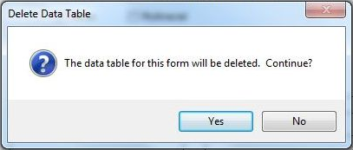
Figure 7.129: Delete Data Table
- Click Yes. The data table associated with your form is deleted. The form remains intact.
- If the data table is deleted, any entered data associated with the form are deleted from the project. Be absolutely sure you do not need the records.
Note: This function should be used only if the data is expendable. This action is permanent and irreversible.

View a Data Dictionary
From the Form Designer toolbar, select. The resulting grid shows the name of the fields in the “Name” column. These names correspond to the column names in the data tables that you will need to use when performing analyses.
The Data Dictionary displays form(s) and defined variables for an open project. Fields or variables are sorted and displayed by page number in the form with defined variables appearing at the end of the listing. Information retrieved from the form includes Page Number, Tab Index, Prompt, Field Type, Name, Variable Type, Format, and Special Info.
From the Form Designer toolbar, select Tools > Data Dictionary. The Data Dictionary table appears on the canvas.
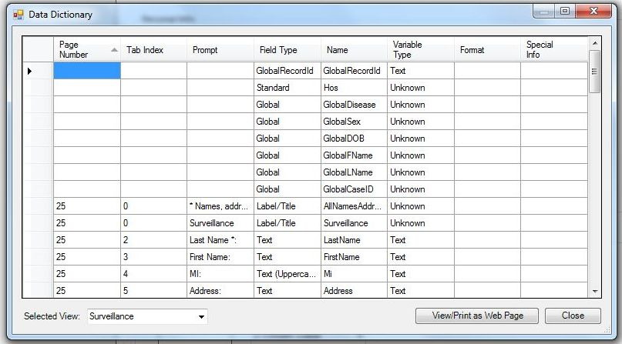
Figure 7.130: Data Dictionary

- Page Number values are developed each time a page is added and corresponds to the page location in the Project Explorer.
- Tab Index corresponds to the tab order for each field.
- Prompt, Field Type, Name and Variable type correspond to the specifications in the Field Definition dialog box for each variable.
- Format column values include selected patterns for number, date, date-time, phone number (anything with a pattern or format) fields and sorted for combo boxes. Combo box is a combination of list box and a drop-down list (legal values, combo).
- Special Info column values include all properties available from the Field Definition dialog box. Properties include Read Only, Legal Value, Repeat Last, Code Table, Groups, Required, Range, and Image Size. The Special Info column also holds the defined variables values of Standard, Global, or Permanent. The Special Info column includes information on related fields to indicate whether they contain one record or an unlimited number of records. This is developed when the related field is created. The default is Unlimited Records. If the Return to the Parent Form after One Record has been Entered box is checked, the format will appear as one record.
To view a data table located in another form:
- Click Selected View. The Selected View drop-down list opens.
- Select the form to view.
- The Data Dictionary for the selected form opens. Note that only the Data Dictionary for the selected form opens.
To open the Data Dictionary as an HTML page inside the browser window:
  - Click View/Print as Web Page.
Note: From the browser, the data can be printed with File > Print, or saved with File > Save As.
- Right click on the HTML page to show the context menu. You can export the data directly to an Excel spreadsheet or print the document.
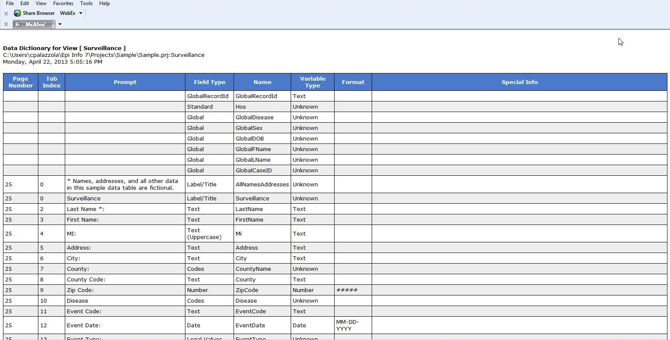
Figure 7.131: Data Dictionary as an HTML Page
- Click Close to exit the Data Dictionary.

Make Form from Data Table
The Make Form from Data Table feature allows you to automatically generate an Epi Info 7 form based on an existing database file. Once completed, you will have the initial structure of a form that could be modified further if needed. Field types, code reference tables and field prompts can be specified during the process. Formats supported include MS Excel, MS Access, Flat ASCII, SQL Server and MySQL among other types.
For example, let’s say that you have an Excel spreadsheet with data that you have historically maintained using MS Excel but would like to create an Epi Info project to collect the data and enjoy the benefits that can be obtained from entering data using Epi Info 7. This feature allows users to do so.
The first step will require you to create an Epi Info 7 project. When prompted for a Form Name, assign any name to the form. This initial form will be deleted eventually after the import process from the MS Excel file is completed.
- From the Epi Info main menu, select Utilities > Make Form from Data Table. The Make Form from Table dialog opens.
- Select the desired Database Type. In this example, we will select Microsoft MS Excel 97-2003 Workbook.
- Navigate to the location of the file.
- Click on the name of the spreadsheet that contains the dataset you would like to import into Epi Info 7.
- Specify a form name.
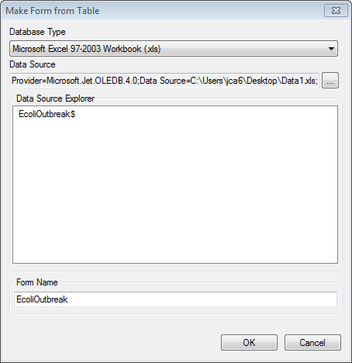
Figure 7.132: Make Form from Table dialog

- Click OK. The Table-to-Form dialog opens.

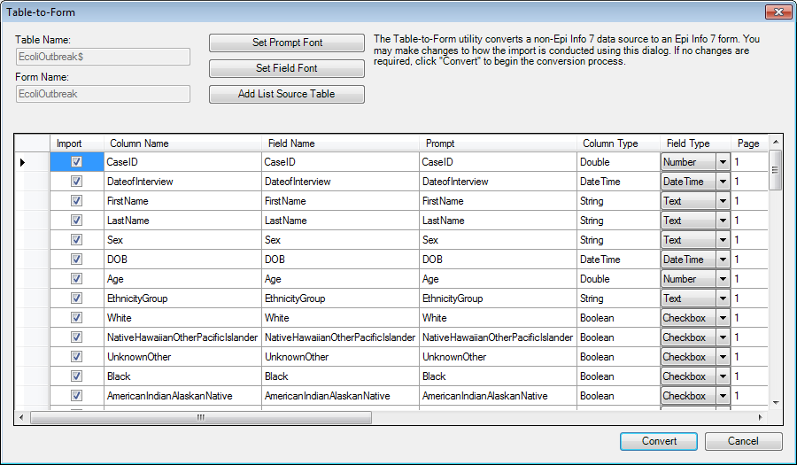
Figure 7.133: Table-to-Form dialog
- Click Set Prompt Font and Set Field Font to set the fonts for the question/prompts and the input fields, respectively.
- If any of the columns in the source table are to become a Legal Value field type, then click Add List Source Table and browse for the table that contains the list of valid values. This will be needed below for the ListSourceTableName column.
A series of columns are displayed. Here is a description of each column:
- Import- This check box allows you to select which fields should be imported into the form and turn off the import for other fields.. By default, all fields are checked.
- Column Name- This specifies the column name from the source table. The column name is initially used for the field name and prompt.
- Field Name- The field name is initially the same as the column name, but you can change it now. If the field name is an Epi Info reserved word, the Table-to-Form process will change it automatically by adding a suffix of “_RW”. You may want to change this name to something more relavent. Note: Be sure these field names are adequate before starting the conversion because they cannot be changed after the data tables are created.
- Prompt- The prompt is initially the same as the field name. You can change it now here, or later by visiting the properties for the field.
- Column Type – This is the type of data that Epi Info™ 7 detected.
- Field Type – This specifies the type of field that probably corresponds to the Column Type. For example, if Epi Info™ 7 detects string data for the column type, then it will suggest the type of field to hold this data might be a Text field. You can override this decision if you know what the data repesent. For example, if the column contains only “Yes” and “No” values, Epi Info™ may suggest the Text field, but you may decide the YesNo field type is more appropriate. Available field types include: Text, Multiline, Number, YesNo, Checkbox, Date, Date-Time, Time, and Legal Values.
- Page- For tables having many columns, Epi Info™ will place the fields on the form based on the order they appear on the source table. It will stack as many fields as will fit on the first page, then it will continue to add pages and stacking fields as needed to accommodate the all of the columns. You can use the Page column to instruct Epi Info™ to keep certain fields together on a specific page.
Note: There is a limit of about 250 fields on any given page.
- Tab- This specifies the order of the field within the page during data entry.
- Tab stop- If data entry will occur for a field, then this should remain checked. Some fields are automatically calculated, so these would not need a Tab stop and therefore the Tab stop checkbox should be unchecked. When Tab Stop is unchecked, the cursor will not move into the field during data entry.
- Read only- This check box sets the Read Only attribute of the field. If checked, the field will be disabled. By default, it is unchecked.
- Required – Fields where data entry is manditory should have this Required attribute checked. By default, it is unchecked.
- Repeat last - When checked, the Repeat Last attribute causes the value of the most recently viewed record to become the pre-populated values when a new record is created. By default, it is unchecked.
- Range - Allows for a specified value between one value and another. During data entry, if you attempt to enter a value outside the specified range, you’ll get a warning message that the value is out of range. Missing values are accepted. By default, it is unchecked. If you check the Range check box, then also specify the Lower and Upper ranges as described below.
- Lower- Specify the smallest or lowest value that can be entered into the field.
- Upper - Specify the largest or highest value that can be accepted by the field.
- List Source Table Name – If a reference table has been imported using the Add List Source Table option, the field can be linked to one of the imported tables. This only applies to Legal Value fields.
- List Source Text Column Name – If more than one column is available on the imported reference table, specify which column name should be used to map to the field from within the table.
- List Source Table- Fields can be removed from the View Fields list using the back single arrow or back double arrows.
- Click Convert to start the import process.
The process of creating the form and importing the process begins. Once the process is completed, the message “Table to form import process complete” message appears.
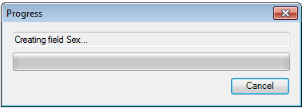
Figure 7.134: In Progress dialog window
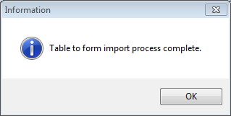
Figure 7.135: Process completed dialog window

After the import process has completed, you can make some changes to the form such as alignment, font, and adding labels and titles. However, do not cut and paste fields from one page to another. If you intend to move fields across pages after the import, we strongly recommended that you first Delete Data Tables Without Deleting the Form, move the fields to the necessary pages, then Use the MERGE Command in Classic Analysis to merge the data into the revised form.
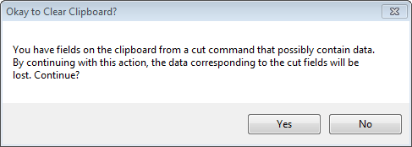
Figure 7.136: Cutting and Pasting fields

3. Check Code: Customizing the Data Entry Process

Introduction

The Check Code tool allows users to customize the data entry process. It is useful to check for errors during the data entry process, to do automatic calculations in fields, and to skip over parts of the questionnaire if certain conditions are met. Check Code makes it possible to instruct the Enter tool to perform such operations automatically. By using Check Code, you can protect data against many common types of errors by setting rules for data entry. Check Code is created using the Check Code Editor.
Examples of operations that can be performed in Check Code include:
- Displaying messages that appear to be part of the questionnaire
- Calculating fields from mathematical operations
- Checking one or more fields for relationships (e.g., making sure birth date is earlier than current date)
- Checking fields for inconsistencies (e.g., male pregnancies)
- Displaying error messages due to improper entries in a field
- Complex statistics or other operations that are written in other languages
- Automatic indexing of fields for faster searching
- Automatic searches during data entry
An operation can be performed automatically each time data is entered in a field or conditionally when a certain value is entered. Check code is optional and is designed to allow the user to provide customized data entry processes.

Accessing Check Code Program Editor

To navigate to the Check Code Program Editor, click the Check Code button in the Form Designer tool bar after opening your Epi Info 7 project.

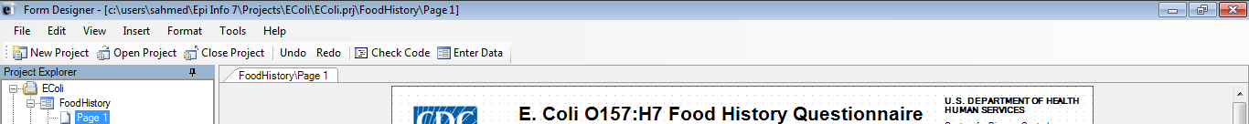
Figure 7.137: Check Code button

Alternatively, select Tools > Check Code Editor from the Form Designer navigation menu.
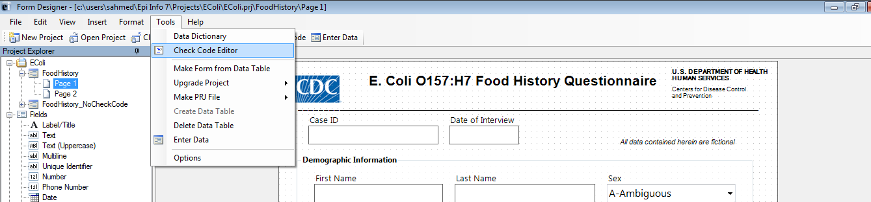
Figure 7.138: Form Designer Menu

Navigate the Check Code Program Editor

The Check Code Editor window contains four sections:
- Choose Field Block for Action
- Add Command to Field Block
- Program Editor
- Messages
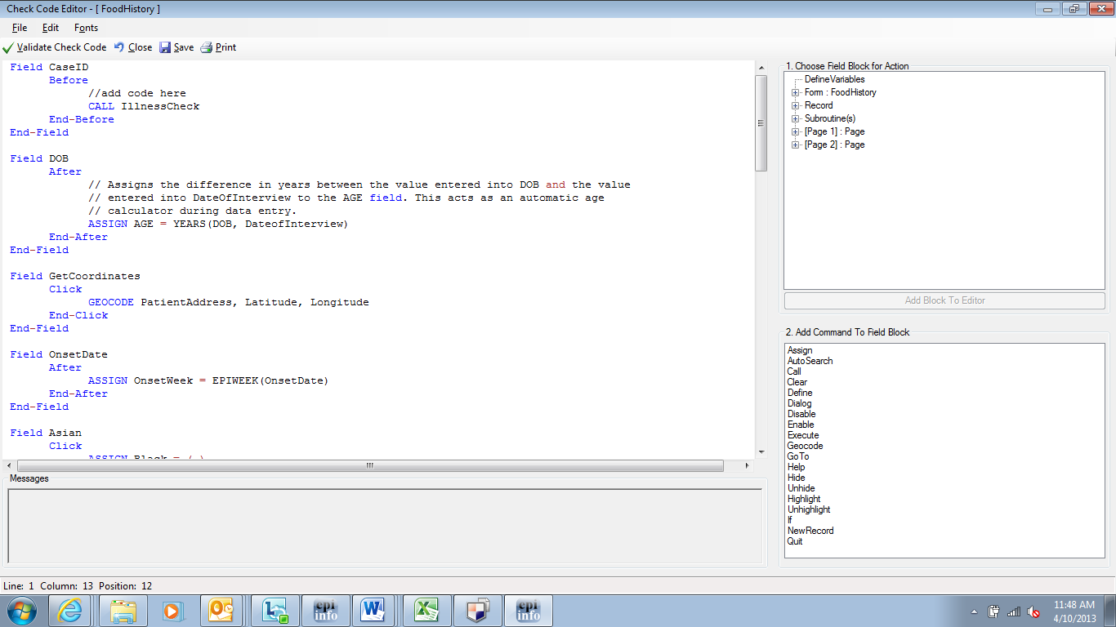
Figure 7.139: Check Code Program Editor
- The Choose Field for Block Action tree allows you to select fields and sets when the actions designated by the Check Commands occur during data entry.
- The Add Command to Field Block window displays all the available check commands used in the Form Designer program.
- The Program Editor window displays the code generated by the commands created from the Choose Field Block for Action or Add Command to Field Block window. Code can also be typed and saved directly into the Program Editor.

- The Message window alerts you of any check command problems

There are several options on the toolbar at the top left that allow you to save, edit, validate and change the font of your program editor. You can close the Check Code Editor and return to your form by clicking on the red X button at the top right of your screen, clicking on the Close button, or by pressing the F10 key.

Check Code Commands

Check commands are structured in blocks. Each block begins with a field, page or form name and ends with the word END. All commands must be within a field-name block. Commands in a block are usually activated either before or after an entry is made in the field. For some field types, blocks can also be activated when clicking on the control (i.e. checkboxes and command buttons). The usual case is that the commands are performed after an entry has been made and the user has pressed the <ENTER> key or when the cursor has left the field automatically. This behavior can be altered by placing commands in blocks called BEFORE. The format of check code blocks is usually structured as follows:

Field VARIABLENAME
After
Check Code syntax inserted here
End-After
End-Field
- The FIELD parameter establishes to which field name the check code block corresponds.
- The AFTER parameter specifies when the action will occur. The AFTER event is executed as soon as the cursor leaves that field.
- The END-AFTER parameter specifies the closing of the commands to be executed, in this example, for the AFTER event. In other words, any check code inserted between the AFTER and END-AFTER section will be executed for that field after the cursor leaves the field.
- The END-FIELD parameter simply closes the block of commands incorporated for the corresponding field.
In the example below, we have incorporated an AFTER event for a field called DOB. The block of check code will execute the assignment of a value to the field AGE using the YEARS function. The YEARS function will calculate the difference between two date fields and provide the result in Years.

Field DOB
After
ASSIGN AGE=YEARS(DOB,SYSTEMDATE)
End-After
End-Field

Basic Check Code Command Rules
- Check Commands must be placed in a block of commands corresponding to a variable/field in the database. Special sections are provided to execute commands before or after you display a form, page, or record.
- Comments preceded by two forward slashes ("//") may be placed within blocks of commands and will be ignored during execution of check code.
- Commands in a block are activated before or after you make an entry in the field. By default, commands are performed after an entry has been completed with <Enter>, <PgUp>, <PgDn>, or <Tab>, or another command causes the cursor to leave the field (e.g., GOTO). Commands can also be activated when clicking on a field or when selecting a value from a drop down list (versions 7.1.4 or higher only).
- Check commands for each field are stored in the form in a record associated with a particular field.
- Commands are inserted automatically through interaction with the dialog boxes. The syntax generated by the dialogs is then displayed in the Check Code Editor. Text can also be edited and saved in the Program Editor.
- BEFORE and AFTER commands can be inserted into fields but also into a form, page or a record.

Creating a Check Code Block
- From Choose Field Block for Action, select and expand the form, page, record, or field that will receive the commands. Expand by clicking the + sign.

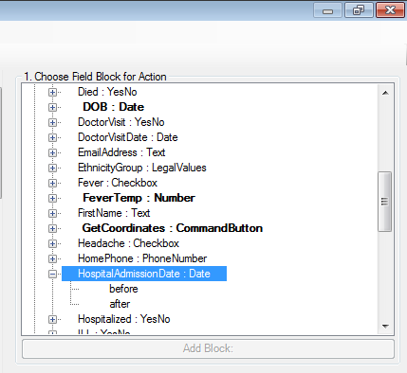
Figure 7.140: Choose Field Block for Action

- Select whether the command will be executed before or after data entry into the form, page, record, or field by clicking in the corresponding option (in this example AFTER).
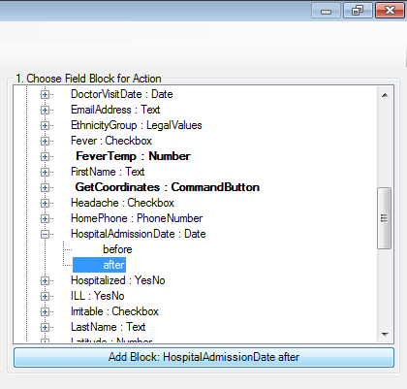
Figure 7.141: Add Block
- You can either double click on the AFTER event or click the Add Block button in order to insert the block. The Check Code Block appears in the Check Code Editor.

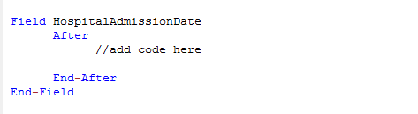
Figure 7.142: Code Block Added to Editor
After a Check Code Block has been created for a form, page, record, or field, you can insert commands within the block using the Add Command to field Block section.

Create a Skip Pattern with GOTO
You can create skip patterns by changing the tab order and setting a new cursor sequence in a form, or by creating Check Code using the GOTO command. Skip patterns can also be created based on the answers to questions using an IF/THEN statement. In the following example, we will add check code to move the cursor to the Ethnicity field after data is entered into the DOB field.
- From Form Designer, Open the Ecoli.prj project.
- Double click on the FoodHistory_NoCheckCode form.
- Click Check Code or select Tools > Check Code Editor. The Check Code Editor opens.
- From the Choose Field Block for Action section, expand the node for Page 1 to see the various fields on the first page.
- Expand the node for the field DOB.

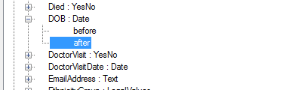
Figure 7.143: Dialog Block for Action after DOB
- Double click on the after event.
- A block of code for the DOB field will display in the Check Code Editor.

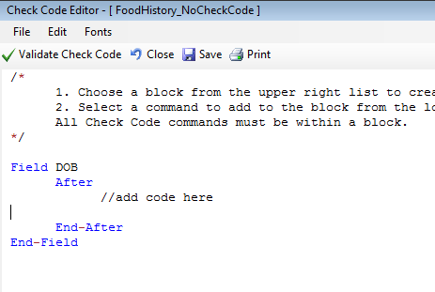
Figure 7.144: Check Code Block for Action After DOB
- Click GoTo from the Add Command to Field Block list box. The GOTO dialog box opens.
- Select the EthnicityGroup field for the cursor to jump into after data has been entered in the DOB field. The code will run after the cursor leaves the field.

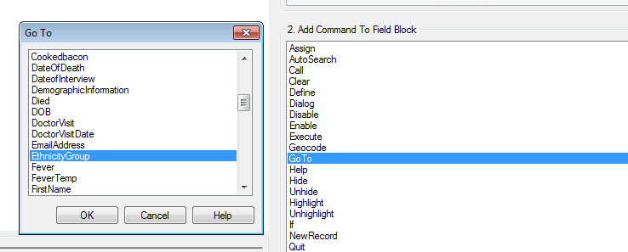
Figure 7.145: Skip Pattern Go To dialog box

- Click OK. The code appears in the Check Code Editor.

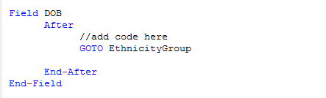
Figure 7.146: Skip Pattern Check Code Command
- Click the Verify Check Code button from the Check Code Editor.
- Click the Save button from the Check Code Editor.
- Click Close to return to the form.

To test the skip pattern, open the form in the Enter Data tool. Use the tab key to ensure that upon leaving the field with the GOTO command, the cursor goes to the specified field.

Create a Skip Pattern Using IF/THEN and GOTO
Use IF/THEN statements to create skip patterns based on the answers to questions in the form. This example creates code, which states that if the person answered No (-) for the Hospitalized field, then the cursor subsequently jumps to the field Was the patient treated with antibiotics? and skips the Hospital Admission date field.

- From Form Designer, Open the Ecoli.prj project.
- Double click on the FoodHistory_NoCheckCode form.
- Click Check Code or select Tools > Check Code Editor. The Check Code Editor opens.
- From the Choose Field Block for Action section, expand the node for Page 1 to see the various fields on the first page.
- Expand the node for the Hospitalized field.
- The action needs to occur after data are entered into the Hospitalized field.
- Double click on the after event.
- A block of code for the Hospitalized field is created and displayed in the Check Code Editor.

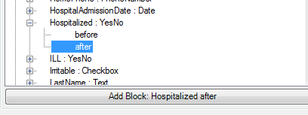
Figure 7.147: Dialog Block for Action after Hospitalized
- The code appears in the Check Code Editor.
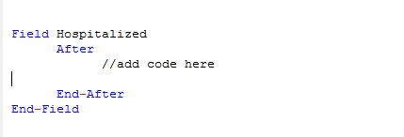
Figure 7.148: If/Then Block Code After Hospitalized
- Click If from the Add Command to Field Block list box. The IF dialog box opens.
- From the Available Variables drop-down list, select the field to contain the action. For this example, select Hospitalized. The selected variable appears in the If Condition field.
- From the Operators, click =.
- From the Operators, click No. The If Condition field will read Hospitalized=(-).
- Click the Code Snippet button in the Then section. A list of available commands appears.
- From the command list, select GoTo. The GOTO dialog box opens.
- Select the field for the cursor to jump to based on a No answer from the list of variables. For this example, select Antibiotics.
- In the GOTO dialog box, click OK to return to the IF dialog box.

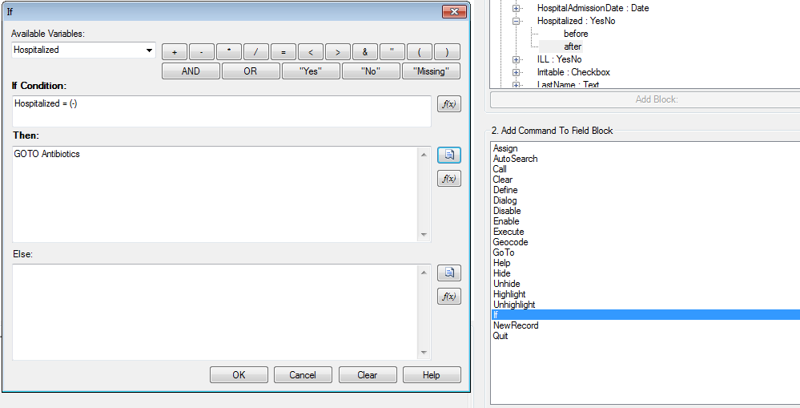
Figure 7.149: If/Then dialog box
- Click OK. The code appears in the Check Code Editor. The example code appears as:

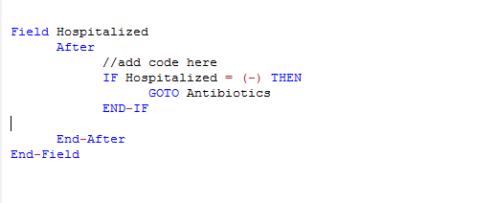
Figure 7.150: If/Then Check Code Command
- Click the Verify Check Code button from the Check Code Editor.
- Click the Save button from the Check Code Editor.

Using Functions with a Date field
To program a mathematical function, use the Program Editor and the ASSIGN command. For example, Check Code can be created to automatically calculate the age of a respondent based on the date of birth and the date the form was completed, or the system date of the computer when data were entered.
This example uses a field called DateOfBirth and a field called Age from the FoodHistory_NoCheckCode form in the Ecoli project to demonstrate the use of the ASSIGN command and the function YEARS.
- Click Check Code or select Tools > Check Code Editor. The Check Code Editor opens.
- From the Choose Field Block for Action section, expand the node for the page where the DateofBirth field is located.
- Expand the node for the DateofBirth field.
- Double click on the after event.
- A block of code for the DateofBirth field is created and displayed in the Check Code Editor.
- Click Assign from the Add Command to Field Block list box. The Assign dialog box opens.
- From the Assign Variable drop-down list, select the field where the calculated value should appear. For this example, select the Age field.
- Click on the functions button.
- Select the Date Functions option.
- Click on the YEARS function.
- Double click on the <start_date> parameter. This will highlight that section of the command.
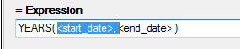
Figure 7.151: Start Date Parameter
- Select DateOfBirth from the list of Available Variables
- Double click on the <end_date> parameter. This will highlight that section of the command.
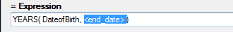
Figure 7.152: End Date Parameter
- Click on the functions button.
- Select the System Functions option.
- Click the SYSTEMDATE function. Once completed, the syntax will be inserted on the dialog window.

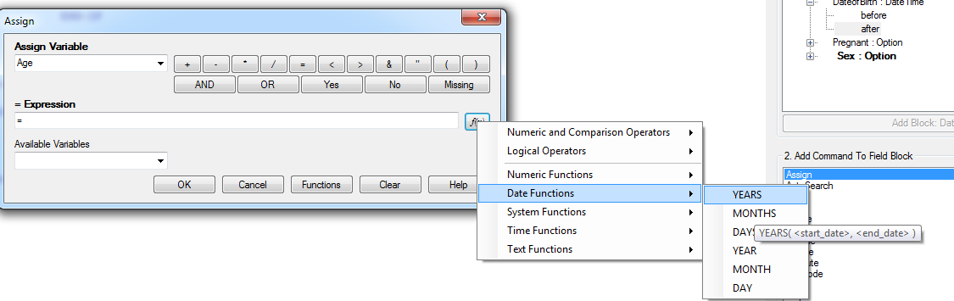
Figure 7.153: Assign Date Function options
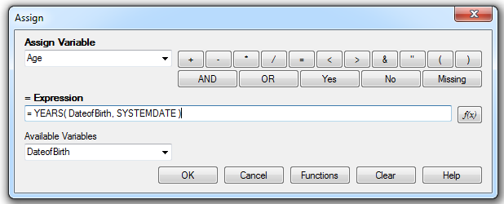
Figure 7.154: Assign dialog box
- Click OK. Check Code will appear in the Check Code Editor.
- Click the Verify Check Code button in the Check Code Editor.
- Click the Save button in the Check Code Editor.

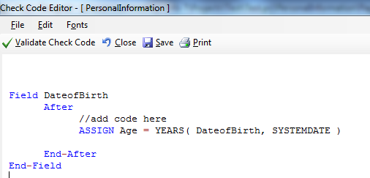
Figure 7.155: Assign Check Code Command
When Date of Birth is entered into the form, the Age field will automatically populate.

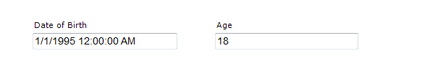
Figure 7.156: Assignment of Age in Enter Data

Interact with Users with the DIALOG command
The DIALOG command provides interaction with data entry personnel from within the program. Dialogs can display information, ask for and receive input, and offer lists to make choices. In the following example, the DIALOG command creates a reminder that all fields on page two of the survey must be completed.
- From Form Designer, Open the FoodHistory_NoCheckCode form in the EColi.prj.
- Click Check Code or select Tools > Check Code Editor. The Check Code Editor opens.
- From the Choose Field Block for Action list box, select Page 2. The action should occur before the page is loaded.
- Select Before from the Before or After Section.
- Click the Add Block button.

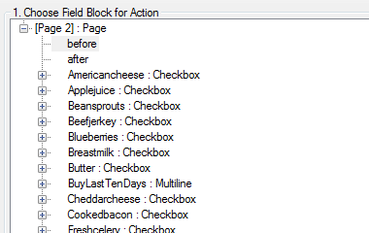
Figure 7.157: Dialog Block for Action
- The code appears in the Check Code Editor.

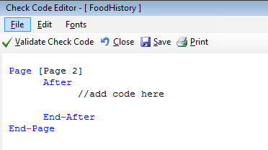
Figure 7.158: Dialog Block Code
- From the Add Command to Field Block list box, select Dialog. The DIALOG box opens.
- Select Simple from the Dialog Type radio button options.
- In the Title field, type Alert.
- In the Prompt field, type All fields on page two must be completed.

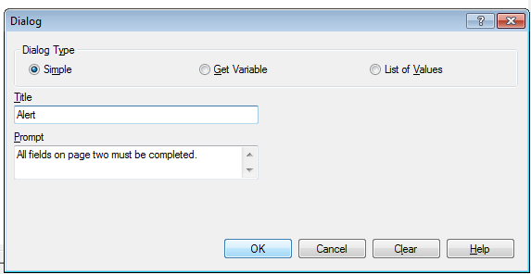
Figure 7.159: Dialog command box
- Click OK. The code appears in the Check Code Editor.

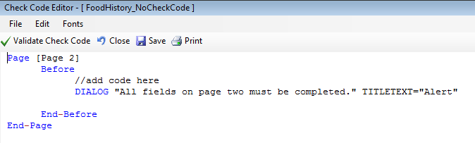
Figure 7.160: Dialog Check Code Command
- Click the Verify Check Code button from the Check Code Editor.
- Click the Save button in the Check Code Editor.

Searching for Records – Using the AUTOSEARCH command
The Autosearch command automatically searches for an existing record that matches the entered values and notifies the user. A choice is then offered between editing the matching record or continuing with data entry in the new record. Duplicate records are detected and may be prevented with the AutoSearch command. For this example, we will incorporate the Autosearch command on the CaseID field.
- From Form Designer, Open the FoodHistory_NoCheckCode form in the EColi.prj.
- Click Check Code or select Tools > Check Code Editor. The Check Code Editor opens.
- From the Choose Field Block for Action section, expand the node for the page where the CaseID field is located, which in this example is Page 1.
- Expand the node for the field CaseID.
- Double click on the after event.
- A block of code for the CaseID field is created and displayed in the Check Code Editor.

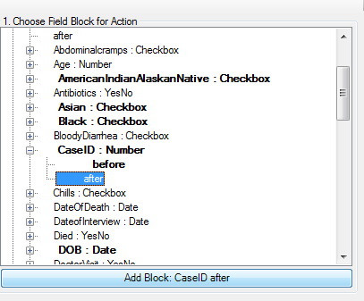
Figure 7.161: AutoSearch Block for Action
- The code appears in the Check Code Editor.

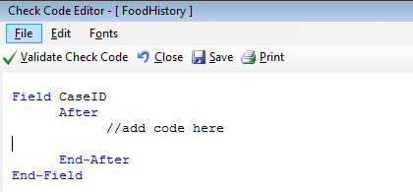
Figure 7.162: AutoSearch Block Code
- From the Add Command to Field Block list box, click Autosearch. The Autosearch window opens.
- Select the variable(s) to be searched during data entry. In this example, select CaseID.

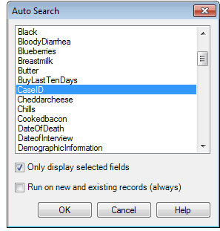
Figure 7.163: Auto Search dialog box
- Click OK. The code appears in the Check Code Editor window.

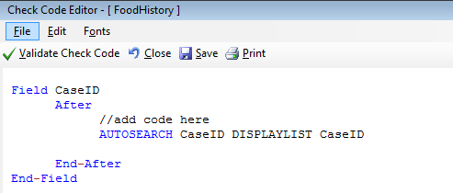
Figure 7.164: AutoSearch Check Code Command
- Click the Verify Check Code button from the Check Code Editor.
- Click the Save button from the Check Code Editor.
- Click Close to return to the form.
When a duplicate record is entered in the Enter Data tool, the Autosearch dialog box opens with all the matching records listed. To view the potential duplicate record, double-click the arrow that appears next to the record. The field where the potential duplicate was entered is cleared. Alternatively, click Cancel to remain on the current record and accept the duplicate value. To display other variables when a matching record is found, add the variable names after the DISPLAYLIST parameter (i.e. Last Name, First Name and Date of Birth as shown below).

Field CaseID
After
//add code here
AUTOSEARCH CaseId DISPLAYLIST CaseID LastName FirstName DOB
End-After
End-Field

In the check code above, the autosearch will be done on the field CaseID and if any matching records are detected, the fields CaseID, LastName, FirstName and DOB will be displayed on the grid.

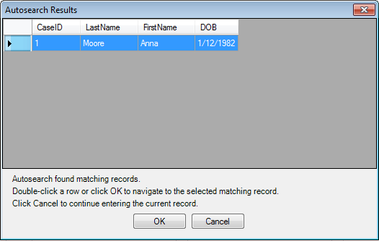
Figure 7.165: Autosearch Results

Note: For more information on using Autosearch, please see the Autosearch topic in the Command Reference.

Copy the Value of a Field from a Main Form to a Related Form
When users have developed a relational database setup using Epi Info™ 7, it might be appropriate to transfer values entered in the parent form (i.e. core demographics) into the child form (i.e. Visits information). In order to accomplish this process, Check Code must be created for a value from a field in the main form to appear in a related form (i.e., there may be a Case ID Number or Patient’s Name that needs to be visible in the parent and child forms).
The following instructions assume the parent and child forms already exist. Let’s assume that the Parent form is called Surveillance while the Child form is called Hepatitis. The field to be copied needs to exist in the parent form or be created in the parent form prior to the incorporation of the check code in the child form (i.e. Last Name in parent form will be passed to Last Name in child form). Let’s make the assumption that the name of the field on the Parent form whose value will be copied to the Child form is called PatientId.
- From Form Designer, open your project and click on the child form name from the Project Explorer tree.
- Create a new field. The new field must be the same field type as the field being copied from the parent form. For this example, use PatientId.
- Select the Read Only option.
- Click OK. The new field appears in the form. This is where the value from the parent form will be assigned and displayed during data entry on the child form.
- Click Check Code or select Tools > Check Code Editor. The Check Code Editor opens.
- From the Choose Field Block for Action list box, select the page corresponding to where the PatientId field was placed. Let’s make the assumption that this field was created on Page 1. For the Page, select the before from the Before or After Section.
- Click the Add Block button.
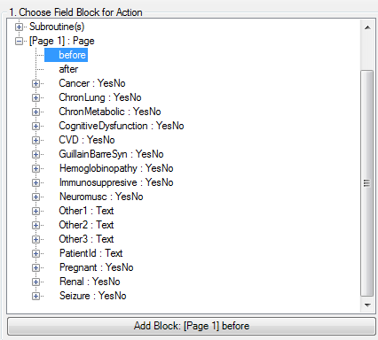

Figure 7.166: Choose Field Block for Action
- From the Add Command to Field Block list box, click Assign. The ASSIGN dialog box appears.
- From the Assign Variable drop-down list, select the new variable, PatientId.
- In the = Expression area, type the field name from the parent form, in this case PatientId. This field name must be prefixed by the parent form’s name followed by a period in the Assign expression. We will need to make that modification once the command is written into the Program Editor.

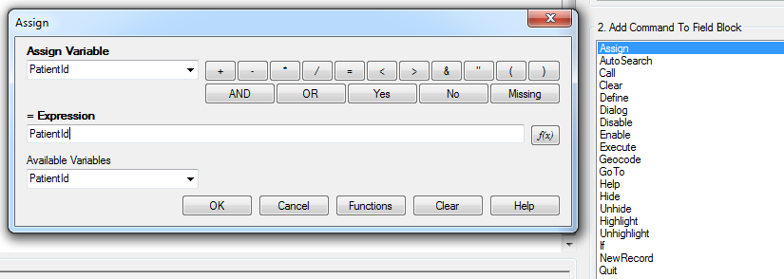
Figure 7.167: Copy Value- Assign dialog box
- Click OK.
- The code appears in the Check Code Editor. If the child form already has a field with the same name as the one being copied from the parent form, it is important to distinguish the parent’s field name. This field name must be prefixed by the parent form’s name followed by a period in the Assign expression. In this example, Hepatitis is the name of the child form while Surveillance is the name of the parent form. If the child form does not have a field with the same name as the one being copied from the parent form, it is sufficient to indicate just the field name. Therefore, for this example, this modification will be required to the syntax since the field is called the same on both forms. Once completed, your syntax should look like the one on Figure 3.32.
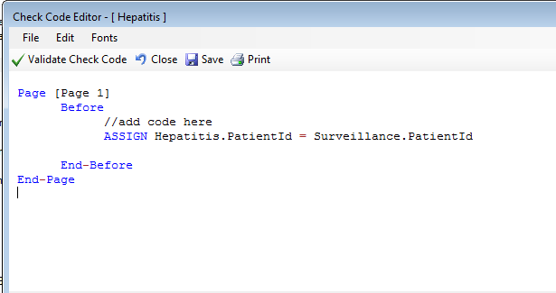
Figure 7.168: Copy Value Check Code Command
- Click the Validate Check Code button and, if needed, correct any issues.
- Click Save.

Concatenate Fields
When writing check code for concatenating fields, syntax will be executed for new records entered. The code will not go back and populate previously entered data. If previously entered data need to be concatenated, use concatenation commands from the Classic Analysis section of the manual.

Concatenate Fields with the Ampersand '&' Operator
This example illustrates how to join data from two fields and assign it into a third field using the ‘&’ operator. In this example, Patient Full Name will be assigned to the concatenation of First Name and Last Name.
- In Form Designer, open your form.
- Click Check Code. The Check Code Editor opens.
- From the Choose Field Block for Action list box, select LastName.
- Select after from the Before or After Section.
- Click the Add Block button.
- From the Add Command to Field Block list box, click Assign. The ASSIGN dialog opens.
- From the Assign Variable drop-down list, select the field to contain the concatenated value.
- Create the = Expression using the '&' operator. In this example, ASSIGN PatientFullName = FirstName & LastName.

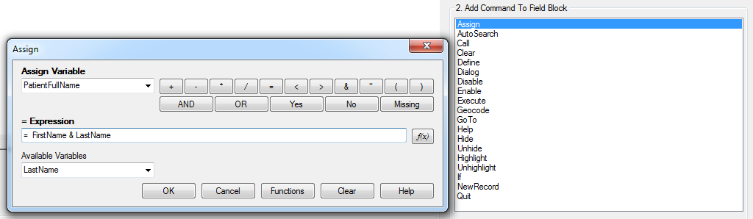
Figure 7.169: Concatenate- Assign dialog box
- Click OK. Check Code appears in the Check Code Editor.

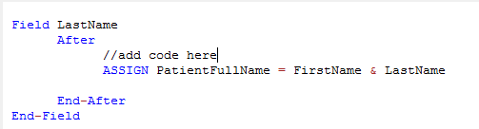
Figure 7.170: Concatenate No Space Check Code Command
- Click the Validate Check Code button and correct any issues.
- Click Save.

If in the Enter tool, Carl was entered for FirstName and Gao was entered for LastName, the result of PatientFullName would be CarlGao. There are no spaces between the names. To add a space between the names, simply modify the ASSIGN statement by adding a blank space in quotes between the first and last names as in the following statement:
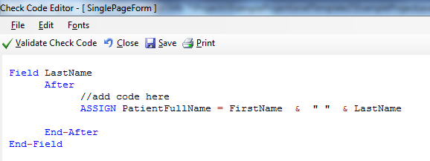
Figure 7.171: Concatenate Include Space Check Code Command

Concatenate Fields with the Substring Function
This example illustrates how to join parts of two variables to create a unique text ID. In this example, you will create a Patient ID made up of parts of the patient's last and first name. The ampersand (&) operator is used to join the two parts together.
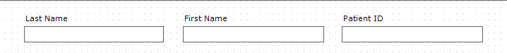
Figure 7.172: Enter Form - Name
- From the Form Designer, click Check Code. The Check Code Editor opens.
- From the Choose Field Block for Action list box, select FirstName.
- Select after from the Before or After Section.
- Click the Add Block button.
- From the Add Command to Field Block list box click Assign. The ASSIGN dialog box opens.
- From the Assign Variable drop-down list, select the field to contain the concatenated value. In this example, select PatientID.
- Create the =Expression using the SUBSTRING syntax.
- SUBSTRING(<variable>, position #, #characters)
- <variable> is the field or variable
- position # is the position of the first character to be extracted from the variable
- #characters is the number of characters to extract
In this example, the PatientID variable contains a combination of the first position and four characters of the last name plus the first position and three characters of the first name.

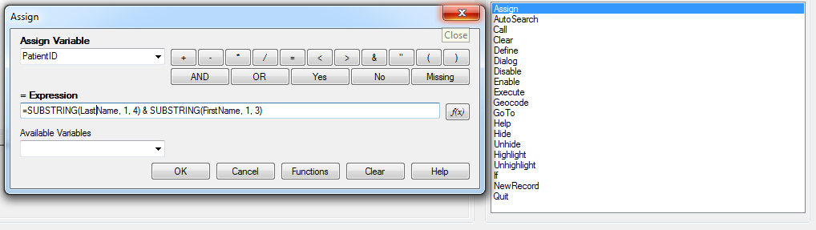
Figure 7.173: Concatenate with Substring Assign dialog box
- Click OK. The code appears in the Check Code Editor window.
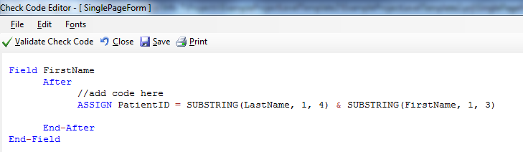
Figure 7.174: Concatenate with Substring Check Code Command
- Click the Validate Check Code button and correct any issues.
- Click the Save button.

The example functions as such:

- Last Name: Smith
- First Name: Megan
- Patient ID: SmitMeg
- The Patient ID field being calculated is Read Only.

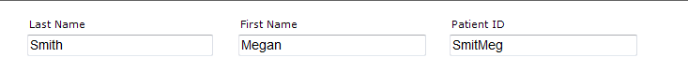
Figure 7.175: Concatenate with Substring Enter Form

Create Check Code for Option Box Fields
Check Code can be added to option box variables. Code can be added to any line/choice present in the option boxes. Use the Check Code Editor to create complex Check Code for option box variables.
For this example, the check code created uses the GOTO command. Check Code was used to create the following scenario. If the answer to TestOptions is Choice 1, the cursor will jump to Question 2. If the answer to TestOptions is Choice 2 or Choice 3, the cursor will jump to Question 1. Check the tab order before creating the Check Code to ensure that the tab order is correct.
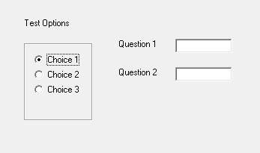
Figure 7.176: Text Options box
- Create an Option Box in a form. Note the name of the variable.
  - The variable is named TestOptions.
  - Each text line that represents a choice in the form represents a numeric position in the Check Code Editor.
  - For example, there are three lines/choices that can be made in the variable TestOptions. In the Check Code Editor the choices are numeric, choice 1 = position 0, choice 2 = position 1, and choice 3 = position 2.
- Open the Check Code Editor.
- From the Choose Field Block for Action list box, select TestOptions.
- Select after from the Before or After Section.
- Click the Add Block button.
- From the Add Command to Field Block list box, click If. The IF dialog box opens.
- From the If Condition field, type Test Options = 1.
- Remember that the number 1 in this instance represents a text value called Choice 2.
- Click the Code Snippet button in the Then section. A list of available commands appears.
- From the command list, select GoTo. The GOTO dialog box opens.
- Select Question2.
- Click OK.
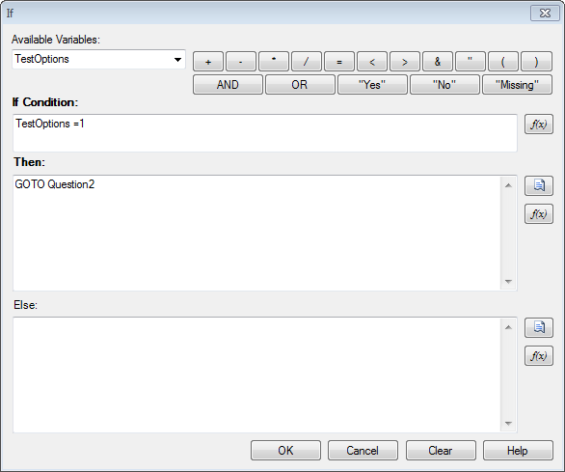
Figure 7.177: If dialog box
- Click Validate Check Code and correct any issues.
- Click Save.

Delete a Line of Code from the Check Code Editor
To delete a line(s) of check code from the Check Code Editor, you can complete the following steps:

- Highlight the line(s) of code/text that you desire to delete.
- Press the Delete key on your keyboard.
- Once done, from the Check Code Editor toolbar, click Save.

Note: Be sure of all deletions made. No confirmation prompt or undo button will appear prior to deletion.

Disable
If there isn’t a need to capture information for a particular field, then it can be disabled. Disable is usually used with the IF, THEN, ELSE conditions. In this example, the field DoctorVisitDate will be disabled if the response to the DoctorVisit is No.
- Open the FoodHistory_NoCheckCode form in the EColi.prj.
- Click Check Code. The Check Code Editor opens.
- Select the DoctorVisit from the Choose Field Block for Action list box.
- Select after from the Before or After Section.
- Click the Add Block button.
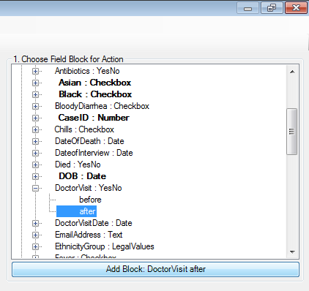
Figure 7.178: Disable Block for Action
- The code block appears in the Check Code Editor.
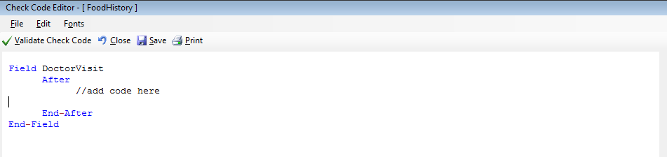
Figure 7.179: Disable Block Command
- Click IF from the Add Command to Field Block list box. The IF dialog box opens.
- From the Available Variables drop-down list, select the field to contain the action. For this example, select DoctorVisit. The selected variable appears in the If Condition field.
- From the Operators, click =.
- From the Operators, click No. The If Condition field will read DoctorVisit=(-).
- Click the Code Snippet button in the Then section. A list of available commands appears.
- From the command list, select DISABLE. The DISABLE dialog box opens.
- Select the field to be disabled based on a No answer from the list of variables. For this example, select DoctorVisitDate.
- Click OK to return to the IF dialog box.
- Click the Code Snippet button in the Else section. A list of available commands appears.
- From the command list, select Enable. The Enable dialog box opens.
- Select the field to enable based on a Yes answer from the list of variables. For this example, select DoctorVisitDate.
- In the Enable dialog box, click OK to return to the If dialog box.
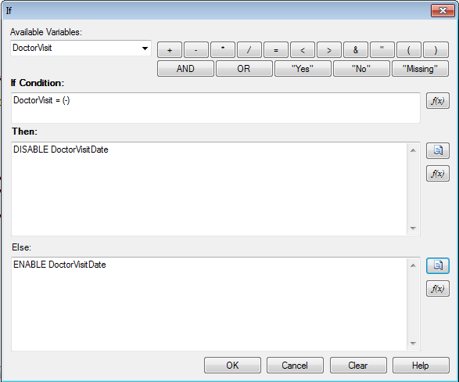
Figure 7.180: Disable- If dialog box
- Click OK. The code appears in the Check Code Editor. The example code appears as:

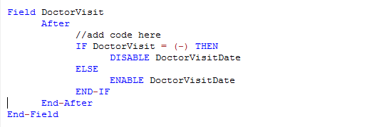
Figure 7.181: Disable Check Code Command
- Click Verify Check Code button.
- Click Save.
- Click Close to return to the form.

To test the Disable, open the form in the Enter Data tool. When No is entered for DoctorVisit, DoctorVisitDate should become disabled.

Hide
A field may be hidden if there is not a need to capture information for a particular field or if it does not apply based on previously answered questions. The field on the form would be hidden from the form. In the following example, the Pregnant option box will be hidden based on the users Sex; Female or Male.
- Click Check Code. The Check Code Editor opens.
- Select Sex from the Choose Field Block for Action list box.
- Select after from the Before or After Section.
- Click the Add Block button. This creates code to run after data is entered and accepted.
- The code appears in the Check Code Editor.
- Click IF from the Add Command to Field Block list box. The IF dialog box opens.
- From the Available Variables drop-down list, select the field to contain the action. For this example, select Sex. The selected variable appears in the If Condition field.
- From the Operators, click =.
- From the If Condition field, type Sex = “Male”. Remember that Sex is a text field and the value must be enclosed in quotes.
- Click the Code Snippet button in the Then section. A list of available commands appears.
- From the command list, select Hide. The Hide dialog box opens.
- Select Pregnant.
- Click OK.
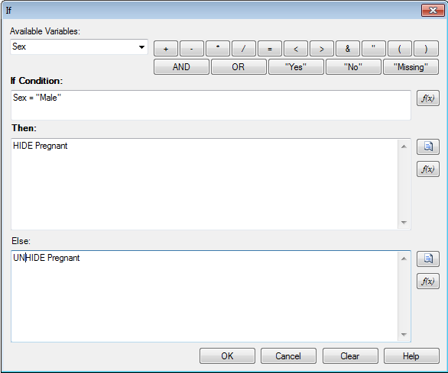
Figure 7.182: Hide- If dialog box
- Click the Code Snippet button in the Else section. A list of available commands appears.
- From the command list, select UNHIDE. The Unhide dialog box opens.
- Select the field to enable based on a Yes answer from the list of variables. For this example, select Pregnant.
- In the Unhide dialog box, click OK to return to the If dialog box.
- Click OK.
- Click OK. The code appears in the Check Code Editor.
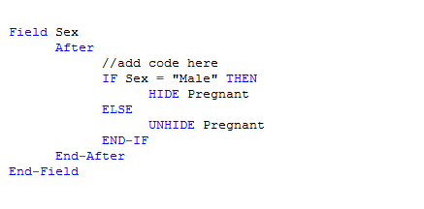
Figure 7.183: Hide Check Code Command
- Click the Save button.
- Click Close to return to the form.

Note: The Unhide command will display any hidden fields. You can select this command in the Add Command to Field Block section of the Check Code Editor. It is recommended to also incorporate a CLEAR command with the HIDE command in order to set null any information previously entered into the Pregnant field.

Geocode
The Geocode command uses the text entered into Address to retrieve and populate Latitude and Longitude coordinates into your form.
- From Form Designer, Open the FoodHistory_NoCheckCode form in the EColi.prj.
- Click Check Code. The Check Code Editor opens.
- Select GetCoordinates from the Choose Field Block for Action list box.
- Select Click.
- Click the Add Block button. This creates code to run after the Get Coordinates command button is clicked.
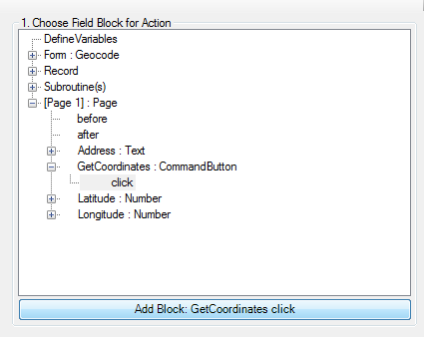
Figure 7.184: Geocode Block for Action
- The code appears in the Check Code Editor.
- Select Geocode from the Add Command to Field Block list box. The Geocode dialog box opens.
- From the Address drop-down list, select Address.
- From the Latitude drop-down list, select Latitude.
- From the Longitude drop-down list, select Longitude.
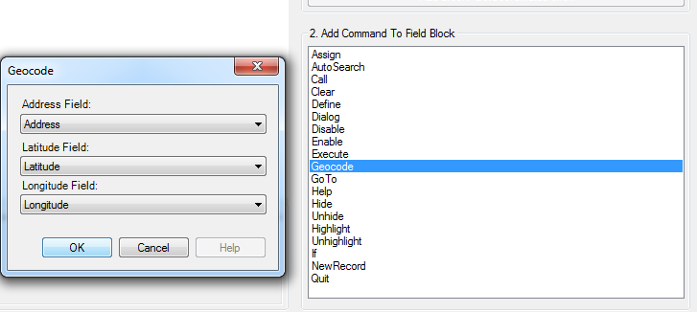
Figure 7.185: Geocode dialog box
- Click OK.
- Click OK. The code appears in the Check Code Editor.

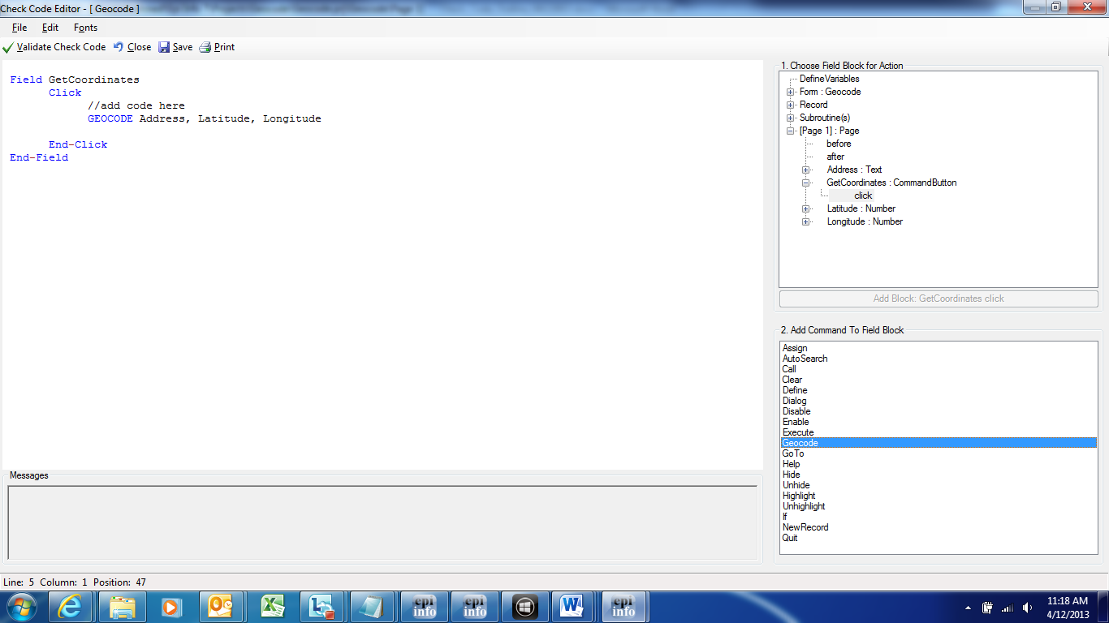
Figure 7.186: Geocode Check Code Command
- Click the Save button.
- Click Close to return to the form.

When the Get Coordinates command button is clicked after an address is entered into your form in the Enter Data tool, the Geocode Results dialog will appear.

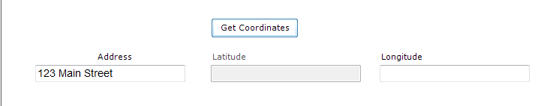
Figure 7.187: Geocode Enter Data Before
The Geocode Results dialog box contains, the Address entered into the form along with the Latitude and Longitude coordinates of that address. The confidence and quality of the geocoding service coordinates are also displayed.

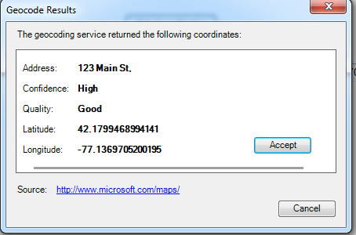
Figure 7.188: Geocode Results
After clicking Accept in the Geocode Results dialog box, the coordinates provided by the geocoding service are copied into the Latitude and Longitude fields in your form.

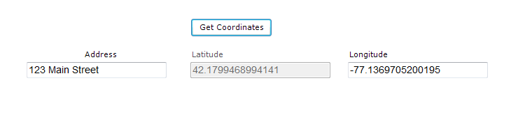
Figure 7.189: Geocode Enter Data After

Additional Check Code Commands

Call
This command redirects to another command block in check code and returns after it has been executed. This command is commonly used with subroutines. Subroutines act as a unit of common check code, which is usually dependent on two variables. The benefit of using subroutines is that it allows maintenance of check code in one common location. Here is an example of a subroutine:

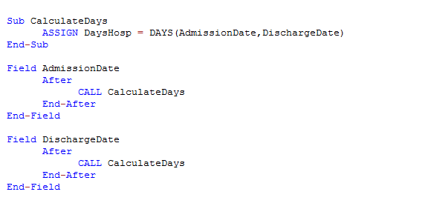
Figure 7.54: Check code syntax for Subroutines

In the example above, the calculation of days hospitalized would have been required to be placed in the AFTER event of the Admission Date and Discharge Date fields. However, through the usage of subroutines, users can update and maintain check code only in one location. By using the CALL command, the block of check code will execute when data are entered or updated in either field.

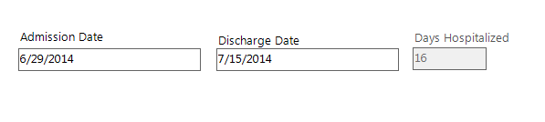
To create a subroutine, complete the following steps:
- From Form Designer, Open your form.
- Click Check Code. The Check Code Editor opens.
- From the Choose Field Block for Action list box, expand the Subroutine item.
- Double click on the Add new item. The New Subroutine window opens.
- Assign a name to your subroutine (i.e. MySubroutine1).
    - 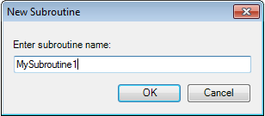
- Click OK.
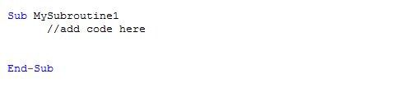
A block of code for the subroutine called MySubroutine1 is created and displayed in the Check Code Editor. At this point, you can establish the check code commands to be incorporated into the subroutine. Make sure to Verify your code and Save once done.

Clear
CLEAR sets a field to a missing value, as though the field had been left blank. For example, it is useful to clear a previous entry in a field after an error has been detected. The CLEAR command can be followed by a GOTO command in order to place the cursor back into the field for further entry after an error. In the example below, the Date of Interview field is cleared after the user is notified that the date value entered is greater than today’s date.

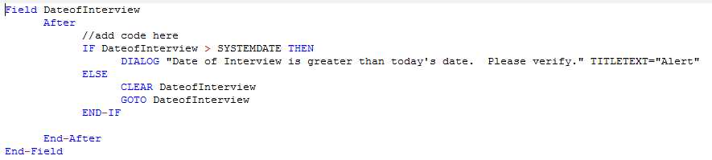
Figure 7.55: Check code syntax for CLEAR command

Define
This command creates a new variable. In Check Code, all user-defined variables are saved in the DEFINEVARIABLES section.
The proper syntax is:
DEFINE <variable name> {<scope>} {<field type indicator>}
- <variable name> represents the name of the variable to be created. <variable> cannot be a reserved word. For a list of reserved words, see the List of Reserved Words section of the User’s Manual.

- <scope> is optional and is the level of visibility and availability of the new variable. This parameter must be one of the reserved words: STANDARD, GLOBAL, or PERMANENT. If omitted, STANDARD is assumed and a type indicator cannot be used.
- <field type indicator> is the data type of the new variable and must be one of the following reserved words: NUMERIC, TEXTINPUT, YN, DATEFORMAT, TIMEFORMAT and DLLOBJECT. If omitted, the variable type will be inferred based on the data type of the first value assigned to the variable. Thereafter, the variable type cannot be changed. An attempt to assign data of a different type to the variable will result in an error.
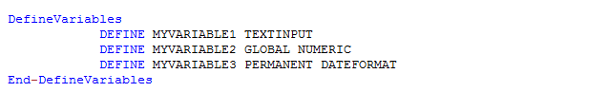
Figure 7.56: Check code syntax for DEFINE command
Below is a description for the optional SCOPE parameter used with the DEFINE command.
- STANDARD variables retain their value only within the current record and are reset when a new record is loaded. Standard variables are used as temporary variables behaving like other fields in the database.
- GLOBAL variables retain values across related forms and when a new form is opened by the program, but are removed when the Enter program is closed. Global variables persist for the duration of program execution.
- PERMANENT variables are stored in the EpiInfo.Config.xml file and retain any value assigned until the value is changed by another assignment or the variable is undefined. Permanent variables are shared among Epi Info modules (Enter, Classic Analysis, etc.) and persist even if the computer is shut down.

Enable/Disable These two commands usually work in conjunction. The DISABLE command disallows data entry into a field while the ENABLE command allows data entry into a previously disabled field.
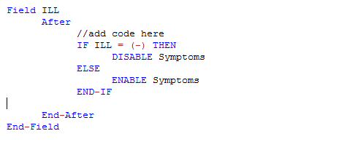
Figure 7.57: Check code syntax for ENABLE/DISABLE command

Execute Use to execute a Windows program.
Executes a Windows program - either one explicitly named in the command or one designated within the Windows registry as appropriate for a document with the file extension that is named. This provides a mechanism for bringing up whatever program is the default on a computer without first knowing its name. The EXECUTE command accepts a series of paths, separated by semicolons, as in:

EXECUTE c:\Users\MyPC\myfile.xls;d:\myfile.xls

If the first is not found, the others are tried in succession. In Check Code, the EXECUTE command can be placed in any command block, but is often used with a command button. Check code syntax is executed when the user clicks on the command button.
EXECUTE WAITFOREXIT "<filename>"EXECUTE NOWAITFOREXIT "<filename>"
- The <filename> represents the path and program name for .exe (filename for registered Windows programs) and .com (filename -DOS binary executables) files.
- The <command-line parameters> represent any additional command-line arguments that the program can accept.
- When Wait for Exit command is specified (modal), the command should run and Enter should continue running. When No Wait for Exit command is specified (non-modal), Enter should wait until the executed program closes before continuing. When EXECUTE is run modally, permanent variables are written before the command is executed and reloaded after the command is executed.
If the example below, the CDC website page is opened when the user clicks on a command button called OpenCDCWebsite. A .pdf file is automatically opened when the user clicks on a command button called OpenPDFdocument.
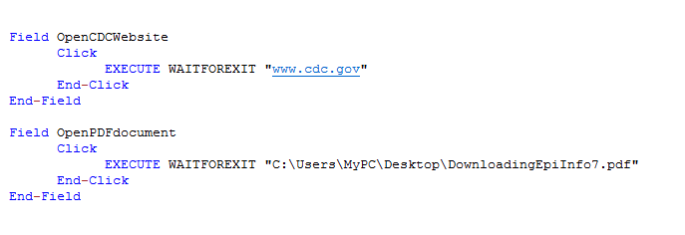
Figure 7.58: Check code syntax for EXECUTE command

Help
The Help command allows you to pop up a help window containing a message, or even a window on a large file that allows the user to move from one block of text to another by choosing highlighted portions of the text. This is a simple form of what is known as “hypertext.”

Highlight/Unhighlight This command emphasizes the location of a field by highlighting in bright yellow, for example, if a data entry error was detected. It also unhighlights the field if needed. In the example below, the field Emergency is highlighted if the response to the field Vaccinated = “No”. All vaccinated questions are skipped and the field “Did you visit the emergency room?” is highlighted.
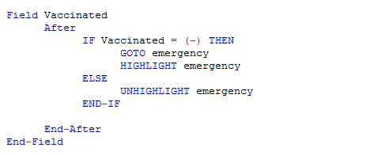
Figure 7.59: Check code syntax for HIGHLIGHT/UNHIGHLIGHT command

New Record
This command saves the current records data and opens a new record for data entry.

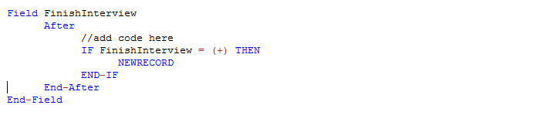
Figure 7.60: Check code syntax for NEWRECORD command

Quit

This command allows the saving of the current record and closing of the Enter application.
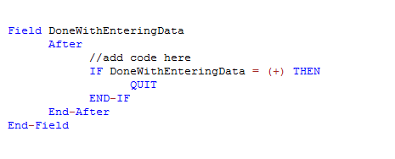
Figure 7.61: Check code syntax for QUIT command

Set-Required-Set Not Required-
Sometimes users might want to set up a field as required only if a specific criterion is met. As with the REQUIRED property, if a field is set to required during data entry through check code, the Enter module will not allow further page navigation until a value has been entered into the field. In the example below, the field VaccinationDate is set as required if the Vaccination question is answered as Yes using the Set-Required command. Notice that the REQUIRE property has not been set during the creation of the field but it has been set with the check code. Once the criterion is met, the field is set back to its original state by using the Set-Not-Required command.
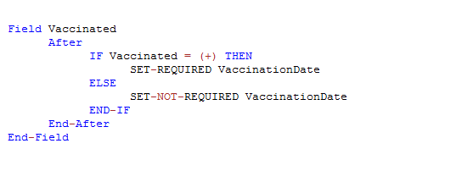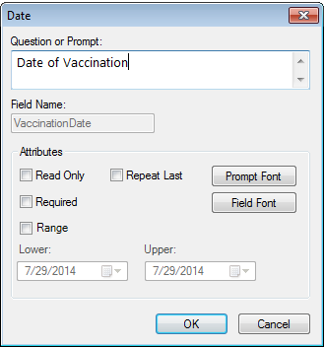
Figure 7.62: Check code syntax for SET REQUIRED command

Check Features Covered Elsewhere- The Enter tool can be programmed to do many interesting and complex operations not discussed in this chapter, including mathematical and logical operations with more than one field, popping up help windows, and calling programs in other languages that act on the contents of fields during data entry.

How to use EpiWeek Function

Epidemiological weeks are usually complete weeks. The ministries of health around the world define the day of the week as the first epidemiologic day. As a result, some countries may consider Sunday as the first day of the week while others may consider the first day of the week to be either Saturday or Monday.
By default, Epi Info™ 7 marks Sunday as the beginning of the epidemiological week. However, the parameter for the Epiweek function can be modified in order to change the beginning of the epidemiological week as desired.
If the year of occurrence is not relevant, use the EpiWeek method instead. The advantage of using EpiWeek is that the value is returned as a number and it can be stored in a numeric field. EpiWeek takes one required parameter that must be a date. The week is calculated relative to the year of the date provided. The Epidemiological week is calculated using the following code:

ASSIGN MyEpiWeek = EPIWEEK( <start_date>, {<first_day_of_week>} )

The example below shows the check code needed for automatically calculating the corresponding Epi Week into a field called SurveillanceWeek based on the value entered in a date field called OnsetDate.
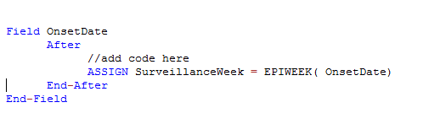
Figure 7.63: Check code syntax for EPIWEEK function

In the other hand, if you are required to modify the first day of the week parameter because the week does not start on a Sunday, the check code syntax would need to be updated. In the example below, the epidemiological week will be calculated based on a starting day of Monday (i.e. Sunday will be 1, Monday will be 2, Tuesday will be 3, etc.)
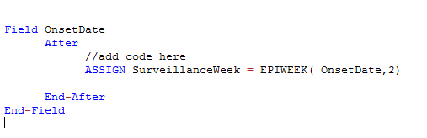
Figure 7.63: Check code syntax for EPIWEEK function with beginning week parameter

Proper Check Code Syntax

Using the proper check code syntax is important based on the field type. Here are some examples of the proper syntax to use based on the field type;
- Assign the ‘Age’ field (numeric field type) the value 24
  - ASSIGN Age = 24

- Assign the ‘Ill’ field (Yes/No field type) the value No
  - ASSIGN Ill = (-)

- Assign the ‘AteChicken’ field (checkbox field type) the value Yes
  - ASSIGN AteChicken = (+)

- Assign the ‘DateOfInterview’ field (Date field type) the value 5/5/2012
  - ASSIGN DateOfInterview = 5/5/2012

- Assign the ‘CaseStatus’ field (legal values field type) the value “Confirmed”
  - ASSIGN CaseStatus = "Confirmed"

- Assign the ‘Gender’ field (Comment Legal field) the value “F”. The field is coded as M-Male, F-Female.
  - ASSIGN Gender = "M"

THIS PAGE IS
INTENTIONALLY BLANK.
- Enter: Entering and Editing Data in Epi Info™

Introduction

The Enter module allows users to enter data into forms constructed in Form Designer. Enter conducts the data entry process according to the settings and Check Code specified in Form Designer. Information entered into the form is stored in Microsoft Access or Microsoft SQL server data tables.
Enter can be used to enter new data, modify existing data, or search for records. When data are entered into a form, the data table inside the project is populated. The Find function allows records to be located based on a series of matched variables. As data are entered, the cursor moves according to the tab order from field-to-field, page-to-page, and saves data when navigating to a new page. If you try to exit a page before data is saved, you will be prompted to save the data (Yes or No).

Open a Project and Form

To access the Enter program, click the Enter Data button on the Epi Info™ main menu or select Tools > Enter Data from the toolbar. In Form Designer, access the Enter module by clicking the Enter Data button in the toolbar. This button is a convenient method to switch between designing a form and entering data to test the form design.
There are three options available to open a project and form. The following example uses the Food History form available in the EColi project.
- From the toolbar, select File > Open Form.
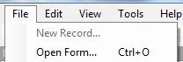
Figure 7.190: Open Form

- Alternatively, click Open Form from the toolbar,
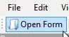
Figure 7.191: Open Form
- These two options will display the Open Form dialog box.
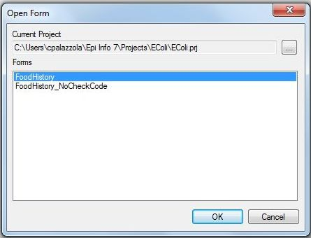
Figure 7.192: Open Form dialog box
- Click the ellipses button next to the Current Project field to browse for a project. Select EColi from the folder. The project file path displays in the Current Project field and a list of available forms in that project appear in the Forms field.
- Select the desired form (FoodHistory) from the Forms field.
- Click OK. The project and form display with the first record in the project appearing on the canvas.
For quick access to a project recently opened with the Enter module, use the Recent Forms option.
1. From the toolbar, select File > Recent Forms.
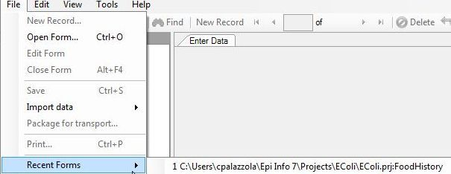
Figure 7.193: Open Recent Form
2. Select the path file containing the desired project and form. The project and form display with the first record in the project appearing on the canvas.
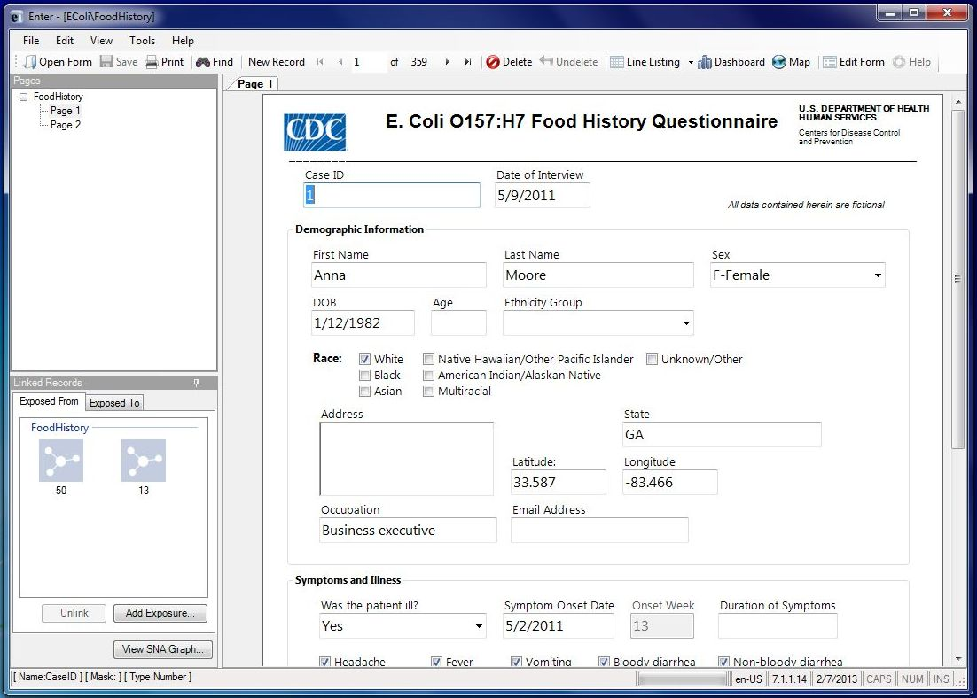
Figure 7.194: Enter Workspace

Navigating the Enter Workspace

There are five main areas in the Enter workspace: Pages, Linked Records, Canvas, Toolbar, and Status Bar. The figure below displays all five areas with information contained in the FoodHistory form of the EColi project.
Figure 7.195: Enter Workspace

Pages
The Pages panel in the top left corner lists all pages associated with the current form. Users may navigate to different pages in the form by selecting the desired page in the Pages panel.

Linked Records
The Linked Records panel in the bottom left is used to conduct contact tracing. It contains information about which records have been exposed to or from the current record.
  - Exposed From – Displays additional records that the current record has been exposed or affected from. The Exposed From icons appear with the Case ID number of the record. Place the mouse over the record to preview the record information.
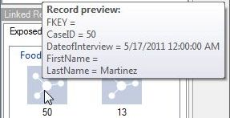
Figure 7.196: Exposed From - Record Preview
    - Double-click on the record to jump to that record and view additional information
  - Exposed To - Displays other records that the current record has been in contact with or possibly affected since acquiring the illness. The Exposed To icons appear with the Case ID number of the record.
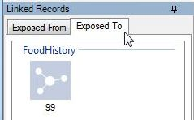
Figure 7.197: Exposed To
    - Similar to the Exposed From tab, users can preview information or jump to the record by double-clicking the icon.
  - Add Exposure – Identifies additional exposures (To and From) for the current record. To add an Exposure To, click Add Exposure in the Exposure To tab. To add an Exposure From, click Add Exposure in the Exposure From tab.
    - Select the form that the exposure record is contained. Click OK.
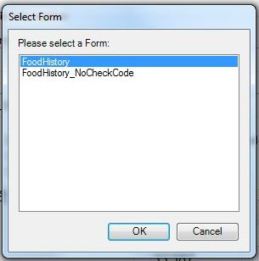
Figure 7.198: Add Exposure from Form
- Find the desired exposure information with Find (information regarding the Find function is located in the Find Records section). Double click on search results to add the exposure to the record.
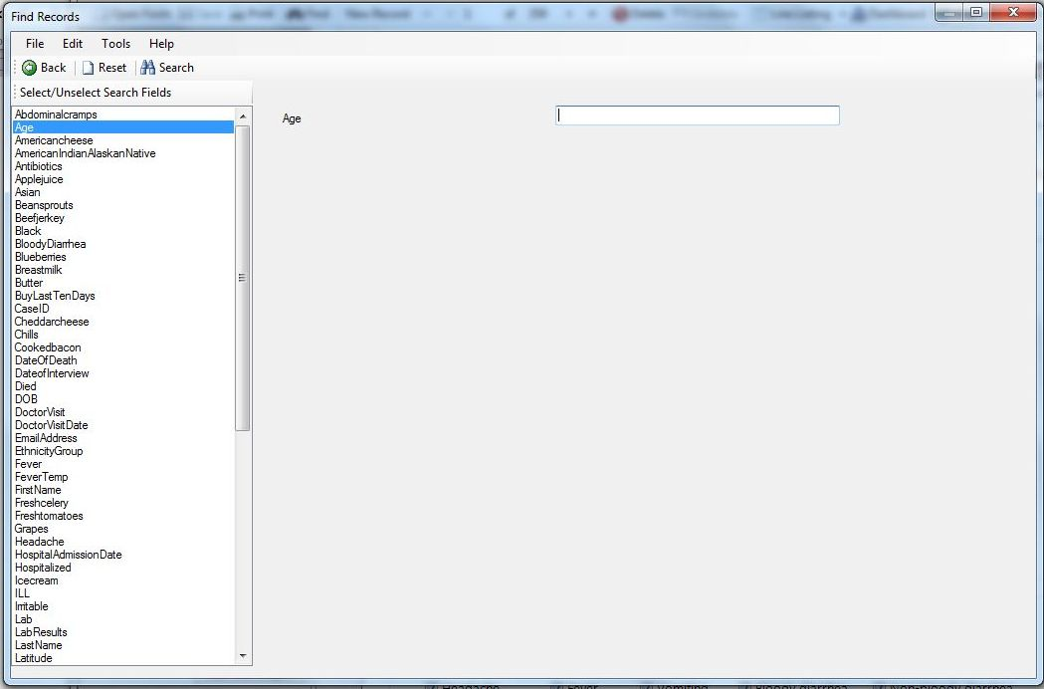
Figure 7.199: Add Exposure from Record
  - SNA graph – Social Network Analysis (SNA) displays the exposed to and from records graphically with the current record in red.
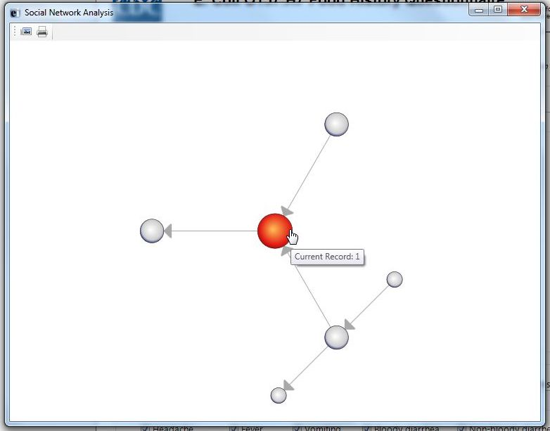
Figure 7.200: SNA Graph
    - The SNA graph directionally shows the flow of exposure at multiple levels. For example, the current record has two records that it has been exposed from; however, one of those records has been exposed from two more records.
    - The SNA graph also displays that the current record has been exposed to another record. This is consistent with the information contained in the Exposed From and Exposed To tabs.
    - The SNA graph can be saved as an image or printed using the buttons in the top left corner of the screen.

Canvas
The Canvas shows the current page in the form with all record information displayed. The canvas is where data entry and editing occurs.

Toolbar
The Toolbar at the top of the screen contains buttons to navigate through the records, create new records, open the Dashboard, open the mapping tool, save the current record, view records in a line list, and print.
  - Line List – allows users to view and search records using the Dashboard interface. Also, users can view the data in MS Excel and HTML formats. For additional information, reference the Visual Dashboard section of the user guide.
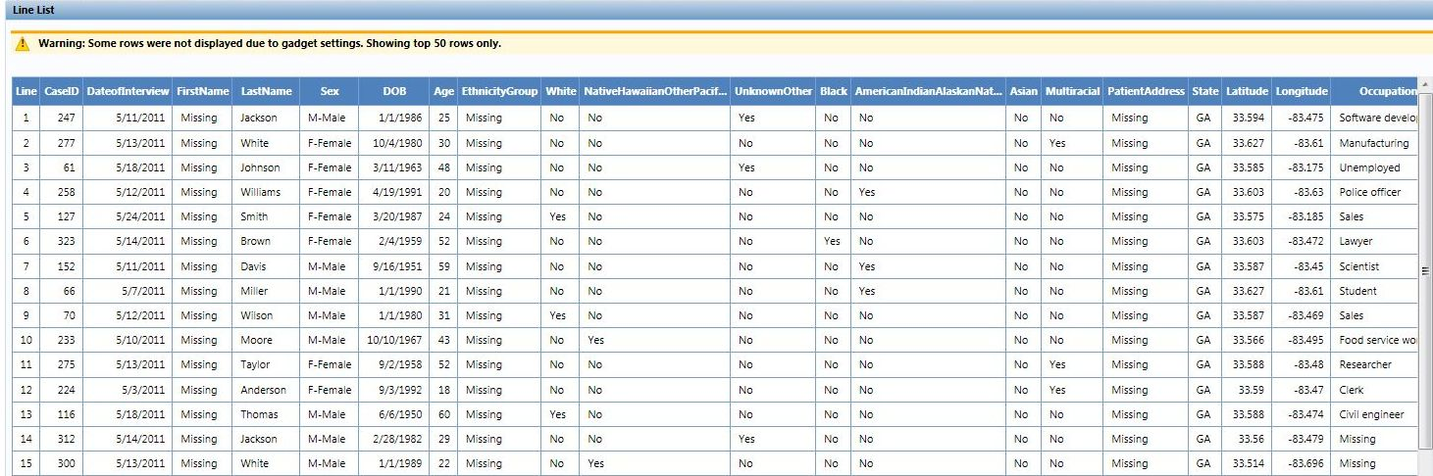
Figure 7.201: Line List View
  - Print – allows the user to print the form and specify customized parameters.
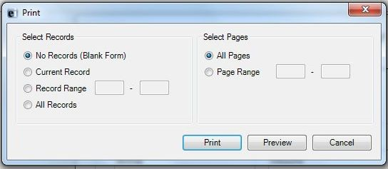
Figure 7.202: Print dialog box
    - To create a PDF version of the form using the print function select Preview. In the Print Preview window select Print and chose the appropriate PDF writer as the printer.
Note: The ability to print to a PDF requires PDF writer software.
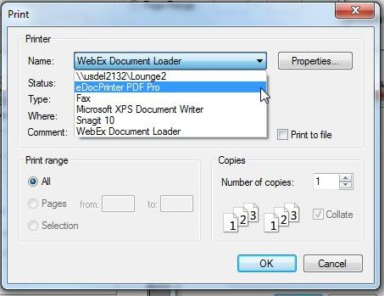
Figure 7.203: Create PDF
  - Navigation Buttons - Navigation is provided for using the New Record button and navigation buttons for, next (), previous (), first (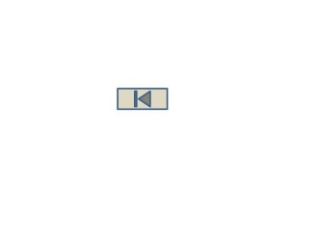), and last () records. The user may also manually type the record ID number into the record list to jump to that record. When entering data into a child form, use the “Back” button to return to the parent form.
  - Maps – Entering Maps from the Enter module allows for some additional functionality between Maps and the project data. The additional functionality allows the user to view case data in the Enter module from the Map window. The following example demonstrates how to create a case cluster map using the FoodHistory form data in the Ecoli project. For additional information regarding maps, reference the Maps section of the user guide.
- Click Maps from the toolbar. The Maps main window appears.
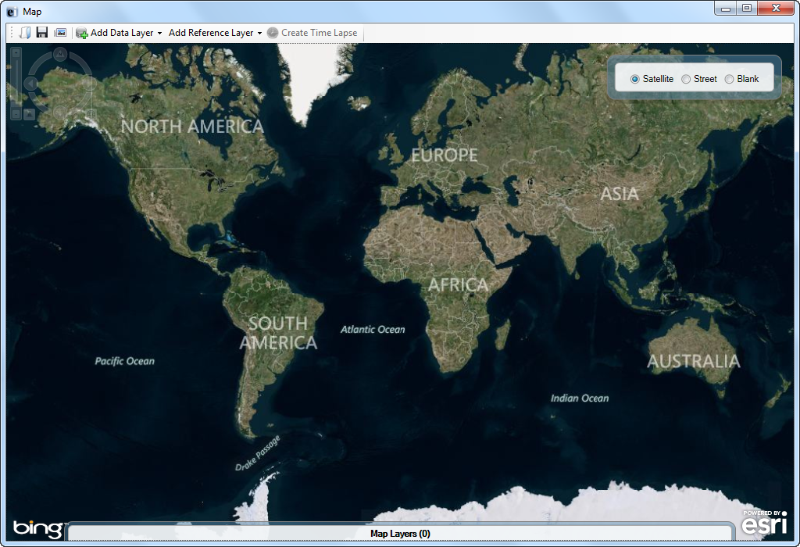
Figure 7.204: Main Map Window
- Select Add Data Layer > Case Cluster from the toolbar.
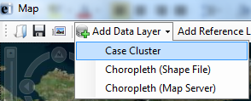
Figure 7.205: Case Cluster
- In the external data dialog box, select No.
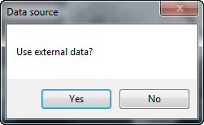
Figure 7.206: Data Source
- Select the field containing the Latitude coordinates (Latitude) from the Latitude drop-down list.
- Select the field containing the Longitude coordinates (Longitude) from the Longitude drop-down list.
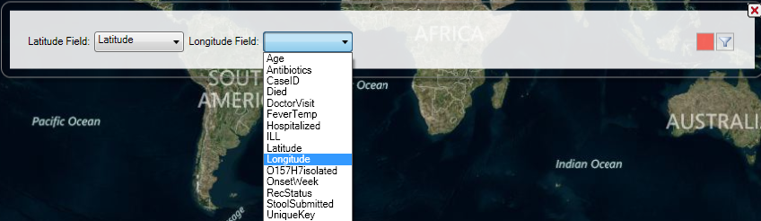
Figure 7.207: Latitude and Longitude Fields
- The case cluster map appears displaying each record’s location on the map.
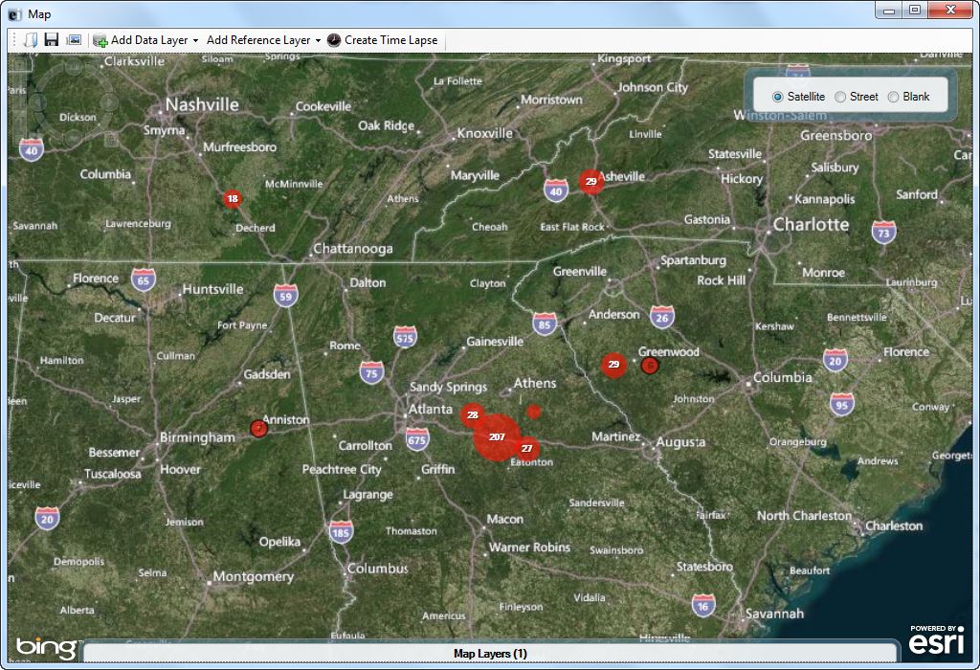
Figure 7.208: Case Cluster Map
- To view the information associated with each record on the map, double-click on a single red dot. The record appears in the Enter data window.
Note: Zoom in on the record of interest to separate the case clusters into single dots.
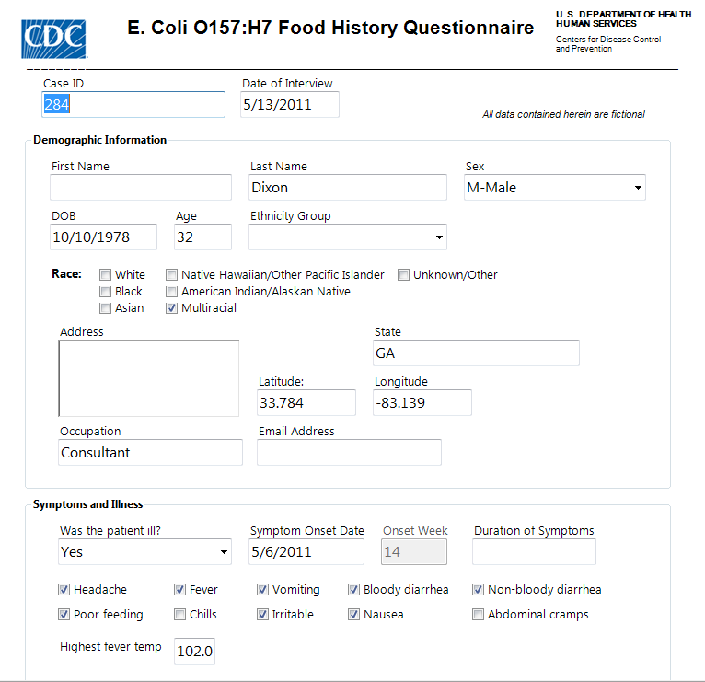
Figure 7.209: Case Record

Status Bar
The Status Bar at the bottom of the screen displays selected information about the field that the cursor is currently located. The status bar can be hidden by deselecting View > Status Bar in the toolbar.
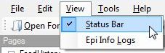
Figure 7.210: Status Bar

Check Code Options
The Enter module allows the user to modify the Check Code features when entering data. Both Check Code options are available under Tools in the toolbar and are enabled by default.
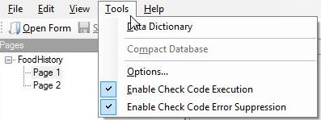
Figure 7.211: Check Code Options
- Enable Check Code Executions – Unchecking this option will disable all check code when entering data into the form
- Enable Check Code Error Suppression - Unchecking this option will not display error messages in check code

Import Data
There are multiple options available to import data from external sources into the Enter module. These options are available under File > Import Data in the toolbar.
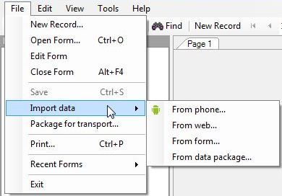
Figure 7.212: Import Data
- From form – This feature requires a Epi Info project file (.prj) and data (.mdb if data tables formed in Microsoft Access).
  - Browse for the Epi Info project file by clicking the ellipses next to the Project containing the data to import field. Select the .prj file
  - Select the Form from the Form data to import drop-down list.
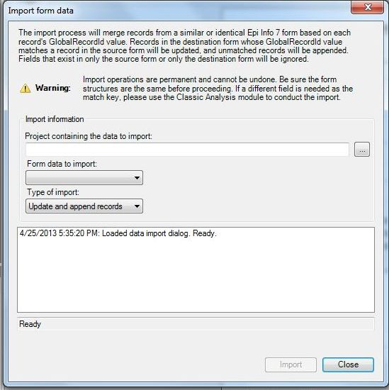
Figure 7.213: Import Data from Form
  - Select the Import Type from the Type of import drop-down list.
- Update and append records – Records in the destination form containing the same GlobalRecordId values as the source form will be updated (overwritten) if there is new information. However, values in the destination table will never be overwritten with a null or missing value. All other records will be appended (added) to the end of the table.
  - Update records only – Records in the destination form containing the same GlobalRecordId values as the source form will be updated (overwritten) if there is new information. However, values in the destination table will never be overwritten with a null or missing value. All other records will be ignored.
  - Append records only – All records in the source form will be appended (added) to the end of the table. No records will be updated (overwritten).
  - Click Import. Import Complete will appear at the bottom of the dialog box upon successful completion of the import.
  - Click Close. The data is imported into the Enter module.
- From mobile device – for information regarding this feature, reference the Companion for Android section of this user guide.
- From web – for information regarding this feature, reference the Web Survey section of this user guide.
- From data package – for information regarding this feature, reference the Data Packager section of this user guide.

Enter Data in a Form

New Record
1. With a form and project open, select New Record from the toolbar or File > New Record. A blank record is added to the end of the record list and displays in the canvas. Place the cursor in the data entry field.
2. Enter data into each field. Use the Tab or Enter key to move to the next field. Moving from one field to another will execute Check Code.
- As records are navigated, data are saved automatically. After completing the last field on a page, the cursor automatically jumps to the next page in the sequence.
- Field properties that were defined in Form Designer, (e.g., Read Only, Required Range) are enforced during data entry.
- Drop-down lists and code tables created in Form Designer are enforced.
- Multiline Fields automatically scroll when filled with text to hold up to 1 gigabyte of information.
- Plain text fields automatically scroll when filled with text to hold up to 255 characters per field.

Edit Record
  - Navigate to the desired record using the navigation tools in the toolbar.
  - Place the cursor in the desired data entry field.
  - Enter data into each field that needs to be updated. Use the Tab or Enter key to move to the next field. Moving from one field to another will execute Check Code.

Delete Record
  - Navigate to the desired record using the navigation tools in the toolbar.
  - Select the Delete button in the toolbar, or select Edit > Mark as Deleted.
  - The record is grayed out and removed from any analysis performed in Visual Dashboard and Classical Analysis.

Undelete Record
  - Navigate to the desired deleted record using the navigation tools in the toolbar.
  - Select the Undelete button in the toolbar, or select Edit > Undelete.
  - The record is enabled and will be available for analysis in Visual Dashboard and Classical Analysis.

Insert an Image in a Record
- Click the Image Field. The Select the Picture File dialog box opens.
- Select an image file.
- Click Open. The selected image appears in the field.
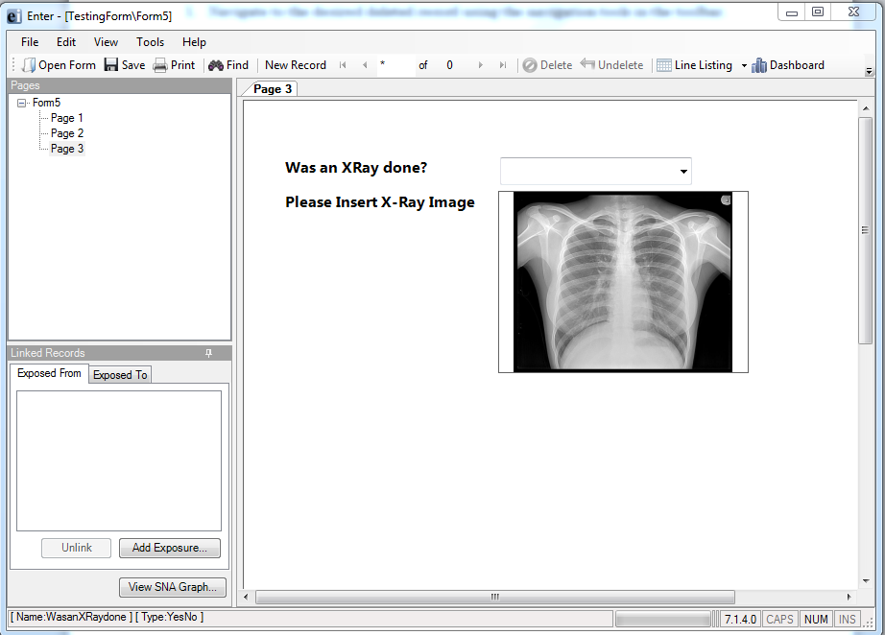
Figure 7.214: Insert Image

Save a Page or Record

The Enter module saves data automatically as the user moves from page-to-page. Data are also saved when navigating to another record. You can move out of a record by tabbing out of the last field of the last page or clicking New Record from the toolbar to open a new record. Records can also be saved manually.
There are three ways to save the current record manually:
- Click Save from the toolbar.
- Select File > Save.
- Press Ctrl+S from the keyboard.

Find Records

Find can search for a record matching any field value or combination of field values. If a form has more than 255 fields and more than one associated data table, only the first data table will be searched with the find feature. As a result, only the fields in the first data table will populate in the search results.

Find Records Matching a Specified Criteria
The example below demonstrates how to find records in the FoodHistory from in the EColi project.
- From the toolbar, select the Find icon or Edit > Find. The Find Records window opens.
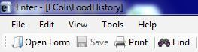
Figure 7.215: Find Record
- The Select/Unselect Search Fields list displays on the left side of the Finds Records window with all fields contained in the form. Click on a field name to select one or more fields. The selected search fields will turn blue and populate the gray area to the right of the list.
- To unselect a field, click on the selected field highlighted in blue. The field will no longer be highlighted and is removed from the search criteria.
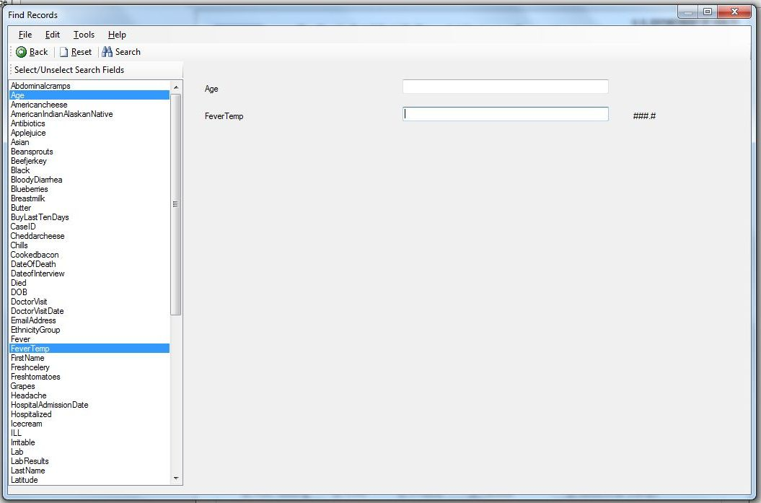
Figure 7.216: Find Records Window
- Enter the search criteria for each field and click Search. Note that certain fields require specific formatting for the search criteria. If more than one field is selected, the search will display records that match all search criteria. This is considered an “AND” search.
  - Yes/No fields can only be searched with the parameters (+), (-) or (.). The parentheses are required.
  - Checkbox can only be searched with the parameters (+) or (-). The parentheses are required.
  - Date fields can only be searched with the date format MM/DD/YYYY.
  - Comment Legal can only be searched with the code (i.e. F- Female, search for F)
  - Option boxes do not store the option labels and therefore must be searched according to the integer that corresponds to each option. In an option box, the first option available corresponds to 0, the second option corresponds to 1, etc. Enter the corresponding value into the search criteria.
  - Number fields will only accept values but do not require a decimal point if the field format specifies a decimal value.
  - Click Reset to begin a new search. Note that more than one field can be searched at a time.
  - Click Back or the close (X) button to return to the Enter workspace.
- Open a record by double-clicking the arrow on the chosen row. The record displays in the Enter Data workspace.
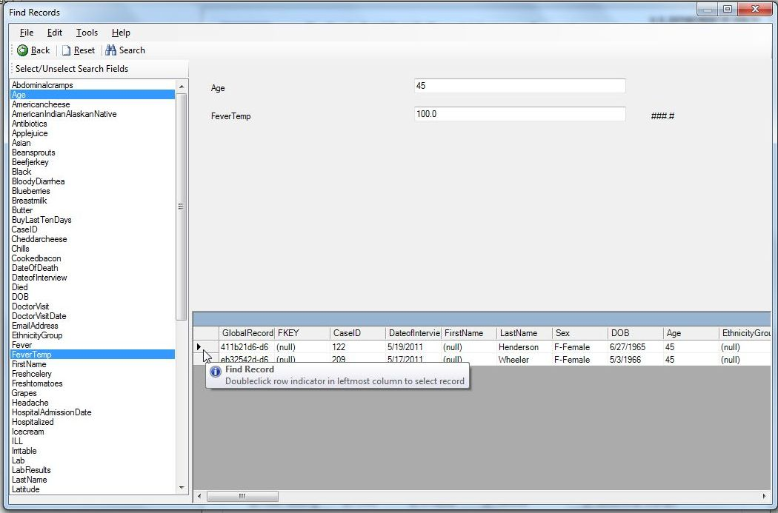
Figure 7.217: Find Records Results
Additional Search Features
- Embedded text items in multiline and text fields can be found by searching for *word* where "word" is the text string being sought. This type of search is called a Wild Card search. In a Wild Card search, the asterisk represents any letter or string of letters (i.e., a search for DIAGNOSES *heart* would identify all records for a large text field called DIAGNOSES which contained the word "heart)."
- Dates and numeric fields can be searched using less than or greater than values (<>).
- Only “OR” can be used to search for matches based on more than one criteria in the same field (i.e. searching last names, Smith OR Doe will return records containing both Smith or Doe. The search field must contain “OR” to perform the desired search. Search criteria cannot be separated by a comma.
- Searches are not case sensitive and are designed to be more inclusive than exclusive.

Printing Forms

Users can print a blank copy of the form or a copy of the form with data if needed. In order to print the form, please complete the following steps:
- Open your Epi Info 7 project and form in the Enter Data module.
- Click on the PRINT option. The following window will be displayed:

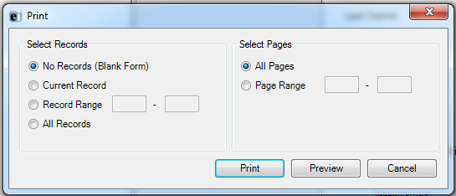
Figure 7.29: Print dialog window

  - To print a copy of the form without including the data that has been entered, just click the PRINT button
  - To print a copy of the form including the data that has been entered for the current record, click on the CURRENT RECORD radio button, and the click the PRINT button. This will print the form with the data for the current record.
  - To print a copy of the form including the data that has been entered for a range of records, click on the RECORD RANGE radio button, and then specify the record number for the records that you want to print the data. When done, click the PRINT button. This will print the form with the data for the records specified.
  - To print a copy of the form including the data for all records, click on the ALL RECORDS radio button, and the click the PRINT button. This will print the form with the data for all records in the database.

- To print an electronic copy of the form without any data, click on the PREVIEW button.
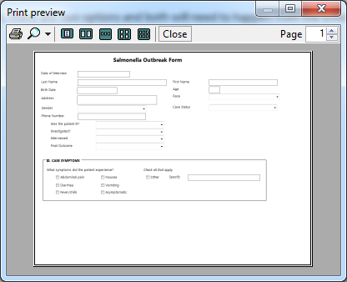
Figure 7.30: Print Preview dialog window

- Click on the printer icon button.
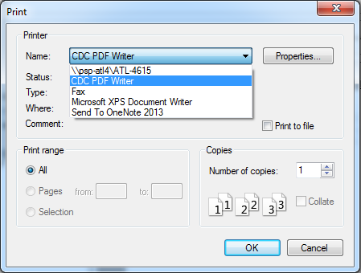
Figure 7.31: Select Printer dialog window

- Select PDF writer or any other option that allows the creation of an electronic copy of a document.

THIS PAGE IS
INTENTIONALLY BLANK.

5. Web Survey: Surveys through the Internet

Introduction

The Epi Info™ Web Survey System allows the survey designer to collect information from participants over the Internet. The ability to distribute and collect surveys remotely is unique to Epi Info™ 7 and provides survey designers access to a wide variety and number of participants. Survey forms can be published to any properly configured web server hosted by your institution or an outside party. When published, Epi Info™ creates a survey specific Universal Resource Locator (URL) or website address. The survey designer can distribute the URL over email, by posting it on a web page, or using other methods. Participants access the web survey and submit their responses through a web browser or mobile device. After the participant submits the response, the survey designer downloads the response directly into the original Epi Info™ 7 project for analysis.
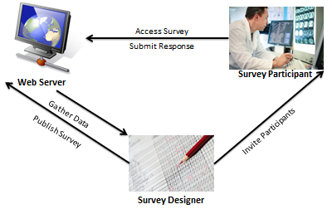
Figure 7.218: Web Survey System

Epi Info™ Web Survey System Deployment

The Epi Info™ Web Survey System is a companion to the Epi Info™ 7 suite of tools, and a separate package apart from Epi Info™ 7. The Web Survey System requires a server running Microsoft Internet Information Services or IIS and a SQL Server database. This database manages the users authorized to publish surveys, published web surveys, and the data submitted by respondents. Without access to the web and database servers that host the Epi Info™ Web Survey System, users will not be able to publish surveys and collect data over the Internet using Epi Info™.
Additional information about the Epi Info™ Web Survey System is located on the Epi Info™ Web Survey page (www.cdc.gov/epiinfo/eiws/index.htm). This site contains setup instructions and links to download the free deployment package kit.
This user guide outlines the steps required to design and publish a form using the Epi Info™ 7 Form Designer tool, and import data submitted by survey participants with the Epi Info™ 7 Enter tool. The technical aspects of configuring the web and database servers are beyond the scope of this guide.
To obtain the necessary keys and settings to use the Web Survey System, contact your Web Survey System administrator, or the person/group that manages the Epi Info™ Web Survey System in your organization.

Designing Forms for the Web

The Epi Info™ Web Survey System allows for publishing short, single form projects (without grids or related forms) to the web for online data entry. This design creates certain features and behavioral differences between the web survey format and the full Epi Info™ functionality. Be aware of these differences and plan for them when designing a survey. For example, not all field types or check code commands are supported or provide value on a web survey. Additionally, required fields and drop-down lists may behave differently on a browser than they do on the Epi Info™ 7 Enter tool.
Before creating a survey, set the computer resolution to 1366 x 768 or 1024 x 768. These are the two most common screen resolutions in use today according to GS.StatCounter.com. If participants take the survey on an average non-mobile browser, this adjustment aligns the resolution to that of the most common participant. This will mitigate any discrepancies between how the survey appears to the designer and the participant.
These specifications are not necessary for participants using browsers on smart phones, tablets or other mobile devices. The Epi Info™ Web Survey System automatically adjusts the display when a survey is accessed with a mobile device. Surveys for these small screen-sized devices appear with a stacked question arrangement by tab order. For small mobile devices, horizontal field placement is irrelevant, as the fields appear one above the next.
After creating a new blank project, but before adding fields to the page, consider the page layout and size. A ‘landscape’ page orientation provides more width than height, which is consistent with most web pages. To set the page size and orientation, select Format > Page Setup from the menu. On the Size drop-down list, select the size to use or select Custom and enter the width and height in pixels. On the Orientation group, select the Landscape option.

Supported Field Types

The Web Survey System does not support all field types available in the Form Designer tool. See below for a list of supported and non-supported field types.
Supported field types: | Non-Supported field types:
- Label/Title  - Text (single line)  - Multiline (text)  - Number  - Date  - Time (not “Date/Time”)  - Checkbox  - Yes/No  - Option  - Legal Values  - Comment Legal  - Codes  - Group | - Text (Uppercase)  - Unique Identifier  - Phone Number  - Date/Time  - Command Button  - Image  - Mirror  - Grid  - Relate
If a survey contains one or more of the non-supported field types, a message will identify the field(s) that will not publish. To publish the survey, perform one of the following two actions:
- Delete the unsupported field(s). This will also delete any data that may have been in the Epi Info™ 7 Enter tool. If you want to preserve pre-existing data, make a project template and create a new project that you will customize for web publishing. In this new project, delete the non-supported fields.
- If a data table does not exist for the form, you can use the “Change To” feature to change the field type to one of the supported types. For example, you can change an unsupported Text (Uppercase) field to a standard Text field or a Multiline field.

Supported Check Code Commands and Functions

The Web Survey tool does not support all Check Code commands and functions available in the Form Designer tool. See below for a list of supported and non-supported commands and functions.
Supported Commands: | Non-Supported Commands:
- Assign  - Clear  - Dialog  - Simple Dialog only  - Enable / Disable,  - Go To  - Hide / Unhide  - Highlight / Unhighlight  - If / Then / Else  - Set-Required / Set-Not-Required | - AutoSearch  - Define  - Dialog  - Get Variable Dialog  - List of Values Dialog  - Execute  - Geocode  - Help  - NewRecord  - Quit

Supported Functions:
- ABS  - Cos  - Day  - Days  - FindText  - Hour  - Hours  - LN  - LOG | - Minute  - Minutes  - Month  - Months  - Rnd  - Round  - Second  - Seconds  - Sin | - StrLen  - Substring  - SystemDate  - SystemTime  - Tan  - Trunc  - UpperCase  - Year  - Years

Non-Supported Functions:
- CurrentUser  - DateDiff  - Date  - Environ  - EpiWeek  - Exists  - Exp  - FileDate  - Format | - Linebreak  - NumToDate  - NumToTime  - PFROMZ  - RecordCount  - Step  - TxtToDate  - TxtToNum  - ZSCORE
Although the non-supported commands and functions do not work when entering data into the web survey, they are still compatible with Check Code on the downloaded version of the survey. After downloading the web survey responses, you can run these commands and functions as normal, or you can use Epi Info™ 7 Analysis tool to perform the necessary operation.

Differences in Check Code Performance

In Check Code, the designer places commands within field blocks for actions such as ‘Before’, ‘After’, and for some field types, ‘Click’. The key variation in performance between Check Code in the Enter tool and the Web Survey is related to the After block for fields that have drop-down lists (such as Yes/No, Legal Values, Comment Legal, and Codes).
In Enter, Check Code in the After block for fields executes when you leave the field either by tabbing to the next field or by clicking on another field on the page. However, in the Web Survey System, the Check Code in the After block for these fields executes as soon as you make a selection. The variation occurs since navigation is typically done by mouse and without a Tab key in the Web Survey System. Therefore, any Check Code commands (i.e. Enable/Disable, Hide/Unhide, Highlight/Unhighlight, and Set-Required/Set-Not-Required, etc.) that depend on the value selected in the drop-down list will occur as soon as the selection is made.
The Required property requires the participant to enter a value for the specified field. In the Enter tool, required fields must contain a value for the respondent to save the record or navigate to a different record. In the Web Survey tool, access to a separate page is also denied if a required field is left blank. If a required field is blank, a message displays notifying the participant that values must be given for required fields before the response can be submitted.

Confirm Web Survey Compatibility
To ensure the web survey functions properly, check the tab order and enter test data into the survey. Additionally, practice sample analyses on the test data before publishing the form.
A logical tab order is critical, especially if the participant might use a mobile device like a smart phone or tablet computer. As previously mentioned, tab order determines the order in which the fields are displayed on the mobile device. Even if the survey participant will use a desktop or laptop, any Check Code used to validate the data entry may depend on a logical tab order. For information regarding Tab Order, refer to the Form Designer section – How To: Set Tab Order.
Review all field names to ensure each is concise and logical. Field names cannot be changed after publishing the final version. A user-friendly way to check the field names is with the Data Dictionary feature. For information regarding Data Dictionary, refer to the Form Designer section – How To: View a Data Dictionary.
With the tab order and field names confirmed, enter sample test records. Click the Enter Data button from the Form Designer menu bar to preview the form in the Enter tool. When entering test data, record any changes that need to be made prior to publishing the survey. Check the field validation to determine if the field should be required, or if there is a valid range for number and date fields, or any other Check Code that may be used.
With test data in the form, attempt the analyses you anticipate performing. Confirm the field names are clear and easy to use. If you intend to use a tool other than Epi Info™ 7 for analysis, export the test data in the desired format. Common corrections include resetting a long field name, or changing/adding a field type.
Note: Corrections can only be made before the survey is distributed to participants for data collection.
Next, practice publishing the survey as a test by following the Publish Form to Web instructions. Confirm that you can successfully publish the form, navigate among the pages, enter more test data, and reconfirm the validations and Check Code behavior is all working properly. To ensure full functionality, download the test data and perform a sample analysis. If an error is observed, make the necessary corrections and repeat this step until the survey functions as desired.
When testing is complete, remove all test data using the Delete Data Table function and publish the final version. For information regarding Delete Data Table, refer to the Form Designer section – How To: Delete an Existing Data Table Without Deleting the Form.

Initial Setup

Publishing a survey and collecting data requires information that is either provided by the Web Survey System administrator or generated by the Web Survey System. This information provides security to the system and access to individual surveys. The following are key terms used in Web Survey:
  - Endpoint Address – designates the location or URL of the application that hosts surveys.
  - Organization Key – provides survey designer access to publish the survey and import the responses.
  - Survey Key – identifies the survey that corresponds to the Security Token for downloading data.
  - Security Token – grants access to the survey data and prevents others with the Organization Key and Survey Key from accessing the data.
Before publishing a survey, the designer must designate the endpoint address and binding protocol.
- Contact your Web Survey System administrator for the following:
  - Endpoint Address
  - Use of Windows Authentication (Yes or No)
  - Binding Protocol (basic or wsHTTP)
  - Organization Key
- From the Epi Info™ Form Designer menu, select Tools > Options.
- Click on the Web Survey tab. The Web Survey Options dialog box appears.
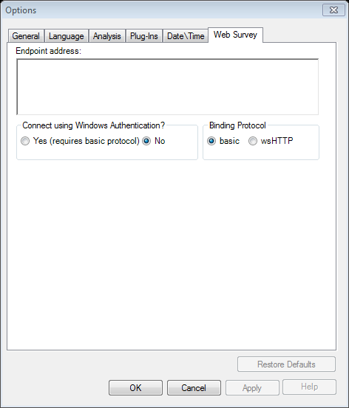
Figure 7.219: Web Survey Options dialog box
- Enter the Endpoint address, and then make your Windows Authentication, and Binding Protocol selections. The Web Survey System administrator provides this information. An example of an endpoint address is: http://MySurveyManager.MyCompany.com/SurveyManagerService.svc

Publish Form to Web

After designing a form that is compatible with the Web Survey System, the survey can be published to the web server. With the completed form open in Form Designer, complete the following steps.
- From the Form Designer menu, select File > Publish Form to Web.
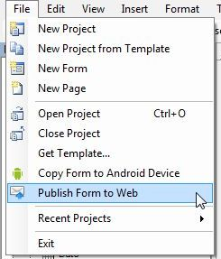
Figure 7.220 Publish Form to Web option
- If a form contains a non-supported field type, an error message occurs stating the name of each invalid field.
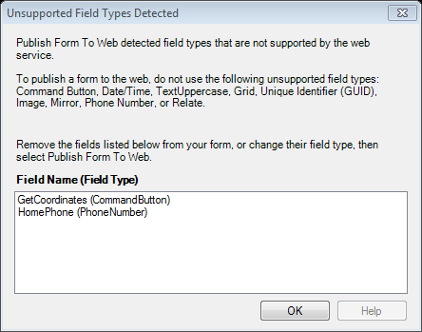
Figure 7.221: Unsupported Field Types error message
To meet publishing requirements, delete or change the field type of non-supported fields. Before deleting a field, be aware that any data collected with that field will be deleted as well. The data removal is automatic and irreversible. Consider backing up all data prior to deleting a field. Alternatively, use the Change To option to change the field to a supported field type. This action can only be performed if there is not a data table associated with the form. For information regarding Delete Data Table, refer to the Form Designer section – How To: Delete an Existing Data Table Without Deleting the Form.
Note: Data tables are created when the form is accessed with the Enter Data tool, regardless of whether data has been collected. To remove a data table, select Tools>Delete Data Table.
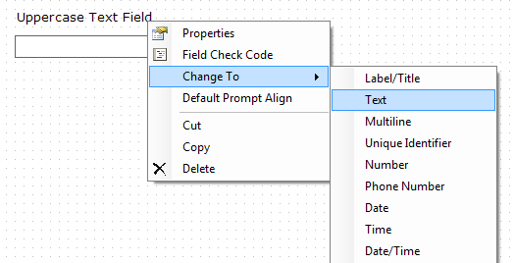
Figure 7.222: Fields Change To function
- In the Publish Form to Web dialog box, there are three tabs that must be filled out prior to publishing the survey:
  - Introduction Page – provides information to the survey participant prior to beginning the survey
  - Exit Page – provides closing remarks to the survey participant after the survey is submitted
  - Publish Options – specifies technical aspects of the web survey posting process
The following navigation buttons are at the bottom of the dialog box:
- The Next button saves the information and proceeds to the next tab.
- The Clear button removes all entries from the page and returns the user to a blank Introduction Page.
- The Cancel button allows the user to exit the Publish Form to Web dialog box and return to the Form Designer window.
- The OK button will attempt to publish the survey. If any information is omitted, an error message will appear.

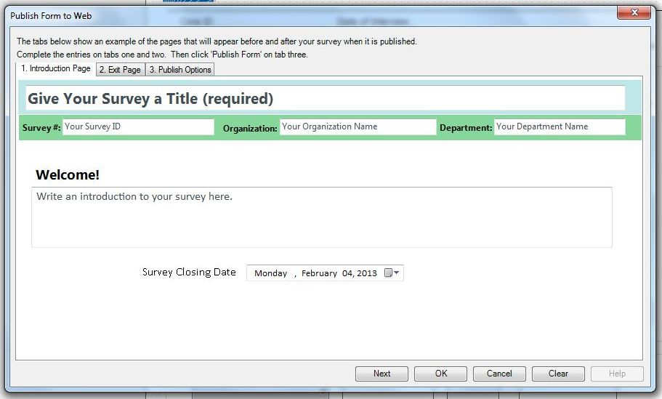
Figure 7.223: Publish Form to Web dialog box
- On the Introduction Page tab, click in the Give Your Survey a Title (required) textbox to enter the survey title. This title will appear at the top of each page in the survey.
- Enter your Survey Number or ID, Organization Name and Department Name. This information appears at the top of the introduction and exit pages.
Note: The Organization Name is used for tracking purposes only.
The Organization Key is the key that allows you to post a survey to the web server. The Organization Key should be kept secure and confidential.
DO NOT PUT THE ORGANIZATION KEY INTO THE ‘Organization Name’ FIELD ON THE INTRODUCTION TAB.
- The Welcome! textbox provides participants with a greeting, special instructions or additional information about the survey. Click in the Welcome! textbox and enter a message.
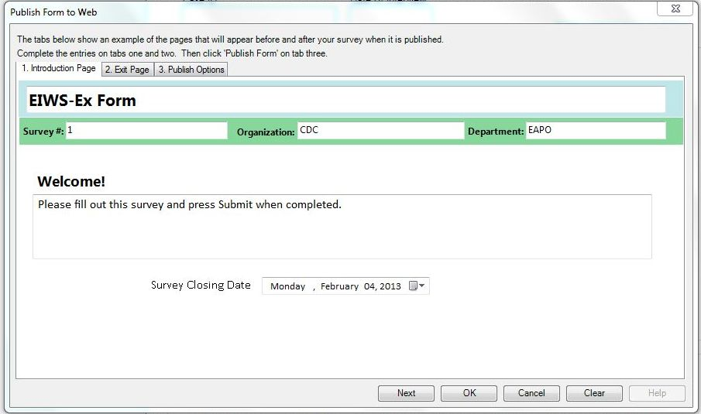
Figure 7.224: Introduction Page
- Select the survey closing date from the Survey Closing Date drop-down menu located below the Welcome! textbox. This field only accepts a date in the future.
Note: The default setting is 10 days from the current date.
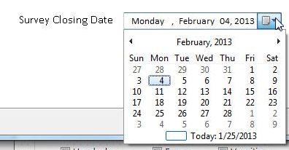
Figure 7.225: Survey Closing Date
At 11:59:59.99 pm on the selected survey closing date, any attempt to access the survey will prompt the message below.

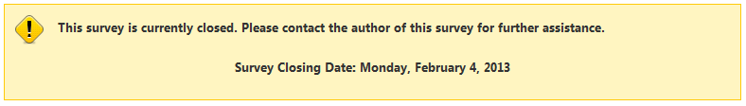
Figure 7.226: Closed Survey dialog box
- Click Next to save this information and proceed to the Exit Page tab.
Note: The Introduction Page can be edited at any point prior to publishing the survey by clicking on the Introduction Page tab.
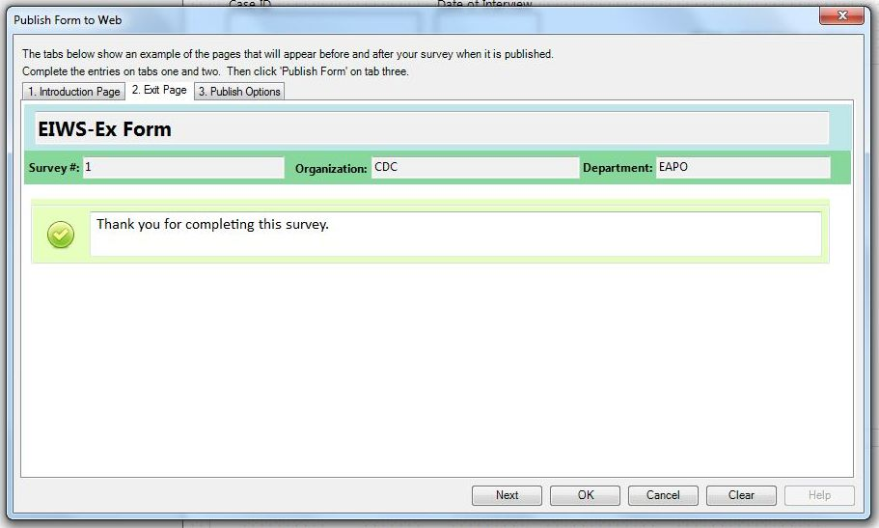
Figure 7.227: Exit Page
- The Exit Page displays closing remarks or additional instructions about the survey. Enter your comments in the textbox next to the green check mark. This example states “Thank you for completing this survey.” The Survey #, Organization and Department fields will automatically populate based on the information provided in the Introduction Page tab. Clicking on either of these fields will direct you back to the Introduction Page.
- Click Next to proceed to the Publish Options tab.
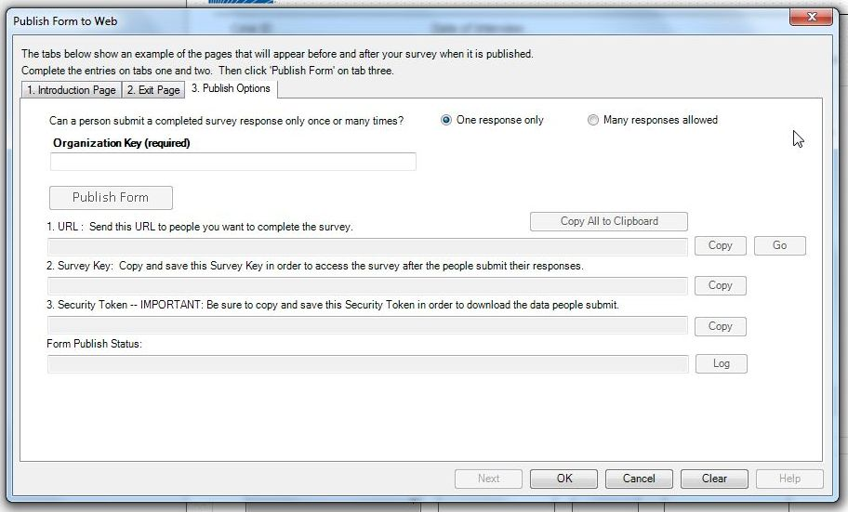
Figure 7.228: Publish Options
- To allow a participant to submit more than one response in a given session, select the Many responses allowed option button. The default setting is One response only, which closes the survey after the participant submits one record.
Note: Selecting “One response only” will not prevent a participant from accessing a survey link more than once.
- Enter/Paste the Organization Key provided by the Web Survey System administrator.
Hint: If the organization key is provided in an email or other electronic file, copy and paste the key into the organization key field to avoid any mistakes. The organization key must be a valid global unique identifier to enable the Publish Form button. An example of an Organization Key is “3f6c6251-4af6-40f7-a440-cb2a9ca92e17.”
- Click Publish Form.
If an error message appears, contact your Web Survey System administrator with the text displayed in the Form Publish Status field. Click the associated Log button to access detailed information regarding the error message if available. Typically, this error occurs with an invalid or missing endpoint address.
After successfully publishing the survey, the URL, Survey Key and Security Token fields will automatically populate. Survey participants will use this URL to access the survey.
- Click the Copy All to Clipboard button. Save this information in a document or a format of your choosing for future use.

Important: The URL, survey key and security token are all required to access the survey and survey data. The security token cannot be recreated if it is lost. Keep the security token in a secure location. DO NOT SHARE THE SECURITY TOKEN WITH SURVEY PARTICIPANTS.

Invite Participants to Take the Survey

After publishing the survey, participants can access the web survey at any time up to and including the survey closing date. The survey can be accessed using the URL generated in the Publish Form to Web steps in the previous section. Designers can invite participants by distributing the web address or URL over email, by posting it on a web page, or using other methods.

Access the Survey Using the URL

- Launch your web browser. Copy and paste the URL into the address bar at the top of your browser window. If the survey is not closed, the survey Welcome! page appears.
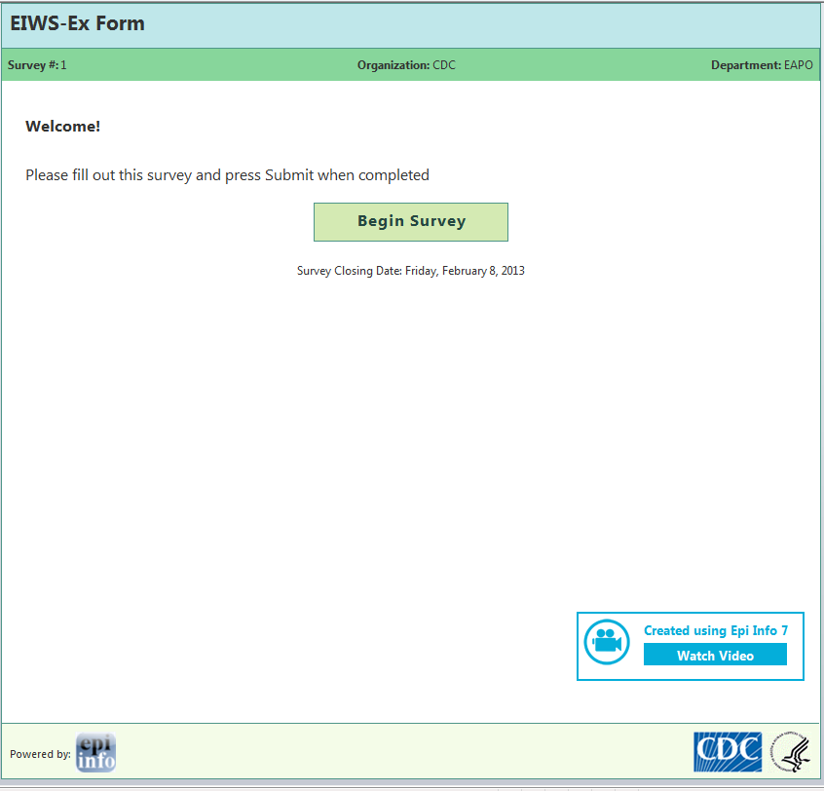
Figure 7.229: Survey Welcome Page
- Click Begin Survey. The first page of the survey appears.
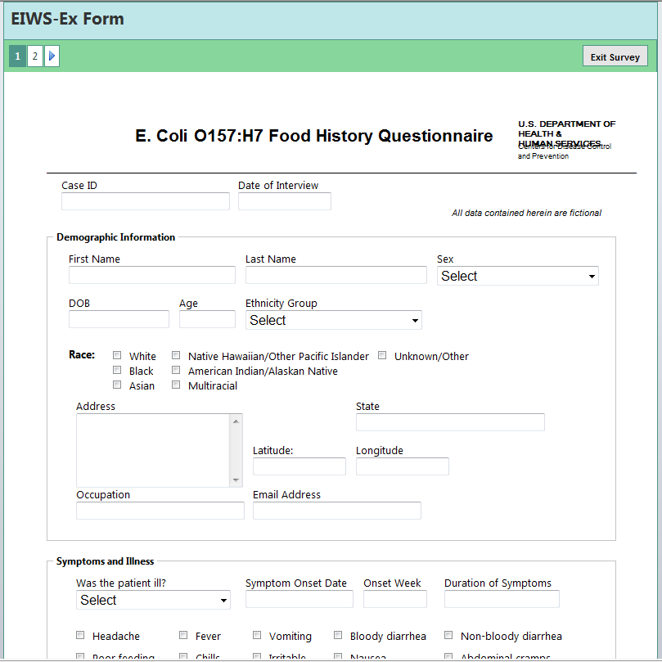
Figure 7.230: Published Web Survey form
Enter your response to each survey question. You can go to the next page of the survey by clicking on the navigation buttons on the top left corner of the screen. You can also click the Continue button at the bottom of the page to navigate between pages. The information entered into the form is not saved until Submit Survey button or the Finish Later button at the bottom of the page is clicked. For information regarding the Finish Later button, refer to the Saving Survey Answers for Future Submission topic.
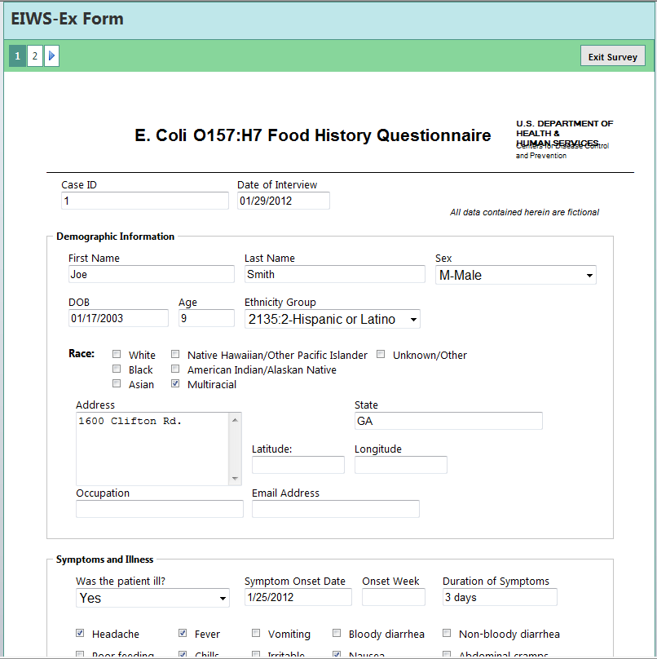
Figure 7.231: E. coli Web Survey form, page 1

Submitting Survey Responses

- After completing the last page of the survey, click Submit Survey to send the response.
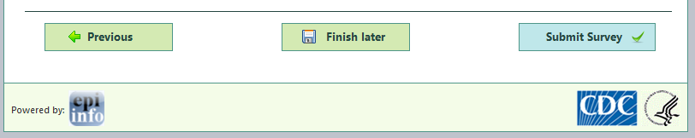
Figure 7.232: Submit Survey
- The Exit Page appears and displays the thank you message.
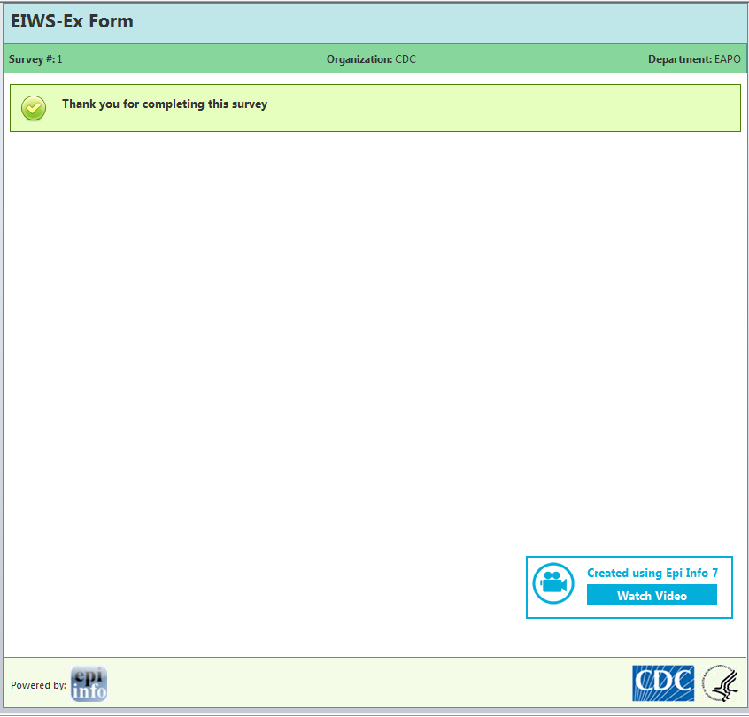
Figure 7.233: Survey Exit Page
- If the Many responses allowed option was selected in the Publish Options tab, the Start Survey Again message will appear allowing the participant to submit more than one response. This is useful when one participant is entering multiple responses to the survey.
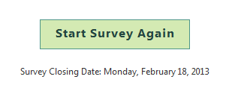
Figure 7.234: Start Survey Again

Saving Survey Answers for Future Submission

If the survey cannot be completed in one sitting, participants can save the survey and finish their responses at a later time.
- To save a survey, click the green Finish later button located at the bottom of each page in the survey.
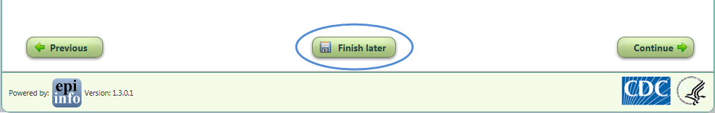
Figure 7.235: Finish Survey later
A dialog box appears with a Survey Link and Pass Code.
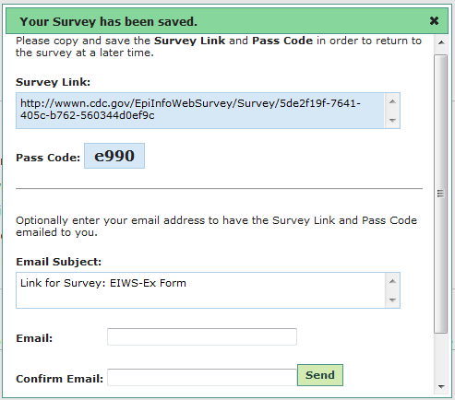
Figure 7.236: Survey Link and Pass Code
- Copy and save the Survey Link and Pass Code. This information is required to return to the survey at a later time. The saved survey contains all information entered into the form and cannot be retrieved by the participant without the Survey Link and Pass Code. If the participant loses the Pass Code or Survey Link, the participant will need to take the survey from the beginning.
There is an option to email the Survey Link and Pass Code. The email address is not saved in the system and is only used to generate the outgoing email.
- Enter a valid email address in the Email textbox.
- Re-enter the email address in the Confirm Email textbox.
- Click Send. The participant will receive the Survey Link and Pass Code via email.
- To complete the survey, copy and paste the Survey Link into a web browser or click the link in the email.
- Enter the Pass Code into the Pass Code textbox. Click Go.
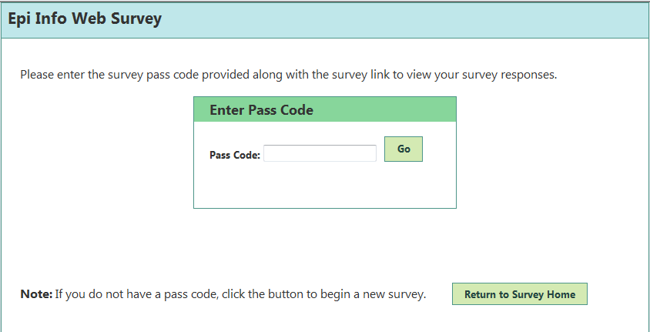
Figure 7.237: Enter Pass Code to complete survey
The saved survey form appears containing all information previously entered.
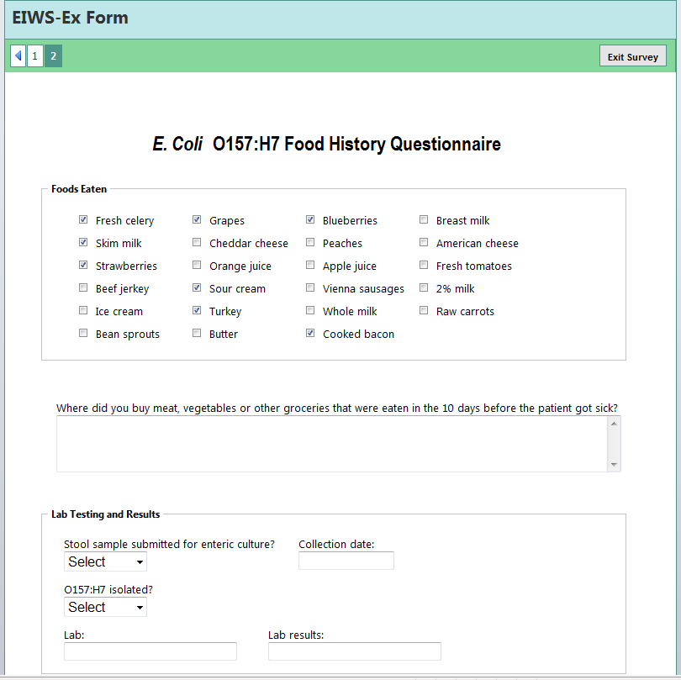
Figure 7.238: Partially Completed Web Survey Form

Importing Survey Data

- From the Epi Info™ main menu, select Enter Data or select Tools > Enter Data. The Enter tool opens.
- Open the project and form used to publish the web survey.
- From the File menu, select Import Data > From Web.
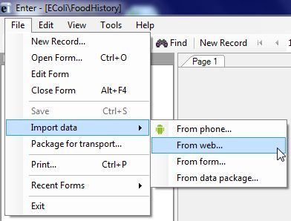
Figure 7.239: Import Data from Web
- Enter the Web Survey Key, Organization Key, and Security Token into the Import web form data dialog box (Refer to Publish Form to Web, Step 13 for this information.)
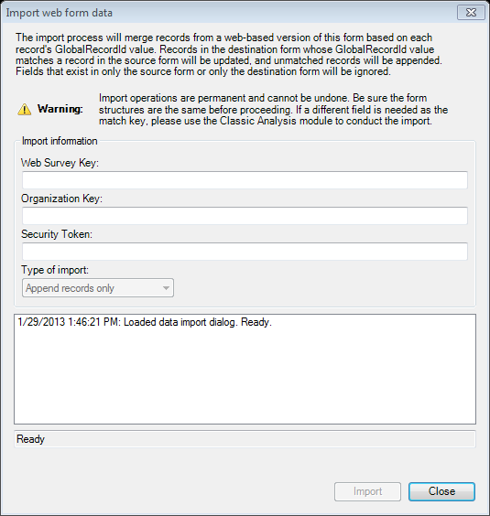
Figure 7.240: Import Web Form Data dialog box
- Click Import.
Note: If you incur an error message, ensure that the endpoint address is entered in the Web Survey dialog box.
- After the import is complete, click Close. The responses to the survey questions appear in the survey form and are added to your Epi Info™ database. The import process can be executed multiple times and will append newly submitted responses without creating duplicate records.
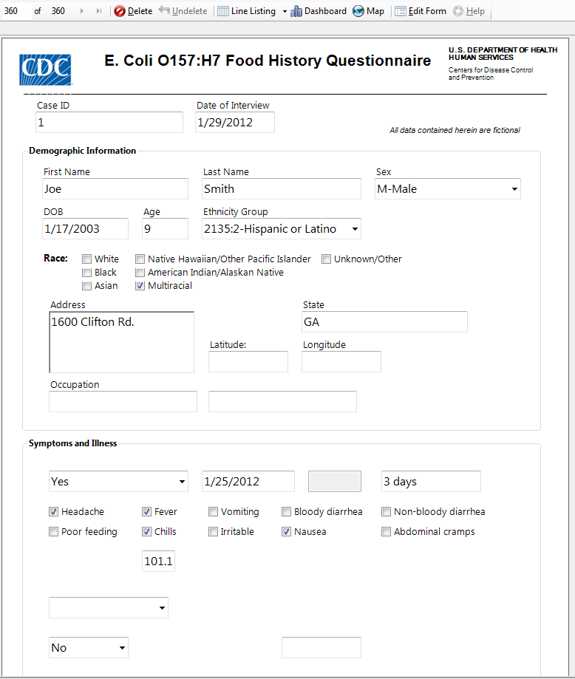
Figure 7.241: Imported Data
The data collected is now ready for analysis. Refer to the Visual Dashboard or Classic Analysis sections of this user guide for further information about analysis.

6. Companion for Android: Collecting and Analyzing Data on an Android Device

Introduction

Epi Info™ Companion for Android allows users to transfer forms to a mobile device and collect data remotely. The mobile application is compatible with Android tablets and phones running Android version 4.0 (codename “Ice Cream Sandwich”) and above. The ability to load Epi Info™ forms onto a mobile device allows users to collect data in places lacking information technology infrastructure and for activities that could benefit from mobility, GPS tacking, or photographic capabilities. Once data is collected, users can perform simple analysis with the Analyze Data function or view geographic data using the built in mapping function. These tools do not contain the full Epi Info™ functionality; however, data can be transferred from the mobile device to a PC for more complex analyses. The mobile application also contains a full featured StatCalc function similar to the one found in Epi Info™ 7.

Supported Field Types

Epi Info™ Companion for Android does not support all field types available in Form Designer. See below for a list of supported and non-supported field types. When designing a form for use with the mobile application, exclude non-supported field types from the form.
Supported field types:  - Label/Title  - Text (single line)  - Text (Uppercase)  - Multiline (text)  - Number  - Date  - Time (not “Date/Time”)  - Checkbox  - Yes/No  - Option  - Legal Values  - Comment Legal  - Group  - Command Button  - Image | Non-Supported field types:  - Unique Identifier  - Phone Number  - Date/Time  - Mirror  - Grid  - Relate  - Codes
If a form contains one or more of the non-supported field types, a message will identify the field(s) that will not publish. To publish the form, perform one of the following two actions:
- Delete the unsupported field(s). This will also delete any data that may have been in the Epi Info™ 7 Enter tool. If you want to preserve pre-existing data, make a project template and create a new project that you will customize for the Mobile application. In this new project, delete the non-supported fields.
- If a data table does not exist for the form, you can use the “Change To” feature to change the field type to one of the supported types. For example, you can change an unsupported Text (Uppercase) field to a standard Text field or a Multiline field.

Supported Check Code Commands and Functions

Epi Info™ Companion for Android does not support all check code commands and functions available in the Form Designer tool. See below for a list of supported and non-supported commands and functions. When designing a form for use with the mobile application, exclude non-supported check code commands from the form.
Supported Commands:  - Assign  - Clear  - Dialog  - Simple Dialog only  - Enable / Disable,  - Go To  - Hide / Unhide  - Highlight / Unhighlight  - If / Then / Else  - Set-Required / Set-Not-Required | Non-Supported Commands:  - AutoSearch  - Define  - Dialog  - Get Variable Dialog  - List of Values Dialog  - Execute  - Geocode  - Help  - NewRecord  - Quit
Supported Functions:
- ABS  - Cos  - Day  - Days  - FindText  - Hour  - Hours  - LN  - LOG | - Minute  - Minutes  - Month  - Months  - Rnd  - Round  - Second  - Seconds  - Sin | - StrLen  - Substring  - SystemDate  - SystemTime  - Tan  - Trunc  - UpperCase  - Year  - Years
Non-Supported Functions:
- CurrentUser  - DateDiff  - Date  - Environ  - EpiWeek  - Exists  - Exp  - FileDate  - Format | - Linebreak  - NumToDate  - NumToTime  - PFROMZ  - RecordCount  - Step  - TxtToDate  - TxtToNum  - ZSCORE
Although the non-supported commands and functions do not work when entering data into the mobile form, they are still compatible with check code on the downloaded version of the form. After downloading the responses to a PC, you can run these commands and functions as normal, or you can use Epi Info™ 7 Analysis y to perform the necessary operation.

Initial Setup

The Epi Info™ Companion for Android is available for download at the Google Play store. Epi Info Android Download Location (https://play.google.com/store/apps/details?id=gov.cdc.epiinfo&hl=en )
With the mobile device connected to the Internet, enter the web address into your browser and select Download. Connect the mobile device to your computer through a USB cable.
Note: The mobile device must be connected through a hard line and will not synchronize with your computer wirelessly.
The mobile application is compatible with Android versions 4.0 and above. Since Android specifications are open source, device manufacturers are free to change positioning and appearance of common elements such as menus and buttons. For example, users should be aware that Samsung Galaxy Note II devices have their “Back” button on the right hand side of the device and the “Options Menu” on the bottom, while Google Nexus 7 devices have their “Back” button on the left hand side of the device and the “Options Menu” on the top corner. Furthermore, when an Android device is connected to a PC via a USB cable, it may register as a disk drive, media device, or a digital camera. Please note that data and forms can only be transferred in disk drive or media device modes.
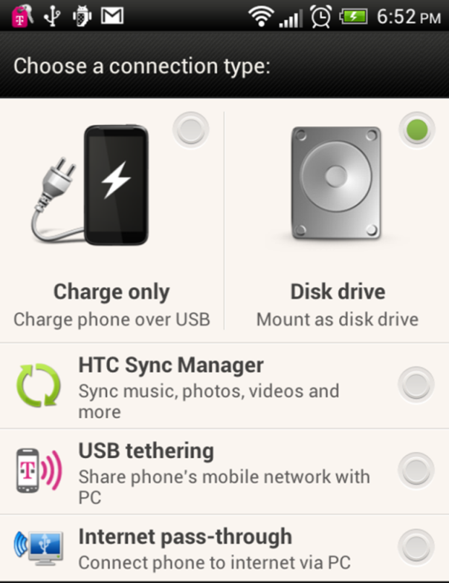
Figure 7.242: Connection Type

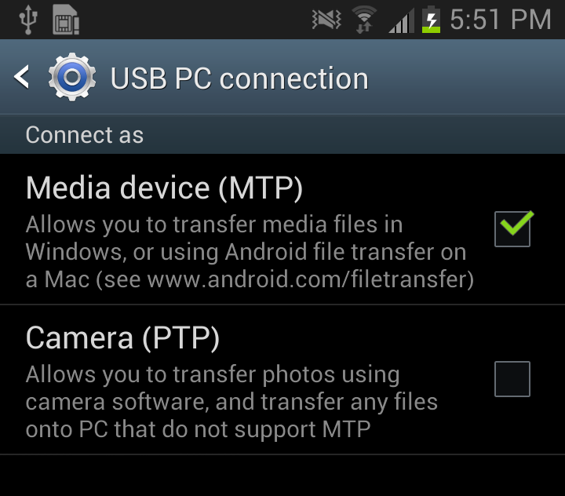
Figure 7.243: USB PC Connection
Internet connectivity is not required for using the core StatCalc, data collection, and data analysis modules. However, the mapping function utilizes Google Maps and requires Internet connectivity for downloading base map information.

Designing Forms for Mobile

Epi Info™ Companion for Android allows for the transferring of short, single form projects (without grids or related forms) to a mobile device for data entry. This design creates certain features and behavioral differences between the mobile and PC format. Be aware of these differences and plan for them when designing a form. For example, not all field types or check code commands are supported or provide value on a mobile device. Additionally, required fields and drop-down lists may behave differently on a mobile device than they do on the Epi Info™ 7 Enter tool.
Note: Forms on a mobile device require a minimum of three data fields.
Companion for Android automatically adjusts the display when a form is accessed with a mobile device. Forms on ten-inch tablets appear with a similar field layout as the PC. For smaller mobile devices (seven inches or less), horizontal field placement is irrelevant, as the fields are stacked vertically.
Note: Fields on a mobile phone display vertically according to the Tab Order. Set the tab order according to the sequence you want the fields to display on the form.
After uploading the form, conduct a usability test before collecting data. Ensure all fields are displayed properly and oriented in the intended order.

Copy Form to Mobile Device

From the Epi Info™ main menu, click Create Forms or select Tools > Create Forms from the navigation menu. Open the desired project form or create a new form to transfer to the mobile device. (See Form Designer).
- Connect the mobile device to your computer via a USB cable. Ensure that the PC recognizes the mobile device in disk drive or media device mode before proceeding to the next step.
- From the Form Designer menu, select Copy Form to Android Device.
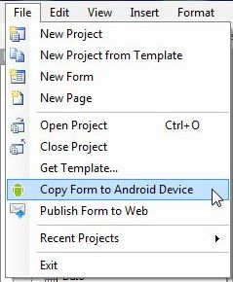
Figure 7.244: Copy Form to Android Device
The form automatically transfers to the device and is ready for use.
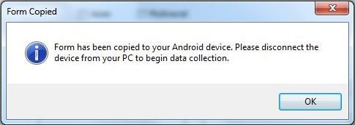
Figure 7.245: Form Copied
When a form is uploaded to a mobile device to replace an existing one of the same name, an error may occur indicating that fields no longer match.
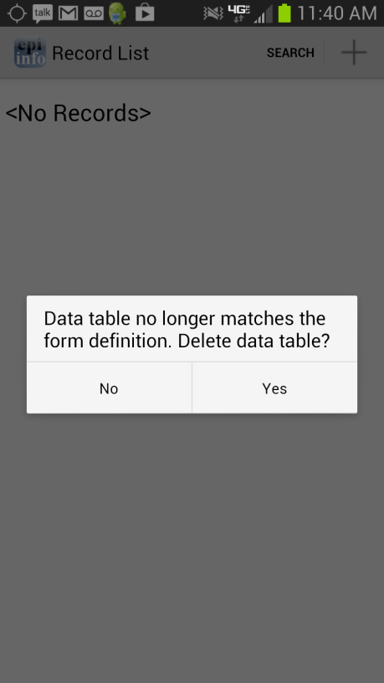
Figure 7.246: Data Table Error Message
Select Yes to delete the data table and continue data collection.
Figure 7.247: Unsupported Field Types error message
To meet publishing requirements, the non-supported fields must be deleted or the field type must be changed. Before deleting a field, be aware that any associated data with that field will be deleted as well. The data removal is automatic and irreversible. Consider backing up all data prior to deleting a field. Alternatively, use the “Change To” option to change the field to a supported field type. This action can only be performed if a data table is not associated with the form.
Figure 7.248: Fields Change To function

NOTE: If you are unable to copy the form into your device because the device is not recognized by Epi Info 7, you could copy the form into your device by creating a template of your form. In order to create a form template, please review the Form Designer chapter of the User’s Manual. Once the form template is created, you can simply copy the form template file (which will have an .XML file extension) into your device or email the form template to yourself or others. Once the file has been copied to your device, it would be recognized by the Companion for Android application and you will be able to begin data collection.

Collect Data on Mobile Device

Access the mobile companion titled Epi Info™ from your device’s application list. Note that the application layout is different between a tablet and a phone. The screen will appear in a portrait format on a phone and landscape format on a tablet.

Figure 7.249: Mobile Home screen
- The Epi Info™ Mobile main menu appears.
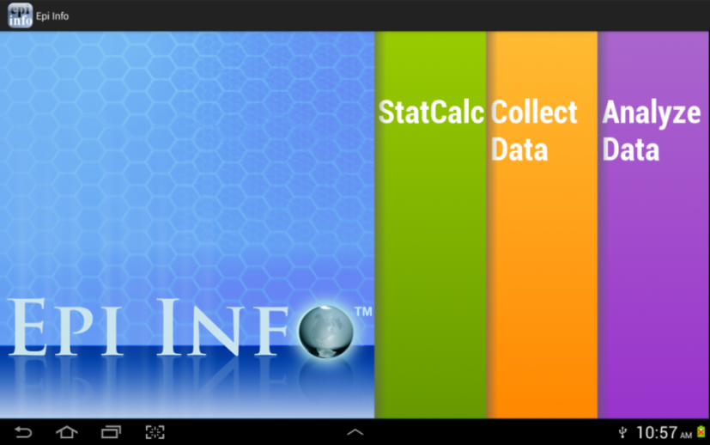  Tablet | 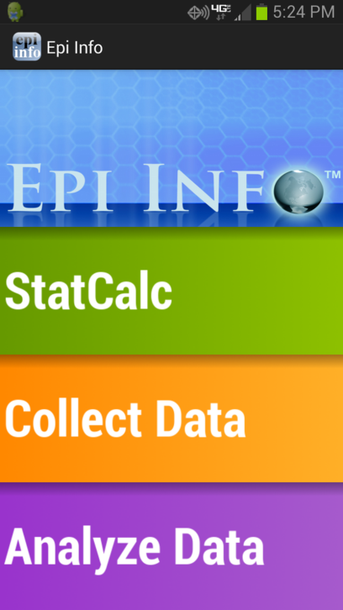  Phone

Figure 7.250: Epi Info™ Mobile main menu
- Select Collect Data. Click on the triangle on the right hand corner to see a list of available forms. Select the form for data collection from the drop-down list by pressing on the form name.
- Click Load.
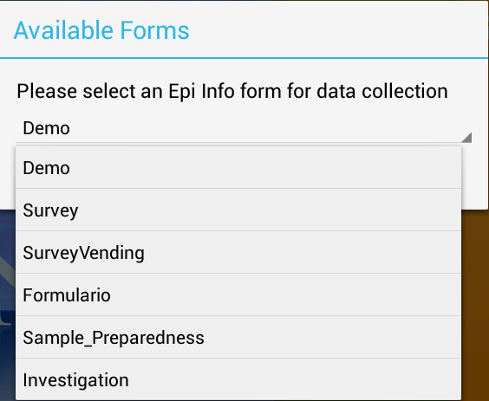
Figure 7.251: Available Forms drop-down list
The Collect Data page appears with a list of all records contained on the mobile device for that form. If there are no records, the record list displays <No Records>.
- To create a new record, select Add New Record or + from the top right corner of the screen.
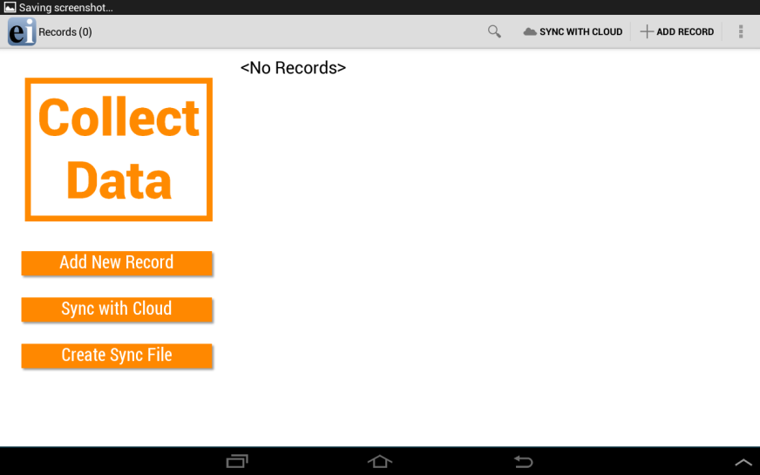  Tablet | 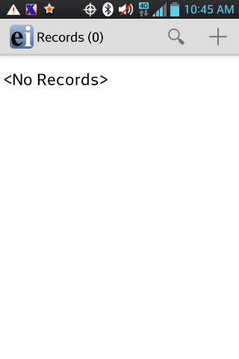  Phone

Figure 7.252: Collect Data main menu
The form appears on the mobile device. Fields appear vertically on a phone while the tablet can display fields horizontally. Users can slide their fingers across the screen to move around the form and tap into the desired field in order to enter data.
Note: Please make sure to check that the date format of the device matches the date format of the PC. Date formats must match between Android device and PC when data is being imported into the central Epi Info 7 database. You can check the date format being used by the device under the Settings>Date and Time>Select Date Format option.
Note: Always navigate using the back button instead of the home button. Use of the home button can cause cache issues that will lead to malfunctions.
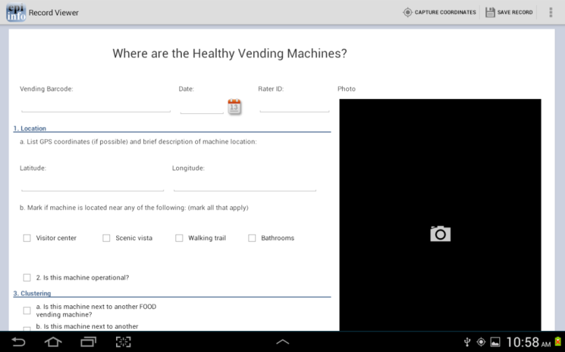  Tablet | 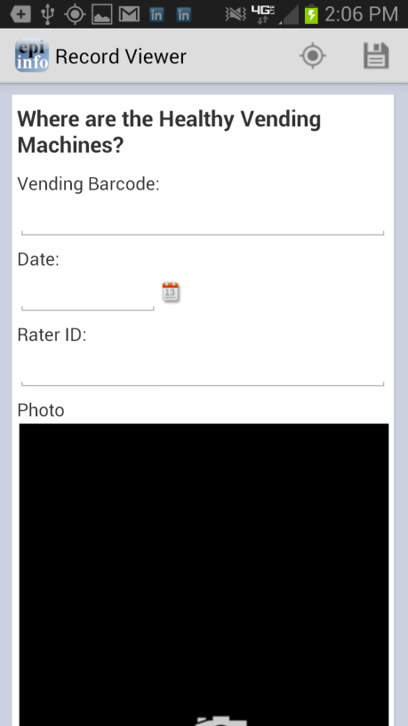  Phone

Figure 7.253: Mobile Form View
Text fields
This field allows open text characters. In order to enter data, tap into the field. A keyboard will be displayed to the user in order to enter data. Once data has been entered, click Done.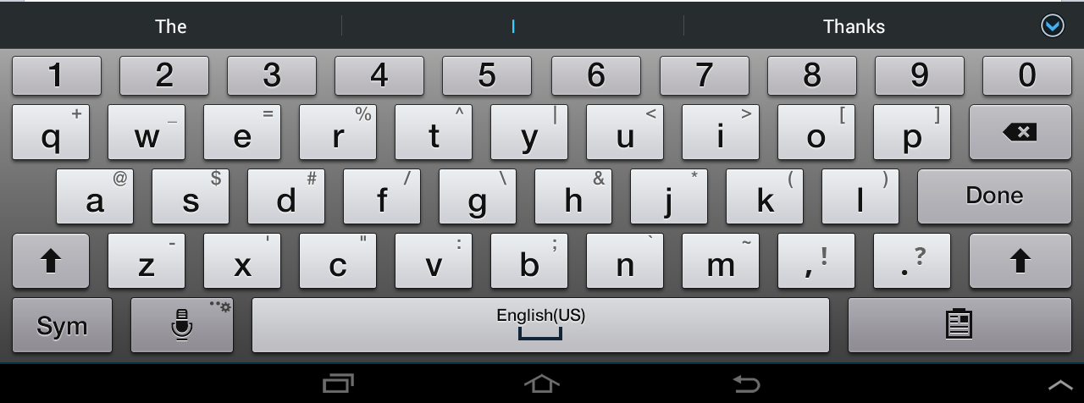
Figure 7.254: Keyboard for Text Fields

Numeric fields
This field allows numerical values. In order to enter data, tap into the field. A keyboard will be displayed to the user allowing only numbers and decimals to be entered. Once data has been entered, click Done.
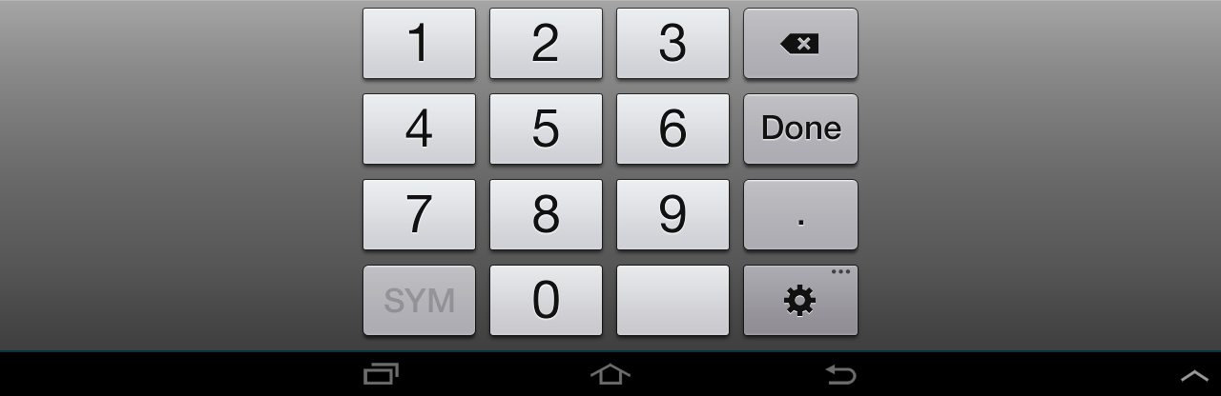Figure 7.255: Keyboard for Numeric Fields

Date fields
Date fields can be entered by clicking the calendar icon located next to the field. The user can then select a value for each of the data elements (month,day,year). Once data has been entered, click Done.
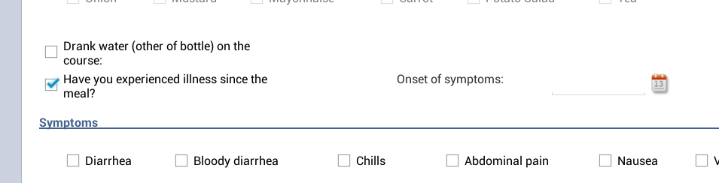
Figure 7.256: Calendar Icon for Dates

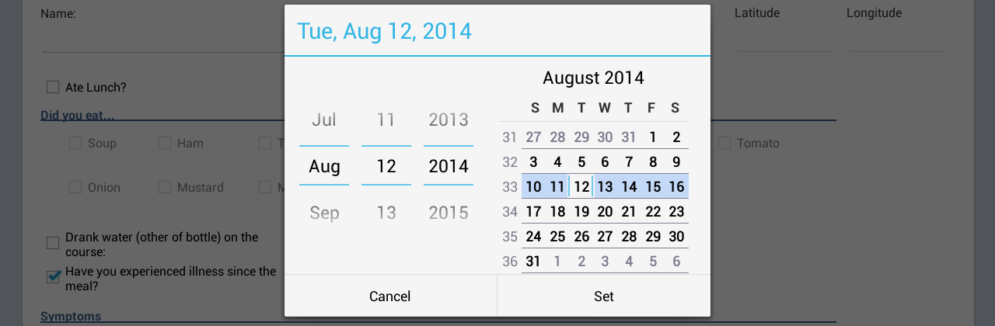
Figure 7.257: Calendar for Selecting Dates

Time fields
Time fields can be entered by clicking the clock icon located next to the field. The user can then specify a value for hour and minutes. Once data has been entered, click Done.
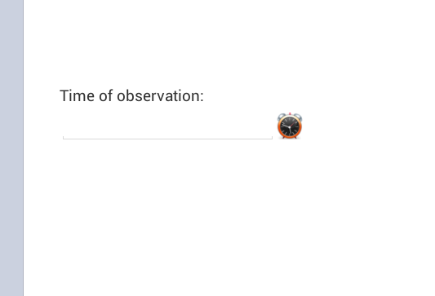
Figure 7.258: Clock Icon
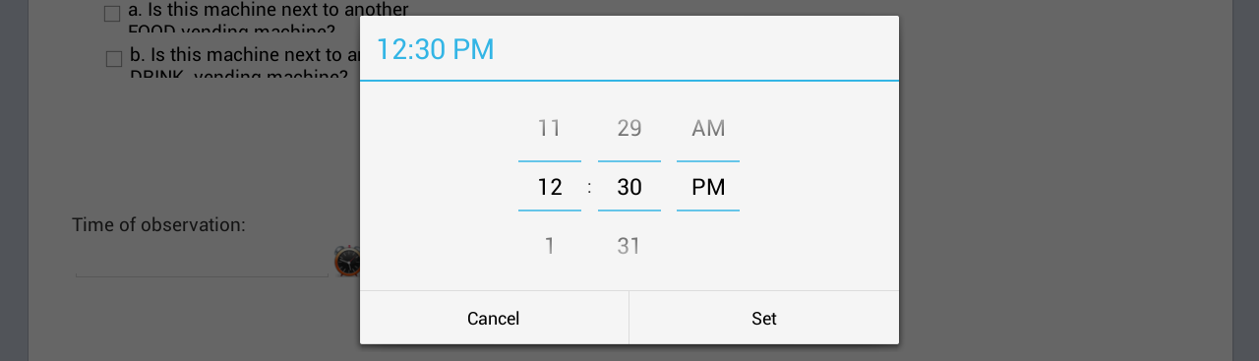
Figure 7.259: Time Selection Screen

Drop down lists
This field type provides a list of possible values in response to a question therefore limiting the number of options to use. Initially this field will present the user with the prompt <Not Selected>. Tap into the field and select the desired response.

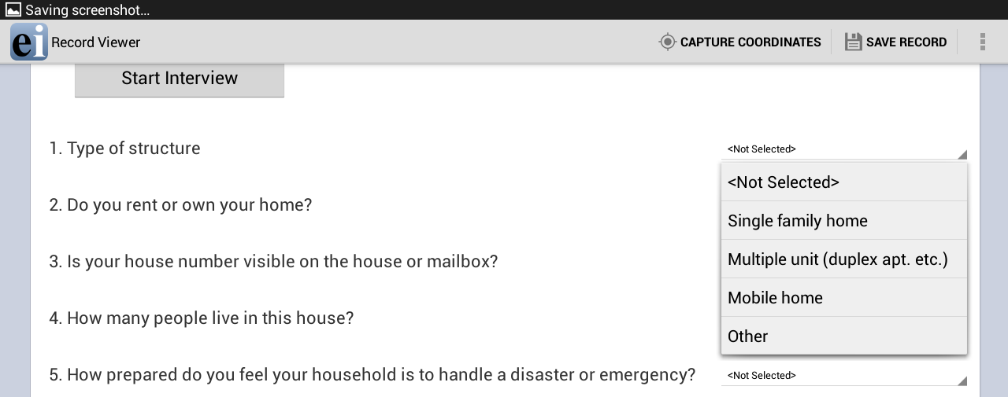
Figure 7.260: Drop Down Lists

Checkbox fields
The Checkbox field allows you to collect data by checking or unchecking a box. Multiple checkboxes can be used to quickly enter responses that are consistent in the study (e.g. symptoms or foods eaten). Checkbox fields collect binary data such as 0 or 1, True or False, Yes or No. The response is stored in the database as a 1 or 0 where 1 equals Yes and 0 equals No. Checkbox fields do not contain missing values. They are considered to be “No” until they are checked. The following figure provides an example of how Checkbox fields appear on a mobile device.
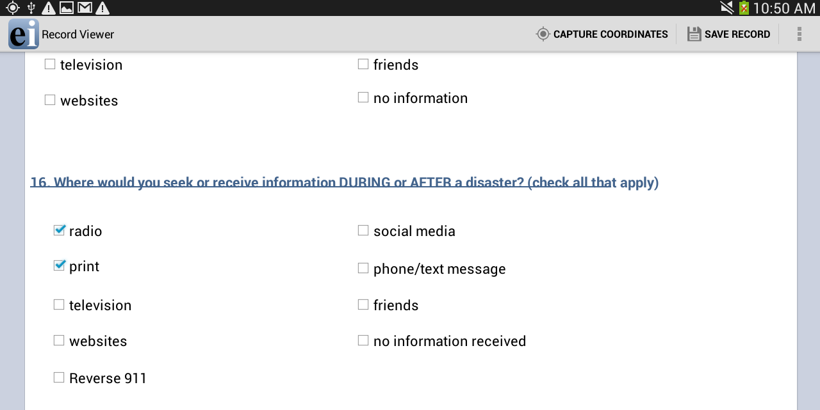
Figure 7.261: Checkbox Fields

Image/Photo Fields
The Image field will appear as a Photo field on a mobile device. This field allows the user to insert pictures taken with the mobile device onto the form. The photos taken will always stretch to the field shape that appears on the mobile device. The retain image size feature in the Image Field Definition dialog box will not affect the Photo field’s functionality. When inserting Image fields, adjust the field size to the anticipated aspect ratio of the mobile device.
      - To add a picture to the form, select the Photo field. The mobile device’s camera function automatically opens.
      - Take the photo (process varies depending on the mobile device)
      - Select Save. Epi Info™ inserts the photo into the Photo field.
Photo fields will appear as the same size regardless of layout on the PC version of Epi Info™ when using a phone.

Capture GPS Coordinates
If the mobile device is connected to the Internet, latitude and longitude coordinates can be captured by selecting Capture Coordinates, located in the top right corner of the screen. Select the field containing the latitude coordinates from the Select latitude field drop-down list. Select the field containing the longitude coordinates from the Select longitude field drop-down list. Select Set.
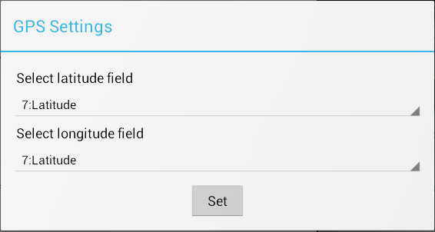
Figure 7.262: GPS Settings
The coordinates appear in the latitude and longitude fields.
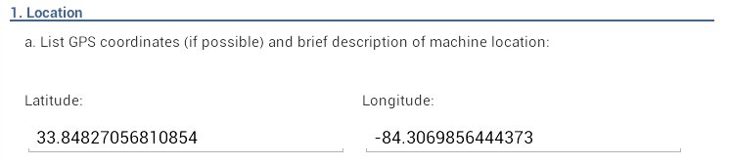
Figure 7.263: Latitude and Longitude Coordinates

Save Record
To save the form, select Save Record in the top right corner of the screen. An incomplete form can be saved and finished at a later time. The data is stored with a Record ID and Preview information.
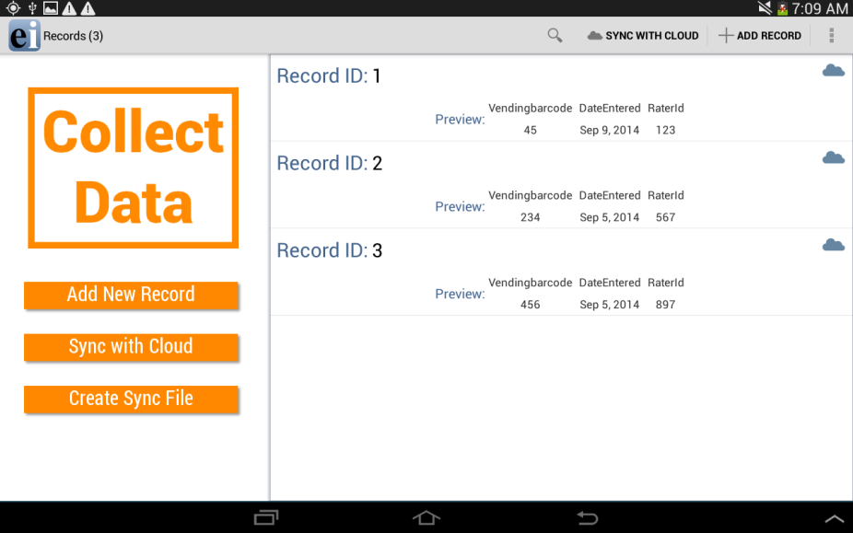
Figure 7.264: Record List

Edit Record
Select the record you wish to edit from the Record List. The form appears on the device and is ready for editing. At any point, select the Save Record button to save the edited record.

Delete Record
Hold down on the desired Record from the Record List and a menu will appear. Select Delete.

Search Record
To search the Record list, select Search in the top right corner of the Collect Data menu. The Epi Info Record list (top left corner of the screen) becomes blank with a blinking cursor. The Search function allows records to be located based on a series of matched variables. Type in the search criteria and press the search button. The records that match the search criteria appear in the record list. When searching for a record, you will need to specify the fieldname, the = operator, and then the value. If you are searching for a text field, use single quotes around the value being searched. For example PATIENTNAME=’Walter’if you are searching for “Walter” as the patient name in your tablet.
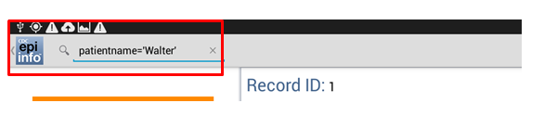
Figure 7.265: Syntax for Search text field

You can use the AND or the OR operator to use more than one variable in your search criteria. If you are searching for a date or numeric field, simply type the value to be searched (i.e. DOB=06/12/1999 or AGE=35) without using any quotes.

Maps
The Maps feature allows users to geographically display case data on a map. The mobile version contains the ability to plot GPS coordinates on a Google Map base map. Internet connectivity is required to display maps on your mobile device using Google Maps. For additional mapping functionality, transfer the data to a computer and use the Epi Info™ Maps tool (See Maps).
        - Select Generate Map from the Collect Data menu or the options menu. Generate Map is only available through the options menu on a phone. A Map Settings dialog box appears.
        - Select the field containing the latitude coordinates from the Select latitude field drop-down list.
        - Select the field containing the longitude coordinates from the Select longitude field drop-down list.
        - Select Set.
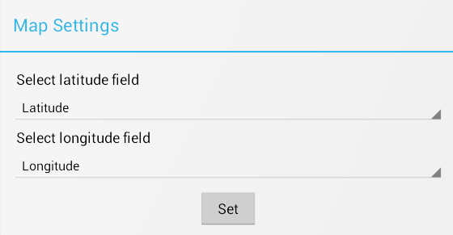
Figure 7.266: Maps Settings
The map appears displaying the location in Google Maps.
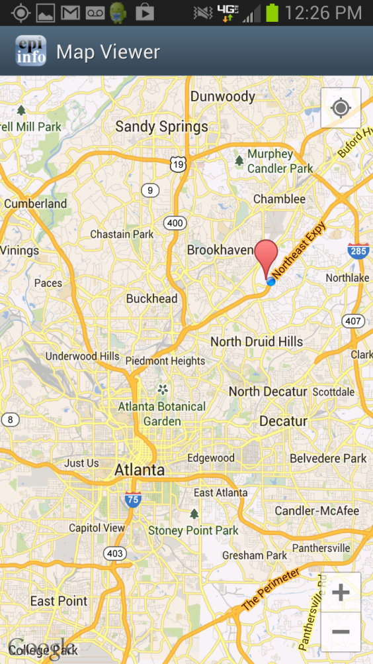
Figure 7.267: Maps

Transfer Data from Mobile Device

          - Select Create Sync File from the Collect Data menu or from the options menu. This feature is only accessible from the options menu on a phone.
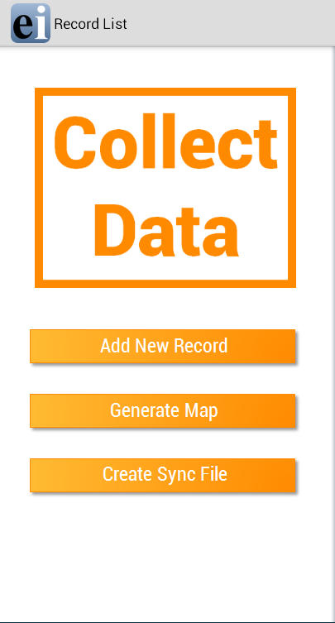  Tablet | 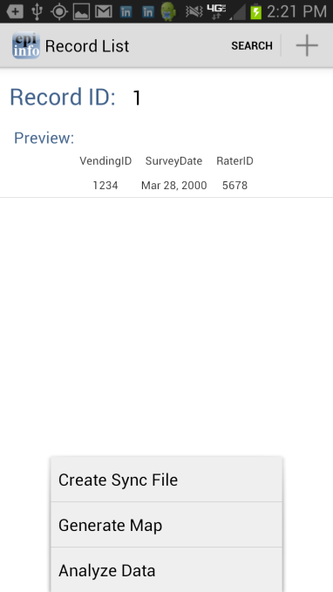  Phone

Figure 7.268: Create Sync File
          - Create a password for the sync file. This password will be required to access the sync file and download the information to a computer. There are no password requirements; however, it is recommended that users create passwords to ensure secure information transfer with encrypted files.
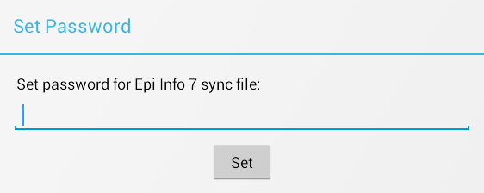
Figure 7.269: Set Sync File Password
          - Click OK and connect the device to your PC.
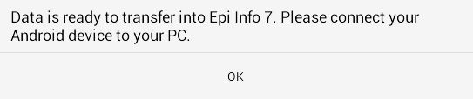
Figure 7.270: Sync File Created

      - Open the Epi Info™ software on your PC.
      - From the Epi Info™ main menu, select Enter Data or select Tools > Enter Data. The Enter tool opens.
      - Open the project and form used to collect the data on the mobile device.
      - From the File menu, select Import Data > From mobile device.

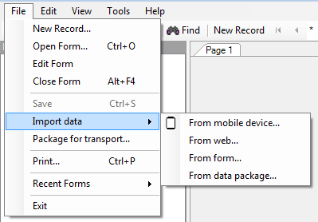

Figure 7.271: Import Data from mobile device
The Import phone data dialog box appears.
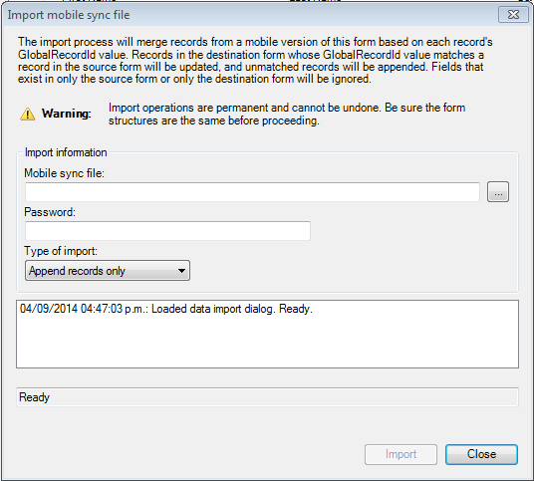

Figure 7.272: Import Mobile Sync File Dialog Box
      - Click the ellipses button next to the Android sync file text box and select the sync file created with the mobile device. The file will be located in the Downloads > EpiInfo> SyncFiles folder on the mobile device.
      - Click Open. Note the file format, “Epi Info for Android” sync files.
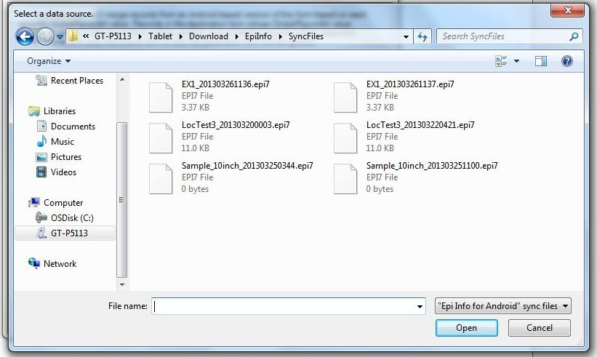
Figure 7.273: Select a Data Source Dialog Box

      - Enter the password created for the sync file in the Password field.
      - Select the Type of Import from the drop-down list.
- Update and append records – Records in the destination form containing the same GlobalRecordId values as the source form will be updated (overwritten) if there is new information. However, values in the destination table will never be overwritten with a null or missing value. All other records will be appended (added) to the end of the table.
  - Update records only – Records in the destination form containing the same GlobalRecordId values as the source form will be updated (overwritten) if there is new information. However, values in the destination table will never be overwritten with a null or missing value. All other records will be ignored.
  - Append records only – All records in the source form will be appended (added) to the end of the table. No records will be updated (overwritten).

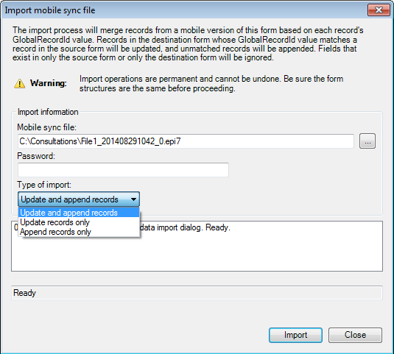

Figure 7.274: Type of Import Drop-Down List
Note: Import operations are permanent and irreversible. Be sure that the form structures are the same (including all form names and form table names) before proceeding.
      - Click Import. Import Complete will appear at the bottom of the dialog box upon successful completion of the import.
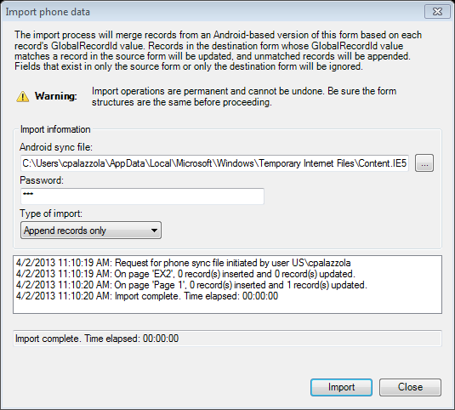
Figure 7.275: Import Complete
      - Click Close.
The data displays in the Enter tool at the end of the Record List. This information is now ready to be analyzed by Classic Analysis or Visual Dashboard.
NOTE: You might need to disconnect the cable from the Android device into your PC and reconnect it in order for the PC to recognize updated files on the device. In some devices, users had to restart the device in order for the PC to recognize updated files on the device.

Configuring cloud synchronization with Windows Azure
The companion for Android application allows you to synchronize with a Windows Azure cloud service and consume the data using Epi Info™ Companion for Android to allow a team of epidemiologists to more efficiently collect data together. Data can be collected offline and synchronized with team members when Internet connectivity becomes available. If you are always connected, data shows up in the cloud instantly to allow for real-time data analysis and situational awareness.
You will need to first create a Windows Azure account at Windows Azure Home (http://windowsazure.com/). The free tier is sufficient for many data collection activities. Please note that you MUST get organizational approval first if you are using this service for official purposes!
Please complete the steps documented below in order to set up your Companion for Android application with Windows Azure

Add a Mobile service
- Select the Create a New Mobile Service option
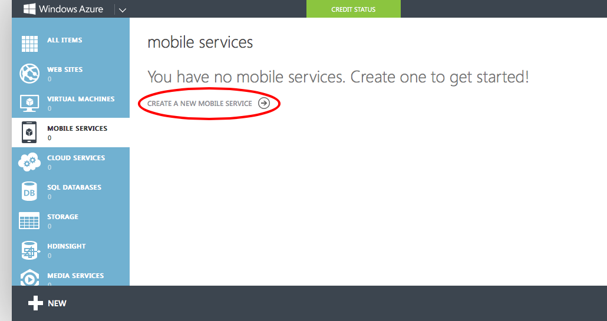
Figure 7.276: Create a New Mobile Service

- Provide a unique Mobile Service Name. You will need to either remember (or copy) the Mobile Service Name and provide it in the configuration settings of the application.
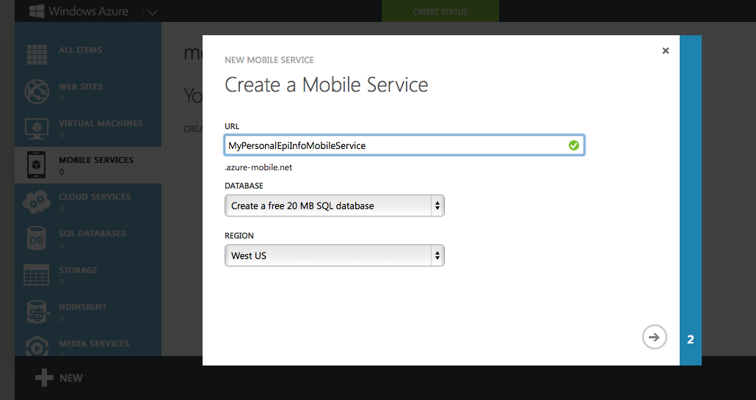
Figure 7.277: Mobile Service Name

- Create an SQL Server database. Specify a database name, Login Name, and Password.
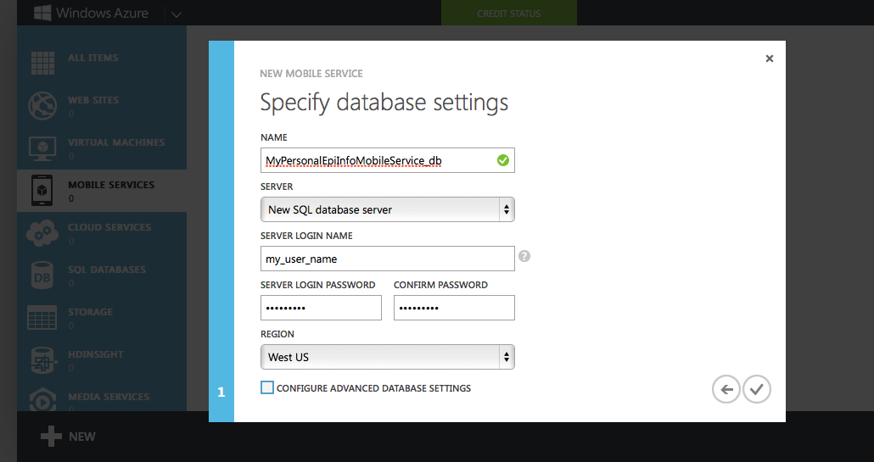
Figure 7.278: Database Settings

- Once completed, click on the Mobile Service Name
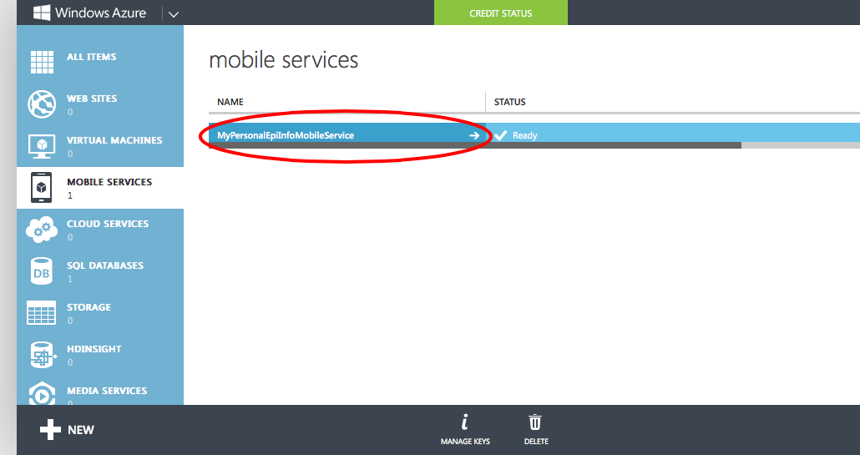
Figure 7.279: Accessing Mobile Service Configuration

- Click on the Manage Access Keys link. You will need to copy this Application Key into the Companion for Android configuration settings in order to authenticate against your service.
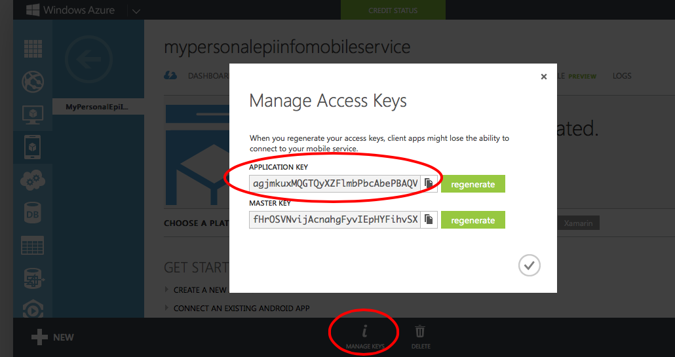
Figure 7.280: Managing Access Keys link

Configuring the application to use the settings
- From the Companion for Android main menu, click on the Settings option.
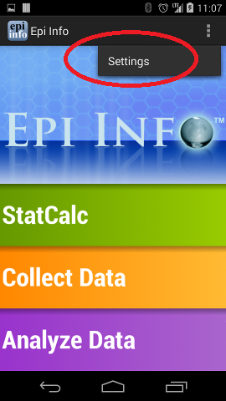
Figure 7.281: Companion for Android Configuration Settings

- Provide the Windows Azure mobile service name to use for data synchronization in the Azure mobile service section. Also, provide the Windows Azure application key to use for data synchronization in the Azure application key section.
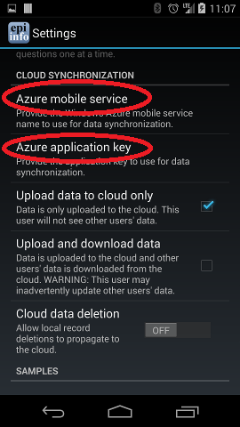
Figure 7.282: Specify mobile service name

Receiving Data and Creating a Data Table in Windows Azure
The last step required in order to synchronize data between the device and the cloud would consist of creating a data table in the cloud. In order to do so, please complete the following steps:
- Login into your Windows Azure account.
- Click on Mobile Services.
- Click on the corresponding mobile service.
- Click on Data.
- Click on Create (located at the bottom of the screen)
- Provide a table name. Please Note that this Table Name must exactly match the corresponding Form Name in the Companion for Android application.
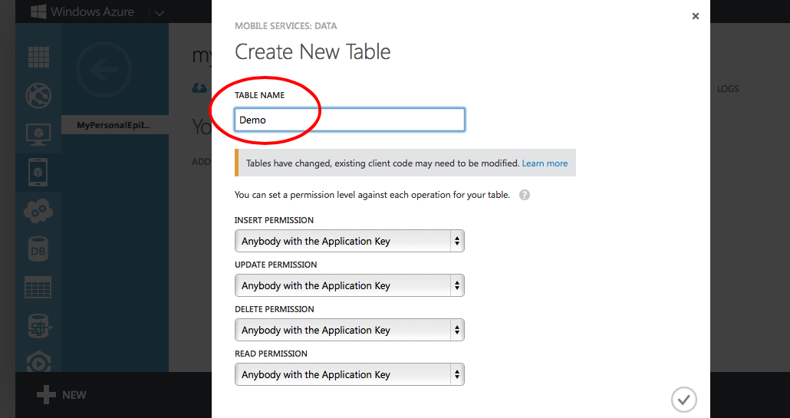
Figure 7.283: Create data table in cloud service

- Click on the check mark icon to complete the table creation process.
At this point, you should be able to start entering data into your android device and synchronizing data using the Sync with Cloud option of the Collect data module.
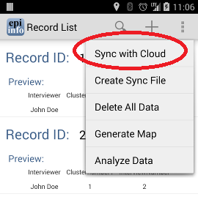
Figure 7.284: Synchronize data with cloud

StatCalc Epidemiologic Calculators

The StatCalc tool is a calculator capable of analysis pre and post data collection. The version available on the Companion for Android has similar functionality to the full Epi Info™ StatCalc tool and is capable of performing the analyses listed in the StatCalc menu listed below.
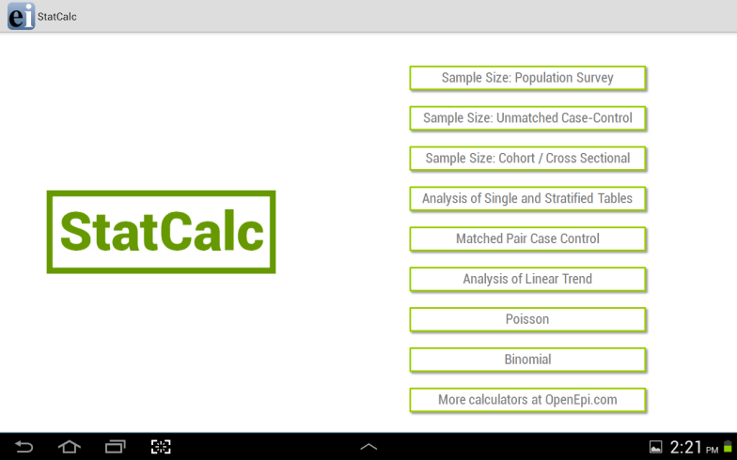  Tablet | 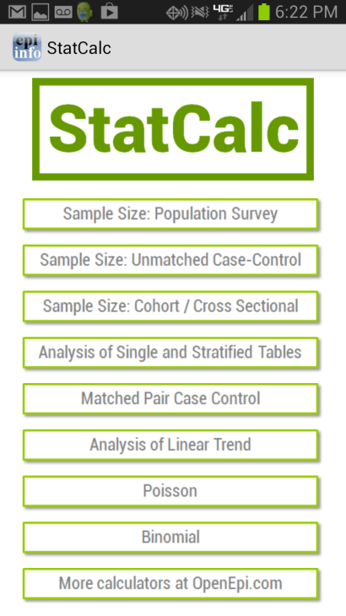  Phone

Figure 7.285: StatCalc main menu

For additional information regarding StatCalc, reference the StatCalc section of the user guide.

Sample Size: Population Survey
The population survey calculates how many samples are recommended for a survey given a population size, expected frequency, design effect, the number of clusters and the desired confidence level.
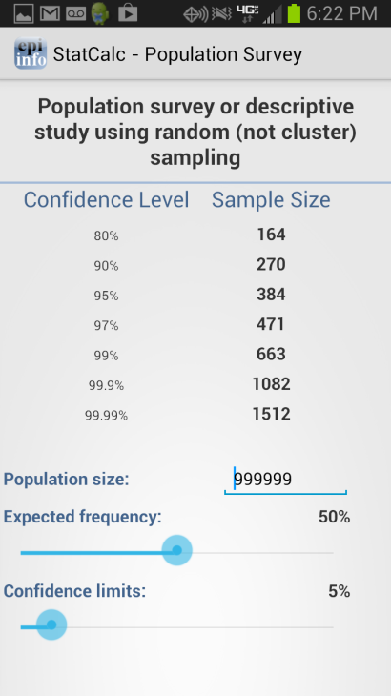
Figure 7.286: Population Survey

Sample Size: Unmatched Case-Control
The Unmatched Case Control study calculates how many samples are recommended for a study given the power, proportion of unexposed vs. exposed, percentage outcome in exposed group, percentage outcome in the unexposed group, and the desired confidence level.
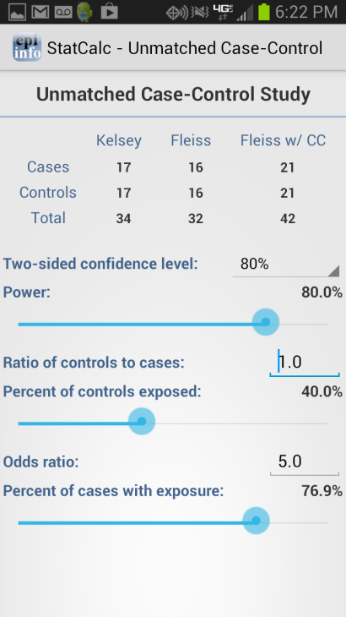
Figure 7.287: Unmatched Case-Control

Sample Size: Cohort / Cross Sectional
The Unmatched Case Control study calculates how many samples are recommended for a study given the power, proportion of unexposed vs. exposed, percentage outcome in exposed group, percentage outcome in the unexposed group, and the desired confidence level.
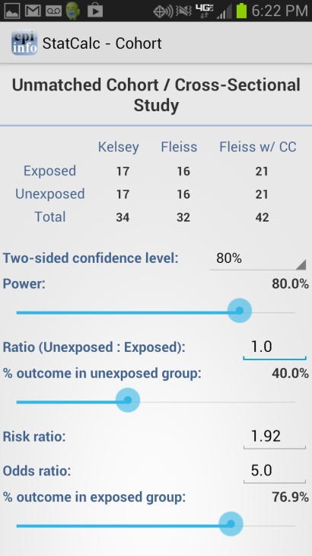
Figure 7.288: Cohort/Cross Sectional

Analysis of Single and Stratified Tables
2 x 2 tables are frequently used in epidemiology to explore associations between exposures to risk factors and disease or other outcomes. The table in StatCalc has Exposure on the left and Outcome across the top. Given a yes-no or other two-choice response describing disease and another describing exposure to a risk factor, StatCalc produces several kinds of statistics that test for relationships between exposure and disease.
Stratifying a dataset separates the population into distinct categories based on a parameter (i.e. sex). If confounding is present, associations between disease and exposure can be missed or falsely detected.
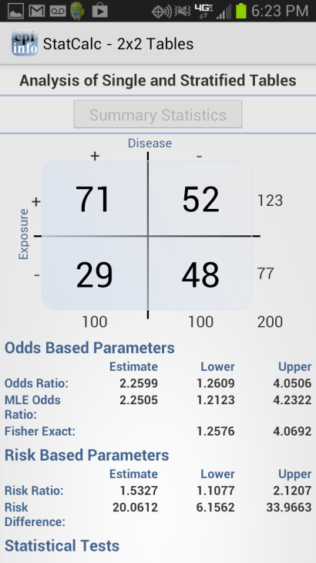
Figure 7.289: Single and Stratified Tables

Matched Pair Case Control
The Matched Pair Case-Control Study calculates the statistical relationship between exposures and the likelihood of becoming ill in a given patient population. This study is used to investigate a cause of an illness by selecting a non-ill person as the control and matching the control to a case. The control can be matched to one or more criteria.

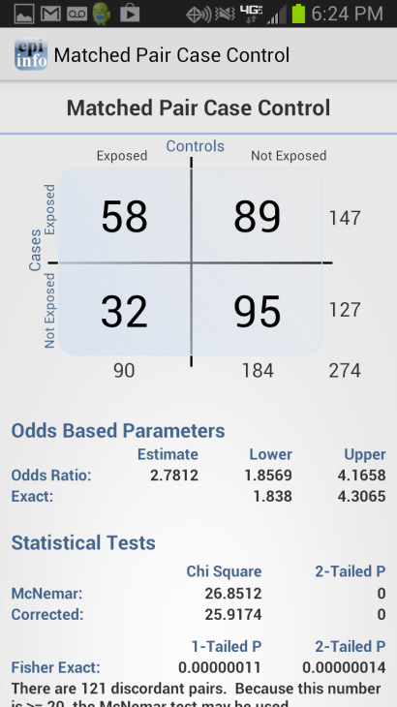
Figure 7.290: Match Pair Case Control

Analysis of Linear Trend
The Linear Trend function calculates the odds ratio, chi square for linear trend, and p-value statistics based on the response to an exposure score and whether or not the patient has become ill. The exposure score is a measured outcome from a study that states the level of exposure the patient received.
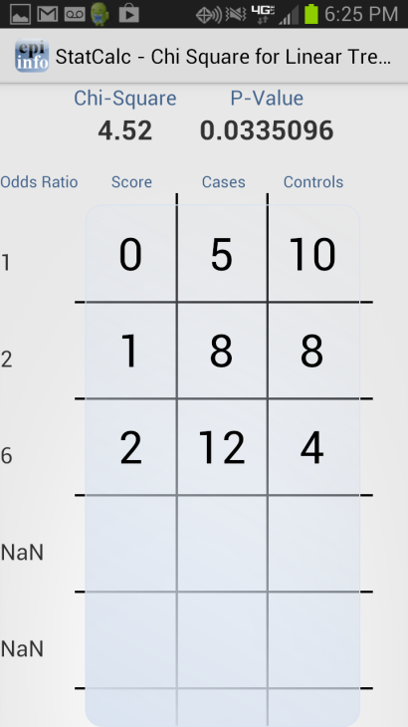
Figure 7.291: Analysis of Linear Trend

Poisson
The Poisson distribution states the probability that a number of positive outcomes occurs based on the expected number of positive outcomes. To analyze the Poisson distribution, enter the expected number of positive outcomes in Expected # of events and the value of positive outcomes you would like to determine the probability of in Observed # of events.
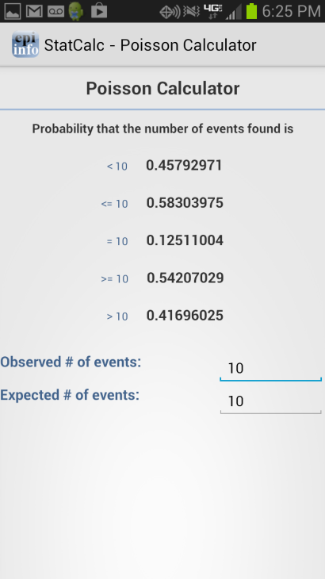
Figure 7.292: Poisson Distribution

Binomial
The binomial distribution states the probability that a number of positive outcomes occurs given the expected percentage of positive outcomes and the total number of observations taken.

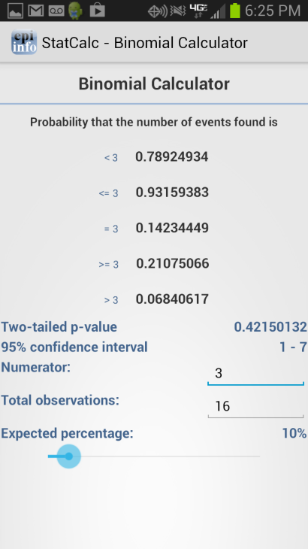
Figure 7.293: Binomial Distribution

OpenEpi.com
This website is an open source web tool that provides additional epidemiologic statistics.
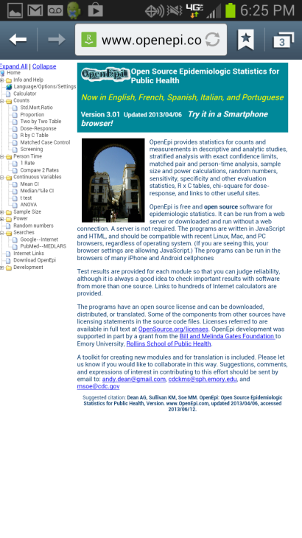
Figure 7.294: OpenEpi.com

Analyze Data

The Analyze Data tool contains three commonly used analysis functions from the Visual Dashboard tool. For additional functionality, transfer the data to a PC and use the Epi Info™ Visual Dashboard tool (refer to Visual Dashboard section of the user guide).
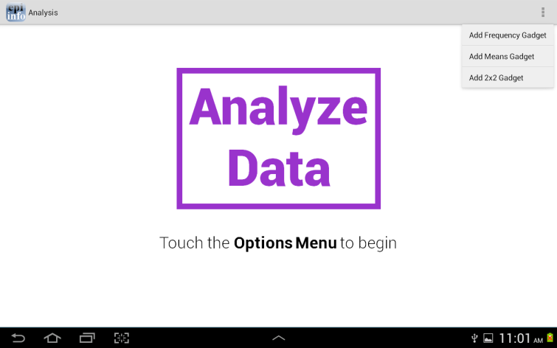  Tablet | 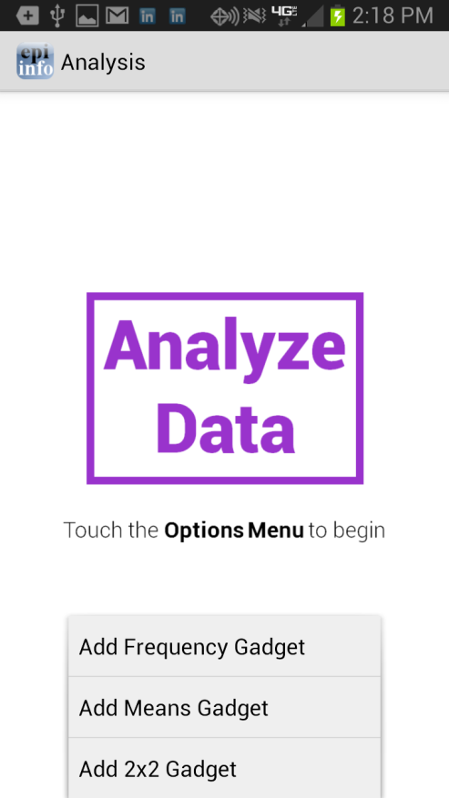  Phone

Figure 7.295: Analyze Data main menu

Note: The location of the options menu varies depending on the device.

Means Gadget
The Means gadget calculates the average for a continuous numeric variable. Mean, Variance, Standard deviation, Median, Minimum and Maximum values are calculated.
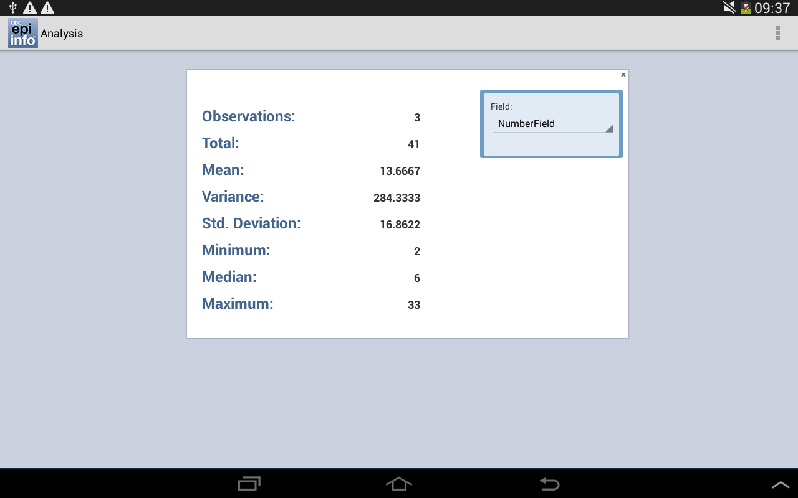
Figure 7.296: Means Gadget

Frequency Gadget
The Frequency gadget counts each occurrence in a category for a specified variable and gives the absolute and relative frequencies for each category. This option then produces a frequency table that shows how many records have a value for each variable, the percentage of the total, a cumulative percentage and upper and lower confidence intervals.
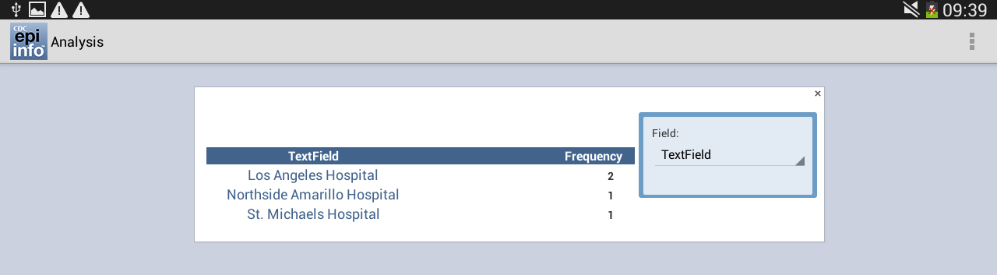
Figure 7.297: Frequency Gadget

2x2 Gadget
In epidemiology, 2 x 2 tables are frequently used to examine the relationship between two or more categorical values. In these tables, usually an “exposure” variable is considered the risk factor. The outcome variable is considered the disease of consequence. (e.g. the person had the disease or outcome of interest or they did not). Values of the first variable will appear on the left margin of the table, and those of the second will be across the top of the table. Normally, cells contain counts of records matching the values in corresponding marginal labels.
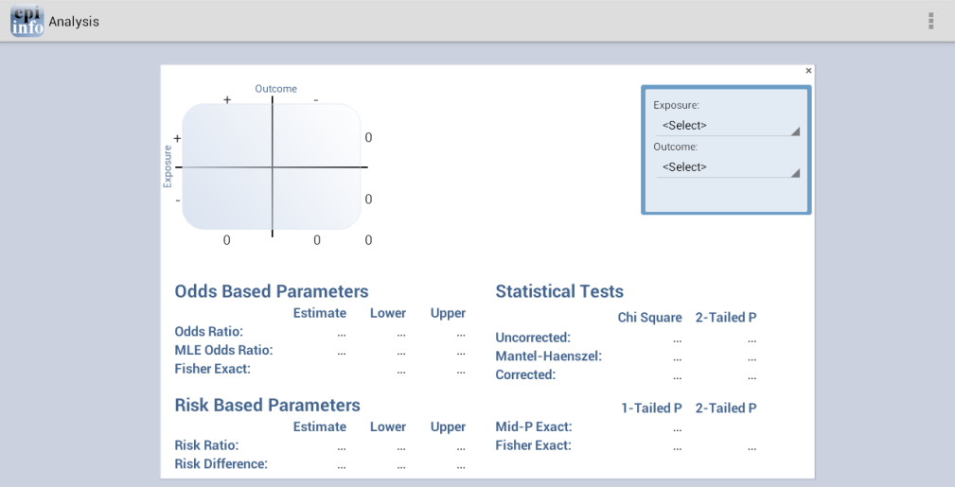
Figure 7.298: 2x2 Gadget

THIS PAGE IS
INTENTIONALLY BLANK.

Data Packager: Sharing and Merging Data

Introduction

The Epi Info™ Data Packager tool provides an easy way to share data with other users or to merge data collected by multiple users into a single database for analyses. The Data Packager does this by offering the option to package and export, as well as import data from Epi Info™ projects.
Data Packager also has several security features that allow data to be shared more safely and securely. One security feature is the capability to encrypt data packages with a password. This prevents anyone without the correct password from accessing the data. Another security feature is the capability to de-identify data by omitting specific fields from your database. Users can strip sensitive fields such as name, address, or ID number from the dataset. Users can also subset the data by specifying conditions for record selection. Data Packager also offers the option to save package settings for future use. Once packaged, the Import Data option easily imports the data.
To access Data Packager, select Enter Data from the Epi Info™ 7 main menu options and open a project and form. The Package for Transport option is located in the toolbar under File > Package for Transport and the Import Data from Data Package option is located under File > Import data > From data package.

Package Data for Transport

An Epi Info™ project must be opened with the Enter tool before the data in that project can be packaged for transport.
- From the Enter screen, open the project and form you wish to transport. If you have related forms in your project, they will not appear in the Project Explorer window of the Enter tool. However, all the data in child forms will be packaged for transport.
- Select File > Package for Transport. The Package data for Transport dialog box appears.
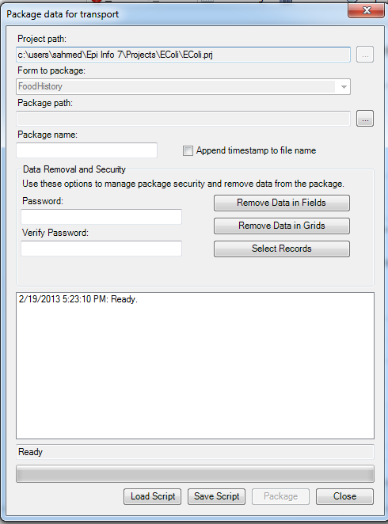

Figure 7.1: Package Data for Transport dialog box
- The Project path and Form to package textboxes automatically populate with the project and form information. Click the ellipses to browse and select a Package Path. The package path designates where the data package will be saved. Click OK.
- Enter a name for the data package in the Package Name field.
- Check the Append Timestamp to File Name checkbox if you wish to add a timestamp to the file name. The default setting is unselected.
- Enter Password if you wish to encrypt the data package. This increases the security of your data transmission. Save your password in a safe location, as this password will be required to access the data package. If you do not wish to encrypt your data, leave the Enter Password field blank and proceed to step eight.
- To Verify Password, re-enter the password from the step above.
There are several options to remove data prior to packaging: Remove Data in Fields, Remove Data in Grids, and Select Records.
- Click the Remove Data in Fields button to omit specific fields from the data package.
- Select a form on which to remove field data from the drop-down list.
- Select fields to remove from the package by clicking on the field names. To select more than one field, hold down the CTRL key.
- Click OK. The selected fields will not be included in the packaged dataset.
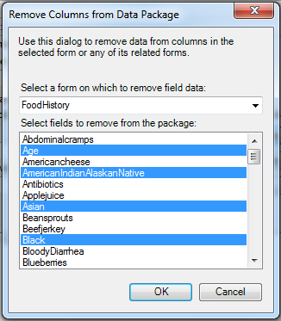
Figure 7.2: Remove Fields from Data Package dialog box

- Click the Remove Data in Grids button to remove data from columns in the selected grid.
  - Select a grid on which to remove data from the drop-down list.
You will only see options in the drop-down list if the form you are packaging contains grid fields. The items in the drop-down list will represent all grids that exist on the form and any descendant forms, and the items in the list box will represent the grid columns in the chosen grid field.
- Select grid columns to remove from the selected grid from the drop-down list.
- Click OK. The selected fields will not be included in the packaged dataset.
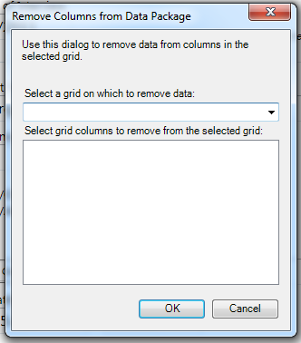
Figure 7.3: Remove Grids from Data Package dialog box
- Click the Select Records button to select specific records to include in the data package.
  - Select a Field from the drop-down list.
  - Select an Operator from the drop-down list.
  - Enter a value in the Value textbox.
  - Click the Add Record Filter button. The specified conditions appear in the textbox. All records that meet this condition will be included in the data package. All other records will be omitted.
  - Click OK.
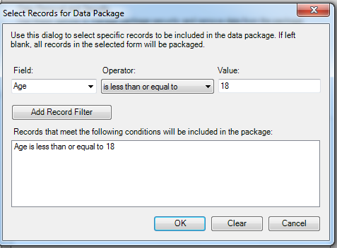
Figure 7.4: Select Records for Data Package dialog box
- The Package data for Transport dialog box appears.
- Click the Package button. When complete, the Package Creation Complete verbiage will appear at the bottom of the dialog box.

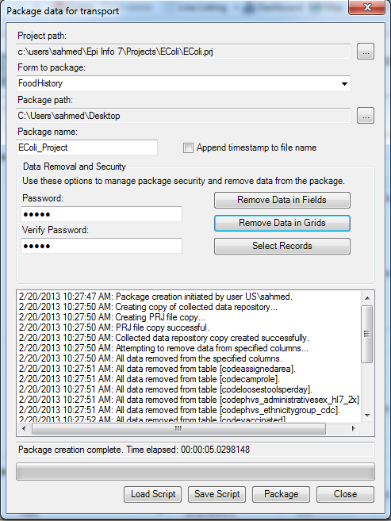
Figure 7.5: Package Creation complete
Additional Options:
Note that the textbox on the bottom half of the screen is populated with your Data Removal and Security selections. You may save this script to be used at a future time. This will prevent you from having to make each selection manually the next time you wish to package data.
  - The Save Script option will save your settings for future use. Note: The password is not saved in this script.
  - The Load Script option imports and replicates the saved script containing your package settings.
- Click Close to exit.
- The data package appears at the location (Package Path) specified in step three.

Import Data from Data Package

- From the Enter screen, select File > Import Data > From Data Package.
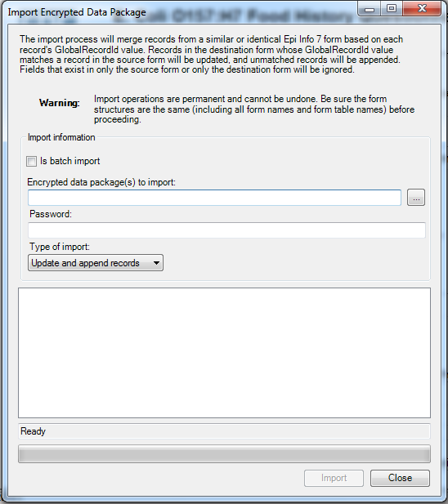
Figure 7.6: Import Encrypted Data Package dialog box
- Check the Is Batch Import checkbox if attempting to import more than one *.edp7 file. When selected, the batch import will only prompt for the folder location containing the *.edp7 files. All files in the selected folder will be imported at once. This option is unchecked by default.
- Click the ellipses to browse the location for the Encrypted data package(s) to import.
- Select the location of your *.edp7 file. Click Open.
- If the data package is encrypted, enter the password in the Password textbox. This password was created when the data was initially packaged. If the data is not encrypted with a password, leave the password textbox blank and continue to the next step.
Note: When accessing an encrypted data package, if the password is incorrect or left blank, the message below will appear at the bottom of the dialog box. In addition, when using batch import, all files in a directory must contain the same password or you will get the error message below:
Import FAILED. The package was unable to be decrypted. Check to make sure the password is correct and try again.
- Select the Type of Import from the drop-down list.
- Update and append records – Records in the destination form containing the same GlobalRecordId values as the source form will be updated (overwritten) if there is new information. However, values in the destination table will never be overwritten with a null or missing value. All other records will be appended (added) to the end of the table.
  - Update records only – Records in the destination form containing the same GlobalRecordId values as the source form will be updated (overwritten) if there is new information. However, values in the destination table will never be overwritten with a null or missing value. All other records will be ignored.
  - Append records only – All records in the source form will be appended (added) to the end of the table. No records will be updated (overwritten).
Note: Import operations are permanent and irreversible. Be sure that the form structures are the same (including all form names and form table names) before proceeding.
- Click Import. Import Complete will appear at the bottom of the dialog box upon successful completion of the import.
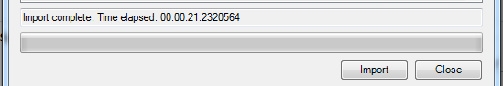
Figure 7.7: Import Complete
- Click Close to exit the dialog box. The imported data appears in the form on the Enter screen.

- Visual Dashboard: Performing Statistical Analyses with Visual Tools

Introduction

Visual Dashboard is one of the Epi Info™ 7 analysis modules. The Visual Dashboard is designed to be intuitive and simple to use. With the use of gadgets, the need for programming code is minimized. Data can be selected, sorted, listed or manipulated with the various gadgets in Visual Dashboard. The statistical analyses tools available in Visual Dashboard include frequencies, means, and more advanced statistical calculations processes (e.g., linear regression and logistic regression). Visual Dashboard has graphing functionality to display data as an Epi Curve, Pareto Chart, and several other bar and column charts.
Visual Dashboard can be accessed from the Epi Info™ 7 main window by clicking the Visual Dashboard button or by selecting Tools > Analyze Data>Visual Dashboard from the main page navigation menu. It can also be accessed from the toolbar menu of the Enter tool once data has been loaded into Epi Info™ 7.

Navigate the Visual Dashboard Workspace

The Visual Dashboard workspace contains four main areas: the canvas, Record Count/Data Source toolbar, Data Recoding and Formatting gadget (sometimes referred to as the Defined Variables gadget) and the Data Filters gadget.
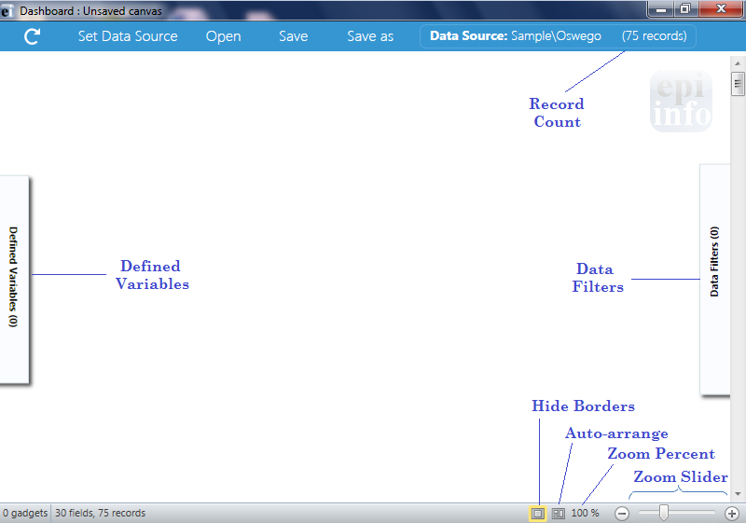
Figure 7.8: Visual Dashboard canvas
The Visual Dashboard canvas displays output generated by the multiple gadgets available in the tool. At the bottom right side of the Dashboard, the Hide Borders button turns off the external borders for each gadget giving the canvas a more report-like appearance. The Auto-arrange button positions the gadgets on the canvas to maximize the display area. The Zoom Percent and Zoom Slider allow you to zoom in and out of the canvas. The gadgets that get loaded automatically after a dataset has been uploaded are:
- The Record Count/Data Source, located in the toolbar at the top of the screen, displays the source and record count of the data being analyzed. The number of fields (columns) in your dataset will be displayed on the bottom left of the status strip.
- The Data Recoding and Formatting Gadget (Defined Variables), allows for the creation, editing, and deletion of variables created during the analysis session. This gadget is located on the left-hand side of the screen.
- The Data Filtering Gadget (Data Filters), which is a canvas wide filter, is on the right-hand side of the screen and used to select a subset of data for analysis.

Gadget Filters and Settings
In addition to setting canvas wide filters, you can also set a gadget-specific filter using the widgets at the top of the gadget. The widgets and borders disappear when the “Hide Borders” button is pressed.
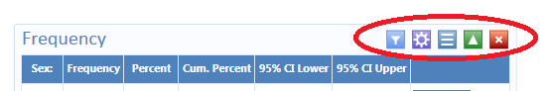
Figure 7.9: Gadget widgets
- The funnel icon on the gadget’s header panel works the same way as the canvas-wide filters (Defined Variables gadget and Data Filters gadget), except that: (1) Advanced mode is not available, and (2) the filtering applies only to that gadget. An important point to note is that gadget filters are combined with canvas filters. E.g. if the canvas filter is ‘Age > 20’ and the gadget filter is ‘ILL = Yes’, then the filter applied to the gadget is ‘Age >20 AND ILL = Yes’. Some gadgets do not have filtering capabilities, such as the advanced statistics.
- The purple button collapses and expands the gadget’s properties.
- The middle button (with the three lines) on the gadget header panel sets a gadget’s title and description. The title and description are displayed when the dashboard is exported in HTML format.
- The green up/down arrow on the gadget’s header panel collapses and expands the gadget’s output, which is useful when you want to minimize the amount of gadgets that are displayed on the canvas.
- You may exit the gadget by clicking on the red “X” at the top right of the header panel.

Canvas Properties
Canvas properties, which can be accessed by right clicking on the canvas and selecting Canvas Properties from the menu options, are used to:
- Change the data source properties by selecting a new project and table
- Change HTML output properties and create a custom title, summary, and conclusion for your Visual Dashboard output
- View miscellaneous information about your data such as number of rows and columns, and cached information
Note: Changing the data source is not advisable except for advanced users.

Save and Open a Canvas
The current canvas including data source, gadgets, filters, and user-defined variables may be saved and reused later. Saved canvases may be opened later with the Visual Dashboard tool. This will allow you to reconnect to the data source without having to manually apply the filters again.
To save a canvas, right click on the canvas and select Save Canvas.
- If the canvas was previously saved and named, this will overwrite the existing file.
- A canvas being saved for the first time will follow the process outlined in the ’Save As’ option. Epi Info™ 7 requires a “save to” location and a file name.
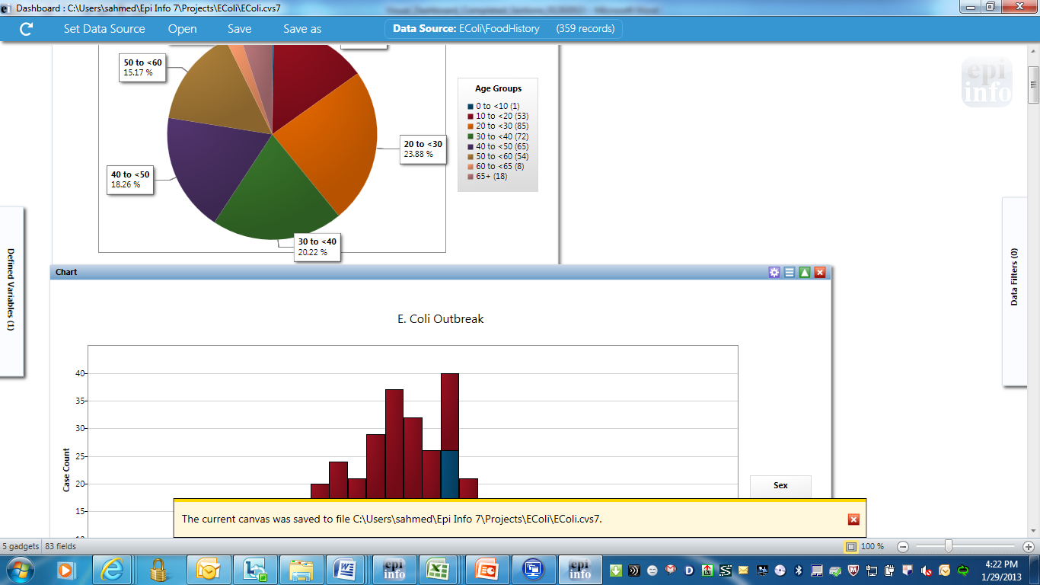
Figure 7.10: Saving Canvas
The yellow message at the bottom of the screen confirms the canvas was saved successfully.

Save Canvas As
The Save Canvas As option allows the canvas to be saved for the first time or saved to a new location.
- Right click on the canvas, select Save Canvas As. The Save As dialog box appears.
- Select a location to save the canvas to and enter a File Name.
- Click Save.
Note: If a file with the same name already exists, an error message will appear asking if you would like to replace existing file.

Open Canvas
Open an existing Visual Dashboard canvas by performing the following steps:
- Right click on the canvas and select Open Canvas. The Open Canvas dialog box appears.
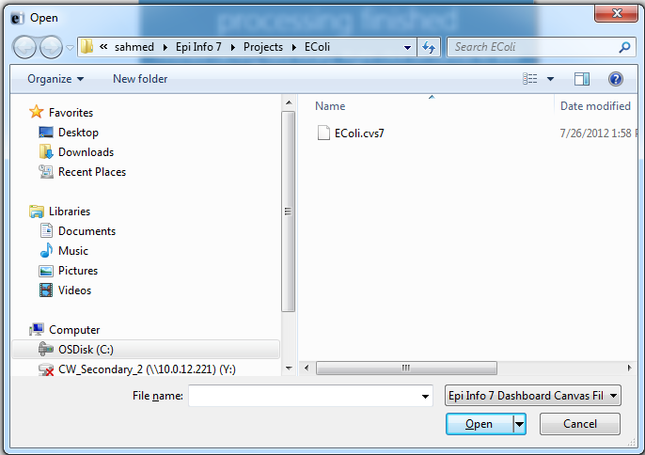
Figure 7.11: Open a Canvas
- Select the location of the canvas file. The file can be identified by the file name extension (.cvs7).
- Click Open. The canvas file appears in Visual Dashboard.
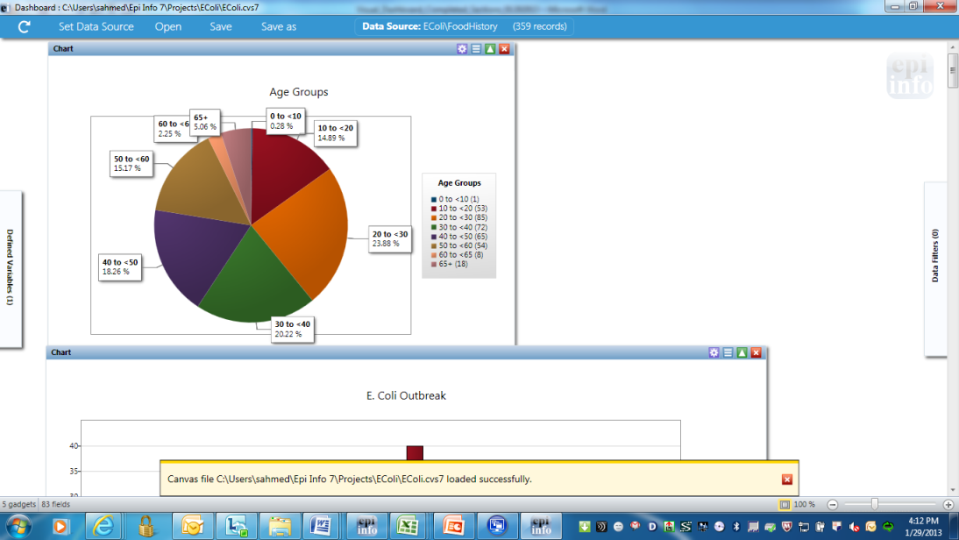
Figure 7.12: Opened Canvas
The yellow message at the bottom of the screen confirms the canvas loaded successfully.

Save Visual Dashboard HTML
Output from the gadgets may be saved as an HTML document. To save the current output:
- Right click on the canvas, select Save Output as HTML. The Save As dialog box appears.
- Select a location to save the canvas and enter a File Name. Select HTML File from the Save as Type drop-down list.
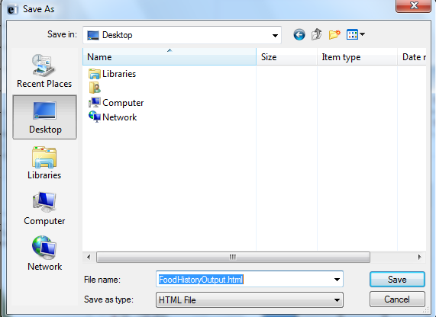
Figure 7.13: Save Output as HTML
- Click the Save button. The output automatically opens in the web browser.
Note: HTML documents can only be opened in a web browser and cannot be used to re-create the Visual Dashboard canvas.

Send Visual Dashboard Output To
Outputs from Visual Dashboard may be viewed in either Microsoft Word or Microsoft Excel with the Send Output To option. You must have Microsoft Word or Microsoft Excel installed to use either option.

Microsoft Excel
  - Right click on the canvas, select Send Output To > Microsoft Excel.
  - The Visual Dashboard output opens in Microsoft Excel.
Note: Charts are not included with the output when sent to Excel.

Microsoft Word
- Right click on the canvas, select Send Output To > Microsoft Word.
- The Visual Dashboard output opens in Microsoft Word as an .html formatted web document. If saved in this format, charts are saved separately to a sub-folder. To share this .html file, remember to share the subfolder as well. Alternatively, change the format to a Microsoft Word .docx format so the charts are included with the file as embedded images.

Managing Data

Selecting a Data Source
Before beginning analysis in Visual Dashboard, select a data source. Data from the following sources can be analyzed in Visual Dashboard: Epi Info™ 7 project files, ASCII Text files, Microsoft Excel, Microsoft Access, Microsoft SQL Server, MySQL, and PostgreSQL. Follow one of the first three steps below to select a data source:
- Click on the Set Data Source option from the bar at the top of the screen.
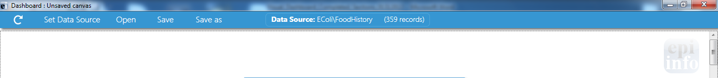
Figure 7.14: Visual Dashboard toolbar
- Click the arrow in the blue box next to Set a Data Source Now.
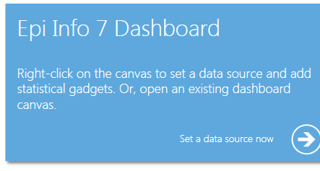
Figure 7.15: Set Data Source option
- Right-click on the canvas and select Set Data Source from the menu options.
- After selecting the Set Data Source option, the Select Data Source dialog box appears. Select a Database Type, Data Source, and form to open data in Visual Dashboard.

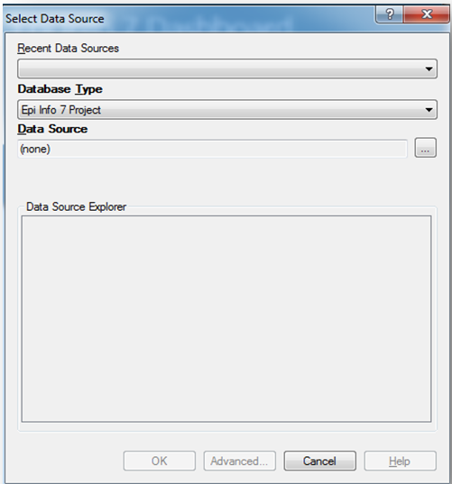
Figure 7.16: Select Data Source dialog box
- The Recent Data Sources field provides a list of recently accessed databases in Classic Analysis or Visual Dashboard. By selecting one of the data sources available on the list, you do not need to provide Database Type or Data Source information. If you are reading an Epi Info™ 7 project file from the Data Source section, all available forms will appear in the Data Source Explorer box.
- The Database Type field indicates the database file to be loaded (.PRJ, .MDB, .XLS). Specify the data format for the data being accessed. Unless otherwise specified, output files are stored in this destination folder as well.
- The Data Source field indicates the file location/path. If you use an SQL Server database, the Data Source field will require server and database names.
- The Data Source Explorer field allows you to select a form in your project. This reads the data table associated with your form.
- The Advanced mode allows the use of SQL queries to select the data source. Only SELECT statements are allowed.

Read an Epi Info™7 Project File
- Click on the Set a Data Source now arrow. The Select Data Source dialog box appears.
- From the Database Type drop-down list, select Epi Info 7 Project.
- In the Data Source field, click on the ellipsis button and the Epi Info 7 Project folder appears.
- Browse for the project file that you would like to import into Visual Dashboard.
- Click Open.
- The Data Source Explorer box populates with a list of all the forms that are associated with the project. Select a form.
- Click OK. The record count and data source appear in the tool bar at the top of the Visual Dashboard canvas.

Read a Microsoft Excel File
- Click on the Set a Data Source now arrow. The Select Data Source dialog box appears.
- From the Database type drop-down list, select either MS Excel 97-2003 Workbook or MS Excel 2007 Workbook.
- In the Data Source field, click on the ellipsis button and the Open Existing File dialog box appears.
- Enter the filename and path to open your workbook or click on the ellipsis button to browse for the MS Excel workbook (.xls or .xlsx).
- Click Open. The “First row contains Field Names” checkbox is selected by default. If this option is unchecked, data will be imported without column headings.
- Click OK. Select a worksheet from the list provided in the Data Source Explorer.
- Click OK. The record count and data source appear in the menu bar at the top of the Visual Dashboard canvas.

Read a Microsoft Access File
- Click on the Set a Data Source now arrow. The Select Data Source dialog box appears.
- From the Database Type drop-down list, select either MS Access 2002-2003 (.mdb) or MS Access 2007(.accdb).
- In the Data Source field, click on the ellipsis button and the Open Microsoft Access File dialog box appears.
- Enter the filename and path to open your file or click on the ellipsis button to browse for the MS Access file (.mdb or .accdb). If the file is password protected, enter the password.
- Click OK.
- Select a data table from the list provided in the Data Source Explorer.
- Click OK. The record count and data source appear in the menu bar at the top of the Visual Dashboard canvas.

Read an ASCII Text File
- Click on the Set a Data Source now arrow. The Select Data Source dialog box appears.
- From the Database Type drop-down list, select Flat ASCII File.
- In the Data Source field, click the ellipsis button to browse.
- Click the ellipsis button in the Flat File location dialog box to browse the directory of the ASCII file
- Click OK. Note that the First row contains header information box is checked by default. If the first row of the file does not contain header information, deselect the checkbox. If this option is unchecked, data will be imported without column headings.
- Select the file name from the list provided in the Data Source Explorer.
- Click OK. The record count and data source appear in the menu bar at the top of the Visual Dashboard canvas.

Read a SQL Server Database
Note: You must have Microsoft SQL Server installed on your computer or you must have access to a server over a network to perform this function.
- Click on the Set a Data Source now arrow. The Select Data Source dialog box appears.
- From the Database Type drop-down list, select Microsoft SQL Server Database.
- In the Data Source field, click the ellipsis button to browse.
- The Connect to SQL Server database dialog box opens. Specify the Server name and Database name to connect to a SQL Server database.
- The Use Windows Authentication radio button is selected by default. You can use SQL Server Authentication by checking the corresponding radio button and then entering Login and Password credentials.
- Click OK.
- From the list provided in the Data Source Explorer, select a data table.
- Click OK. The record count and data source appear in the menu bar at the top of the Visual Dashboard canvas.

Read a MySQL Server Database
Note: You must have MySQL Server installed on your computer or you must have access to a server over a network to perform this function.
- Click on the Set Data Source arrow. The Select Data Source dialog box appears.
- From the Database Type drop-down list, select MySQL Database.
- In the Data Source field, click the ellipsis button to browse SQL databases.
- The Connect to MySQL database dialog box appears. Enter the Server name, Database name, Username and Password to connect to the MySQL database. You can select <Browse for more> from the Server name drop-down list to select a MySQL server instance in your network.
- Click OK.
- From the list provided in the Data Source Explorer, select a data table.
- Click OK. The record count and data source appear in the menu bar at the top of the Visual Dashboard canvas.

Add a Related Data Source
Analysis in Visual Dashboard may be performed on data from multiple data sources. The Add a Related Data Source option links one or more tables using a common identifier to find matching records. The form/table to be linked requires a key field that relates records in the two forms/tables together. The keys in the main and related tables or forms do not require the same name. If the table was created in Form Designer and the data entry was completed using Enter, Visual Dashboard can establish a relationship by using the Global Record ID and Foreign Key variables created by Epi Info™ 7. The example below demonstrates how to add a related data source.
Epi Info™ 7 contains a related database in the Sample.PRJ file with two forms: Surveillance and RHepatitis. The variable GLOBAL RECORD ID is the internal Epi Info™ 7 identification key located in more than one form in the project.

- Select the Sample.PRJ Data Source. Open Surveillance.
- Right click on the canvas and select Add related data source. The Select Data Source dialog box opens.
- Select RHepatitis from the list of forms in the Data Source Explorer. The Child Key Field drop-down list populates.
- From the Parent Key Field drop-down list, select GLOBALRECORDID.
- From the Child Key Field drop-down list, select FKEY.
- Click OK. The related form information appears on the canvas. Data from the two tables can now be used for analysis.

Note: You can only perform a one-to-one analysis with a related table in Visual Dashboard. To perform a one-to-many analysis, please see the Classic Analysis section of this user guide.

Managing Variables

The Data Recoding and Formatting Gadget in Visual Dashboard allow you to create, edit, or delete variables with no coding. To access the Data Recoding and Formatting gadget, move your mouse over Defined Variables on the left-hand side of the screen.
Creating a New Variable
Project data are not always in the proper format needed for analysis. As an example, a patient’s age may be entered in a questionnaire but the ages may need to be in five-year increments for proper analysis. The data may contain county codes, but descriptive county names may be more useful for analysis. Creating a new variable is one of the functions of the Data Recoding and Formatting gadget. By creating a new variable, the ages of patients can be recoded to five-year increments, or county names may be assigned to the county codes making the data useful for analysis. A new variable may be created to change the format of existing data with recoded value, simple assignment, formatted value, assigned expression, or by grouping existing variables.

Recoded Value
The New Variable with Recoded Value option assigns a new value to existing data and places the results in defined variables. The Add Recoded Variable dialog box is pictured below.
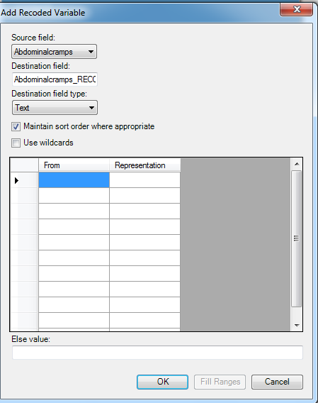
Figure 7.17: Add Recoded Variable Options
- The Source field drop-down list represents the column in the current data source that will have its values recoded.
- The Destination field drop-down list represents a new column that will be temporarily created in the current data source that will store the recoded values.
- The Destination field type represents the data type of the new column that will be created to store the recoded values. The available options are text, numeric, or Yes/No.
- The Maintain Sort Order Where Appropriate is checked by default. Usually output in Visual Dashboard is sorted alphabetically or sequentially. Leave this box checked if you would like the output to remain sorted exactly in the sequence that the data was entered.
- The Use Wildcards option can be used for text searches in the FROM column below. This option is unchecked by default. The asterisk (*) is the wildcard character.
- The From column identifies the bottom of a range of values or a single value. To recode a single value instead of a range, use this From column only and ignore the To column. When used to recode a range of values, the recode range includes the value in the From column and extends up to, but not including the value in the To column. To recode all unspecified values, leave both From and To columns blank.
- To value (if any) identifies the upper limit of a range of values to be recoded. The recode range does not include the value in the To column. This option only appears if a numeric variable is selected.
- The Else Value represents an optional value to assign to any records that do not match the recoding rules above. If left blank, unmatched records will be left null.
- Representation Value identifies the value to be assigned to the destination variable for the specified values of the source variable.
  - Fill Ranges can be used to automatically populate range values on a numeric source field and is a very quick way to create numeric groupings such as age categories.
  - OK accepts the current settings and data, and closes the form or window.
  - Cancel exits the window without saving or executing a command.

The example below demonstrates how to add a recoded variable:
In the E. coli Food History table, there are over 60 different values for Age. When performing an analysis, it is difficult to compare all of the different age values. By grouping the age values in 10-year increments, analysis on this variable is simplified. To group the values in Age groupings or categories:
- Select the EColi.PRJ Data Source.
- From the Form section, click FoodHistory. Click OK.
- On the left-hand side of the Visual Dashboard canvas, move the mouse cursor over the Defined Variables gadget. The gadget expands and becomes fully visible.
- Click the New Variable button.
- Select With Recoded Value. The Add Recoded Variable dialog box appears.

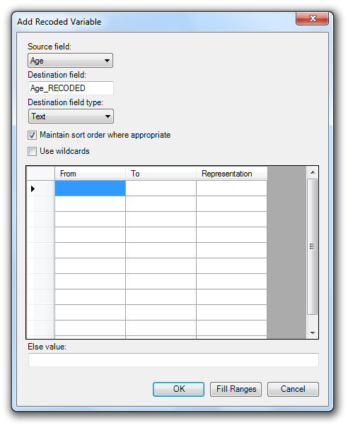
Figure 7.18: Add Recoded Variable dialog box 2
- From the Source field drop-down list, select Age.
- Click the Fill Ranges button. The Fill Ranges dialog box appears.
- Enter 0 for the Start value, 65 for the End value, and 10 for By.

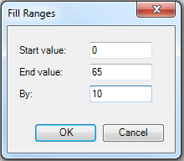
Figure 7.19: Add Recoded Variable/Fill Ranges
- Click OK. The Add Recoded Variable dialog box appears with the From, To, and Representation columns populated.
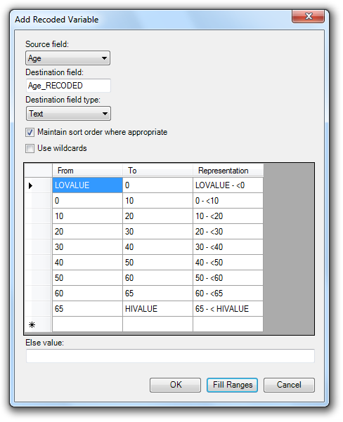
Figure 7.20: Add Recoded Variable Ranges Populated
- Click OK. The variables are recoded and the conditions appear in the Variable Definitions textbox.
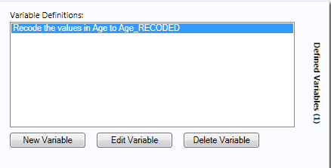
Figure 7.21: Variable Definitions dialog box
To see the frequency of Age_RECODED in line list view, right click on the canvas, and then select Add Analysis Gadget > Frequency. Select Age_RECODED from the Frequency of drop-down list and then click Run. For information regarding the Analysis Gadget, refer to the Displaying Statistics and Records section.
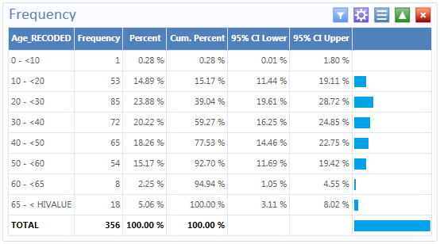
Figure 7.22: Age_Recoded Line List
The Age_Recoded variable contains eight distinct values, which makes analysis easier.

Simple Assignment
Simple Assignment will assign the value of an existing variable to a newly defined variable. The example below demonstrates Simple Assignment.
- Select the Sample.PRJ Data Source.
- From the Data Source Explorer menu, select Surveillance. Click OK.
- On the left-hand side of the Visual Dashboard canvas, move the mouse cursor over the Defined Variables gadget. The gadget expands and becomes fully visible.
- Click the New Variable button.
- Select With Simple Assignment. The Simple Assignment dialog box appears.
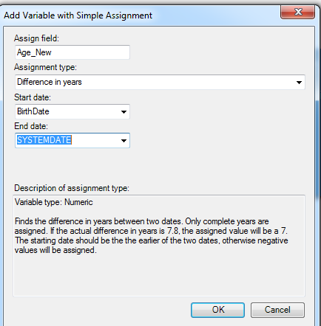
Figure 7.23: Add Variable with Simple Assignment Options
- In the Assign field, enter Age_New.
- Select Difference in years from the Assignment type drop-down list.
- Select BirthDate from the Start Date drop-down list.
- Select SYSTEMDATE from the End Date drop-down list. The System Date is a system-level variable that represents the current date and time on your computer.
- Click OK. A description of the assignment appears in the Variable Definitions textbox.
To see the Age_New variable in line list view, right click on the canvas and then select Add Analysis Gadget > Line List. Select Age_New from List of Variables to display and then click Generate Line List.
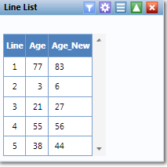
Figure 7.24: Simple Assignment Line List
In this example, the current age of the patient is calculated from the difference between the birth date and today’s date. The Analysis Gadget > Line List view displays the new variable created via Simple Assignment. For information regarding the Analysis Gadget, refer to the Displaying Statistics and Records section.

Conditional Assignment
Conditional Assignment defines conditions and one or more events that occur if the specified conditions are met. An alternative event can be given after the ELSE statement. The ELSE statement will be executed if the first set of conditions is not true. If the condition is true, the first event is executed. If the statement is false and no ELSE statement is selected, the statement is bypassed.
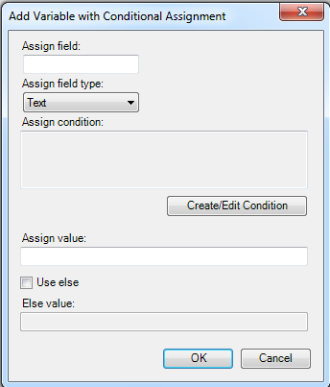
Figure 7.25: Add Variable with Conditional Assignment
- Assign Field indicates the new variable name.
- Assign Field Type indicates the format of the new variable. The available options are Text, Numeric, or Yes/No.
- Assign Condition determines whether subsequent commands will be run. If the condition specified in this textbox is true, the Assign Value will be applied.
- Assign Value states the value of the new variable when the Assign Condition is true.
- Use Else checkbox indicates whether an Else Value is specified. This checkbox is unmarked by default.
- The Else Value is applied when the statement in the Assign Condition textbox is false.
In the following example, the YoungAdult variable will be conditionally assigned the value of Yes if the Age variable has a value between (but not including) 17 and 30. If the Age value falls outside of this range, a value of No will be assigned to YoungAdult.
- Select the Sample.PRJ Data Source.
- From the Data Source Explorer menu, select Surveillance. Click OK.
- On the left-hand side of the Visual Dashboard canvas, move the mouse cursor over the Defined Variables gadget. The gadget expands and becomes fully visible.
- Click the New Variable button.
- Select With Conditional Assignment. The Add Variable with Conditional Assignment dialog box appears.
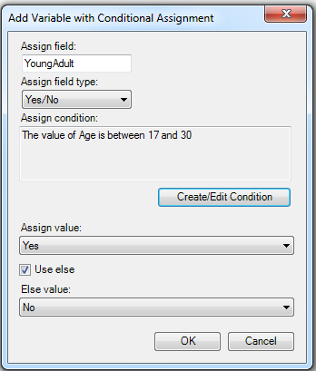
Figure 7.26: Conditional Assignment/ Create Edit Condition
- In the Assign field, enter YoungAdult.
- Select Yes/No from the Assign field type drop-down list.
- Click on the Create/Edit Condition button. The Specify Assign Condition dialog box appears.
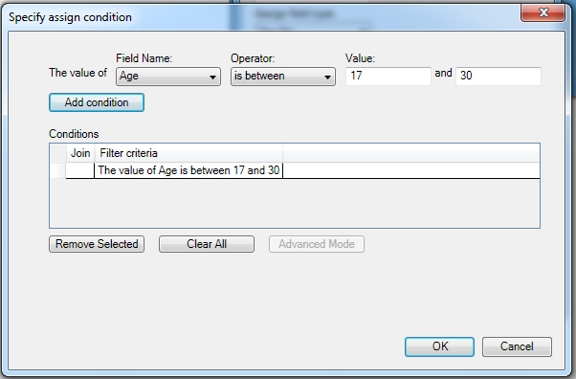
Figure 7.27: Conditional Assignment Add Condition
- Select Age from the Field Name drop-down list.
- Select is between from the Operator drop-down list.
- Enter 17 and 30 for Values. Click Add Condition.
- Click OK. The Add Variable with Conditional Assignment dialog box appears.
- The condition now appears in the Assign Condition textbox.
- Select Yes from the Assign Value drop-down list.
- Check the Use Else checkbox.
- Select No from the Else Value drop-down list.
- Click OK. A description of the assignment appears in the Variable Definitions textbox.

To see the YoungAdult variable in line list view, right click on the canvas and then select Add Analysis Gadget > Line List. Select YoungAdult from List of Variables to display and then click Generate Line List.
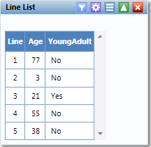
Figure 7.28: Conditional Assignment Line List
Note: The Else clause at the end of the IF statement is important to specify what should happen if the conditions are not met. Without the Else clause, YoungAdult would be null or missing for any values falling outside the 17 to 30 range. For information regarding the Analysis Gadget, refer to the Displaying Statistics and Records section.

Formatted Value
The format and name of an existing variable may be changed with the Formatted Value option. This is currently only useful with dates as demonstrated by the example below.
- Select the Sample.PRJ Data Source.
- From the Data Source Explorer menu, select Surveillance. Click OK.
- On the left-hand side of the Visual Dashboard canvas, move the mouse cursor over the Defined Variables gadget. The gadget expands and becomes fully visible.
- Click the New Variable button.
- Select With Formatted Value. The Add Formatted Value dialog box appears.
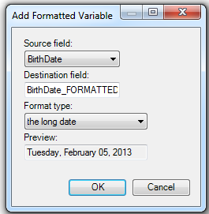
Figure 7.29: Add Formatted Variable Options
- Select BirthDate from the Source field drop-down list.
- The Destination field automatically shows the source field with a suffix of “FORMATTED”. Modify the name of the Destination field as needed.
- Select the long date from the Format type drop-down list. Using the current system date, a sample long date value appears in the Preview field. The current system date is used for the preview.
- Click OK. A description of the assignment appears in the Variable Definitions textbox.

To see the BirthDate_FORMATTED variable in line list view, right click on the canvas and then select Add Analysis Gadget > Line List. Select BirthDate_FORMATTED from List of Variables to display and then click Generate Line List.
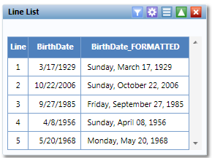
Figure 7.30: Formatted Variable Line List
The Analysis Gadget > Line List view displays the new variable created via Formatted Value. For information regarding the Analysis Gadget, refer to the Displaying Statistics and Records section.

Assigned Expression
Assigned Expression assigns the result of an expression or the field value to a variable as demonstrated in the example below. In the following example, the zip code field is a number. To use the zip code in a map, a new zip code variable must be defined and assigned text values.
- Select the Sample.PRJ Data Source.
- From the Data Source Explorer menu, select Surveillance. Click OK.
- On the left-hand side of the Visual Dashboard canvas, move the mouse cursor over the Defined Variables gadget. The gadget expands and becomes fully visible.
- Click the New Variable button.
- Select With Assigned Expression. The Add Variable with Expression dialog box appears.
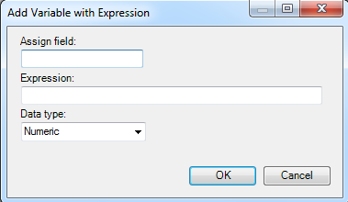
Figure 7.31: Add Variable with Expression
- In the Assign Field, enter Zip2.
- In the Expression field, type the syntax: ZipCode + ‘-0000’.
- Select Text from the Data type drop-down list.
- Click OK. The assignment appears in the Variable Definition textbox.

To see the Zip2 variable in line list view, right click on the canvas and then select Add Analysis Gadget > Line List. Select Zip2 from List of Variables to display and then click Generate Line List. For information regarding the Analysis Gadget, refer to the Displaying Statistics and Records section.
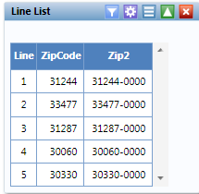
Figure 7.32: Add Variable with Expression Line List

Creating a Variable Group
The Create variable group option in Visual Dashboard allows for the temporary grouping of variables. This option is useful when there are many variables and analyzing each is impractical. Group variables can be used in the Combined Frequency and MxN/2x2 gadgets. The example below demonstrates how to create a variable group.
- Select the Sample.PRJ Data Source.
- From the Data Source Explorer menu, select Oswego. Click OK.
- On the left-hand side of the Visual Dashboard canvas, move the mouse cursor over the Defined Variables gadget. The gadget expands and becomes fully visible.
- Click the New Variable button.
- Select Create Variable Group. The Create Group dialog box appears.
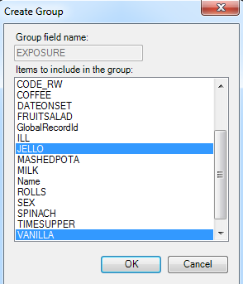
Figure 7.33: Create Group Variable Options
- In the Group field name, enter Exposure.
- Select Jello and Vanilla from the Items to include in the group list. Hold down the Ctrl key on your keyboard to select more than one variable at a time.
- Click OK.
- The variable group statement now appears in the Variable Definitions textbox.

Edit Variable
Edit Variable allows an existing variable definition to be changed. The following example will add a new variable to the Exposure group variable created above.
- On the left-hand side of the Visual Dashboard canvas, move the mouse cursor over the Defined Variables gadget. The gadget expands and becomes fully visible.
- Click the Edit Variable button.
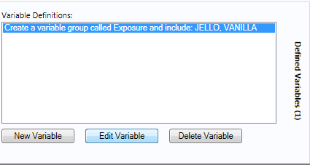
Figure 7.34: Defined Variable/Edit Variable
- The Create Group dialog box appears.
- Press and hold the Ctrl key on your keyboard and select Spinach.
- Click OK.
- The Exposure variable group now includes Spinach, which appears in the Variable Definitions text box.

Delete Variable
The Delete Variable option in the Data Recoding and Formatting Gadget removes a defined variable from the system. In the example below, the Exposure group variable will be deleted.
- On the left-hand side of the Visual Dashboard canvas, move the mouse cursor over the Defined Variables gadget. The gadget expands and becomes fully visible.
- Select the Exposure variable definition.
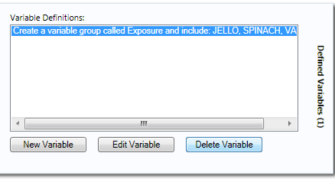
Figure 7.35: Defined Variable/Delete Variable
- Click on the Delete Variable button.
- The variable is deleted from the Variable Definitions text box.

Adding and Removing Data Filters

Add a Filter
Visual Dashboard typically opens all records in a file. The Data Filter Gadget in Visual Dashboard allows you to select a subset of data by specifying certain conditions. This is useful when trying to analyze a specific group of records. There are two modes in this gadget; guided and advanced. The Guided Mode allows you to apply conditions by selecting values from Field Name, Operator, and Value drop-down lists. Filters may be applied in the Advanced Mode by entering the filtering conditions in the free form text box. To add a filter, follow the steps below.
- Select the EColi.PRJ Data Source.
- From the Data Source Explorer menu, click FoodHistory.
- Click OK.
- From the right-hand side of the Visual Dashboard canvas, move the mouse over the Data Filter gadget. The gadget expands outwards.
- From the Field Name drop-down list, select Ill.
- From the Operator drop-down list, select is equal to.
- From the Value drop-down list, select Yes.
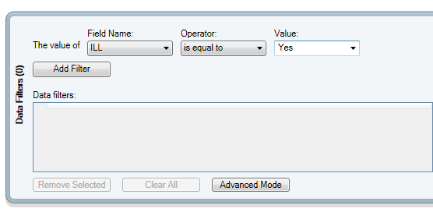
Figure 7.36: Data Filter Gadget/Add Filter
- Click the Add Filter button. The filter condition is added to the Data filters grid view.
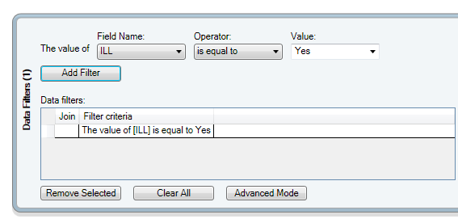
Figure 7.37: Data Filter Gadget/Add Filter with Condition
If a filter condition is added or removed, all gadgets on the canvas will automatically refresh. The record count at the top now reads 276, indicating that there are 276 out of 359 records where the value of ILL is Yes.
Follow the steps below to add an additional filter:
- On the right-hand side of the Visual Dashboard canvas, move the mouse over the Data Filter gadget. The gadget expands outwards.
- From the Field Name drop-down list, select Age.
- From the Operator drop-down list, select is between.
- From the Value text boxes, type 20 for the first box.
- From the Value text boxes, type 29 for the second box.
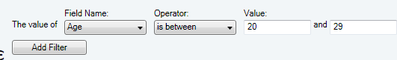
Figure 7.38: Data Filter Gadget/Add Filter/Specify Condition
- Click Add Filter. A context menu appears asking if you want to add this condition using an AND or an OR.
- Select the AND option. The filter condition is added to the Data filters grid view beneath the first condition.
The record count shows 64 records. Only 64 records match the two established filter criterion. The patient must have been ill and be between 20 and 29 years of age. All gadgets added to the Visual Dashboard canvas will only display data from these 64 records. The filter settings appear at the top of the canvas.
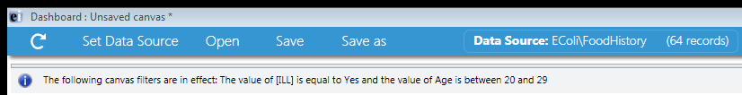
Figure 7.39: Data Filter Setting

Remove Selected Filter
The data filters must be cleared to continue working with the full dataset. Follow the steps below to remove a filter.
- On the right-hand side of the Visual Dashboard canvas, move the mouse over the Data Filter gadget. The gadget expands outwards.
- Select the second condition, which should appear as “The value of Age is between 20 and 29.”
- Click the Remove Selected button. The condition disappears.
- Select the only remaining condition.
- Click the Remove Selected button. The condition disappears.

Clear All Filters
The Clear All button removes all existing filters at once as demonstrated in the example below.
- On the right-hand side of the Visual Dashboard canvas, move the mouse over the Data Filter gadget. The gadget expands outwards.
- Click the Clear All button. All existing filter conditions disappear.
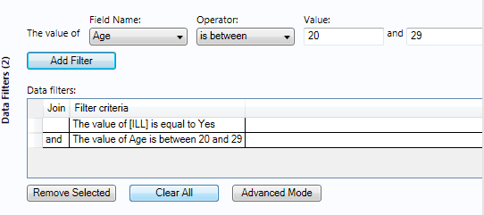
Figure 7.40: Data Filter Gadget/Add Filter with Two Conditions

Advanced Filter Mode
The advanced filter mode allows you to type the desired data filter string into the text box provided. Once the filter is applied, the canvas will only display the records that meet the specified condition(s). The Data Filtering Gadget is located on the right-hand side of the Visual Dashboard canvas. The gadget expands outwards.
Note: Advanced Filtering uses the .NET DataView.RowFilter syntax. For more information about this syntax, refer to Microsoft’s website describing the DataView.RowFilter Property.
The example below demonstrates how to use advanced filters. Select Advanced Mode. The Advanced Filter Mode appears.
- In the text box, enter the following condition “(([ILL] = 1) and (Age >= 20 and Age <= 29)) AND RECSTATUS > 0”.
- Click the Apply Filter button.
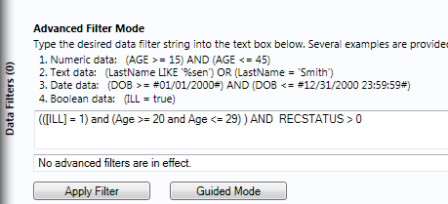
Figure 7.41: Advanced Filter Mode
- The verbiage “No advanced filters are in effect” will be replaced with “The filter is valid and is now in effect.” When filters are applied, the conditions appear in green font.
- The record count in the top-left corner of the Visual Dashboard canvas now reads 64, indicating that there are 64 out of 359 records where the value of ILL is Yes and the value for age is between 20 and 29.

Note: You can toggle between the Guided Mode and the Advanced Mode by clicking on the respective button on each screen.

Displaying Statistics and Records

Analysis Gadget > Line List
The Line List option creates a list of the current dataset. This allows you to view the details of the data in your current data source. You can select variables to display and then sort or group those variables accordingly. Line List supports adding groups or pages. All fields in a group or on a page will be displayed in such cases. Groups and pages always appear at the bottom of the list.
- Select the EColi.PRJ Data Source. Open the FoodHistory form from the Data Source Explorer menu.
- Right click on the canvas and select Add Analysis Gadget > Line list.
- The Line List gadget appears on the Visual Dashboard canvas.
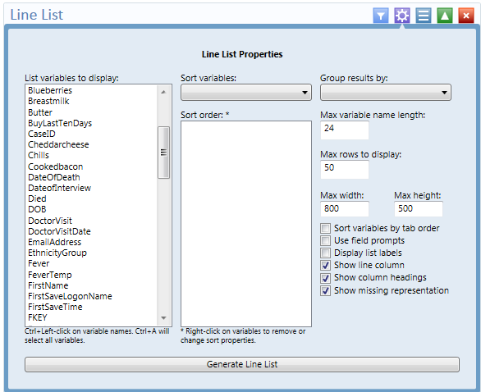
Figure 7.42: Line List Properties
- To select multiple variables from List variables to display, hold down the Ctrl key and click on the variables to display. The Ctrl + A combination selects all variables at once.
- Click the Generate Line List button. The line list appears on the canvas.
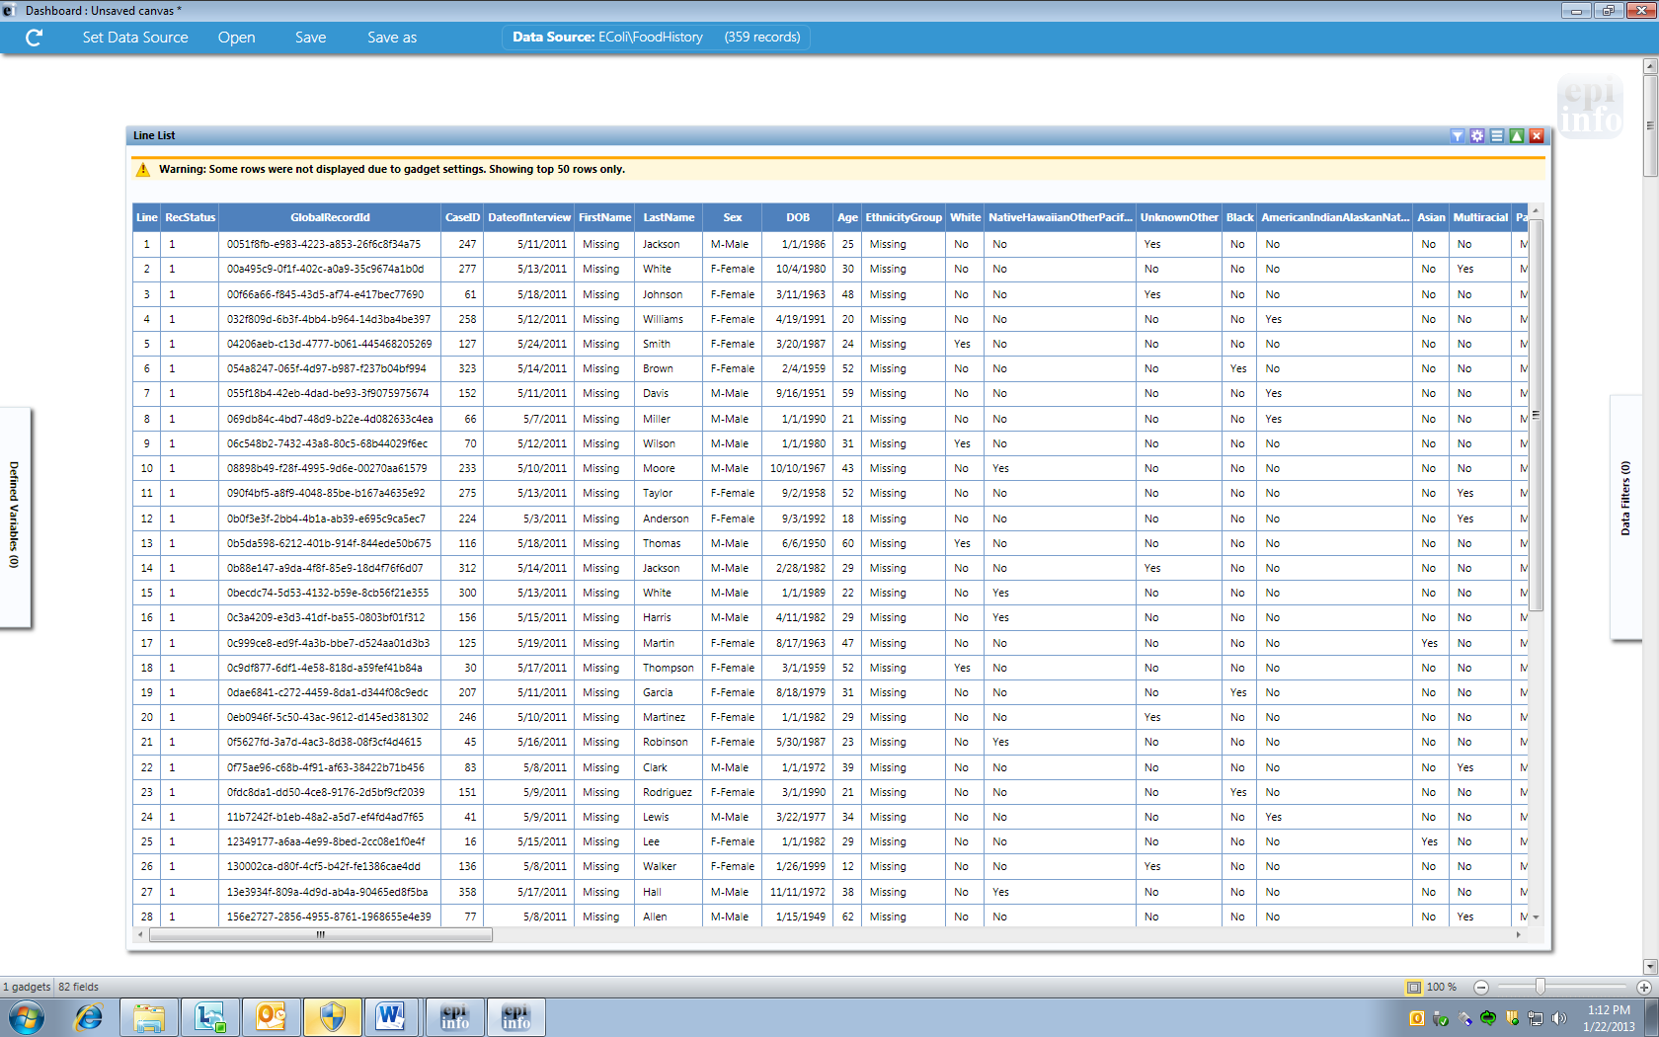
Figure 7.43: Generate Line List
Note: There is a yellow warning at the top of the output. By default, the line list will only show the top 50 rows. The row limit exists to improve performance when working with large datasets. The Max Rows to Display setting can be modified in the Line List Properties panel.

Sorting Records
Sometimes it is important to have the records in a file arranged in a particular order, for example alphabetically by name, or numerically by age. There are two ways to sort the records; by clicking on the column name in the line list or by using the sort options in the line list properties dialog box.

Sorting a List Using by Column Name
Follow the steps below to sort the list by Age.
- Select the EColi.PRJ Data Source. Open the FoodHistory form from the Data Source Explorer menu.
- Right click on the canvas and select Add Analysis Gadget > Line list.
- Select all variables from List Variables to Display box by pressing Ctrl + A on your keyboard.
- Click Generate Line List.
- The Line List gadget appears on the Visual Dashboard canvas.
- Click on the Age column heading.
- The records are displayed by Age in ascending order.
Sorting a List Using Line List Properties
- Select the EColi.PRJ Data Source. Open the FoodHistory form from the Data Source Explorer menu.
- Right click on the canvas and select Add Analysis Gadget > Line list.
- The Line List gadget appears on the Visual Dashboard canvas.
- Select all variables from List Variables to Display box by pressing Ctrl + A on your keyboard.
- The list data is not sorted in any particular order. To sort variables, select the variable from the Sort variables drop-down list. The selected variable will appear in the Sort Order box.

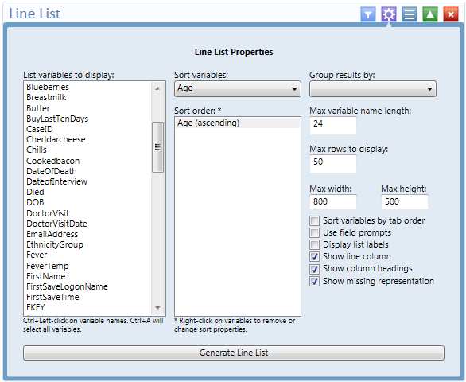
Figure 7.44: Line List/ Sort Order
- Right click on the variable in the Sort Order box to remove the sort variable or to change the sort order from ascending to descending.
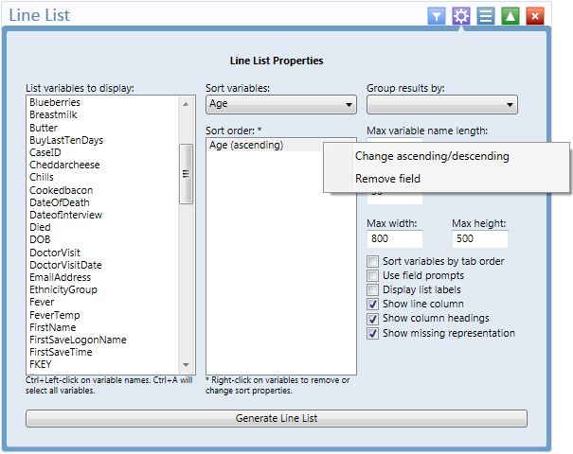
Figure 7.45: Line List/Sort Order options
- Select a variable from the Group results by drop-down list to group the list by a particular field.
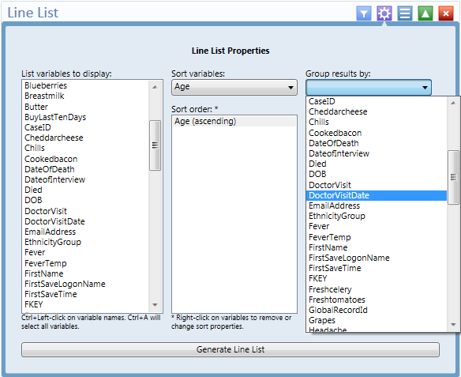
Figure 7.46: Line List/Group results options
- Click the Generate Line List button. A separate line list, grouped by DoctorVisitDate, is generated and displayed. The records in each list are ordered by Age.
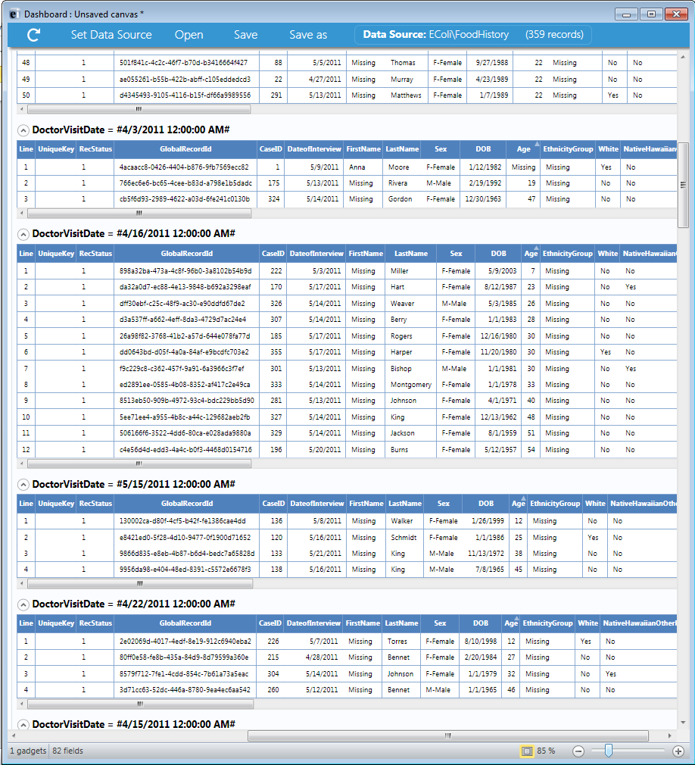
Figure 7.47: Line List with Group results
- A list may be hidden from view by clicking on the arrow to the left of the list heading.
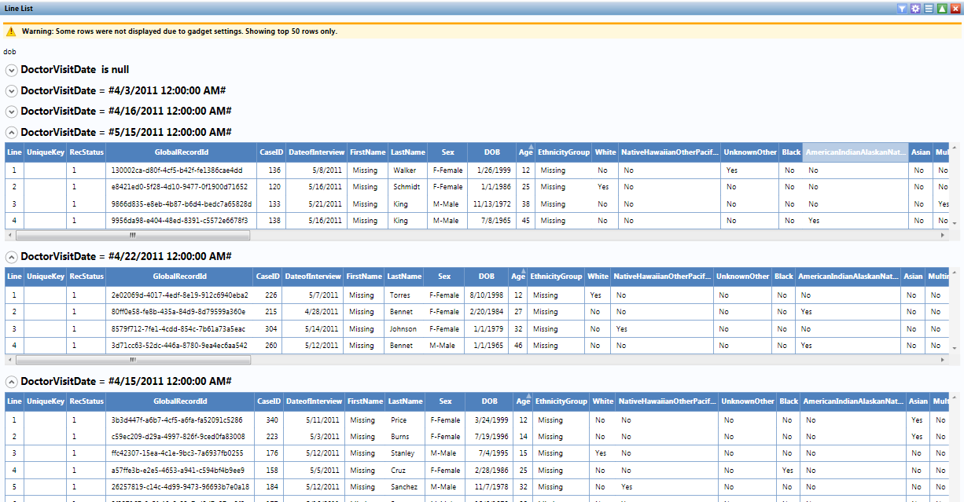
Figure 7.48: Line List Hidden View

Remove Sort Criteria
Remove sort criteria by following the steps below.
- Right click on the Line List.
- Select Remove All Sort Criteria.
- The Line List will appear with the sort criteria removed.

Other Line List Properties
Figure 7.49: Other Line List properties
- The Max Variable Name Length text box allows truncating long column names in the list output. It is set to 24 by default.
- The Max Rows to Display text box allows changing the maximum number of rows that the line list gadget will display. It is set to 50 by default. A maximum of 2000 rows may be displayed at any given time.
- The Sort Variables by Tab Order checkbox forces the columns in the output to be sorted by their tab order.* It is not checked by default.
- The Use Field Prompts checkbox will use the field’s prompt as the column heading, rather than the field’s name.* It is not checked by default.
- The Display List Labels checkbox will use the label value for option fields and comment legal fields rather than the underlying value stored in the database.*
* Note: These features are available only when the Data Source is an Epi Info 7 project. If the Data Source is not an Epi Info 7 project, such as an Excel spreadsheet, these options have no effect.
- The Show Line Column option adds the Line column to the list and displays the line number when the checkbox is selected.
- The Show Column Headings option displays the line list column headings when the checkbox is selected.
- The Show Missing Representation option displays the word or symbol that represents a missing value for any field that does not have a value. By default, the word “Missing” is used, but other options include “Unknown”, “(.)” or another custom setting as specified in the Tools > Options > Analysis tab. If the checkbox is not selected, a field without a value will be left blank.

Exporting a Line List
Once the Line List is created, the following export options are available: Copy List Data to Clipboard, Send List Data to Web Browser, and Send List Data to Excel.
Follow the steps below to Copy List Data to Clipboard.
- Right click on the Line List.
- Select Copy List Data to Clipboard.
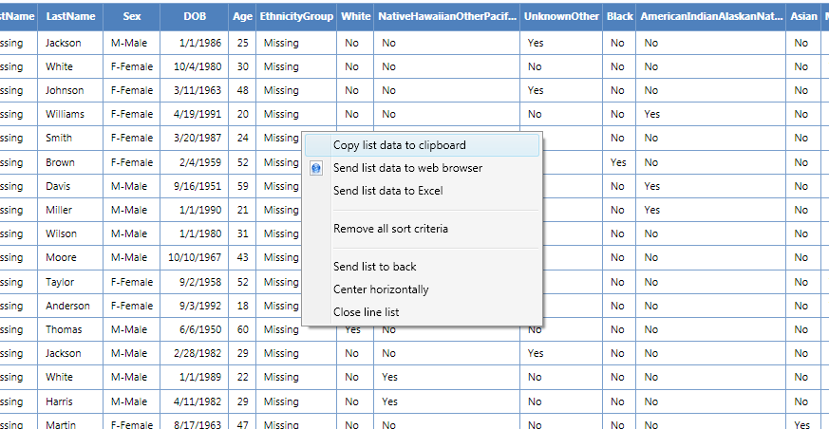
Figure 7.50: Copy List to Clipboard
- The data is now on the clipboard and may be exported.
Follow the steps below to Send List Data to Web Browser.
- Right click on the Line List.
- Select Send List Data to Web Browser.
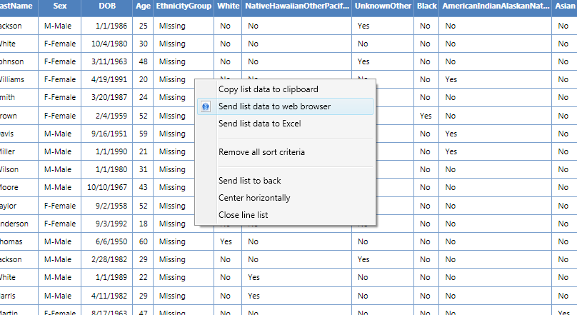
Figure 7.51: Send List Data to Web Browser
- The data now appears in your web browser.
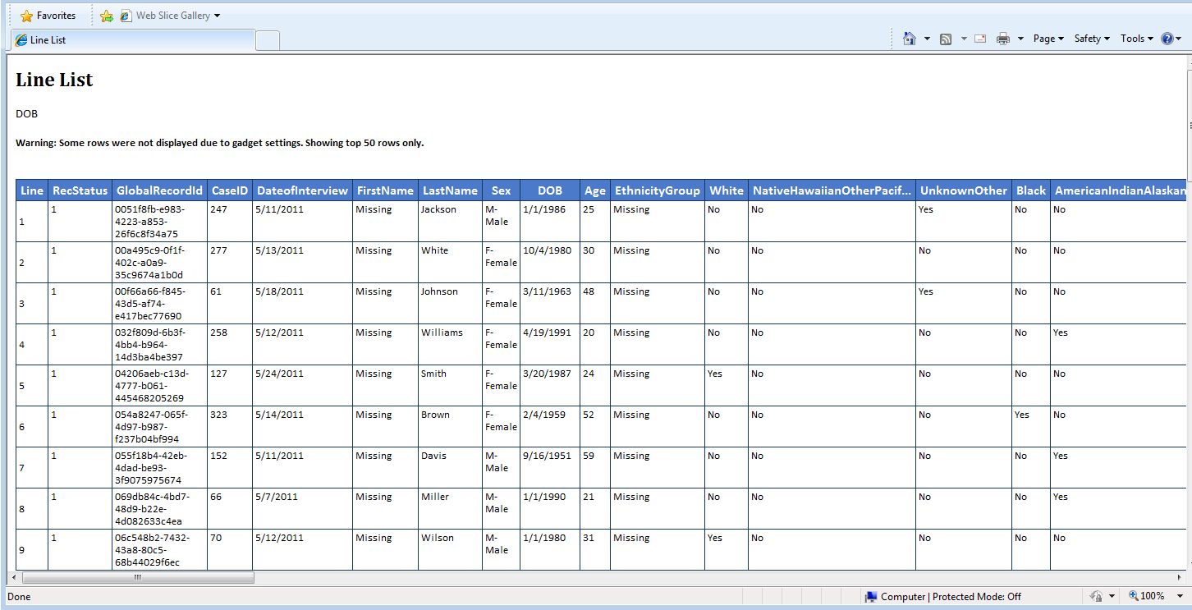
Figure 7.52: List Data in Web Browser
Follow the steps below to Send List Data to Excel.
- Right click on the Line List.
- Select Send List Data to Excel.
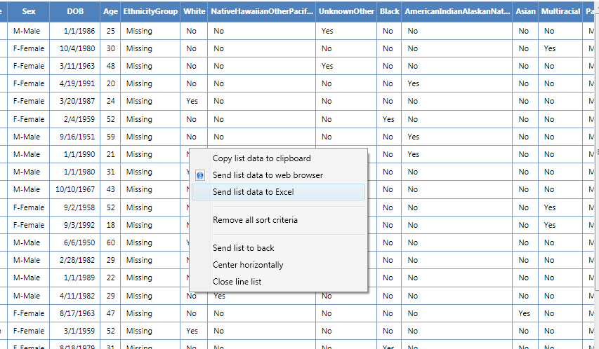
Figure 7.53: Send List Data to Excel
- The list data appears in a Microsoft Excel spreadsheet.
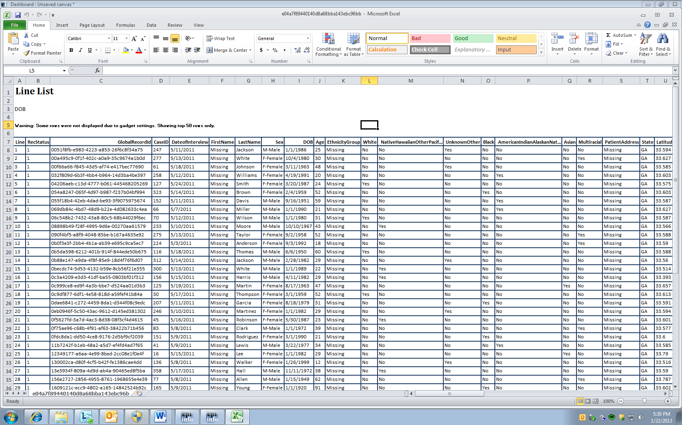
Figure 7.54: List Data in Excel
Note: You must have Microsoft Excel installed to use this feature.

Analysis Gadget > Frequency
The Frequency gadget counts each occurrence in a category for a specified variable and gives the absolute and relative frequencies for each category. This option then produces a frequency table that shows how many records have a value for each variable, the percentage of the total, a cumulative percentage and upper and lower confidence intervals.
- Select the EColi.PRJ Data Source. Open the FoodHistory form from the Data Source Explorer menu.
- Right click on the canvas and select Add Analysis Gadget > Frequency. The frequency gadget appears on the Visual Dashboard canvas.
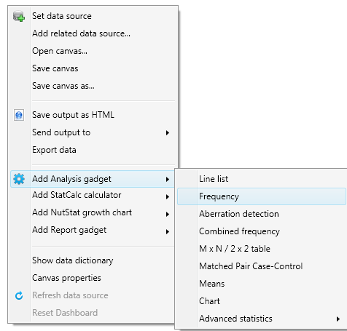
Figure 7.55: Frequency Menu Option
- From the Frequency Of drop-down list, select a variable from the data table.
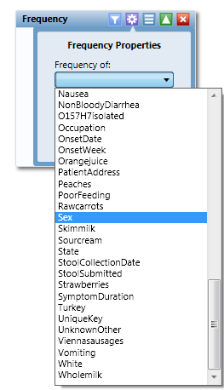
Figure 7.56: Selecting Frequency Of variable
- Click Run. The results appear on the Visual Dashboard canvas.
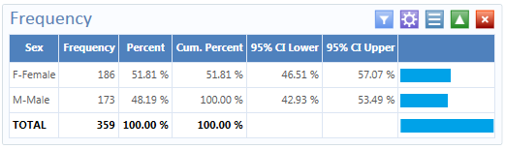
Figure 7.57: Frequency Results
The Frequency column provides the count of individuals that are either female or male. The Percent column indicates the percentage of female or male. The 95% Confidence Limits are a range of values that indicates the likely location of the true value of a measure, meaning (in this instance) that the percentage of females is likely to be between 46.51% and 57.07%.

Frequency Advanced Options
To use the Frequency Advanced options:
- Select the EColi.PRJ Data Source. Open the FoodHistory form from the Data Source Explorer menu.
- Right click on the canvas and select Add Analysis Gadget > Frequency. The frequency gadget appears on the Visual Dashboard canvas.
- Click on the Advanced options arrow. The Frequency Properties dialog box appears.
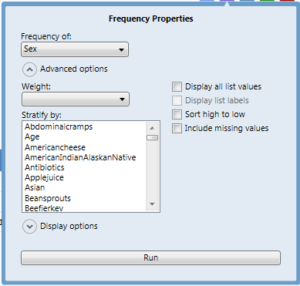
Figure 7.58: Frequency Properties
The following options are available in Frequency Properties:
- Weight- The field to use as the weight variable, for example if aggregate data is being analyzed.
- Stratify By- The field to use for stratifying the output.
- Display all list values- Only applicable when the frequency variable is a drop-down list field in an Epi Info™ 7 project. When selected, the output will show all of the drop-down list values even if they have a count of zero.
- Display list labels – Only applicable when the frequency variable is a Comment Legal field or Option Field in an Epi Info™ 7 project. When selected, the output will show the value and the label for Comment Legal fields and the label for Option fields.
- Sort high to low – displays the results sorted from high to low based on the selected Frequency of variable
- Include Missing Values – This option, which is unchecked by default, displays ‘Missing’ for any field with missing values.

- From the Frequency of drop-down list, select Age from the data table.
- From the Weight drop-down list, select Died from the data table.
- Select Hospitalized from the Stratify by list.
- Click OK. Results appear on the canvas.
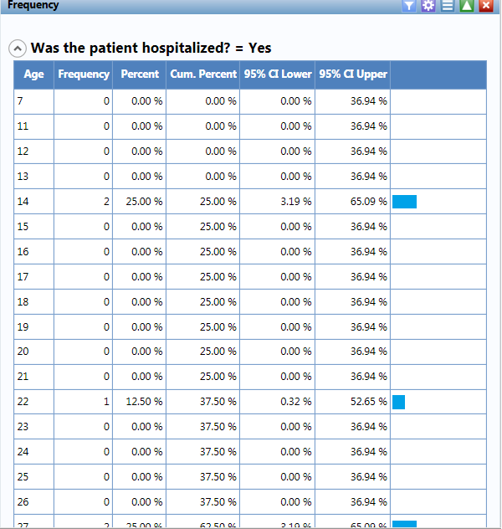
Figure 7.59: Frequency Line List Stratified View #1
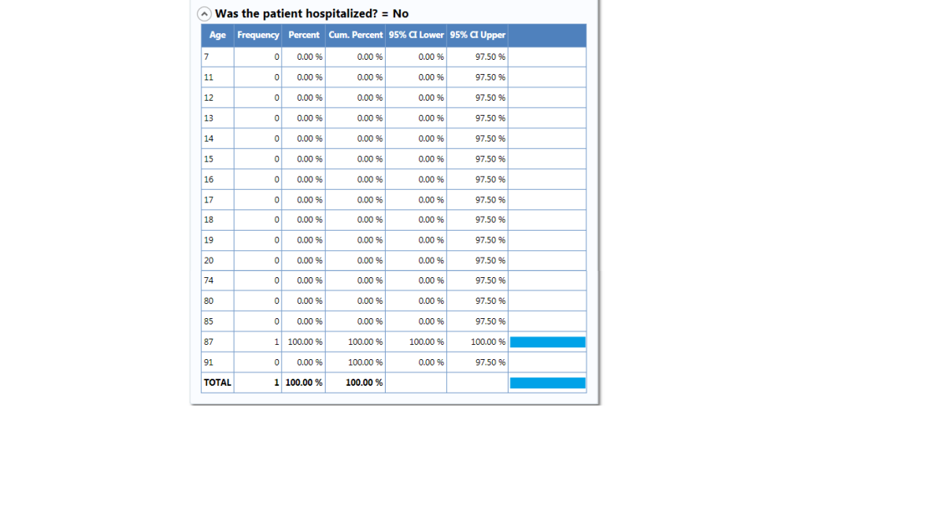
Figure 7.60: Frequency Line List Stratified View #2
The results display the frequency of deceased patients by age and are stratified by whether the patient was hospitalized or not. The age, frequency, percent, cumulative percent and upper and lower 95% confidence intervals are displayed. The last column is the percent bar.

You can also click on the Display options arrow and expand the Frequency Properties. The following options are available in Frequency Properties:
- Use field prompt – specifies whether to use field prompts and is checked by default
- Draw borders – Setting for drawing the frequency’s border.
- Draw header row – Setting for displaying the frequency’s headers.
- Draw total row – Setting for displaying the frequency’s totals.
- Decimals to Display – specifies the number of decimals that will be displayed in the results. The possible values range from zero to four. This is set to two by default.
- Maximum rows to display – Specifies number of rows to display.
- Max width of percent bar – Width for percent bar column using a % value.

Analysis Gadget > Aberration Detection
The Aberration Detection Analysis gadget can be used with syndromic or national surveillance data. It is designed to monitor changes in the distribution or frequency of health events when compared to historical data. This gadget uses an algorithm implemented by the Early Aberration Reporting System, which is a tool developed by CDC’s Division of Bioterrorism Preparedness and Response to assist local-level health offices with early detection of bioterrorism events or possible outbreaks.

- Select the Ears.xls Data Source from the Sample project folder. Click on Sheet 1$.
- Right click on the canvas and select Add Analysis Gadget > Aberration Detection. The Aberration Detection Properties dialog box appears.
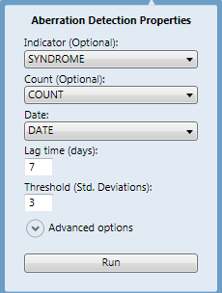
Figure 7.61: Aberration Detection Properties
- Select Syndrome from the Indicator drop-down list.
- Select Count from the Count (Optional) drop-down list.
- Select Date from the Date drop-down list.
- Enter 7 for Lag Time (days).
- Enter 3 for Threshold (Std. Deviations).
- Click the Run button. The Aberration Detection line graph displays on the canvas.
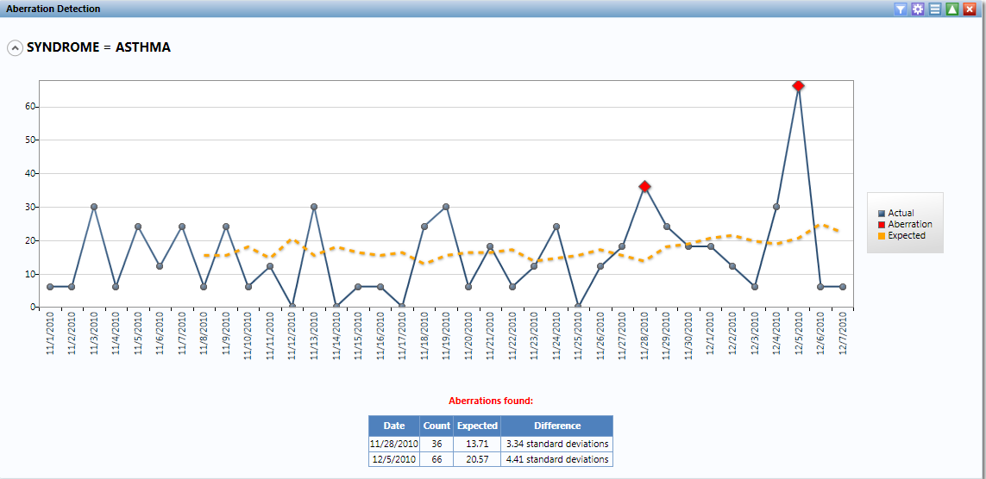
Figure 7.62: Aberration Detection Line Graph
The result displays the aberrations found, date, count, expected count, and the standard deviations. The current number of patient visits with Asthma is higher (Count: 36, 66) than the defined threshold (Expected; 13.71, 20.57), hence the aberrations detected on 11/28/2010 and 12/05/2010. These aberrations may need to be evaluated by an epidemiologist (or other public health professional) to determine whether it signifies an event of public health importance warranting further investigation.

Analysis Gadget > Combined Frequency
The Combined Frequency option produces a table that illustrates the frequency and percentage of grouped variables.
- Select the EColi.PRJ Data Source. Open the FoodHistory form from the Data Source Explorer menu.
- Right click on the canvas and select Add Analysis Gadget > Combined Frequency. The combined frequency gadget appears on the Visual Dashboard canvas.

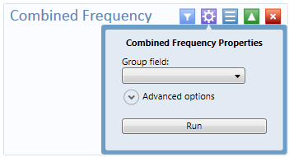
Figure 7.63: Combined Frequency Properties
- From the Group field drop-down list, select a DemographicInformation.
- Click Run. The results appear on the Visual Dashboard canvas.
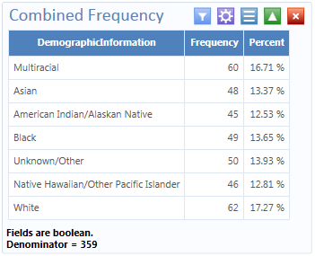
Figure 7.64: Combined Frequency Results

Combined Frequency Advanced Options
To use the Combined Frequency Advanced options:
- Select the EColi.PRJ Data Source. Open the FoodHistory form from the Data Source Explorer menu.
- Right click on the canvas and select Add Analysis Gadget > Combined Frequency. The combined frequency gadget appears on the Visual Dashboard canvas.
- Click on the arrow to display Advanced Options.
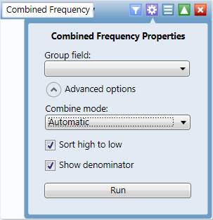
Figure 7.65: Combined Frequency Properties Combine Mode
- From the Group Field drop-down list, select DemographicInformation.
- Select Automatic from the Combine Mode drop-down list.
  - Automatic- will automatically determine the appropriate combination mode of either Boolean or Categorical.
  - Boolean- use this mode for Yes/No and Checkbox fields or if you wish for the fields in the group to be treated as such.
  - Categorical- use this mode if your data is grouped according to similar characteristics in a way that shows the relative frequencies of each group or category.
  - Value to treat as true – This field appears when the Combine Mode is Boolean. The specified value will be treated as the true or positive value and all other values will be treated as false or negative values.
- Mark your selection for Sort High to Low. This option will display the results sorted from highest group field frequency to the lowest. The Sort High to Low checkbox is checked by default.
- Mark your selection for Show Denominator. This option will display the total number of records in the results. The Show Denominator checkbox is checked by default.
- Click Run. The Combined Frequency results appear on the Visual Dashboard canvas.
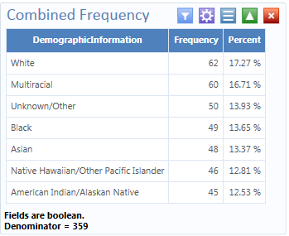
Figure 7.66: Combined Frequency Results
The result displays the frequency and percentage of each demographic category.

Analysis Gadget > M x N/ 2 x 2 Table
In epidemiology, 2 x 2 tables are frequently used to examine the relationship between two or more categorical values. In these tables, usually an exposure variable is considered the risk factor. The outcome variable is considered the disease of consequence (e.g., the person had the disease or outcome of interest or they did not). Values of the first variable will appear on the left margin of the table, and those of the second will be across the top of the table. Normally, cells contain counts of records matching the values in corresponding marginal labels. The M x N /2 x 2 Table analysis gadget in Visual Dashboard is demonstrated below:
- Select the Sample.PRJ Data Source. Open the Oswego form from the Data Source Explorer menu. Click OK.
- Right click on the canvas and select Add Analysis Gadget > M x N /2 x 2 table. The Crosstabulation Properties dialog box appears on the Visual Dashboard canvas.
- From the Exposure drop-down list, select Vanilla.
- From the Outcome drop-down list, select ILL.

Advanced Options allow you to; add a weight variable, select Stratify by variable and alter display settings. Advanced Options are not used in this example.

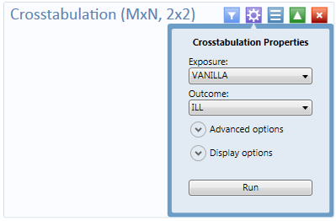
Figure 7.67: Crosstabulation Properties
- Click Run. Results appear on the Visual Dashboard canvas.

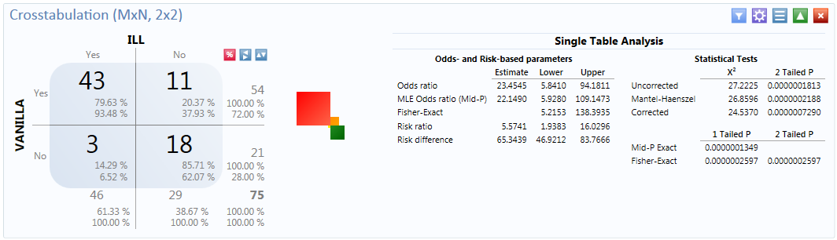
Figure 7.68: Crosstabulation Results
The results display a 2 x 2 table and a single table analysis of all records cross-tabulated by exposure to vanilla where the outcome was ill. Out of the 75 records in this dataset, 43 patients were exposed to vanilla and became ill. Eleven patients were exposed to vanilla and did not become ill. Of the 21 patients that were not exposed to vanilla, only three became ill.
The Single Table Analysis chart on the right displays Odds Ratios, Risk Ratios, and Statistical Tests results for this example.

Analysis Gadget > Matched Pair-Case Control
The Matched Pair Case Control option in Visual Dashboard is for use with pair-matched case-control studies. Each case must have exactly one matched control. For this reason, it is generally incorrect to perform the analysis using 2x2 tables since it does not take matching into consideration. To use this option, you need to specify an Exposure Variable, the Outcome Variable (i.e., case vs. control), and a Match variable that links each case to its control. The following example demonstrates a matched pair-case control analysis.

The dataset below is from a matched case-control study of the consumption of chicken where the outcome resulted in the patient becoming ill. The primary exposure was the consumption of chicken (AnyChkn), the case control is CaCO, and the Pair Group ID is Matched pairs.
- Select the Case Control DatabaseExample.xlsx Data Source.
- Select Section_1_3 & 8 form in the Data Source Explorer menu.
- Click Ok.
- Select Add Analysis Gadget > Matched Pair-Case Control.
- The Matched Pair Case Control Properties dialog box appears.
- From the Exposure drop-down list, select AnyChkn_RECODED.
- From the Case/Control drop-down list, select CaCo.
- From the Pair Group ID drop-down list, select Matched pairs.
- Click on Define Value Mappings
- Click on 1
- Click on the > button on the Yes values: section
- Click on 0
- Click on the > button on the No values: section
- Click Ok.
- Click Run

The Matched Pair Case-Control results appear on the canvas.

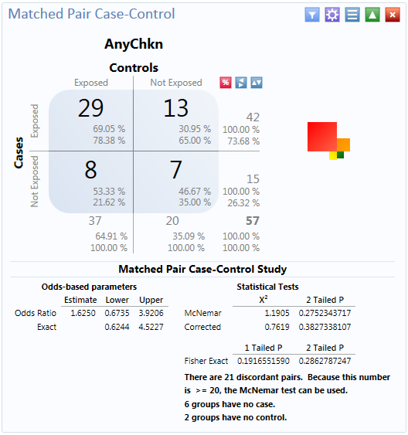
Figure 7.69: Matched Pair Case-Control results
The results display that out of 57 matched pairs, 29 had both the case and the control exposed to AnyChkn, 13 had the case but not the control exposed, eight pairs had the control exposed but the case unexposed, and seven had neither the case nor the control exposed.

The Odds-Ratio is greater than 1, which suggests that eating chicken may be more likely to result in being ill. However, the confidence intervals contain 1 and the P values are less than 0.05, which indicate that there is no significant association between eating chicken and becoming ill.

Analysis Gadget > Means
The Means gadget calculates the average for a continuous numeric variable. A Yes/No field returns numeric values (Yes=1, No=0) which allows the Means gadget to calculate the proportion of respondents answering yes. For this situation, Analysis Gadget > Frequency, has two formats:
- If only one variable is selected, the program produces a table similar to one produced by the Frequency option with descriptive statistics.
- If two variables are selected, the first variable contains the data to be analyzed. The second indicates how groups will be distinguished. The output of this format is a table similar to one produced by the M x N/ 2 x 2 table with descriptive statistics.
- Select the Sample.PRJ Data Source. Open the Oswego form from the Data Source Explorer menu.
- Click OK.
- Right click on the canvas and select Add Analysis Gadget > Means. The Means Properties dialog box appears on the Visual Dashboard canvas.
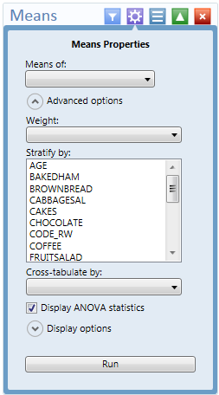
Figure 7.70: Means Properties
- From the Means Of drop-down list, select Age.
- Click the arrow to display Advanced Options.
- The Cross-tabulate by value of drop-down list contains a variable to help determine if the means of a group are equal.
- The Stratify by drop-down list contains a variable to act as a grouping variable.
- The Weight drop-down list contains a variable for weighted analysis.
- The Output columns to display option specifies the columns to include in this analysis.
- The Decimals to Display specifies the number of decimals that will be displayed in the results. The possible values range from zero to four. This is set to two by default.
- The Display ANOVA statistics checkbox specifies whether to display the analysis of variance statistics. This option is selected by default. If with large data sets, the ANOVA statistics are not required, performance may be improved by turning off (un-checking) this feature.
- Click Run. The results are displayed on the canvas.
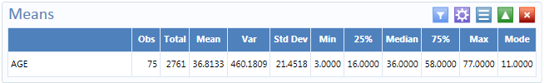
Figure 7.71: Means Table
The Mean age of individuals in the dataset is 36.8.

Analysis Gadget > Chart
Visual Dashboard produces histograms, scatter plots, pie charts, bar and line graphs directly from data files. This option produces charts based on the types of data available in the project. The following are the graph types capable of being generated by the Chart option:
- Epi Curve charts use vertical bars to represent the count or weight for each value of the main variable. Each series creates an additional vertical bar at each point. The main variable must be either numeric or date/time. This graph differs from the bar graph because adjacent bars represent equal ranges of the main variable.
- Scatter charts display variables along an X-Y axis as a scatter plot. The X variable is the independent variable and Y variable is the dependent variable. Each series is represented by a different point style.
- Stacked Column is similar to a bar chart but represents the counts or weights of two variables.
- Bar charts use horizontal bars to represent the count or weight of each value of the main variable(s). Each series creates an additional horizontal bar at each point.
- Column charts use vertical bars to represent the count or weight for each value of the main variable(s). Each series results in an additional vertical bar at each point; the bars are distinguished by their style.
- Line charts connect X and Y data points with straight lines. Each series is represented by a different style of line and both variables must be numeric.
- Pie charts use a circle to represent each series and each value of the main variable has a slice of the circle proportional to the value associated with it.
- Pareto charts use vertical bars to represent the count or weight for each value of the main variable(s) and a dashed line to represent the accumulated percentage. Each series results in an additional vertical bar at each point; the bars are distinguished by their style.
The examples below demonstrate how to create a column chart, a pie chart, an Epi Curve chart, and a Pareto chart.

Generate a Column Chart
Follow the steps below to create a bar graph using data from the Sample.PRJ project.
- Open the Sample.PRJ project and select the Oswego form.
- Right click on the canvas and select Add Analysis Gadget > Charts>Column chart. The Chart Properties dialog box appears on the Visual Dashboard canvas.
- From the Main variable drop-down list, select the variable Age to use for the independent variable.
- Leave the Weight, Stratify By, Chart size, and Show grid Lines options at the default settings.
- Click Run. The graph appears on the canvas displaying the number of patients by age.
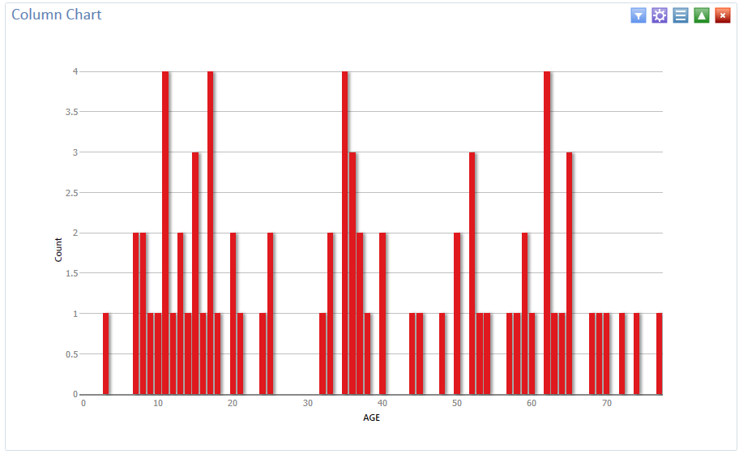
Figure 7.72: Column Chart

Generate a Pie Chart
Follow the steps below to create a pie chart showing age categories of church supper attendees.
- Open the Sample.PRJ project and select the Oswego form. Recode the Age variable using the Defined Variables gadget.
- On the left-hand side of the Visual Dashboard canvas, move the mouse cursor over the Defined Variables gadget. The gadget expands and becomes fully visible.
- Click the New Variable button.
- Select With Recoded Value. The Add Recoded Variable dialog box appears.
- From the Source field drop-down list, select Age.
- Click the Fill Ranges button. The Fill Ranges dialog box appears.
- Enter 0 for Start value, 70 for End value, and 10 for By.
- Click OK. The Add Recoded Variable window appears with the From, To, and Representation columns populated.
- Click OK. The variables are recoded.
- Right click on the canvas and select Add Analysis Gadget > Charts>Pie chart. The Chart Properties dialog box appears on the Visual Dashboard canvas.
- From the Main variable drop-down list, select the variable AGE_RECODED.
- Leave the Weight, Chart Size, Show grid lines options at the default settings.
- Click Run. The graph appears on the canvas.
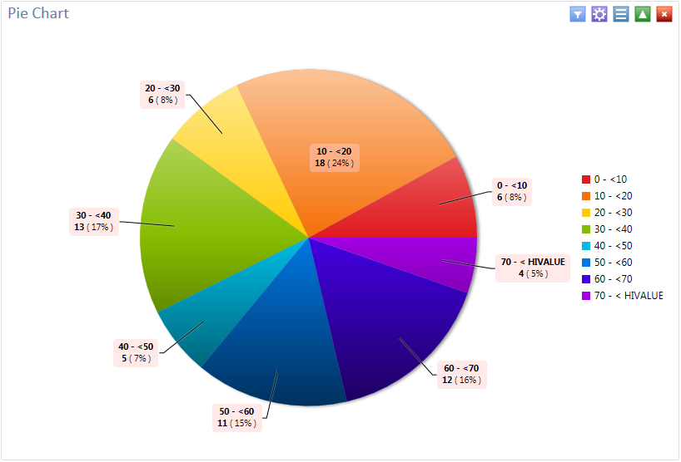
Figure 7.73: Pie Chart
The chart shows the age categories of church supper attendees by age group.

Generate an Epi Curve
Follow the steps below to create an Epi Curve showing the incubation time for an unknown pathogen.
- Open the Ecoli.PRJ project and select the FoodHistory form.
- Right click on the canvas and select Add Analysis Gadget > Chart>Epi curve chart. The Chart Properties dialog box appears on the Visual Dashboard canvas.
- From the Main variable drop-down list, select OnsetDate.
- Click on the Configuration panel icon.
- Click the arrow to expand the Display options.
- Update the X-axis angle: setting to -90. The date values should now be displayed on the x-axis. If your computer screen is too small, you might need to change the width setting of the chart to a higher number until the values are displayed.
- Change the width setting to 1000
- Click on the Show Legend box
- Click on the arrow to expand the Advanced options.
- Click on the Sex variable in the Stratify by: section.
- Click on the Run button. The Epi Curve chart appears on the canvas.
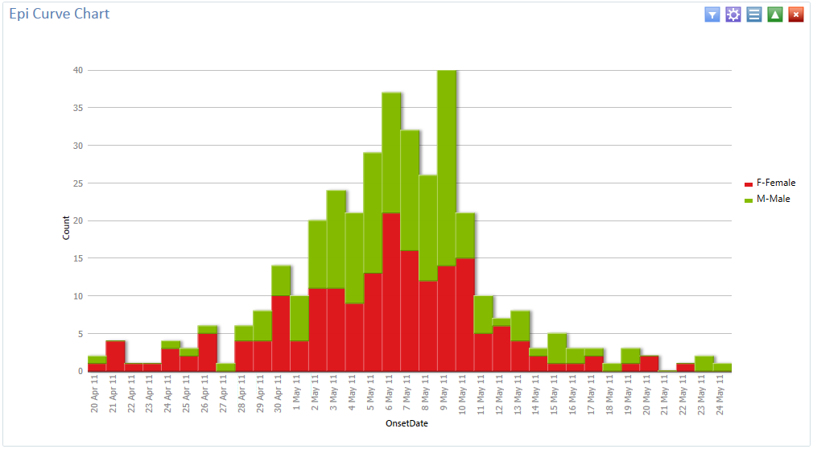
Figure 7.74: Epi Curve Chart

Generate a Pareto Chart
Follow the steps below to create an Epi Curve showing the incubation time for an unknown pathogen.
- Open the Ecoli.PRJ project and select the FoodHistory form.
- Recode the Age variable using the Defined Variables gadget.
- On the left-hand side of the Visual Dashboard canvas, move the mouse cursor over the Defined Variables gadget. The gadget expands and becomes fully visible.
- Click the New Variable button.
- Select With Recoded Value. The Add Recoded Variable dialog box appears.
- From the Source field drop-down list, select Age.
- Click the Fill Ranges button. The Fill Ranges dialog box appears.
- Enter 0 for Start value, 70 for End value, and 2 for By.
- Click OK. The Add Recoded Variable window appears with the From, To, and Representation columns populated.
- Click OK.
- Right click on the canvas and select Add Analysis Gadget > Charts>Pareto chart. The Chart Properties dialog box appears on the Visual Dashboard canvas.
- From the Chart Type drop-down list, select Pareto.
- From the Main variable drop-down list, select the Age_Recoded.
- Click on the Run button. The Pareto chart appears on the canvas.
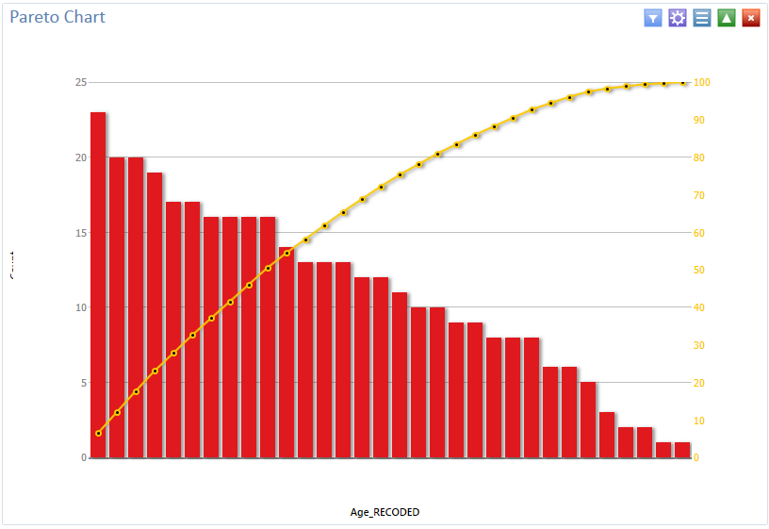
Figure 7.75: Pareto Chart

Using Advanced Statistics

Linear Regression
Linear regression is an analysis tool that identifies a relationship between a continuous variable and one or more independent variables. It can be used for simple linear regression (only one independent variable), for multiple linear regression (more than one independent variable), and for quantifying the relationship between two continuous variables (correlation). Linear regression is used when you want to determine the relationship between one dependent variable with one or more independent variables.
In the example below, linear regression is used to determine if systolic blood pressure can be predicted by an infant’s birth weight and age. The dependent variable is systolic blood pressure, and the independent variables are birth weight in ounces and age in days.

- Select the Sample.prj project. Open the BabyBloodPressure form from the Data Source Explorer menu.
- Click OK.
- Right click on the canvas and select Add Analysis Gadget > Advanced Statistics > Linear Regression. The Regression Properties dialog box appears on the Visual Dashboard canvas.
- From the Outcome Variable drop-down list, select SystolicBlood.
- From the Fields drop-down list, select AgeInDays and Birthweight.
- Click Run. Results appear in the Visual Dashboard canvas.
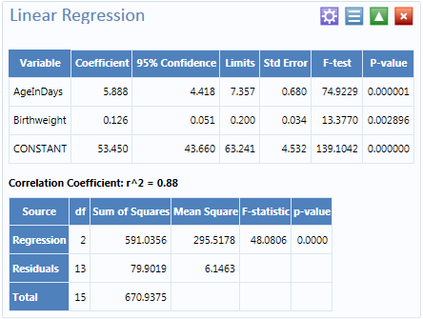
Figure 7.76: Linear Regression Results
Both independent variables’ coefficients are positive and the F-statistic associated with each independent variable is highly significant (p-value < 0.01), suggesting that each variable is a predictor of higher systolic blood pressure.

Linear Regression Properties
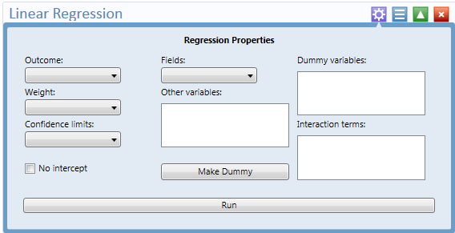
Figure 7.77: Linear Regression Properties
- The Outcome is the dependent variable for the regression. The outcome variable must be numeric or a Yes/No field.
- A Weight variable may be selected to use in weighted analyses.
- The Confidence Limits specifies the probability level at which confidence limits are computed.
- If No Intercept is selected, the regression is performed without a constant term, forcing the regression line through the origin.
- The Fields drop-down list contains the predictor (independent) variables.
- When selected, the predictor variables will appear in the Other variables list box. Double click on a variable to remove it from the Other variables list box.
- Select a variable from the Other Variables list box to activate the Make Dummy button. The selected variable will then appear in the Dummy Variable list box.
- Interaction Terms are defined with the Make Interaction button. Make Interaction appears if two or more variables are selected from the Other Variables list box. If you click Make Interaction, the relationship populates the Interaction Terms list box. Make Interaction adds all possible combinations of the selected variables to the regression as interaction terms.

Logistic Regression
In Epi Info™ 7, either the M x N/ 2 x 2 table or Logistic Regression may be used when the outcome variable is dichotomous (for example, Ill- Yes/ Ill- No). However, an M x N/ 2 x 2 analysis is useful only when there is one “risk factor”. Logistic regression is useful when the number of explanatory variables (“risk factors”) is more than one. Logistic regression shows the relationship between an outcome variable with two values and explanatory variables that can be categorical or continuous. To use Logistic Regression, the dependent (outcome) variable must have a Yes/No value but independent (other variables) can be numeric, categorical, or Yes/No variables.
Records with missing values are excluded from the analyses. If Include Missing is used with missing values and Yes/No fields, dummy variables will generate automatically, which contribute Yes vs. Missing and No vs. Missing. Independent variables of text type are automatically turned into dummy variables, which compare each value relative to the lowest value in the sort order. Date or numeric type independent variables are treated as continuous variables unless they are set as dummy variables, which compare each value relative to the lowest value.
In the following example, logistic regression is used to determine the odds ratio of six foods that could be the cause of a hypothetical food borne illness. The dependent variable is Ill, and the independent variables are brownbread, cabbage, water, milk, chocolate, and vanilla.

- Select the Sample.PRJ Data Source. Open the Oswego form from the Data Source Explorer menu.
- Click OK.
- Right click on the canvas and select Add Analysis Gadget > Advanced Statistics > Logistic Regression. The Regression Properties dialog box appears on the Visual Dashboard canvas.
- From the Outcome drop-down list, select ILL.
- From the Fields drop-down list, select BROWNBREAD, CABBAGESAL, WATER, MILK, CHOCOLATE, and VANILLA.
- Click Run. Results appear on the Visual Dashboard canvas.
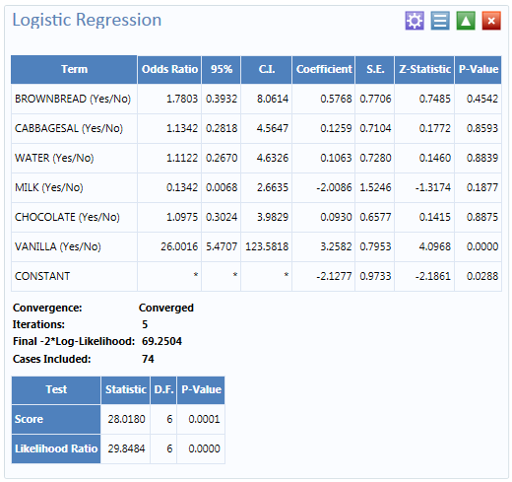
Figure 7.78 Logistic Regression Results
The results show that Vanilla has an Odds Ratio and Confidence Interval significantly greater than one. This indicates that consumption of vanilla was likely the cause of food borne illness.

Logistic Regression Properties
- The Outcome variable is the dependent variable for the regression. The outcome variable must be numeric or a Yes/No field.
- A Weight variable may be selected to use in weighted analyses.
- Match Variable identifies the variable indicating the group membership of each record.
- The Confidence Limits specifies the probability level at which confidence limits are computed.
- If No Intercept is selected, the regression is performed without a constant term.
- The Include Missing setting controls independent variables. If Include Missing is used with missing values and true/false, dummy variables will be made automatically. This will contribute Yes vs. Missing and No vs. Missing. Independent variables of text type are automatically turned into dummy variables, which compare each value relative to the lowest value in the sort order. Date or numeric type Independent variables are treated as continuous variables unless designated as dummy values through the Make Dummy button. If that occurs, they automatically turn into dummy variables, which compare each value relative to the lowest value.
- The Fields drop-down list contains the predictor (independent) variables.
- When selected, the predictor variables will appear in the Other variables list box. Double click on a variable to remove it from the Other variables list box. Select a variable from the Other variables list box to activate the Make Dummy button. The selected variable will then appear in the Dummy variable list box. Double click on a variable to remove it from the Dummy variable list box,
- Interaction terms are defined with the Make Interaction button. Make Interaction appears if two or more variables are selected from the Other Variables list box. If you click Make Interaction, the relationship populates the Interaction terms list box. Make Interaction adds all possible combinations of the selected variables to the regression as interaction terms. Double click on a variable to remove it from the Interaction terms list box.
- The Clear Terms button clears all variables from the Dummy variables and Interaction Terms list boxes.

Complex Sample Frequencies, Tables, and Means
The Frequency, Table, and Means options in Epi Info™ 7 perform statistical calculations assuming the data were collected using simple random sampling (SRS) or unbiased systematic sampling. More complicated sampling strategies such as stratification, cluster sampling, and the use of unequal sampling fractions are used in many surveys. Visual Dashboard provides three options to analyze complex sample data: Complex Sample Frequencies, Complex Sample Means, and Complex Sample Tables.
Generally, in complex sample analysis, there is a variable for the primary sampling unit (PSU) or Cluster from which a sample subject was selected. If the PSUs were chosen from different Strata (e.g., states or counties), there may be a stratification variable (Stratify by). The concept of sample stratification in complex sample design differs from the concept of stratification during epidemiologic analysis using the TABLES command, as the Strata are chosen in the sampling process before analysis. In addition, a weight variable (Weight) is used when sampling strategies result in unequal selection probabilities. The complex sample commands in Epi Info™ 7 can compute proportions or means with standard errors and confidence limits. If a 2x2 table is requested, the odds ratio, risk ratio, and risk difference are provided.

Complex Sample Frequencies
The Complex Samples Frequencies procedure produces frequency tables for selected variables. The Sample project contains an Expanded Program for Immunization (EPI) cluster survey. Using the EPI method, a team selected 30 communities (i.e., clusters) from the chosen geographic area and visited each of the 30 communities. In each, they selected seven children in an appropriate age range and determined each child’s immunization (VAC) status. The following example will determine the frequency of vaccinations using Complex Sample Frequency.
  - Open the Sample.PRJ project.
  - Select the Epi1 form from the Data Source Explorer menu.
  - Right click on the canvas to display the menu options.
  - Select Add Analysis Gadget > Advanced Statistics > Complex Sample Frequencies.
  - The Complex Sample Frequency Properties dialog box appears.
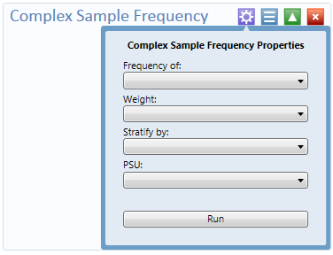
Figure 7.79: Complex Sample Frequency Properties
Complex Sample Frequency Options:
- Frequency of identifies the variable(s) whose frequency is computed.
- A Weight variable is selected for use in weighted analyses.
- Stratify by identifies the variable to be used to stratify or group the frequency data.
- The PSU identifies the Primary Sampling Unit.
  - From the Frequency Of drop-down list, select VAC.
  - From the PSU drop-down list, select Cluster.
  - Click Run.
  - The Complex Sample Frequency results appear on the canvas.
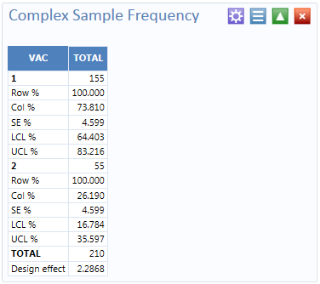
Figure 7.80: Complex Sample Frequency Results
Information provided in the output includes:
- Row % - the row percentage, frequency will always be 100%.
- Col % - the column percentage.
- SE % - the standard error, which takes into account the complex sample design.
- LCL % - Lower Confidence Limit.
- UCL % - Upper Confidence Limit.
- Total - total number of individuals/elements surveyed.

The results indicate that 73.8% of the 210 children surveyed are vaccinated with a 95% confidence interval range from 64.4 to 83.2.
The following example is similar to the one above, except that this is a stratified cluster survey with a separate 30-cluster survey completed in each of 10 strata. To analyze this dataset correctly, we will take into account where each child lives (LOCATION). We will also use a weight variable to account for the differences in population sizes between the different locations.
- Open the Sample.PRJ project.
- Select the Epi10 form from the Data Source Explorer menu.
- Right click on the canvas to display the menu options.
- Select Add Analysis Gadget > Advanced Statistics > Complex Sample Frequencies.
- The Complex Sample Frequency Properties dialog box appears.
- From the Frequency Of drop-down list, select VAC.
- From the Weight drop-down list, select POPW.
- From the Stratify By drop-down list, select Location.
- From the PSU drop-down list, select Cluster.
- Click Run.
- The Complex Sample Frequency results appear on the canvas.
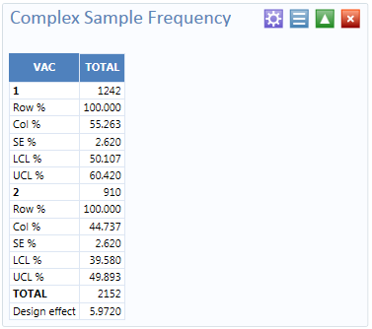
Figure 7.81: Complex Sample Frequency (Stratified, Weighted) Results
The results indicate that 55.3% of the 2,152 children surveyed are vaccinated with a 95% confidence interval range from 50.1to 60.4.

Complex Sample Means
The Complex Sample Means command can be used when the outcome variable is continuous, such as age, cholesterol level, etc. You can either calculate an overall mean with its measures of variation or compare means across a grouping variable.
As an example of calculating means with a grouping variable, use the Smoke data file located in the Sample project folder. In this example, the investigator is interested in determining if, among smokers, there is a difference in the average number of cigarettes smoked between males and females. In these data, the variable SEX is coded as 1=male and 2=female.
    - Open the Sample.PRJ project.
    - Select the Smoke form from the Data Source Explorer menu.
    - Right click on the canvas to display the menu options.
    - Select Add Analysis Gadget > Advanced Statistics > Complex Sample Means.
    - The Complex Sample Frequency Means dialog box appears.
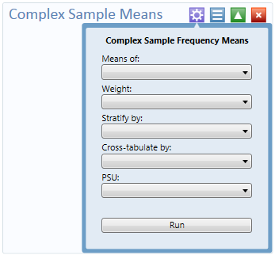
Figure 7.82: Complex Sample Frequency Means
Complex Sample Tables Options:
- Means of identifies the variable whose mean is to be computed.
- A Weight variable is selected for use in weighted analyses.
- Stratify by identifies the variable to be used to stratify or group the frequency data.
- Cross-Tabulate by identifies the variable to be used to cross-tabulate the main variable.
- The PSU identifies the Primary Sampling Unit.
    - From the Means Of drop-down list, select Numcigar.
    - From the Weight drop-down list, select SAMPW.
    - From the Stratify By drop-down list, select Strata.
    - From the Cross-tabulate By drop-down list, select Sex.
    - From the PSU drop-down list, select PSUID.
    - Click Run.
    - The Complex Sample Means results appear on the canvas.

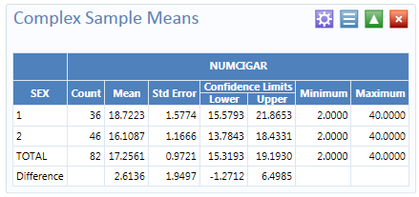
Figure 7.83: Complex Sample Means Results
The results indicate that among the 82 individuals who smoked cigarettes, the average number of cigarettes smoked per day for men was 18.7, and 16.1 for women with a 95% confidence interval range of 15.6 to 21.8 for men and 13.7 to 18.4 for women. Note that the Smoke file has 337 individuals. However, the number of cigarettes smoked per day (NUMCIGAR) has data for only the 82 smokers. For nonsmokers this variable was left blank and therefore is treated as missing data and excluded from analysis.

Complex Sample Tables
The Complex Sample Tables option in Visual Dashboard allows you to specify an Exposure Variable and an Outcome Variable. The following example using Complex Sample Tables to show whether the mother received prenatal care (PRENATAL) has an effect on the child’s vaccination status. If the mother had received prenatal care, PRENATAL=1 else PRENATAL=2.
- Open the Sample.PRJ project.
- Select the Epi10 form from the Data Source Explorer menu.
- Right click on the canvas to display the menu options.
- Select Add Analysis Gadget > Advanced Statistics > Complex Sample Tables.
- The Complex Sample Tables Properties dialog box appears.
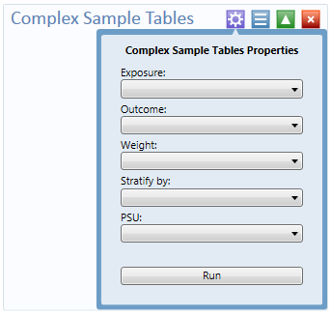
Figure 7.84: Complex Sample Tables Properties
Complex Sample Tables Options:
- Exposure Variable identifies the variable that will appear on the horizontal axis of the table. It is considered to be the risk factor (or * for all variables).
- Outcome Variable identifies the variable that will appear on the vertical axis of the table.
- A Weight variable is selected for use in weighted analyses.
- Stratify by identifies the variable to be used to stratify or group the frequency data.
- The PSU identifies the Primary Sampling Unit.
- From the Exposure drop-down list, select Prenatal.
- From the Outcome drop-down list, select VAC.
- From the Weight drop-down list, select POPW.
- From the Stratify By drop-down list, select Location.
- From the PSU drop-down list, select Cluster.
- Click Run.
- The Complex Sample Tables results appear on the canvas.
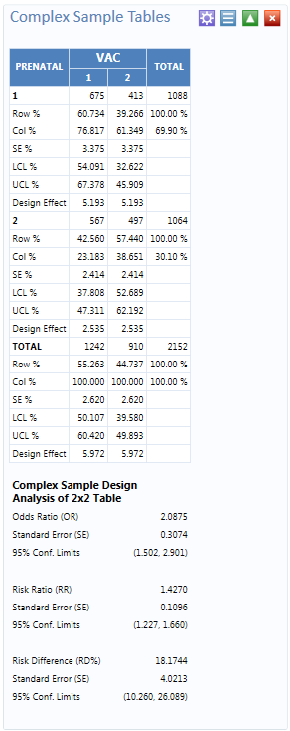
Figure 7.85: Complex Sample Tables Results

The results show that 60.7% of children whose mothers received prenatal care were immunized compared to 42.7% of those children whose mothers did not receive prenatal care.
The 2 x 2 data shows that the odds ratio in the data was 2.088, the risk ratio was 1.427 and this risk difference is 18.2%. The prevalence ratio says that 1.427 times as many children of women who received prenatal care were immunized (60.734% /42.560% = 1.427) compared to children born to women who had not received prenatal care, a 40% difference.

StatCalc Calculator

Refer to the StatCalc Calculator section of this user guide.

NutStat Growth Chart

Refer to the NutStat section of this user guide.

Data Dictionary

Show Data Dictionary
The Data Dictionary displays form(s) and defined variables for an open project. Fields or variables are sorted and displayed by page number in the form. Defined variables appear at the end of the listing. Information retrieved from the form includes Field Name, Prompt, Form, Page, Tab, Data Type, Epi Info Field Type, and Table.
- Right click on the canvas and select Show Data Dictionary.
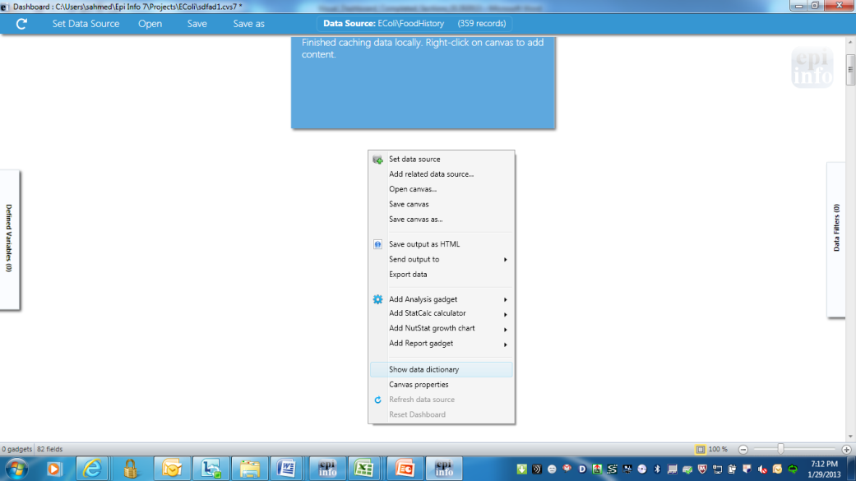
Figure 7.86: Data Dictionary Menu Option

- The Data Dictionary is displayed in Visual Dashboard.
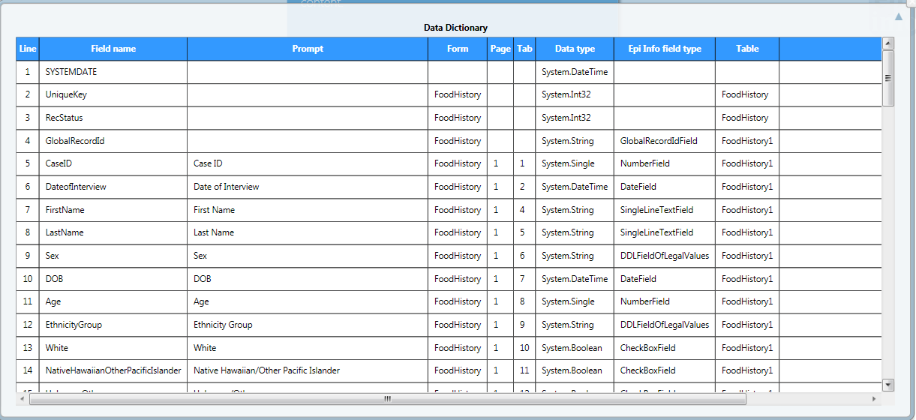
Figure 7.87: Data Dictionary View
Column values for Prompt, Data Type, Field Name and Epi Info Field type are developed when fields are created from the Field Definition dialog box.
- To open the Data Dictionary as an HTML page inside the browser window, right click and then select Send Data Dictionary to Web Browser.
From the browser, the data can be printed with File > Print, or saved with File > Save As.
- Right click on the HTML page to show the pop-up menu. You can export the data directly to an Excel spreadsheet.
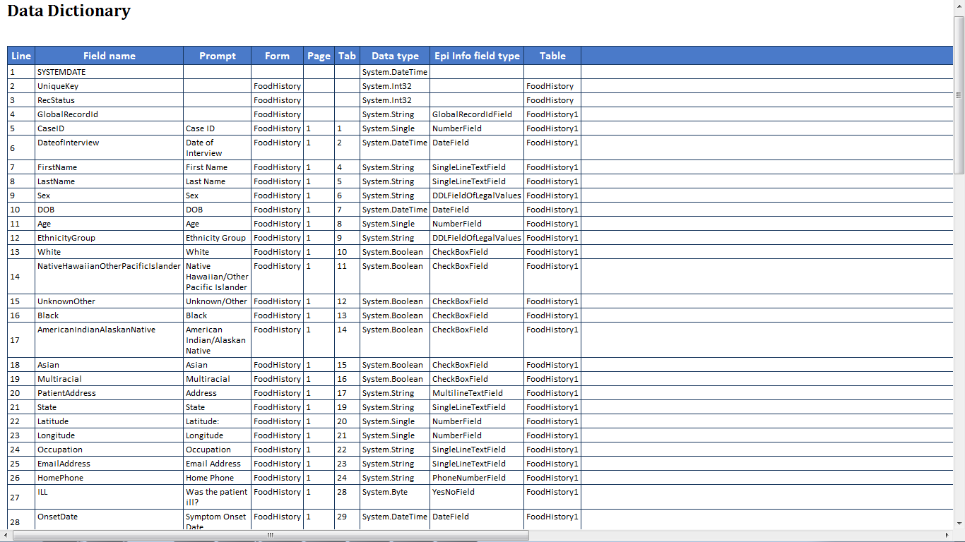
Figure 7.88: Data Dictionary Export to HTML
- Click Close to exit the Data Dictionary.
Note: The Data Dictionary can be refreshed at any time to display the most current data. Right click on the Data Dictionary and select Refresh Data Dictionary.

Report Gadgets

There are several report gadgets available to add text and images to your reports. The Simple Text box option allows you to specify several lines of text to appear at the top of the table, frequency, chart, or graph. This is particularly useful for adding a title to charts or graphs. To add a title to your graph:
- Right click on the Visual Dashboard canvas. Select Add Report Gadget from the menu options, and then select Simple Text box.
- The text box appears.
- Enter a title for your graph.
To remove your title:
- Right click on the textbox border.
- Click Close this gadget.

Image Gadget is another report gadget, which allows you to add an image to your charts or graphs.
- Right click on the Visual Dashboard canvas. Select Add Report Gadget from the menu options, and then select Image Gadget.
- A light blue box appears on the canvas. Click the box.
- The Open dialog box appears. Select the location of your image or enter the File name of your image.

Note: You may only select a * .png file.
- Click Open.
- The image appears on the canvas.
To remove your image:
- Right click on your image.
- Click Close this gadget.

THIS PAGE IS
INTENTIONALLY BLANK.

9. Classic Analysis

Introduction

Classic Analysis manipulates, manages, and analyzes data. It acts as a statistical toolbox providing many ways to transform data and perform statistical Classic Analysis. Data can be selected, sorted, listed, or manipulated with a series of commands, functions, and operators. Available statistics include frequencies, means, and more advanced processes (i.e., Kaplan-Meier Survival Classic Analysis and Logistic Regression). Classic Analysis can be accessed by clicking Classic from the Epi Info™ main window or by selecting Tools > Analyze Data>Classic . It reads data files created in Form Designer and other types of databases (e.g., MS Access, MS Excel, SQL Server, and ASCII). Classic Analysis can also produce graphs to present graphic representations of data.
Classic Analysis provides access to existing data directly or through forms created in Form Designer. It reads data from files and tables created in Epi Info 7, Microsoft Access, Microsoft Excel, SQL Server, and ASCII.

Navigate the Classic Analysis Workspace

The Classic Analysis module contains four areas: the Classic Analysis Command Tree, Program Editor, Classic Analysis Output window, and the Message Area.
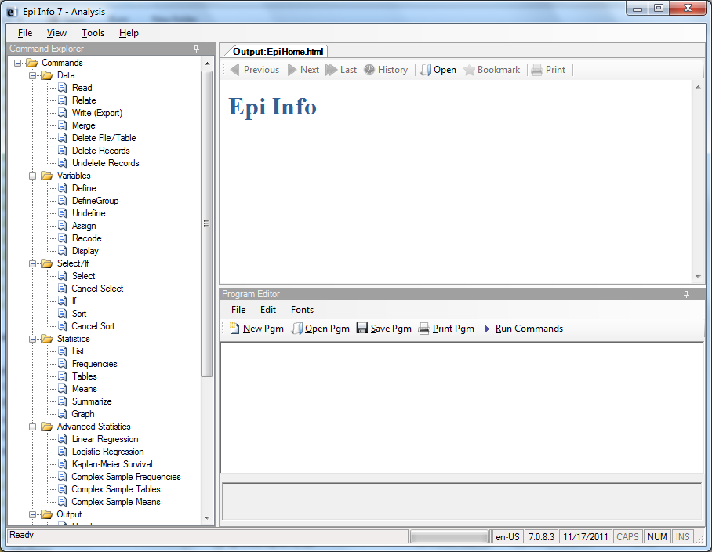
Figure 7.89: Classic Analysis Workspace
- The Command Explorer contains a list of available commands separated into folders by command type. Commands are generated, edited, and executed. Selecting a command opens the corresponding dialog box for that command, function, or statistic to run.
- The Program Editor displays the commands and code created using the Classic Analysis Command Tree. Commands can also be typed directly into the Program Editor. Programs or .PGM files written in Classic Analysis can be stored in the current .PRJ or as text files. Saved programs can be run against new data, or shared with others.
- The Output window acts as a browser and displays information generated from commands run in Program Editor. The buttons allow you to navigate through program scripts that run and display in the output screen.
- The Message window alerts you if any problems occur with any executed commands.

How to Manage Data

Use the READ Command

To analyze data, it must be read or imported into Classic Analysis. The READ command allows you to select a project and/or data table to run statistics. The READ command is used almost every time you open Classic Analysis.
Warning! Never manipulate the Form table in a software application outside of Epi Info 7. The database may become corrupt and render the form unusable.
- From the Classic Analysis Command Tree Data folder, click Read. The READ dialog box opens.

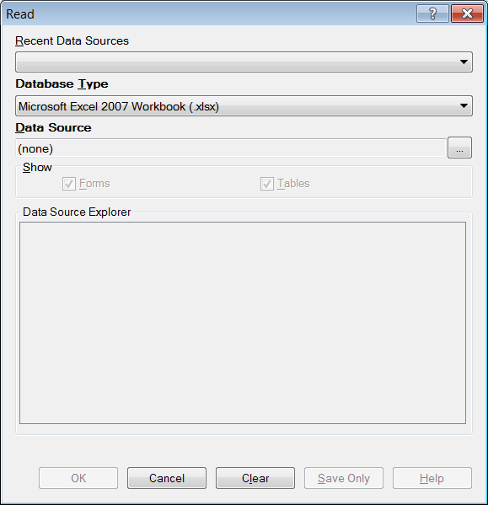

Figure 7.90: Read Window

- The Database Type field indicates the database file to be loaded (.PRJ, .MDB, .XLS). Specify the data format for the data to be read. Unless otherwise specified, output files created from these data are stored in this destination folder.
- The Data Source field indicates the file location/path. If you use an SQL Server database, the Data Source field will require server and database names.
- The Recent Data Sources field provides a list of recently-accessed databases in Classic Analysis or Visual Dashboard. By selecting one of the data sources available on the list, you do not need to provide Database Type or Data Source information. Only data tables or forms will need to be selected again. If you are reading an Epi Info 7 project file from the Data Source section, select the Forms checkbox to view available forms in the project, or select the Tables checkbox to view all project tables.
- From the Forms section, select a form in your project. This reads the data table associated with your form.
- Click OK. The READ command is saved in the Program Editor and run simultaneously. The current form file location, Record Count, and Date appear in the Classic Analysis Output window; the READ command appears in the Program Editor.
- Click Save Only to save the command in the Program Editor. The command does not run and the Record Count is not displayed.

Read a Microsoft Excel File

- From the Classic Analysis Command Tree, click Read. The READ dialog box opens.
- From the Data Formats drop-down list, select either MS Excel 97-2003 Workbook or MS Excel 2007 Workbook.
- In the Data Source field, click on the Browse button to browse and select the workbook (.xls or .xlsx) to import into Classic Analysis.
- Click Open.
- First Row Contains Field Names is checked by default. If the first row of the spreadsheet does not contain field names, deselect the checkbox.
- Click OK
- Select a Worksheet from the list provided in the Data Source Explorer.
- Click OK. The Record Count and file information appear in the Classic Analysis Output window.

Read a Microsoft Access File

- From the Classic Analysis Command Tree, click Read. The READ dialog box opens.
- From the Data Formats drop-down list, select either MS Access 2002-2003 (.mdb) or MS Access 2007(.accdb).
- In the Data Source field, click on the Browse button to browse and select the file to import into Classic Analysis.
- Click OK.
- Select a data table from the list provided in the Data Source Explorer.
- Click OK. The Record Count and file information appear in the Classic Analysis Output window.

Read an ASCII Text File

- From the Classic Analysis Command Tree, click Read. The READ dialog box opens.
- From the Data Formats drop-down list, select Flat ASCII File.
- In the Data Source field, click the Browse button to browse.
- Click the Browse button again. Select directory of the file to import into Classic Analysis.
- Click OK.
- Select the file from the list provided in the Data Source Explorer
- Click OK.
Note: There are two forms of text files. Since both have only one table per file, you do not have to specify a table. Both put the data for one record on a single line. The difference is in how the fields are indicated.

Read an SQL Server Database

- From the Classic Analysis Command Tree, click Read. The READ dialog box opens.
- From the Data Formats drop-down list, select Microsoft SQL Server Database.
- In the Data Source field, click the Browse button to browse.
- When the Connect to SQL Server Database dialog opens, specify the server name and database name to connect and import into Classic Analysis.
- Click OK.
- From the list provided in the Data Source Explorer, select a data table.
- Click OK. The Record Count and file information appear in the Classic Analysis Output window.

Use Related Forms

To use RELATE, the READ command must open at least one form/table. The form/table to be linked requires a key field that relates records in the two forms/tables and can be used to join them together. The keys in the main and related tables or forms do not require the same name. If the table was created in Form Designer and the data entry completed using Enter, Classic Analysis can establish a relationship automatically using the Global Record ID and Foreign Key variables created by Epi Info 7. If the relationship was created in another program that uses different keys, the key variables in both files must be identified. Relationships are represented by double colons (::). Classic Analysis can establish relationships using multiple keys. Currently, only Epi Info 7 projects can be related in Classic Analysis.
After issuing the RELATE command, the variables in the related table may be used as if they were part of the main table. Variable names are duplicated in the related tables; variable names will be suffixed with a sequence number. Frequencies, cross-tabulations, and other operations involving data in the main and related tables can be performed. The WRITE command can create a new table containing both sets of data. More than one table can be related to the main table by using a series of RELATE commands.
Relate keys can contain mathematical or string concatenation expressions. Epi Info 7 functions can be used to determine relationships. It may be easier, however, to write out a new file in which the complex key is included as a single variable. Use this single variable as a key.
PRJ File RELATE Syntax
Use READ to open the first PRJ file, and RELATE to open the second and create the relationship.
READ {C:\My_Project_Folder\Sample\Sample.prj}:Surveillance
RELATE RHepatitis GlobalRecordId :: GlobalRecordId

Try It
Epi Info 7 has a related database in the Sample.PRJ file which contains two forms: Surveillance and RHepatitis. The variable GLOBAL RECORD ID is the internal Epi Info 7 identification key located in more than one form in the project.
- Read in the Sample.PRJ project. Open Surveillance.
- Click RELATE. The RELATE dialog box opens.
- Select RHepatitis. The Build Key button activates.
- Click Build Key. The RELATE-BUILD KEY dialog box opens. Make sure the Current Table radio button is selected.
- From the Available Variables drop-down list, select GLOBALRECORDID.
- Select the Related Table radio button.
- From the Available Variables drop-down list, select GLOBALRECORDID.
- Click OK. The Related Tables field populates.
- Click OK. The RELATE dialog box opens and the Key field populates with the join information.

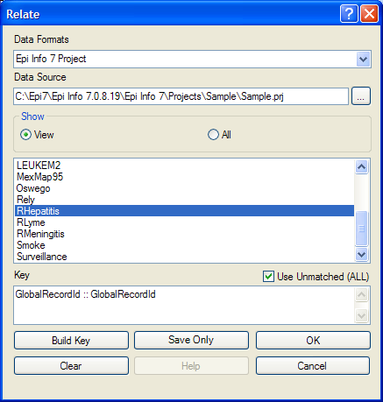
Figure 7.91: Relate Dialog Box

- Click OK. The related form information appears in the Output window.
- Data from the two tables can now be used to compute statistics.

Use the WRITE Command

Use to create a new file with selected variables.
Syntax
WRITE <METHOD> {<output type>} {<project>:}table {[<variable(s)>]}
WRITE <METHOD> {<output type>} {<project>:}table * EXCEPT {[<variable(s)>]}

To use the WRITE command, open a project using the READ command. Follow these steps:
- From the Classic Analysis Command Tree, click Write. The WRITE dialog box opens.
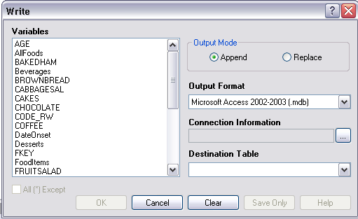
Figure 7.92: Write Dialog Box

- Keep the default setting All (*) unchecked to write all the variables to a new file.
Note: You can also choose individual variables from the file list by clicking on the variable name or select All (*) Except to exclude specific variables.
- From the Output Mode section, click the Replace radio button.
- Replace creates a new file and overwrites any existing variables and records. To overwrite or replace data in a table, use the Replace selection.
- Append adds new variables and records to the end of existing data.
- Using the drop-down list, select the desired Output Format.
- Available output formats are the same as ones that can be imported using the READ command (i.e., MS Access, MS Excel, SQL Server and Flat ASCII file).
- Click the Browse button in the Connection Information field to specify file name and location.
- Click OK.
- Establish a name for the Destination Table or select a table name from the drop down list (if the table already exists).
- Click OK.
- To see the data, use the READ command to open the newly-created project.
- The WRITE command will not create a form and cannot create a data table to work with a form. To preserve forms, use the MERGE command.
- Not all output formats support all possible input formats.

Use the MERGE Command

Use the MERGE command to join records. MERGE is only supported if the READ data source is an Epi Info 7 project. A merge requires a key, called the GLOBAL RECORD ID, which represents an internal matching variable inside both sets of data.
Syntax
MERGE <table specification> <key(s)> <type>
- From the Classic Analysis Command Tree, use the READ command to open a PRJ project file.
- From the Classic Analysis Command Tree, click Data > Merge. The MERGE dialog box opens.

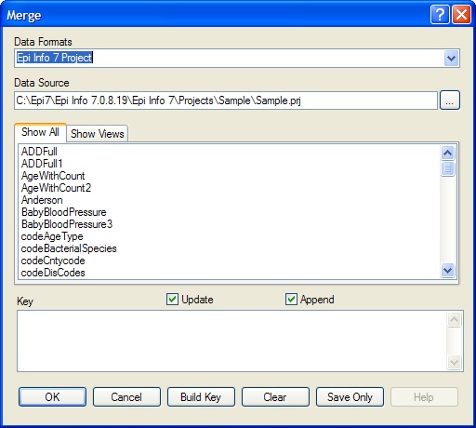
Figure 7.93: Merge Dialog Box

- From the Data Formats drop-down list, specify the other Epi Info 7 project to be read. (Other data sources will be supported in a future release).
- In the Data Source field, click the Browse button. The Merge File Name dialog box opens.
- Select the project file that contains the data to be merged.
- Click Open. The MERGE dialog box populates with available tables or worksheets.
- Merge a data table or worksheet. The Build Key button activates.
- Click Build Key. The RELATE - BUILD KEY dialog box opens.
- There must be a variable in the Current Table that corresponds to a one in the Related Table (i.e., Patient ID).

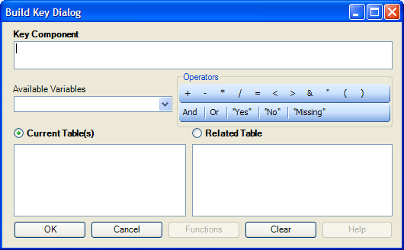
Figure 7.94: Build Key Dialog Box

- From the Available Variables drop-down list, select the current table merge variable.
- Click OK. The Current Table field shows the selection.
- From the Available Variables drop-down list, select the related table merge variable.
- Click OK. The Related Tables field shows the selection.
- Click OK to accept the Build Key designations. The MERGE dialog box opens.
- Make Update and Append selections from the corresponding checkboxes.
- For matching records, Update replaces the value of any field in the READ table whose build key matches the MERGE table.
- For unmatched records, Append creates a new record in the READ table with values only for those fields that exist in the MERGE table.
- For most merges, select Update and Append records. If you select both options, records containing the same selected merge variables will be updated (overwritten) if there is new information. All other records will be appended (added) to the end of the data table.
- From the Merge dialog box, click OK.
- If the MERGE table is the same project as the READ table, the Record Count in the Output window updates to reflect any new records added to the table.
Use the ASSIGN Command

This command assigns an expression result or the field value to a variable. Variables are usually created with the DEFINE command and assigned a value.
Syntax
ASSIGN <variable> = <expression>
- From the Classic Analysis Command Tree, click Variables > Assign. The ASSIGN dialog box opens.

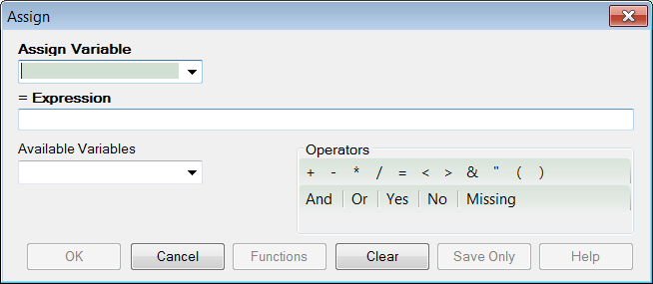
Figure 7.95: Assign Dialog Box

- From the Assign Variable drop-down list, select the variable to have a value assigned.
- In the =Expression field, create the assignment syntax based on needed data.
- Click OK. The code appears in the Program Editor.
Try It
In the following example, the zip code field is a number. To use the zip code in a map, a new zip code variable must be defined and assigned text values.
- From the Classic Analysis Command Tree, use the READ command to open the Sample.PRJ project.
- From the Form section, click Surveillance.
- Click OK.
- Click Variables > Display.>--Variables currently available.
- Click OK. The variables information appears.
- Click Variables > Define. The DEFINE dialog box opens.
- In the Variable Name field, create a new variable named Zip2.
- Select Text for Variable Type
- Click OK.
- From the Classic Analysis Command Tree, click Variables > Assign. The ASSIGN dialog box opens.
- From the Assign Variable drop-down list, select Zip2.
- In the =Expression field, type the syntax FORMAT(ZipCode,"00000").
- In this example, the FORMAT function converts the format of the values of the variable ZipCode into text format. Text values are always surrounded by double quotes and assigned to the new Zip2 variable.
- Click OK. The code appears in the Program Editor.
- Use the DISPLAY command to view variable information.

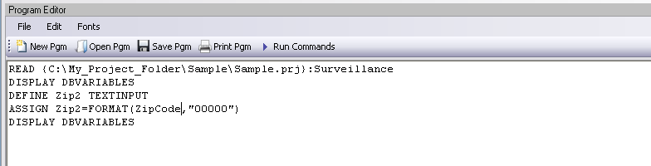
Figure 7.96: Variable Information in Program Editor

Delete File/Table

Delete Files
The file(s) specified explicitly or implicitly (via wildcards) are deleted. If no files are specified, or if any specified files cannot be deleted, a message is produced unless you select Run Silent. Wildcards are not allowed in the suffix.

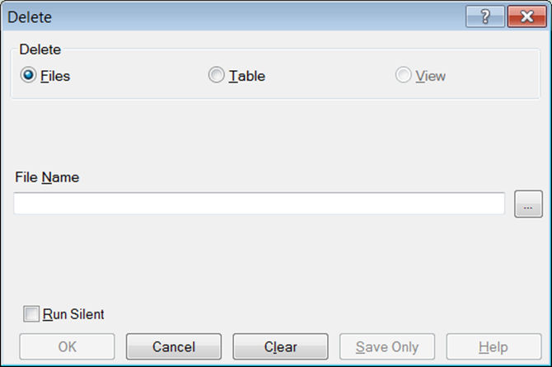
Figure 7.97: Delete Dialog Box
- File Name contains the name of the file to be deleted.
- Run Silent causes the command to run without any warning or error messages from the Program Editor.
- OK accepts the current settings and data, and subsequently closes the form or window.
- Save Only saves the created code to the Program Editor, but does not run the code.
- Cancel closes the dialog box without saving or executing a command.
- Clear empties the fields to allow information to be re-entered.
- Help opens the Help topic associated with the module being used (Currently Disabled).

Delete Table
The specified table is deleted. If the table does not exist or cannot be deleted, a message is produced unless you select Run Silent. To delete tables with spaces in their names, specify the file and the table even if the table is in the current project. The table must be enclosed in single quotes. It is possible to read a table with a space in its name and then delete it, resulting in errors during subsequent procedures.
DELETE TABLES will not delete and produce messages if any of the tables specified are data, grid, or program. Code tables are deleted only if they are not referenced by any form.

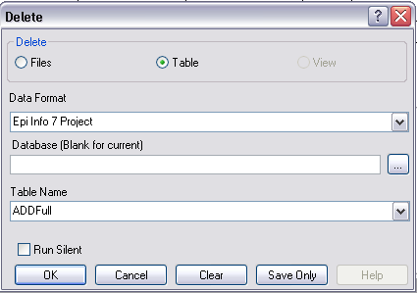
Figure 7.98: Delete Tables Dialog Box

- Data Format specifies the data source format of the file containing the table to be deleted.
- Database (Blank or Current) specifies the name and location of the dataset containing the table to be deleted.
- Table Name specifies the name of the table to be deleted.
- Run Silent causes the command to run without any warning or error messages from the Program Editor.
- OK accepts the current settings and data, and subsequently closes the form or window.
- Save Only saves the created code to the Program Editor, but does not run the code.
- Cancel closes the dialog box without saving or executing a command.
- Clear empties the fields to re-enter information.
- Help opens the Help topic associated with the module being used. (Currently Disabled).

Delete Records
Delete Records may not be used with related tables. For DELETE * and DELETE TABLES, space will not be reclaimed. You can run the Epi Info 3.5.3 Compact Database utility to reclaim space. All records in the current selection matching the expression are set to deleted status, or if PERMANENT is specified, physically deleted. Unless you select RUNSILENT, a confirmation message is displayed.

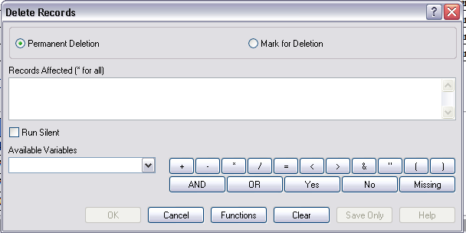
Figure 7.99: Delete Records Dialog Box

- Permanent Deletion causes records to be inaccessible after deletion.
- Mark for Deletion marks the selected records as to be deleted, and permits you to undelete. This feature can only be applied to Epi Info 7 projects.
- The Records Affected (* for all) field specifies which records to delete.
- Run Silent causes the command to run without any warning or error messages from the Program Editor.
- The Available Variables drop down allows you to select variables available in the current project.
- Functions and operators appear within commands and are used for common tasks (e.g., extracting a year from a date, combining two numeric values, or testing logical conditions).
- OK accepts the current settings and data, and subsequently closes the form or window.
- Save Only saves the created code to the Program Editor, but does not run the code.
- Cancel closes the dialog box without saving or executing a command.
- Clear empties the fields to re-enter information.
- Help opens the Help topic associated with the module being used. (Currently Disabled).

Use the ROUTEOUT Command

You can locate output by using the ROUTEOUT command. If no directory exists, the file is placed in the current project’s directory. Results accumulate until you execute a CLOSEOUT command. Output files can be placed in any folder. The ROUTEOUT command selects a path and filename. If no output file is selected, Classic Analysis uses the default value. In each folder, Classic Analysis creates a new index table that contains links to the files created.
- From the Classic Analysis Command Tree, use the READ command to open a PRJ project file.
- From the Classic Analysis Command Tree, click Output > RouteOut. The ROUTEOUT dialog box opens.

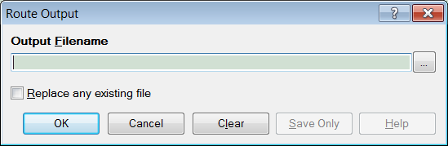
Figure 7.100: Route Output Dialog Box

- In the Output Filename field, enter a file name to locate an existing file.
- If necessary, select Replace Existing File to write over any files with the same name.
- Click OK. Create Output on the existing project.
- Notice the title bar contains the output filename specified in the ROUTEOUT command.
- The new file is placed in the selected directory with the extension .HTM.
- From the Output window toolbar, click Open. The Browse dialog box opens.
- Locate and select the file created with ROUTEOUT. Click Open. The Output appears in the Output window.
- The saved Output file can be opened by any application that can read an HTML file.
To end the ROUTEOUT command, choose one of the following options.
- From the Output folder, click Closeout.
- READ in a new project.
- Close Epi Info 7.

Use the CANCEL SORT Command

Syntax
CANCEL SORT Command Generator
CANCEL SORT Command Reference

- From the Classic Analysis Command Tree, click Select/If > Cancel Sort. The CANCEL SORT dialog box opens.

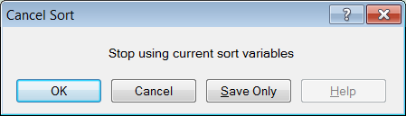
Figure 7.101: Cancel Sort Dialog Box

- Click OK. The selection criteria are removed from the data, and the original record count is restored.

Undelete Records
The UNDELETE command causes all logically deleted records in the current selection matching the expression to be set to normal status. This applies only to Epi Info 7 forms and may not be used when using related tables.

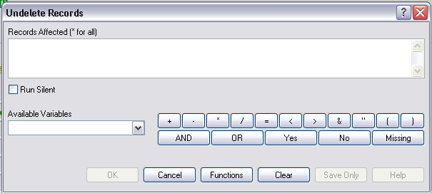
Figure 7.102: Undelete Records Dialog Box

- The Records Affected (*for all) field contains the expression for which records to undelete.
- The Available Variables field allows you to select available variables in the current project.
- Functions and operators appear within commands and are used for common tasks (e.g., extracting a year from a date, combining two numeric values, or testing logical conditions).
- OK accepts the current settings and data, and subsequently closes the form or window.
- Save Only saves the created code to the Program Editor, but does not run the code.
- Functions opens the online help file, which explains how to use functions and operators.
- Cancel closes the dialog box without saving or executing a command.
- Clear empties the fields to re-enter information.
- Help opens the Help topic associated with the module being used. (Currently Disabled).

How to Manage Variables

Use the DEFINE Command

This command creates new variables.
Syntax
DEFINE <variable> {<scope>} {<type indicator>} {("<prompt>")}

- From the Classic Analysis Command Tree, click Variables > Define. The DEFINE Variable dialog box opens.

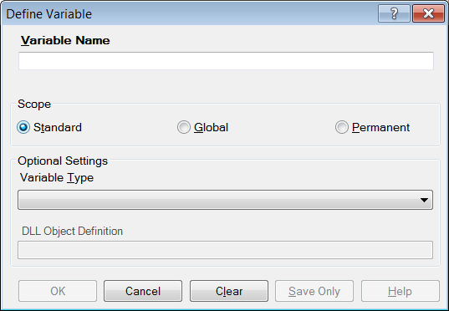
Figure 7.103: Define Variable Dialog Box

- From the Scope section, select one of the following variables:
- Standard variables remain in a current project and are one variable in that form. They can assume new values with each record during a file query (e.g., a LIST or FREQ).
- Global variables persist throughout program execution. They pass values from one form to a related form, and do not change during a file query.
- Permanent variables are stored in the EpiInfo.Config.xml file or system registry and retain any value assigned until changed by another assignment, or until the variable is undefined. They are shared among Epi Info 7 programs and persist even if the computer is shut down and restarted.
- From the Variable Type drop-down list, select one of the following types: Date, Numeric, Text, or Yes-No.
- Optional: Variable Type is required and cannot be used if <scope> is omitted. <type indicator> is the data type of the new variable and must be one of the following reserved words: NUMERIC, TEXTINPUT, YN, or DATEFORMAT. If omitted, the variable type will be inferred based on the data type of the first value assigned to the variable. However, omitting field type is not recommended.
- Click OK.

Define a Group
To define a group, take the following steps:
- From the Classic Analysis Command Tree, click Variables > Define Group. The DEFINE GROUP dialog box opens.
- In the Group Variable field, type a name.
- From the Variables list box, select the variables to be included in the group.
- Click OK.

Convert a Number to Text

Numbers can be converted to text using the FORMAT function. FORMAT changes the format of one variable type to another.
Syntax
FORMAT(<variable>, {"<format specifcation>"})
Example
The Format function can be used to convert a numeric postal code or zip code field to a text type variable for mapping.
- The READ command opens a new file that contains a numeric field called zipcode. To use Epi Map with the zipcode values, change the values to text.
- The DEFINE command creates a new variable called NewZip. The variable NewZip will hold the values of zipcode in a text format. The code appears in the Program Editor as DEFINE NewZip.
- The ASSIGN command formats the variable NewZip with the values of ZipCode and the format of text. Text values are enclosed in quotes. The code appears in the Program Editor as:
ASSIGN NewZip=FORMAT(ZipCode,"00000")
- The variable NewZip can now be used as a geographic variable in Epi Map because it is a text type variable that contains numeric data.

Try It
For this example, use the Classic Analysis Program Editor to create the code.
- Read in the Sample.PRJ project. Open Oswego. Seventy five (75) records should be listed in the Output window.
- In the Program Editor window, place the cursor under the created Read command. Type DEFINE MyAge TEXTINPUT
- Do not press the Enter key. Leave your cursor on the line of code you just created.
- In the Program Editor window, type the following: ASSIGN MyAge = FORMAT(Age, "00").
- From the Program Editor navigation menu, click Run Commands. The code will turn gray to indicate a syntax review.
- From the Classic Analysis Command Tree, click Statistics > List. Click OK. The records appear.
- Notice that the values in ‘MyAge’ are all two characters with a leading ‘0’ before each single digit year. The leading zero is present because of the ‘00’ format specification.
- From the Classic Analysis Command Tree, click Variables > Display. Click OK. The variable types appear.
- The variable MyAge now contains the values of Age and the format type of Text.

Use IF Statements with Permanent or Global Variables

- If the condition of an IF statement depends on global or permanent variables, the value is computed immediately and only the true or false branch, as appropriate, is followed.
- If the condition of an IF statement depends on a field variable, neither branch is followed. However, computations within the branches are saved for execution as appropriate on each record. In the second case, non-computational commands (e.g., READ, SELECT, SORT, HEADER, and ROUTEOUT) are never executed.

Handle Date Fields

Date formats are often determined by default computer settings. To access Regional Settings in a Windows environment, click Start > Control Panel > Regional and Language Options.
- Date fields in forms are entered in European, American, or ISO format as specified in Form Designer. They are stored in the database in a neutral format.
- Date fields in Excel, and Text files are read into Classic Analysis according to the date format found in Regional Settings, and stored in a neutral format. Excel files prepared with one date format often do not import properly on machines with a different date format.
- Date fields in forms are displayed in European, American, or ISO format as specified in Form Designer by the following Classic Analysis commands: LIST, LIST GRIDTABLE, TABLES, and FREQ.
- Date fields in forms are displayed according to the date format found in Regional Settings in the following Classic Analysis commands: DISPLAY, and GRAPH.
- Date fields in tables without forms are displayed according to the date format found in Regional Settings.
- Date fields written to Excel or Text files are written according to the date format in Regional Settings.
- Date literals in Form Designer, Check Code, or Classic Analysis Programs; and date-type permanent variables in the EpiInfo.Config.xml file, should be in American format unless enclosed in braces or pipe symbols. European date format (DD/MM/YYYY) literals must be enclosed in braces (i.e., {23/11/2007}). ISO date literals (YYYY/MM/DD) must be enclosed in pipe symbols (i.e.,|.,2007/11/23|.
- Dates formatted with the FORMAT function are formatted according to the date format found in Regional Settings when no format is specified as a second argument.
- Dates converted from text with TXTTODATE are converted to a neutral format according to the date format found in Regional Settings. For multi-national applications, it may be safer to use the NUMTODATE function.
If you are not sure, conduct experiments and examine the results.

How to Use Undefine

The Undefine command in Classic Analysis removes a defined variable from the system.

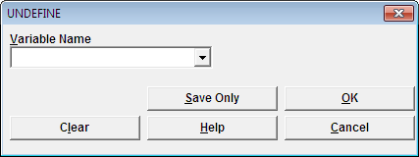
Figure 7.104: Undefine Command Box

- Variable Name indicates the name of the variable to be removed from the data table.
- OK accepts the current settings and data, and subsequently closes the form or window.
- Save Only saves the created code to the Program Editor, but does not run the code.
- Cancel command generation window without saving or executing a command.
- Clear empties fields so that information can be re-entered.
- Help opens the Help topic associated with the module being used. (Currently Disabled).

Use the ASSIGN Command

This command assigns the result of an expression or the field value to a variable. Variables are usually created with the DEFINE command and subsequently assigned a value.
Syntax
ASSIGN <variable> = <expression>
<variable> = <expression>

- From the Classic Analysis Command Tree, click Variables > Assign. The ASSIGN dialog box opens.

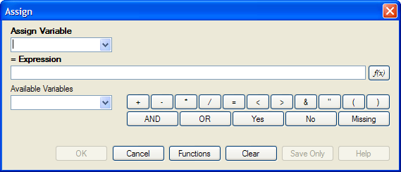
Figure 7.105: Assign Variable Dialog Box

- From the Assign Variable drop-down list, select the variable to have a value assigned.
- In the =Expression field, create the assignment syntax based on the needed data.
- Click OK. The code appears in the Program Editor.
Try It
In the following example, the zip code field is a number. To use the zip code in a map, a new zip code variable must be defined and assigned text values.
- From the Classic Analysis Command Tree, use the READ command to open the Sample.PRJ project.
- From the form section, click Surveillance. Click OK.
- Click Variables > Display. Click OK. The variables information appears.
- Click Variables > Define. The DEFINE dialog box opens.
- In the Variable Name field, create a new variable named Zip2.
- Click OK.
- From the Classic Analysis Command Tree, click Variables > Assign. The ASSIGN dialog box opens.
- From the Assign Variable drop-down list, select Zip2.
- In the =Expression field, type the syntax FORMAT(ZipCode,"00000").
- In this example, the FORMAT function is used to convert the format of the values of the variable ZipCode into the text format. Text values are always surrounded by double quotes and are assigned to the new Zip2 variable.
- Click OK. The code appears in the Program Editor.
- Use the DISPLAY command to view variable information.

Figure 7.106: Assign Variables in Program Editor

How to Use Recode

The Recode command allows grouping of data for age and other variables, or changing code from one system to another.
- To insert a line in the table, select the row and press Ctrl-Insert.
- To delete a line in the table, select the row and press Ctrl-Delete.
- Delete any blank rows prior to selecting OK or Save Only.
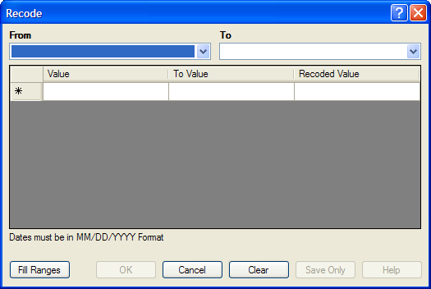
Figure 7.107: Recode Dialog Box

- The From drop down identifies the variable whose values are to be recoded.
- The To drop down identifies the variable slated to receive the recoded values.
- Value (blank = other) identifies the bottom of a range of values, a single value, or all remaining values slated to be recoded. Enclose text in quotation marks. The word LOVALUE may be used to indicate the smallest value in the database. HIVALUE may be used to indicate the largest. To recode a single value instead of a range, use only this column. To recode all unspecified values, leave this column and the To column blank.
- To Value (if any) identifies the top of a range of values that will be recoded.
- Recoded Value identifies the value to be assigned to the destination variable for the specified values of the source variable. Enclose text in quotation marks.
  - Fill Ranges allows you to redefine recoded ranges of equal distribution.
  - OK accepts the current settings and data, and closes the form or window.
  - Save Only saves the created code to the Program Editor, but does not run the code.
  - Cancel command generation window without saving or executing a command.
  - Clear empties fields so information can be re-entered.
  - Help opens the Help topic associated with the module being used. (Currently Disabled).

Use the DISPLAY Command

This command displays table, form, and database information.
Syntax
DISPLAY <option> [<sub-option>] [OUTTABLE=<tablename>]

- From the Classic Analysis Command Tree, use the READ command to open a PRJ project file.
- If a .PRJ file is not opened, only language is shown for selected variables.
- From the Classic Analysis Command Tree, click Variables > Display. The DISPLAY dialog box opens.

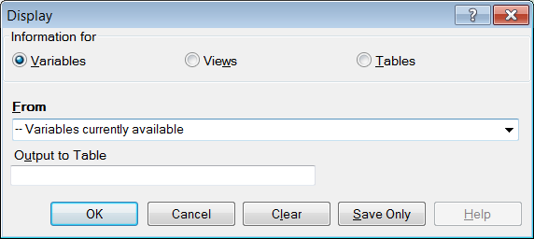
Figure 7.108: Display Dialog Box

- From the Information for section, select one of the following form data options:
- Variables displays information about all of the variables in the dataset; the defined, field, and selected variables.
- Forms displays the forms in the current dataset or a selected dataset. Information about forms and other Epi Info-specific tables is shown.
- Tables displays information about tables in a database. Information about tables and other Epi Info-specific or generic tables is shown.
- If needed, type an Output to Table name.
- Click OK. The information is displayed in the Output window.

How to Select Records

Use the SELECT Command

Use SELECT to view or analyze specific records based on selection criteria.
Syntax
SELECT <expression>

- From the Classic Analysis Command Tree, click Select/If > Select. The SELECT dialog box opens.

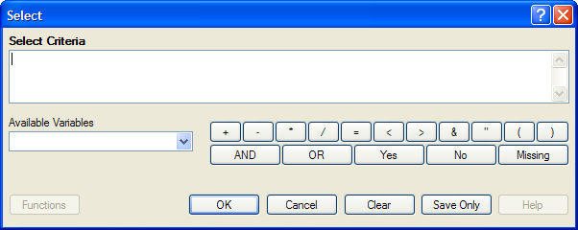
Figure 7.109: Blank Select Dialog Box

- Use the Available Variables drop-down list to select variables from the open dataset.
- Use the Select Criteria field and the Functions and Operators buttons to create selection code.
- Click OK. The Record Count in the Output window should alter based on the number of records meeting the new criteria.
- From the Classic Analysis Command Tree, click Statistics > List to view the records matching the selection criteria.
- From the Classic Analysis Command Tree Select/If folder, click Cancel Select to cancel the selection criteria and return the Record Count to all records in the dataset.

Select a Date Range

- From the Classic Analysis Command Tree, use the READ command to open a PRJ project file.
- From the Classic Analysis Command Tree, click Select/If > Select. The SELECT dialog box opens.

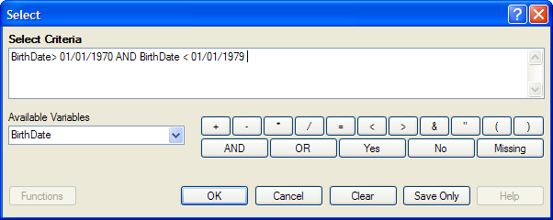
Figure 7.110: Select Dialog Box
- From the Available Variables drop-down list, select a date variable.
- In this example, DateVar is a date variable used in the data table. The DateVar has to be a date field or be converted into a date field using the NUMTODATE or TXTTONUM functions.
- In the Select Criteria field, create the date range selection code by using the greater than >, less than <, and AND operators.
Note: Unless the date literal is enclosed in braces or pipe symbols, literal dates in PGMs are always in U.S. date format. European date format (DD/MM/YYYY) literals must be enclosed in braces (i.e., {23/11/2007}). ISO date literals (YYYY/MM/DD) must be enclosed in pipe symbols (i.e.,|.,2007/11/23|).

Create the following example using the project called Sample.PRJ and the data from Surveillance.
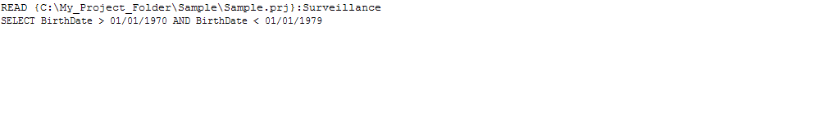

Use the CANCEL SELECT Command

SELECT
CANCEL SELECT Command Generator
CANCEL SELECT Command Reference

- From the Classic Analysis Command Tree, click Select/If > Cancel Select. The CANCEL SELECT dialog box opens.
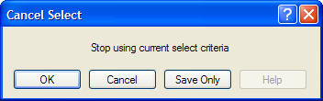
Figure 7.111: Cancel Select Dialog Box

- Click OK. The selection criteria are removed from the data and the original record count is restored.

Use the IF Command

The IF command defines a condition. True causes the THEN code block to be executed; false causes the ELSE code block (if present) to be executed.

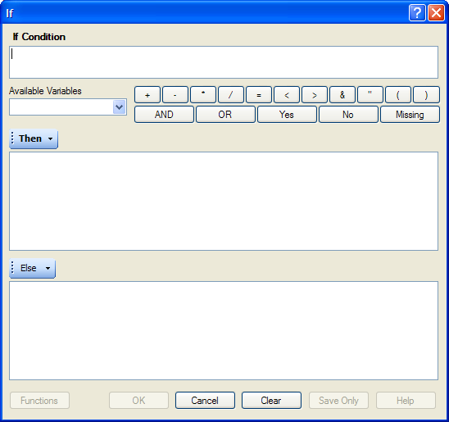
Figure 7.112: If Command Dialog Box

- The If Condition field specifies the condition to determine which statement that follows it is executed.
- The Available Variables field allows you to select variables available in the current project.
- The Then button is part of the If Condition statement. It starts the section of code executed when the If condition is true.
- The Else button is part of the If Condition and works as follows: If the condition is true, the first statement is executed. If false, the statement is bypassed, and if an else statement exists, it is executed instead.
- Functions and operators appear within commands and are used for common tasks (e.g., extracting a year from a date, combining two numeric values, or testing logical conditions).
- OK accepts the current settings and data, and subsequently closes the form or window.
- Save Only saves the created code to the Program Editor, but does not run the code.
- Functions opens the online Help file which explains the functions and operators. (Currently Disabled).
- Cancel closes the dialog box without saving or executing a command.
- Clear empties the fields so information can be re-entered.
- Help opens the Help topic associated with the module being used. (Currently Disabled).

Use the Sort Command
The Sort command allows you to specify a sequence for records to appear when using the LIST, GRAPH, and WRITE commands.

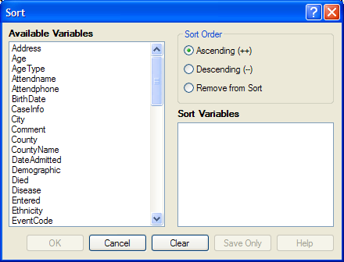
Figure 7.113: Sort Command Dialog Box
- The Available Variables field allows you to select variables available in the current project.
- Sort Order allows variables to be sorted in ascending (A to Z) or descending (Z to A) order. If the order is not specified, the sort order will be ascending. To sort one or more variables in descending order, the descending parameter (--) must be after each variable.
- Select Remove from Sort to remove the variables selected from the list.
- Sort Variables contains a list of variables selected for the sort.
- OK accepts the current settings and data, and subsequently closes the form or window.
- Save Only saves the created code to the Program Editor, but does not run the code.
- Cancel closes the dialog box without saving or executing a command.
- Clear empties the fields so that information can be re-entered.
- Help opens the Help topic associated with the module being used. (Currently Disabled).

CANCEL SORT

How to Use the CANCEL SORT command
The Cancel Sort command in Classic Analysis cancels a previous SORT command.

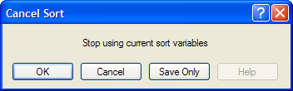
Figure 7.114: Cancel Sort

- OK accepts the current settings and data, and subsequently closes the form or window.
- Save Only saves the created code to the Program Editor, but does not run the code.
- Cancel closes the dialog box without saving or executing a command.
- Help opens the Help topic associated with the module being used. (Currently Disabled).

How to Display Statistics and Records

Use the LIST Command

The LIST command creates a line listing of the current dataset. Select specific variables from the Variables drop-down to narrow the list or select * (the Wild Card) to display all the variables. Check the All (*) Except box and select from the Variables drop-down to exclude variables from the list.
To navigate LIST * GRIDTABLE results, use the Tab key to move forward one cell at a time and the Shift+Tab keys to move back one cell at a time. Navigate through the records and cells using the left, right, up, and down arrow keys.
Syntax
LIST {* EXCEPT} [<variable(s)>] LIST {* EXCEPT} [<variable(s)>] {GRIDTABLE}

- From the Classic Analysis Command Tree, use the READ command to open a PRJ project file.
- From the Classic Analysis Command Tree, click Statistics > List. The LIST dialog box opens.

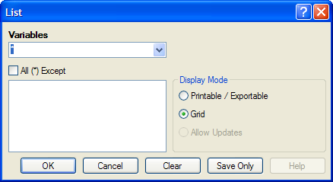
Figure 7.115: List Dialog Box

- Click OK to accept the default settings. The variables in the dataset appear in a grid table inside the Output Window.
- Grid output is not embedded. An Output file is not created.

Create a Web Format List
- From the Classic Analysis Command Tree, click Statistics > List. The LIST dialog box opens.
- From the Display Mode section, select the Printable / Exportable radio button.
- Click OK. The List appears in the Output window in a web table format. Web display mode creates an embedded output file.

Use the FREQ Command

The FREQ command produces a frequency table that shows how many records have a value for each variable, the percentage of the total, and a cumulative percentage. The command FREQ * creates a table for each variable in the current form other than unique identifiers. This command is used to begin analyses on a new data set.
Syntax
FREQ [<variable(s)>]
FREQ * {EXCEPT [<variable(s)>]}

- From the Classic Analysis Command Tree, use the READ command to open a PRJ project file.
- From the Classic Analysis Command Tree, click Statistics > Frequencies. The FREQ dialog box opens.

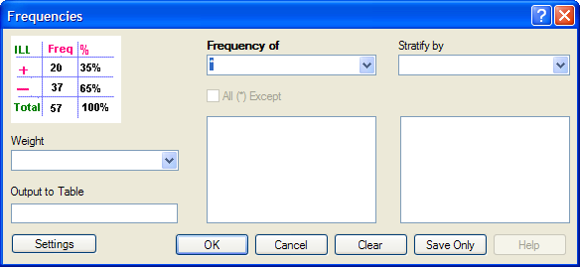
Figure 7.116: Frequency Dialog Box

- From the Frequency of drop-down list, select a variable from the data table.
- Click the All (*) Except checkbox to exclude variables.
- Use the corresponding drop-down lists to select a Weight variable or a Stratify by variable from the data source.
- Use the Output to Table field to specify a location for table results. The new table can be accessed using the READ command.
- Click OK. Results appear in the Output window.

Try It
For this example, use the Classic Analysis Command Tree to generate the FREQ command.
- Read in the Sample.PRJ project. Open Oswego. Seventy five (75) records should be listed in the Output window.
- Click Frequencies. The FREQ dialog opens.
- From the Frequency of drop-down list, select ILL.
- Click OK. Results appear in the Output window.
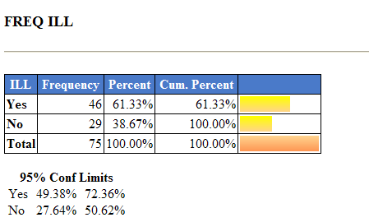
Figure 7.117: Frequency Output Window

- The Frequency column provides the count of individuals that were ill and not ill. The Percent column indicates the percentage of who were ill or not ill.
- The 95% Confidence Limits are a range of values that indicates the likely location of the true value of a measure, meaning (in this instance) that the number of ill could be as low as 49.38%, or as high as 72.36%. Note that the Yes Ill percentage of 61.33% falls within the 95% Confidence Limits range of values based on the data.

Try It
For this example, use the Classic Analysis Program Editor to create the code.
- Read in the Sample.PRJ project. Open Oswego. Seventy five (75) records should be listed in the Output window.
- In the Program Editor window, place the cursor under the Read command created. Type FREQ ILL.
- Do not press the Enter key. Leave the cursor on the line of code just created.

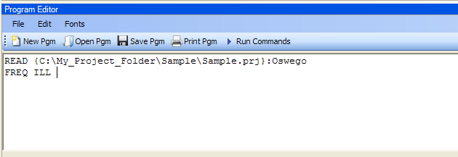
Figure 7.118: Frequency Command in Program Editor

- Click Run Commands from the Program Editor navigation menu. The code turns green indicating syntax review and execution.
- Results of the command appear in the Output window.
- Results are the same as those created using the Command Tree dialog boxes.

Try It
A program or PGM can be saved and run repeatedly against a dataset for continuously updated statistics and analyses.
- Read in the Sample.PRJ project. Open Oswego. Seventy five (75) records should be listed in the Output window.
- Click Open from the Program Editor. The Read Program dialog box opens.
- From the Program drop-down list, select Statistics.
- Click OK. The PGM opens in the Program Editor.
- Click Run. The Program Editor runs the code and output is placed in the Classic Analysis Output window.
- Use the scroll bar to review all the results computed to the Output window.

Use the TABLES Command

The Tables command examines the relationship between two or more categorical values. For 2x2 tables, the Tables command produces odds and risk ratios. A 2x2 table is created when each selected variable has a yes or no answer.
Syntax
TABLES <exposure> <outcome> {STRATAVAR=[<variable(s)>]} {WEIGHTVAR=<variable>} {PSUVAR=<variable>} {OUTTABLE=<table>} }

- From the Classic Analysis Command Tree, use the READ command to open a PRJ project file.
- From the Classic Analysis Command Tree, click Statistics > Tables. The TABLES dialog box opens.

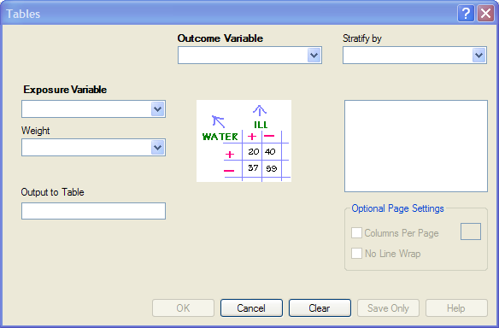
Figure 7.119: Tables Dialog Box

- From the Exposure Variable drop-down list, select a variable from the data to indicate a risk factor exists.
- From the Exposure Variable drop-down list, select a variable from the data to indicate the presence of an outcome. Use the:
- Stratify by drop-down list to select a variable to act as a grouping variable.
- Weight drop-down list to select a variable for weighted Classic Analysis.
- Output to Table field to specify a location for table results.
- READ command to access the READ command.
- Click OK. Results appear in the Output window.
- Scroll down to view the Single Table Classic Analysis.

Try It
Create a 2x2 table using data from the Sample.MDB project.
- Read in the Sample.PRJ project. Open Oswego. Seventy five (75) records should be listed in the Output window.
- Click Tables. The TABLES dialog box opens.
- From the Exposure Variable drop-down list, select Vanilla.
- From the Outcome Variable drop-down list, select ILL.
- Click OK. Results appear in the Output window.

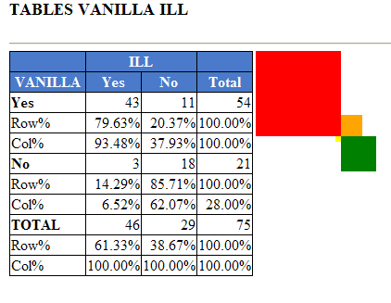
Figure 7.120: Tables Output Window

- Scroll down to view the Single Table Classic Analysis.

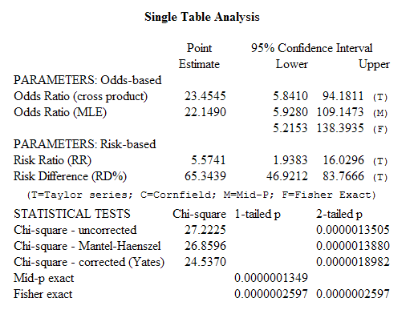
Figure 7.121: Single Tables Classic Analysis

Try It
For this example, use the Classic Analysis Program Editor to create the code.
- Read in the Sample.PRJ project. Open Oswego
- In the Program Editor window, place the cursor under the Read command created. Type TABLES Chocolate ill.
- Do not press the Enter key. Leave the cursor on the line of code just created.

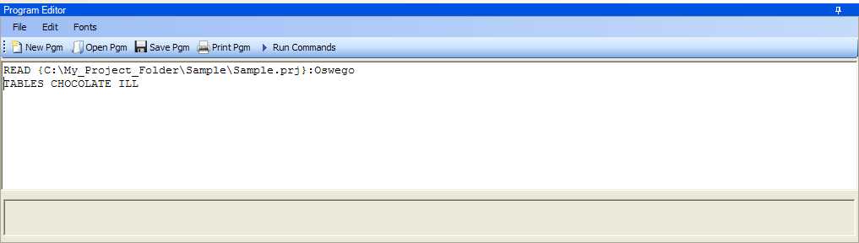
Figure 7.122: Tables Command in Program Editor

- Click Run Commands from the Program Editor navigation menu. The code turns gray indicating syntax review and execution.
- Results of the command appear in the Output window.
- Results are the same as those created using the Command Tree dialog boxes.

Try It
A program or PGM can be saved and run repeatedly against a dataset for continuously updated statistics and analyses.
- To see an example of a PGM, read in the Sample.PRJ project. Open Oswego.
- From the Program Editor, click Open Pgm. The Read Program dialog box opens.
- From the Program drop-down list, select Statistics.
- Click OK. The PGM opens in the Program Editor.
- Click Run Commands. The Program Editor runs the code and output is placed in the Classic Analysis Output window. Use the scroll bar to review all the results computed to the Output window.

Use the MEANS Command

The MEANS command can obtain an average for a continuous numeric variable. Since Yes equals ‘1’ and No equals ‘0’, the mean of a yes-no variable is the proportion of respondents answering yes. For this situation, use the FREQ command. It has two formats. If only one variable is supplied, the program produces a table similar to one produced by FREQUENCIES with descriptive statistics. If two variables are supplied, the first is numeric containing data to be analyzed. The second indicates how groups will be distinguished. The output of this format is a table similar to one produced by TABLES with descriptive statistics of the numeric variable for each group variable value.
Syntax
MEANS <variable 1> {<variable 2>} {STRATAVAR=<variable(s)>} {WEIGHTVAR=<variable>} {OUTTABLE=<tablename>}

- From the Classic Analysis Command Tree, use the READ command to open a PRJ project file.
- From the Classic Analysis Command Tree, click Statistics > Means. The MEANS dialog box opens.

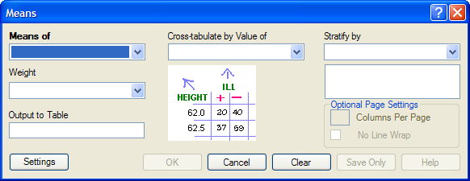
Figure 7.123: Means Dialog Box

- From the Means Of drop-down list, select a variable from the data source.
- The Cross-tabulate by value of drop-down list contains a variable to help determine if the means of a group are equal.
- The Stratify by drop-down list contains a variable to act as a grouping variable.
- The Weight drop-down list contains a variable for weighted Classic Analysis.
- The Output to Table field specifies a location for table results. The new table can be accessed using the READ command.
- Click OK. The Output window populates with the results. Scroll down to view the Mean and Standard Deviation results.

Try It
Use the MEANS command to find the average for a continuous variable.
- Read in the Sample.PRJ project. Open Oswego. Seventy five (75) records should be listed in the Output window.
- Click MEANS. The MEANS dialog box opens.
- From the Means of drop-down list, select Age.
- Click OK. Results appear in the Output window.
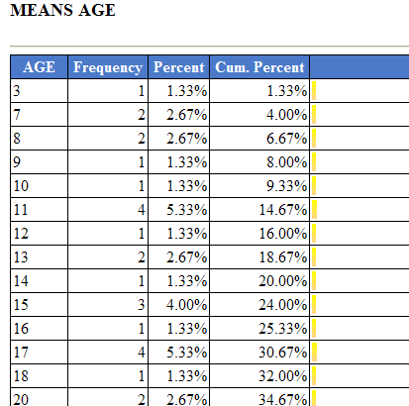
Figure 7.124: Means Output Window
- To view the Descriptive Statistics, scroll down the Age listing.
- Notice the mean age of individuals in the dataset is 36.8.
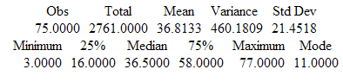
Figure 7.125: Output Data

Try It
For this example, use a numeric variable and a Yes/No variable to determine the MEANS for a group.

- Read in the Sample.PRJ project.
- Click MEANS. The MEANS dialog box opens.
- From the Means of drop-down list, select Age.
- From the Cross-Tabulate by Value of drop-down list, select ILL.
- Click OK. Results appear in the Output window.
- To view the Descriptive Statistics, scroll down the Age listing.
- Notice the Mean Age of those answering yes to ill is 39.2. Those answering no to ill is 32.9.

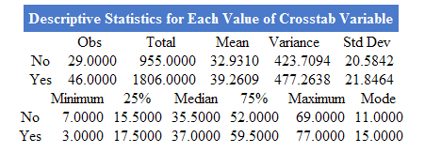
Figure 7.126: Descriptive Statistics Output Window

Other available statistics include:
- ANOVA, a Parametric Test for Inequality of Population Means.
- Bartlett's Test for Inequality of Population Variances.
- Mann-Whitney/Wilcoxon Two-Sample Test (Kruskal-Wallis test for two groups).
Try It
For this example, use the Classic Analysis Program Editor to create the code.
- Read in the Sample.PRJ project. Open Oswego.
- In the Program Editor window, place the cursor under the Read command created. Type MEANS Age.
- Do not press the Enter key. Leave the cursor on the line of code just created.

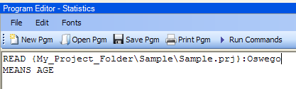
Figure 7.127: Means Age in Program Editor

- Click Run Commands from the Program Editor navigation menu. The code turns gray to indicate execution of syntax.
- Results of the command appear in the Output window.
- Results are the same as those created using the Command Tree dialog boxes.

Use the SUMMARIZE Command

The SUMMARIZE command aggregates data producing an output table showing the descriptive statistics.
Syntax
SUMMARIZE varname::aggregate(variable) [varname::aggregate(variable) ...] TO tablename STRATAVAR=variable list {WEIGHTVAR=variable}

- From the Classic Analysis Command Tree, use the READ command to open a PRJ project file.
- From the Classic Analysis Command Tree, click Statistics > Summarize. The Summarize dialog box opens.

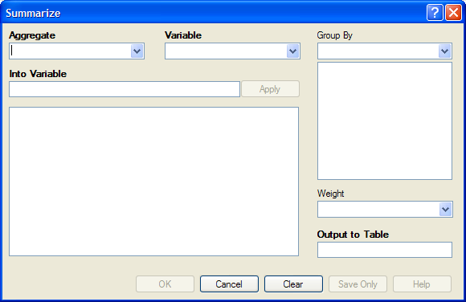
Figure 7.128: Summarize Dialog Box

- From the Aggregate drop-down list, select from the available functions to specify how records will be combined. The options are:
- Average - used only on numeric fields.
- Count
- First - based on sorts order.
- Last - based on sorts order.
- Maximum
- Minimum
- StdDev - Standard Deviation.
- StdDev(Pop)
- Sum - only used on numeric fields.
- Var- Variance - only used on numeric fields.
- Var(Pop)
- From the Variable drop-down list, select from the variables in the dataset.
- In the Into Variable field, type a name to title the summarized variable.
- Click Apply. The code appears in the open field.
- If grouping is necessary, use the Group By drop-down list to select a variable to group the aggregated data.
- If a weight variable exists, use the Weight drop-down list to select a variable to weight the aggregated data.
- In the Output to Table field, type a name for the new data table.
- Click OK. The following message appears in the Output window: Output table created: location listed.
- Click Read/Import. The READ dialog box opens.
- Click the All radio button. All the tables in the dataset appear in a list.
- Locate and select the summary table just created.
- Click OK. The Output window populates with the Record Count for the summary table.
- Use the LIST command to view the summary table.

Try It
- Read in the Sample.PRJ project. Open ADDFull. Three hundred and fifty nine (359) records should be listed in the Output window.
- Click Statistics > Summarize. The SUMMARIZE dialog box opens.
- From the Aggregate drop-down list, select Average.
- From the Variable drop-down list, select the variable GPA.
- In the Into Variable field, type AverageGPA.
- Click Apply. The code appears in the open field.
- From the Group By drop-down list, select the variable GENDER.
- In the Output to Table field, type DATATABLE1.
- Click OK. The following message appears in the Output window:
SUMMARIZE AverageGPA :: Avg(GPA) TO DATATABLE1 STRATAVAR = GENDER
- Click Read/Import. The READ dialog box opens.
- Click the Tables checkbox. All the tables in your dataset appear in a list.
- Select the summary table DATATABLE1.
- Click OK. The Output window populates with a record count of two for the summary table.
- Use the LIST command to view the summary table.

Use the GRAPH Command

The following steps create a basic graph containing one main variable. The GRAPH command opens the Epi Graph application and creates a variety of graph types based on the types of data available in the project.
Syntax
GRAPH [<Variable(s)>] GRAPHTYPE ="<GraphType>" [<OptionName>=OptionValue]
GRAPH [<Variable(s)>] * <Crosstab> GRAPHTYPE ="<GraphType>" [<OptionName>=OptionValue]
GRAPH [<Variable(s)>] GRAPHTYPE="<GraphType>" XTITLE="<string>" YTITLE="<string>"

- From the Classic Analysis Command Tree, use the READ command to open an Epi Info 7 .PRJ file.
- From the Classic Analysis Command Tree, click Statistics > Graph. The GRAPH dialog box opens.
- The default graph selection is Bar.

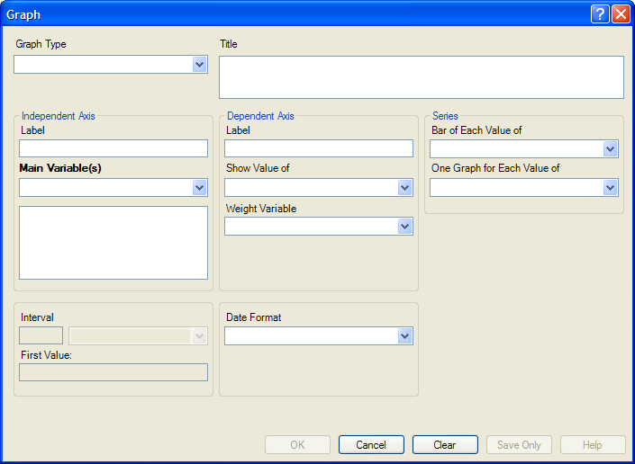
Figure 7.129: Graph Dialog Box

- From the Graph Type drop-down list, select a type of graph from the list.
- From the Main Variable(s) drop-down list, select the X-Axis value to graph. Use the:
- Show Value Of drop-down list to select an aggregate when multiple records need to be displayed as a group.
- Weight Variable drop-down list to select a variable for weighted Classic Analysis.
- Bar for Each Value Of drop-down list to select a variable to generate multiple series from a single data source, each with a different color or style.
- One Graph for Each Value of drop-down list to select a variable to generate a multiple series from a single data source, each displayed on a separate set of axes.
- X-Axis Label box to type a label to appear in the graph.
- Click OK. Epi Graph opens.
- View the graph. Graphs can be saved by clicking on the floppy disk icon located on the top right hand side of the graph.
- The graph is now embedded in the Output window as part of your output file.

Try It
Create a bar graph using data from the Sample.MDB project.
- Read in the Sample.PRJ project. Open Oswego. Seventy five (75) records should be listed in the Output window.
- Click Statistics > Graph. The GRAPH dialog box opens.
- From the Graph Type drop-down list, select Column.
- From the Main Variable drop-down list, select the variable Age to use for the X-Axis.
- Click OK. Epi Graph opens.
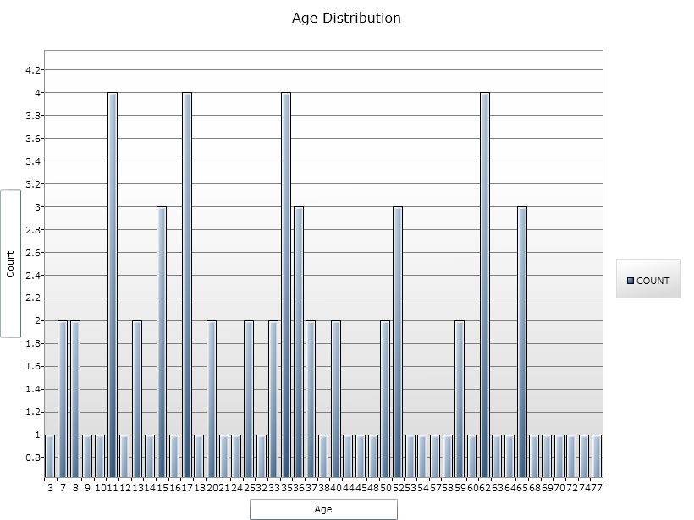
Figure 7.130: Bar Graph

- The bar graph is now embedded in the Output window and part of the output file.
- Notice the Graph code that appears in the Program Editor.

How to Manage Output

Header
The Header command in Classic Analysis sets up specific headings as part of the output in Analysis.

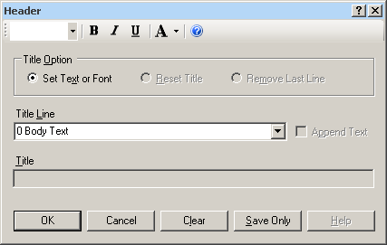
Figure 7.131: Header Command Window
- Title Option permits title lines to be set or changed. If you select Reset Title, the selected title level will be reset to default titles. If you select Remove Last Line, the last line of a title level will be removed.
- Title Line indicates which level of titles or body text is affected by the command and settings.
- Append Text adds a new line of text to an existing header. If not selected, the current title is replaced.
- Title indicates the text in the header title.
- Bold displays header fonts in bold style text.
- Italic italicizes header fonts.
- Underline underlines header fonts.
- Font Size sets the text font size.
- Font Color allows you to apply a color to the header text.
- OK accepts the current settings and data, and subsequently closes the form or window.
- Save Only saves the created code to the Program Editor, but does not run the code.
- Cancel closes the dialog box without saving or executing a command.
- Clear empties the fields so information can be re-entered.
- Help opens the Help topic associated with the module being used. (Currently Disabled).

TypeOut
The TypeOut command in Classic Analysis inserts text, either a string or the contents of a file, into the output. Typical uses may include comments or boilerplates.

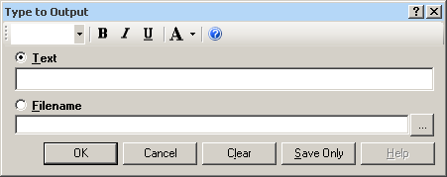
Figure 7.132: Type to Output, or TypeOut, Window
Selecting “Filename” opens the Windows File Explorer to allow you to select a file to be included in your output.

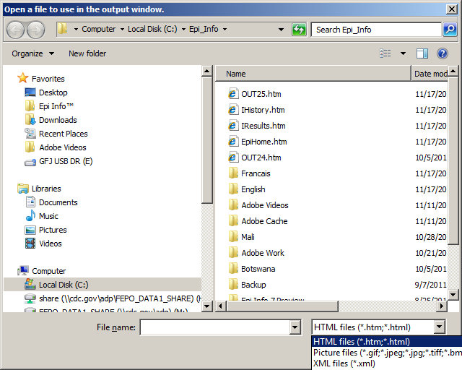
Figure 7.133: Open File Window

- The Text or Filename field contains the text or file name to be inserted in the output file.
- Bold displays type fonts in bold style text.
- Italic italicizes type fonts.
- Underline underlines type fonts.
- Font Size sets the type text font size.
- Font Color allows you to apply a color to the type text.
- Type a filename or click the ellipse to locate a file (e.g., HTM, JPEG, XML).
- OK accepts the current settings and data, and subsequently closes the form or window.
- Save Only saves the created code to the Program Editor, but does not run the code.
- Cancel closes the dialog box without saving or executing a command.
- Clear empties the fields so information can be re-entered.
- Help opens the Help topic associated with the module being used. (Currently Disabled).

Use the ROUTEOUT Command

The ROUTEOUT command enables you to locate output. If no directory exists, the file is placed in the current project’s directory. Results accumulate until a CLOSEOUT command is executed. Output files can be placed in any folder. The ROUTEOUT command selects a path and filename. If no output file is selected, Analysis uses the default value. In each folder, Analysis creates a new index table that contains links to the files created.
- From the Analysis Command Tree, use the READ command to open a PRJ project file.
- From the Analysis Command Tree, click Output > RouteOut. The ROUTEOUT dialog box opens.

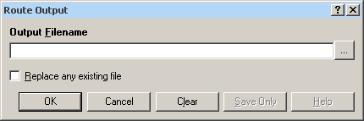
Figure 7.134: Route Output Window

- In the Output Filename field, enter a file name to locate an existing file.
- If necessary, select Replace Existing File to write over any files with the same name.
- Click OK. Create Output on the existing project.
- Notice the title bar contains the output filename specified in the ROUTEOUT command.
- The new file is placed in the selected directory with the extension .HTM.
- From the Output window toolbar, click Open. The Browse dialog box opens.
- Locate and select the file created with ROUTEOUT. Click Open. The Output appears in the Output window.
- The saved Output file can be opened by any application that can read an HTML file.

To end the ROUTEOUT command, choose one of the following options.
- From the Output folder, click Closeout.
- READ in a new project.
- Close Epi Info.

Closeout
The Closeout command closes the current output file.

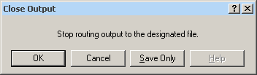
Figure 7.135: Close Output Window
- OK accepts the current settings and data, and subsequently closes the form or window.
- Save Only saves the created code to the Program Editor, but does not run the code.
- Cancel closes the dialog box without saving or executing a command.
- Help opens the Help topic associated with the module being used. (Currently Disabled).

Printout
Command Reference
The Printout command sends the current output file, or another file specified by the user, to the default printer. This differs from the print button on the output window because a command is generated that causes printing whenever it is run.

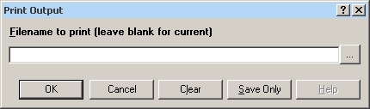
Figure 7.136: Print Output Window
- If Filename is selected, the file will print. If blank, it prints the current output.
- The ellipses (…) to the right of the filename opens a Windows dialog box and allows you to search the computer for the program or command to execute.
- OK accepts the current settings and data, and subsequently closes the form or window.
- Save Only saves the created code to the Program Editor, but does not run the code.
- Cancel closes the dialog box without saving or executing a command.
- Clear empties the fields so information can be re-entered.
- Help opens the Help topic associated with the module being used. (Currently Disabled).

Storing Output
The Storing Output command defines how output files are stored in the current project directory with a name composed of a prefix and a sequence number.

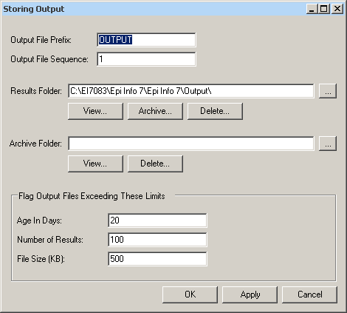
Figure 7.137: Storing Output Command Window

- Output File Prefix contains the first part of the filename of the output files. It is used with the Output File Sequence to store output files in the directory.
- Output File Sequence contains the second part of the filename for output files. This number is automatically incremented for each file. Along with the Output File Prefix, it stores output files in the directory.
- Results Folder locates the Results index file in the project directory.
- The Archive Folder allows you to locate the Archive file in the directory.
- Archive opens the Archive Results window, and allows specific output files to be selected and archived to the current directory.
- Delete opens the Delete Results window and allows you to delete specific files from the directory.
- Age in Days marks output files older than the indicated number of days in the form window if Flags are active. If output file limits are placed on number of days, it appears in the Flag Files operation.
- Number of Results marks output files in excess of the number indicated in the form window if Flags are active.
- File Size marks output files in excess of the size indicated in the form window if Flags are active. Enter output file size limits in this field.
- OK accepts the current settings and data, and subsequently closes the form or window.
- Apply accepts the current settings and data, and subsequently closes the form or window.
- Cancel exits the dialog box without saving or executing a command.

How to Use User-Defined Commands

Define Command (CMD)
The User Define Command allows you to create a block of code that can be invoked by name, like a subroutine. This is useful for sequences of commands that will be called more than once.

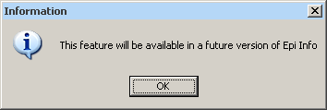
Figure 7.138: Future Version Notice
- This command will be available in a future version of Epi Info 7.

Run Saved Program

Command Reference
The Run Saved Program command in Classic Analysis transfers control to the second program returning to the first automatically, beginning with the line following the RUN statement. A program being run from another program is similar to an INCLUDE or subroutine in other systems.

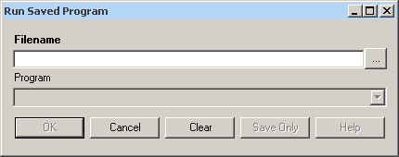
Figure 7.139: Run Saved Program

- Filename indicates the database or text file containing the program. If the path or filename contains a space, it must be enclosed in double quotes. If the program to be run is in the current project, the path does not need to be supplied.
- Program indicates the program name if it’s in the database.
- OK accepts the current settings and data, and subsequently closes the form or window.
- Cancel closes the dialog box without saving or executing a command.
- Clear empties the fields so information can be re-entered.
- Save Only saves the created code to the Program Editor, but does not run the code.
- Help opens the Help topic associated with the module being used. (Currently Disabled).

Save and Open a Program (PGM)

Commands entered into Classic Analysis generate lines of code in the Program Editor and can be stored in the current data source (.mdb file or SQL server). Programs can be saved internally within the project or externally as a text file with a .pgm7 file extension. Saved programs that can be run as data are updated. Programs can be saved as text files, and shared without sharing data tables or projects.

Example of Code Created in the Program Editor
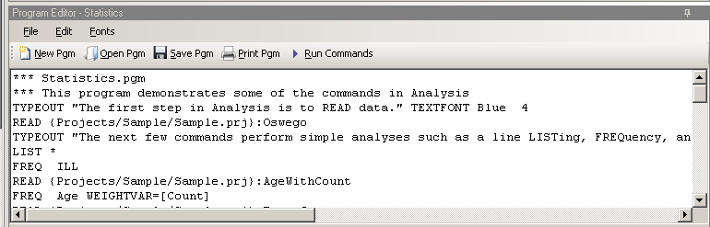
Figure 7.140: Example Code in Program Editor

Save Code as a PGM
- From the Program Editor Navigation bar, click the Save Pgm icon. The Save Program dialog box opens.
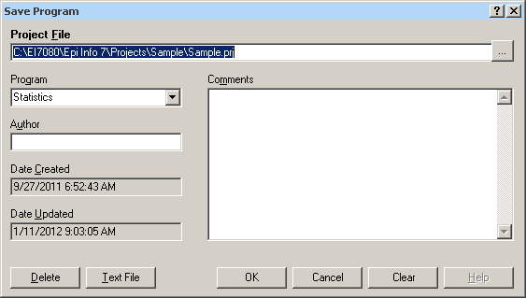
Figure 7.141: Save Program Dialog Box

- In the Program field, type a name for the program.
- In the Author field, type a name or initials.
- In the Comments field, type a description of the program.
- Click OK.
- When code is saved, it is written to a special table in the current .mdb, called Programs.
- A saved program can be executed with the RUNPGM command, or opened in the Program Editor.
- From the Save Program dialog box, click Text File to save code to a text file.

Open and Run a Saved PGM
- From the Program Editor, select File > Open Pgm or click the Open Pgm icon. The Read Program dialog box opens.
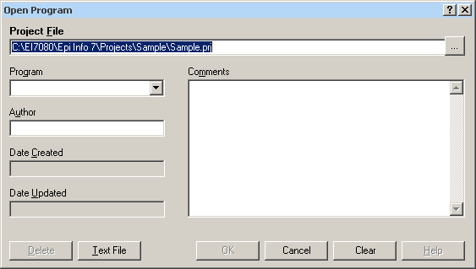
Figure 7.142: Read Program Dialog Box

- From the Program drop-down list, select a saved Pgm.
- Information about the program automatically populates the open fields in the dialog box.
- To open a program that was saved externally, click Text File to view all available .pgm files.
- Click OK. The program code opens in the Program Editor.
- Code can now be run, edited, or saved.
- Click Run Commands. The Program Editor runs all the code listed and displays the results in the Output window.
- To run individual commands, use the cursor to highlight the commands you want to run. Click Run Commands.

Execute File
Command Reference
This command executes a Windows program in Classic Analysis. You can either explicitly name the command (e.g., WinWord.exe) or one designated within the Windows registry as appropriate for a document with the named file extension (C:\Temp\MyDocument.doc). This provides a mechanism for bringing up whatever word processor or browser is the default on a computer without first knowing its name.

If the pathname is a long filename, it must be surrounded in single quotes. If the command takes parameters, surround the command and the parameters with a single set of double quotes. Do not use single quotes.

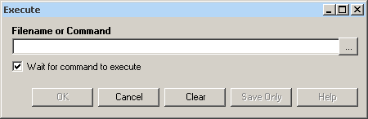
Figure 7.143: Execute File Dialog Box
- Filename is the file name, program name, or command to execute. Enter a path and program name for .EXE and .COM files along with any desired command line arguments.
- Wait for command to execute indicates whether the program should run before or after the command is executed.
- OK accepts the current settings and data, and subsequently closes the form or window.
- Cancel closes the dialog box without saving or executing a command.
- Clear empties the fields so information can be re-entered.
- Save Only saves the created code to the Program Editor, but does not run the code.
- Help opens the Help topic associated with the module being used. (Currently Disabled).
Syntax
EXECUTE <filename>
EXECUTE <program-name>
EXECUTE "<fprogram-name><command-line parameters>"
EXECUTE NOWAITFOREXIT <filename>
EXECUTE NOWAITFOREXIT '<filename>'
EXECUTE NOWAITFOREXIT "<filename>"
EXECUTE WAITFOREXIT <filename>
EXECUTE WAITFOREXIT '<filename>'
EXECUTE WAITFOREXIT "<filename>"
- The <program name> represents the path and program name for .exe (filename for registered Windows programs) and .com (any Internet address) files, along with any desired command line arguments. If a parameter is added, the whole string should be enclosed within double quotes.
- If EXECUTE is run modally, permanent variables are written before the command is executed, and reloaded after it is executed.
Comments
If the given name is not a program, but a file with an extension (the three characters after the ".") registered by Windows for displaying the document, the correct program to display the file will be activated (i.e., WRITEUP.DOC might cause Microsoft Word to run and load the file on one computer). Usually .TXT will run NOTEPAD.EXE or WORDPAD.EXE, and image files will appear either in a browser or graphics program. An .HTM file will bring up the default browser.
Example
EXECUTE "C:\Epi_Info_7\Enter.exe sample.prj:oswego"
EXECUTE "C:\ Epi_Info_7\OUT120.htm'
EXECUTE "C:\windows\notepad.exe c:\Test1.txt"

How to Create User Interaction

DIALOG
How to Use the DIALOG Command
The DIALOG command provides user interaction from within a program. Dialogs can display information, ask for and receive input, and offer lists to make choices.

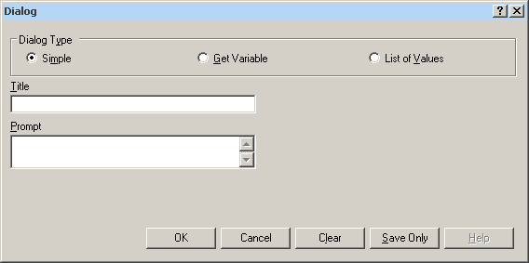
Figure 7.144: Dialog Command

DIALOG Type Simple
- Title holds the text of the heading title.
- Prompt contains the text to be used in the dialog as a message.
- OK accepts the current settings and data, and subsequently closes the form or window.
- Cancel closes the command generation window without saving or executing a command.
- Clear empties fields so information can be re-entered.
- Save Only saves the command in the Program Editor, but does not run the command.
- Help opens the Help topic associated with the module being used. (Currently Disabled).

DIALOG Type Get Variable
This form of dialog displays a combo box of databases or form variables.

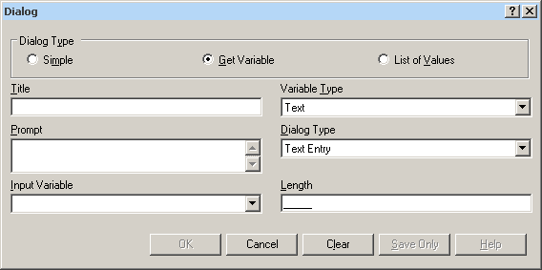
Figure 7.145: Dialog Type Combination Box

- Title holds the text of the heading title.
- Prompt contains the text to be used in the dialog as a message.
- Input Variable allows you to select a variable from the current data table.
- Variable Type allows you to select the dialog format to receive the value. Formats include Text, Number, Date, and Yes-No-Cancel. This field defaults to any previously assigned types. If the Variable Type is Text, the Dialog Type drop down allows you to select Text Entry, Multiple Choice, Variable List, Form List, Database List, File Open, and File Save. Database List options are not restricted to databases, but can include any file type. The Multiple Choice selection opens another set of dialog boxes to set up the choice selection.
- Pattern and/or Length create the pattern or size that allows input to follow when entered into the variable. Pattern options are based on Variable and Dialog Type selections. Number Type patterns consist of pound signs (#) and can contain one decimal place with a boundary. Date pattern options are DD-MM-YYYY, MM-DD-YYYY, or YYYY-MM-DD.
- OK accepts the current settings and data, and subsequently closes the form or window.
- Cancel closes the command generation window without saving or executing a command.
- Clear empties fields to re-enter information.
- Save Only saves the command in the Program Editor, but does not run the command.
- Help opens the Help topic associated with the module being used (Currently Disabled).

DIALOG Type List of Values
This dialog type displays a combo box of distinct values of the specified variable in the specified database.

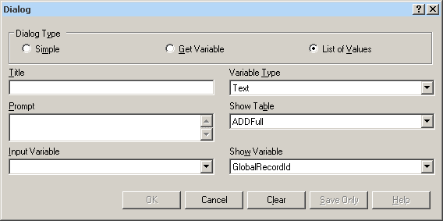
Figure 7.146: Dialog Type List of Values

- Title holds the text of the heading title.
- Prompt contains the text to be used in the dialog as a message.
- Input Variable allows you to select a variable from the current data table.
- Variable Type allows you to select the dialog format to receive the value. Options are Text, Number, Date, and Yes-No-Cancel.
- Show Table contains a list of available forms or tables in the current project.
- Show Variable contains a list of available fields that act as selection criteria for the input variable in the current project.
- OK accepts the current settings and data, and subsequently closes the form or window.
- Cancel closes the command generation window without saving or executing a command.
- Clear empties fields to re-enter information.
- Save Only saves the command in the Program Editor, but does not run the command.
- Help opens the Help topic associated with the module being used (Currently Disabled).

BEEP
The Beep command generates a sound when a function is performed.

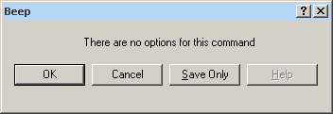
Figure 7.147: Beep Command Box

- OK accepts the current settings and data, and subsequently closes the form or window.
- Cancel closes the dialog box without saving or executing a command.
- Save Only saves the created code to the Program Editor, but does not run the code.
- Help opens the Help topic associated with the module being used (Currently Disabled).

QUIT
The Quit command closes the current data files and terminates the current program, closing Analysis.

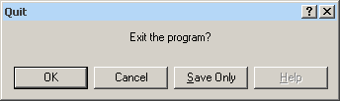
Figure 7.148: Quit Command Box

- OK accepts the current settings and data, and subsequently closes the form or window.
- Cancel closes the dialog box without saving or executing a command.
- Save Only saves the created code to the Program Editor, but does not run the code.
- Help opens the Help topic associated with the module being used (Currently Disabled).

Use IF Statements with Permanent or Global Variables

- If an IF statement condition depends on global or permanent variables, the value is computed immediately and only the true or false branch, as appropriate, is followed.
- If an IF statement condition depends on a field variable, neither branch is followed. However, computations within the branches are saved for execution, as appropriate, on each record. In the second case, non-computational commands (e.g., READ, SELECT, SORT, HEADER, and ROUTEOUT) are never executed.

SET

Description
This command provides various options that affect the performance and output of data in Classic Analysis. These settings are utilized whenever the Classic Analysis program is used.
Syntax
SET [<parameter> = <value>]

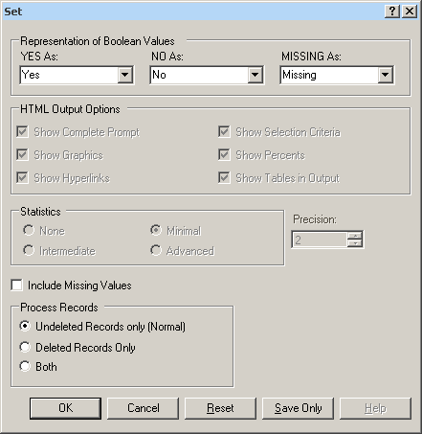
Figure 7.149: Set Options Window

- Representation of Boolean Values allows you to determine how values in the Epi Info 7 projects line list are displayed for Yes/No and Checkbox fields. Boolean Values are stored in the database according to the convention used by that database. Epi Info 7 converts the line listing displayed in analysis according to the selection in this menu.
- HTML Output Options are not available in this version of Epi Info 7.
- Statistics settings are not available in this version of Epi Info 7. The grayed-out display indicates analysis statistics are advanced. The None, Minimal and Intermediate settings will be available in a future release.
- Precision setting is not available in this version of Epi Info 7.
- Include Missing Values allows you to determine if you want missing values to be included if statistical calculations are made.
- Process Records selects how records marked for deletion (deleted) will be processed. The normal default is to process only the undeleted records.
- OK accepts the current settings and data, and subsequently closes the form or window.
- Cancel closes the dialog box without saving or executing a command.
- Reset clears (removes) any changes and returns all values to their default settings.
- Save Only saves the created code to the Program Editor, but does not run the code.
- Help opens the Help topic associated with the module being used. (Currently Disabled).

How to Use Advanced Statistics

Use the REGRESS Command

The REGRESS command performs linear regression and contains support for automatic dummy variables and multiple interactions.
REGRESS can be used for simple linear regression (only one independent variable), for multiple linear regression (more than one independent variable), and for quantifying the relationship between two continuous variables (correlation). Regression is used when you want to predict one dependent variable from one or more independent variables.

Syntax
REGRESS <dependent variable> = <independent variable(s)> [NOINTERCEPT] [OUTTABLE=<tablename>] [WEIGHTVAR=<weight variable>] [PVALUE=<PValue>]

Dialog Box

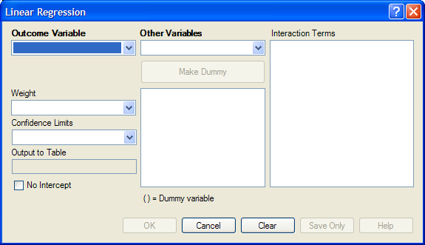
Figure 7.150: Linear Regression Window
- The Outcome Variable is the dependent variable for the regression.
- Other Variables appear in the predictor variables list.
- Interaction Terms are defined with the Make Interaction button. Make Interaction appears if two or more variables are selected from the Other Variables list box. If you click Make Interaction, the relationship populates the Interaction Terms list box.
- Make Dummy is activated if you select a predictor variable. If you select a numeric variable, it will be treated as discrete rather than continuous; the variable is enclosed in parentheses to indicate that dummy variables are being created. If a predictor variable enclosed in parentheses is selected in the list, the Make Dummy button changes to Make Continuous. Selecting it results in the variable being treated as continuous. If you select more than one predictor variable, the Make Dummy button changes to Make Interaction. Selecting it results in all possible combinations of the selected variables being added to the regression as interaction terms.
- A Weight variable may selected to use in weighted analyses.
- Confidence Limits specifies the probability level at which confidence limits are computed (default=.05).
- The Output to Table field identifies a table to receive output from the command. (Currently Disabled).
- If you select No Intercept, the regression is performed without a constant term, forcing the regression line through the origin.
- OK accepts the current settings and data, and subsequently closes the form or window.
- Save Only saves the created code to the Program Editor, but does not run the code.
- Cancel closes the dialog box without saving or executing a command.
- Clear empties the fields so information can be re-entered.
- Help opens the Help topic associated with the module being used. (Currently Disabled).
How to Use
- From the Analysis Command Tree, use the READ command to open a PRJ project file. Select a form or table.
- From the Analysis Command Tree, click Advanced Statistics > Linear Regression. The REGRESS dialog box opens.

Figure 7.151: Linear Regression Window

- From the Outcome Variable drop-down list, select a variable to be the dependent variable for regression.
- From the Other Variables drop-down list, select the variable(s) to be the predictors.
- If you select any predictor variables, Make Dummy will be activated. Selecting one will allow a numeric variable to become discrete rather than continuous; the variable is enclosed in parentheses to indicate that dummy variables are created. If a predictor variable enclosed in parentheses is selected, the Make Dummy button changes to Make Continuous. Selecting it makes the variable continuous. If you select more than one, the Make Dummy button changes to Make Interaction. Selecting it adds all possible selected combinations to the regression as interaction terms.
- Make Interaction appears if you select two or more variables from the Other Variables list box. Interaction Terms are defined with the Make Interaction button. Click Make Interaction. The relationship populates the Interaction Terms list.
- The Output to Table field identifies a data table to receive output from the command. Results can be sent to an output table for graphing. (Currently Disabled).
- If No Intercept is selected, the regression is performed without a constant term, forcing the regression line through the origin.
- Click OK. Results appear in the Output window.

Try It
- Read in the project Sample.PRJ. Open BabyBloodPressure.
- Click Linear Regression. The REGRESS dialog box opens.
- From the Outcome Variable drop-down list, select SystolicBlood.
- From the Other Variables drop-down list, select AgeInDays.
- From the Other Variables drop-down list, select Birthweight.
- Click OK. Results appear in the Output window.
Linear Regression

Variable | Coefficient | Std Error | F-test | P-Value
AgeInDays | 5.888 | 0.680 | 74.9229 | 0.000002
Birthweight | 0.126 | 0.034 | 13.3770 | 0.003281
CONSTANT | 53.450 | 4.532 | 139.1042 | 0.000000

Correlation Coefficient: r^2= | 0.88

Source | df | Sum of Squares | Mean Square | F-statistic
Regression | 2 | 591.036 | 295.518 | 48.081
Residuals | 13 | 79.902 | 6.146
Total | 15 | 670.938

Use the LOGISTIC Command

The Logistic Regression command performs conditional or unconditional multivariate logistic regression with automatic dummy variables and support for multiple interactions.
The dependent (Outcome) variable must have a Yes/No value. Records with missing values are excluded from the analyses.
Independent (Other Variables) can be numeric, categorical, or Yes/No variables. Missing is interpreted as missing, 0 is false, and any other response is true. Independent variables are controlled by the Include Missing setting. If Include Missing is used with missing values and true and false, dummy variables will be made automatically, which contribute Yes vs. Missing and No vs. Missing. Independent variables of text type are automatically turned into dummy variables, which compare each value relative to the value lowest in the sort order. Date or numeric type Independent variables are treated as continuous variables unless surrounded by parentheses in the command. If that occurs, they automatically turn into dummy variables which compare each value relative to the lowest value.
Syntax
LOGISTIC <dependent variable> = <independent variable(s)> [MATCHVAR=<match variable>] [NOINTERCEPT] [OUTTABLE=<tablename>] [WEIGHTVAR=<weight variable>] [PVALUE=<PValue>]
Dialog Box
- From the Analysis Command Tree, use the READ command to open a PRJ project file. Select a form or table.
- From the Analysis Command Tree, click Advanced Statistics > Logistic Regression. The LOGISTIC dialog box opens.

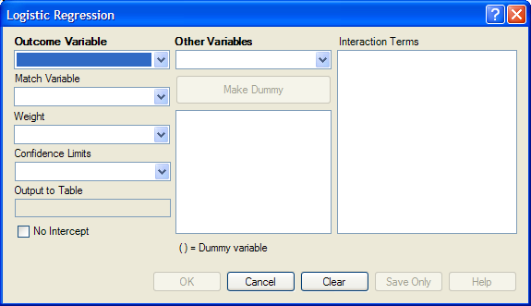
Figure 7.152: Logistic Regression Window

- From the Outcome Variable drop-down list, select a variable to act as the dependent variable for regression.
- From the Other Variables drop-down list, select the variable(s) to act as the predictors.
- If you select any predictor variables, Make Dummy will be activated. Selecting one will allow a numeric variable to become discrete rather than continuous; the variable is enclosed in parentheses to indicate that dummy variables are created. If a predictor variable enclosed in parentheses is selected, the Make Dummy button changes to Make Continuous. Selecting it makes the variable continuous. If you select more than one, the Make Dummy button changes to Make Interaction. Selecting it adds all possible selected combinations to the regression as interaction terms.
- Make Interaction appears if two or more variables are selected from the Other Variables list box. Interaction Terms are defined with the Make Interaction button. Click Make Interaction. The relationship populates the Interaction Terms list.
- Match Variable identifies the variable indicating the group membership of each record.
- The Output to Table field identifies a data table to receive output from the command. Results can be sent to an output table for graphing. (Currently Disabled).
- If No Intercept is selected, the regression is performed without a constant term forcing the regression line through the origin.
- Click OK. Results appear in the Output window.

Try It
- Read in the project Sample.PRJ. Open Oswego
- Click Logistic Regression. The LOGISTIC dialog box opens.
- From the Outcome Variable drop-down list, select ILL.
- From the Other Variables drop-down list, select BROWNBREAD, CABBAGESAL, WATER, MILK, CHOCOLATE, and VANILLA.
- Click OK. Results appear in the Output window.
Unconditional Logistic Regression
Term | Odds Ratio | 95% | C.I. | Coefficient | S. E. | Z-Statistic | P-Value
BROWNBREAD (Yes/No) | 1.7803 | 0.3932 | 8.0614 | 0.5768 | 0.7706 | 0.7485 | 0.4542
CABBAGESAL (Yes/No) | 1.1342 | 0.2818 | 4.5647 | 0.1259 | 0.7104 | 0.1772 | 0.8593
WATER (Yes/No) | 1.1122 | 0.2670 | 4.6326 | 0.1063 | 0.7280 | 0.1460 | 0.8839
MILK (Yes/No) | 0.1342 | 0.0068 | 2.6635 | -2.0086 | 1.5246 | -1.3174 | 0.1877
CHOCOLATE (Yes/No) | 1.0975 | 0.3024 | 3.9829 | 0.0930 | 0.6577 | 0.1415 | 0.8875
VANILLA (Yes/No) | 26.0016 | 5.4707 | 123.5818 | 3.2582 | 0.7953 | 4.0968 | 0.0000
CONSTANT | * | * | * | -2.1277 | 0.9733 | -2.1861 | 0.0288

Convergence: | Converged
Iterations: | 5
Final -2*Log-Likelihood: | 69.2504
Cases included: | 74

Test | Statistic | D.F. | P-Value
Score | 28.0180 | 6 | 0.0001
Likelihood Ratio | 29.8484 | 6 | 0.0000

Use the KMSURVIVAL Command

The KMSURVIVAL command performs Kaplan-Meier (KM) Survival Analysis. The objective of this methodology is to estimate the probability of survival of a defined group at a designated time interval. KM uses a non-parametric survival function for a group of patients (their survival probability at time t) and does not make assumptions about the survival distribution.
What distinguishes survival analysis from most other statistical methods is the presence of “censoring” for incomplete observations. In a study following two different treatment regimens, analysis of the trial typically occurred well before all patients died. For those still alive at the time of analysis, the true survival time was known only to be greater than the time observed to date. These observations are called “censored.” Two other sources of incomplete observation are patients “lost to follow-up,” and the appearance of an event other than the event being studied.
Survival analysis requires censored and time variables, the units of time, and the groups being compared.
Syntax
KMSURVIVAL <TimeVar> = <GroupVar> * <CensorVar> (<Value>) [TIMEUNIT="<TimeUnit>"] [OUTTABLE=<TableName>] [GRAPHTYPE ="<GraphType>"] [WEIGHTVAR=<WeightVar>]
Dialog Box
- From the Analysis Command Tree, use the READ command to open a PRJ project file. Select a form or table.
- From the Analysis Command Tree, click Advanced Statistics > Kaplan-Meier Survival. The Kaplan-Meier Survival dialog box opens.
- From the Censored Variable drop-down list, select the variable that indicates whether the case is a failure or a censored case.
- From the Value for Uncensored drop-down list, select the value of the censored variable that indicates a failure.
- From the Time Variable drop-down list, select the variable that indicates at which time the failure or censorship occurred.
- From the Test Group Variable drop-down list, select the discrete variable used to divide cases into groups.
- Click OK. Results appear in the Output window.
- A Survival Probability graph is produced by default. Use the Graph Type drop-down list to select the Log-Survival graph type or None to view the results in a table.

Try It
- Read in the Sample.PRJ project. Open the Addicts table.
- Click KAPLAN-MEIER SURVIVAL. The Kaplan-Meier Survival dialog box opens.
- From the Censored Variable drop-down list, select Status.
- From the Value for Uncensored drop-down list, select 1.
- From the Time Variable drop-down list, select Survival_Time_Days.
- From the Test Group Variable drop-down list, select Clinic.
- Click OK. Results appear in the Output window.
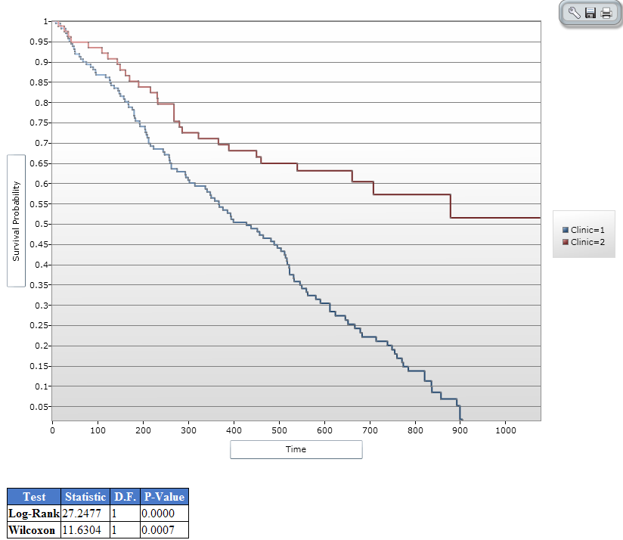
Figure 7.153: Results of Kaplan-Meier Example Survey

Use the COXPH Command

The COXPH command performs Cox Proportional Hazards survival analysis. This form of survival analysis relates covariates to failure through hazard ratios. A covariate with a hazard ratio less than one suggests improved survival for the level being compared with the reference level. COXPH output includes regression coefficients, test statistics with p-values, hazard ratios, and cumulative survival plots.
What distinguishes survival analysis from most other statistical methods is the presence of “censoring” for incomplete observations. In a study following two different treatment regimens, analysis of the trial typically occurred well before all patients died. For those still alive at the time of analysis, the true survival time is known only to be greater than the time observed to date. These observations are called “censored”. Two other sources of incomplete observation are patients “lost to follow-up”, and the appearance of an event other than the event being studied.
Survival analysis requires censored and time variables, the units of time, and the groups being compared.
Syntax
COXPH <time variable>= <covariate(s)>[: <time function>:] * <censor variable> (<value>) [TIMEUNIT="<time unit>"] [OUTTABLE=<tablename>] [GRAPHTYPE="<graph type>"] [WEIGHTVAR=<weight variable>] [STRATAVAR=<strata variable(s)>] [GRAPH=<graph variable(s)>]
Dialog Box

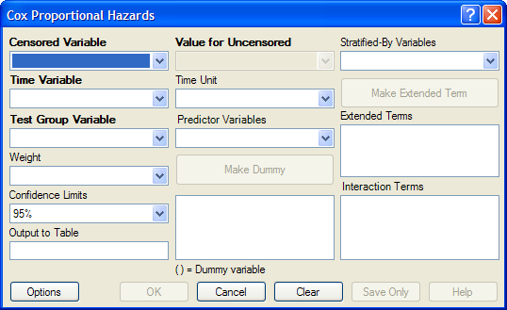
Figure 7.154: Cox Proportional Hazards Dialog Box

- The Censored Variable indicates whether the case is a failure or censored.
- The Time Variable indicates at which time the failure or censorship occurred.
- Test Group Variable is a discrete variable used to divide cases into groups for comparison. In the Cox model, there is no essential difference between the group variable and other predictor terms. For this reason, its use is optional.
- A Weight variable is selected for use in weighted analyses. The weight variable applies to all aggregation clauses.
- Confidence Limits indicate the probability level at which confidence limits should be computed (default=.05).
- The Output to Table field identifies a data table to receive output from the command. (Currently Disabled).
- Value for Uncensored is the value of the censored variable that indicates a failure.
- Time Unit is the unit in which the time variable is expressed.
- Predictor Variables populates the predictor variables list.
- If a predictor variable is selected, Make Dummy is active. If selected, a numeric variable is treated as discrete rather than continuous; the variable is enclosed in parentheses to indicate that dummy variables are being created. If you select a predictor variable enclosed in parentheses, the button changes to Make Continuous. Selecting it results in the variable being treated as continuous.
- Stratify by identifies the variable (if any) to be used to stratify data.
- Options opens the graph selection window and allows you to select variables for graphing and graph types.
- OK accepts the current settings and data, and subsequently closes the form or window.
- Save Only saves the created code to the Program Editor, but does not run the code.
- Cancel closes the dialog box without saving or executing a command.
- Clear empties the fields so information can be re-entered.
- Help opens the Help topic associated with the module being used. (Currently Disabled).

Try It
- From the Analysis Command Tree, use the READ command to open a PRJ project file. Select a form or table.
- From the Analysis Command Tree, click Advanced Statistics > Cox Proportional Hazards. The Cox Proportional Hazards dialog box opens.
- From the Censored Variable drop-down list, select the variable that indicates whether the case is a failure or a censored case.
- From the Value for Uncensored drop-down list, select the value of the censored variable that indicates a failure.
- From the Time Variable drop-down list, select the variable that indicates at which time the failure or censorship occurred.
- From the Time Unit drop-down list, select the unit in which the time variable is expressed, if needed.
- From the Test Group Variable drop-down list, select the discrete variable used to divide cases into groups.
- In the Cox model, there is no essential difference between the group variable and other predictor terms. For this reason, using the group variable is optional.
- From the Other Variables drop-down list, select the predictor variables.
- If you select any predictor variables, Make Dummy will be activated. Selecting will allow a numeric variable to become discrete rather than continuous; the variable is enclosed in parentheses to indicate that dummy variables are created. If a predictor variable enclosed in parentheses is selected in the list, the Make Dummy button changes to Make Continuous. Selecting it makes the variable continuous. If you select more than one, the Make Dummy button changes to Make Interaction. Selecting it results in all possible combinations of the selected variables being added to the regression as interaction terms.
- Click Graph Options. The Cox Graph Options dialog box opens.
- From the Plot Variables drop-down list, select a graph type.
- From the list box, select a variable(s) to graph.
- Clear the Customize Graph checkbox.
- Click OK. The Cox Proportional Hazards dialog box opens.
- Click OK. Results appear in the Output window.

Try It
- Read in the Sample.PRJ project. Open the Addicts table.
- Click Cox Proportional Hazards. The Cox Proportional Hazards dialog box opens.
- From the Censored Variable drop-down list, select Status.
- From the Value for Uncensored drop-down list, select 1.
- From the Time Variable drop-down list, select Survival_Time_Days.
- From the Test Group Variable drop-down list, select Clinic.
- From the Predictor Variables drop-down list, select Methadone_dose__mg_day and Prison_Record.
- Click Options. The Cox Graph Options dialog box opens.
- From the Plot Variables drop-down list, select Survival Observed.
- From the list box, select Clinic.
- Clear the Customize Graph checkbox.
- Click OK. The Cox Proportional Hazards dialog box opens.
- Click OK. Results appear in the Output window.
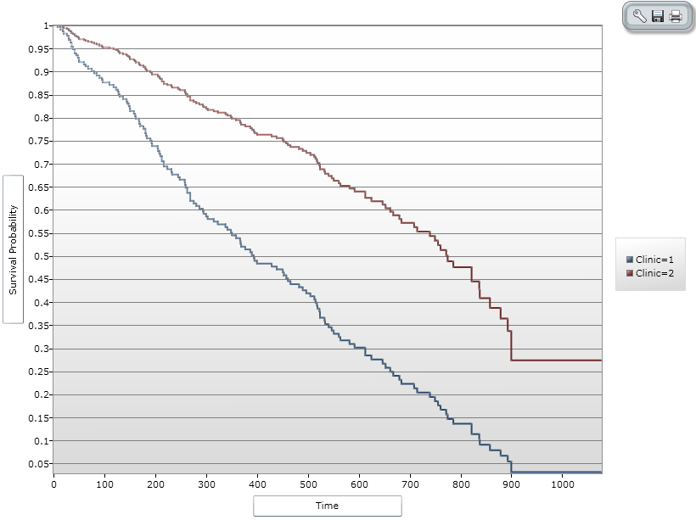
Figure 7.155: Cox Proportional Hazards Graph Result

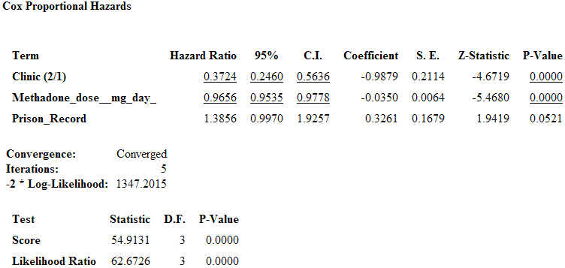

Figure 7.156: Cox Proportional Hazards Statistical Results

Complex Sample Frequencies, Tables, and Means

The Frequencies (FREQ), Tables (TABLES), and Means (MEANS) commands in the Classic Analysis program perform statistical calculations that assume the data comes from simple random (or unbiased systematic) samples. More complicated sampling strategies are used in many survey applications. These may involve sampling features (i.e., stratification, cluster sampling, and the use of unequal sampling fractions). Surveys that include some form of complex sampling include the coverage surveys of the WHO Expanded Program on Immunization (EPI) (Lemeshow and Robinson, 1985) and CDC’s Behavioral Risk Factor Surveillance System (Marks et al., 1985).
The CSAMPLE functions compute proportions or means with standard errors and confidence limits for studies where the data did not come from a simple random sample. If tables with two dimensions are requested, the odds ratio, risk ratio, and risk difference are also calculated.
Data from complex sample designs should be analyzed with methods that account for the sampling design. In the past, easy-to-use programs were not available for analysis of such data. CSAMPLE provides these facilities. It can form the basis of a complete survey system with an understanding of sampling design and analysis.

Complex Sample Frequencies

Dialog Box

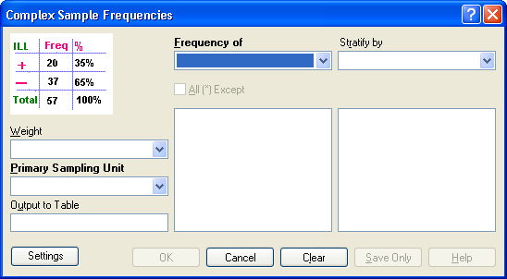
Figure 7.157: Complex Sample Frequencies Dialog Box

- A Weight variable is selected for use in weighted analyses.
- The Output to Table field identifies a data table to receive output from the command.
- Frequency of identifies the variable(s) whose frequency is computed.
- All (*) Except indicates that all the variables except those selected will have frequencies computed.
- Stratify by identifies the variable to be used to stratify or group the frequency data.
- OK accepts the current settings and data, and subsequently closes the form or window.
- Save Only saves the created code to the Program Editor but does not run the code.
- Cancel closes the dialog box without saving or executing a command.
- Clear empties the fields so information can be re-entered.
- Help opens the Help topic associated with the module being used. (Currently Disabled).

Complex Sample Means

Dialog Box

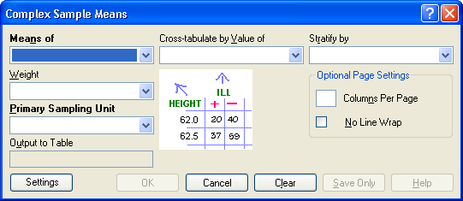
Figure 7.158: Complex Sample Means Dialog Box

- Means of identifies the variable whose mean is to be computed
- A Weight variable is selected for use in weighted analyses.
- The Output to Table field identifies a data table to receive output from the command. (Currently Disabled).
- Cross-Tabulate by Value of identifies the variable to be used to cross-tabulate the main variable.
- Stratify by identifies the variable to be used to stratify or group the frequency data.
- OK accepts the current settings and data, and subsequently closes the form or window.
- Save Only saves the created code to the Program Editor, but does not run the code.
- Cancel closes the dialog box without saving or executing a command.
- Clear empties the fields so information can be re-entered.
- Help opens the Help topic associated with the module being used. (Currently Disabled).

Complex Sample Tables

Dialog Box

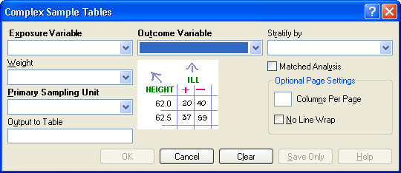
Figure 7.159: Complex Sample Tables Dialog Box

- Exposure Variable identifies the variable that will appear on the horizontal axis of the table. It is considered to be the risk factor (or * for all variables).
- A Weight variable is selected for use in weighted analyses.
- The Output to Table field identifies a data table to receive output from the command.
- Outcome Variable identifies the variable that will appear on the vertical axis of the table.
- Stratify by identifies the variable to be used to stratify or group the frequency data.
- OK accepts the current settings and data, and subsequently closes the form or window.
- Save Only saves the created code to the Program Editor, but does not run the code.
- Cancel closes the dialog box without saving or executing a command.
- Clear empties the fields so information can be re-entered.
- Help opens the Help topic associated with the module being used. (Currently Disabled).

THIS PAGE IS
INTENTIONALLY BLANK.

Maps: Visual Representation of Data by Location

Introduction
Epi Info™ 7 Maps is a versatile tool that geographically displays data on a map. The Maps tool has the ability to display multiple views from the same dataset. Datasets can be filtered or shown over a series of time using features in the Maps tool. Users can tailor these features to create a customized map containing public health data.
Information displayed in the main map window appears in the form of layers. Data layers exist in the form of case clusters, choropleth maps, or dot density maps. Reference layers add geographical boundaries and markers from shape files, a map server, or KML files. This format allows the Maps tool to uniquely identify and designate display settings from both internal and external data sources. Users may modify or filter map data using the data layers gadget located at the bottom of the main map window

Basic Tools

To open Maps, click Create Maps from the Epi Info™ 7 main menu, or select Tools > Create Maps from the main page navigation menu. Maps can also be accessed from the navigation menu at the top of the Enter screen. This section of the user guide provides instructions on how to use the Maps tool when accessed from the main menu. Accessing the Maps tool from the Enter navigation menu enables additional interactivity between the project data and the mapping tool. For additional information regarding the Maps tool’s functionality from the Enter Data tool, refer to the Enter Data section of this user guide.
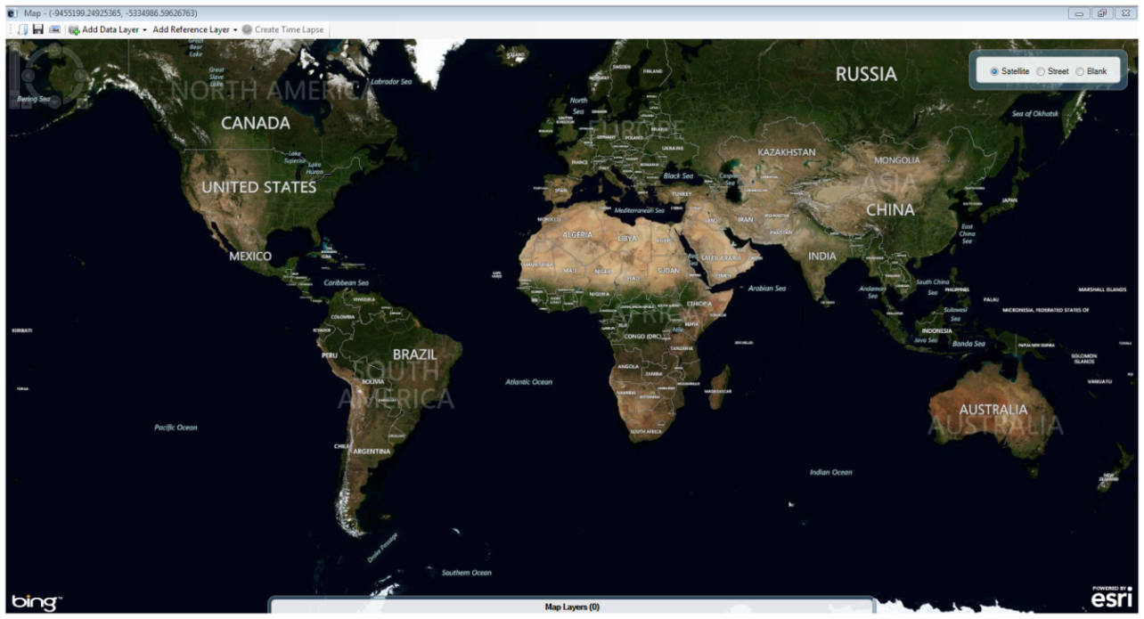
Figure 10.1: Main Map window

View Settings
The default setting in the main window is satellite view. The satellite view displays national boundaries, major roadways and geographic markings along with the region’s topography. To change the view setting, click on the Street or Blank radio button at the top right corner of the screen. The street view displays similar geographic landmarks, roadways and boundaries without the region’s topography. The blank view displays an empty canvas, which is beneficial when working with custom boundary files or adding reference layers (See Reference Layers).

Navigation Tools
To zoom in and out on a location, place the mouse over the desired location and rotate the mouse wheel forwards or backwards respectively. You can also zoom in or out by using the navigation panel at the top left corner of the screen. Click the + to zoom in or the – to zoom out. The navigation panel also allows you to click and drag the bar located in between the + and –to adjust the view. Directly to the right of the zoom option is a compass. Clicking on the arrows representing north, south, east and west will move the map location in the selected direction. You can also click and drag the map to adjust the screen. To rotate the view, click and drag the compass wheel until the map view meets your specifications.

Basic Functions
The map window contains the following tools to help create a meaningful representation of your data:
- Add marker
- Add zone
- Add label
- Remove all layers
Access each of these basic functions from the main map window.

Add Marker
A marker identifies a point of interest by placing a symbol on the map. Symbols are available in various shapes and sizes to identify multiple points of interest.
- Right click on the main map window in the location where you would like to place the marker. A menu appears displaying the available options.
- Select Add marker.
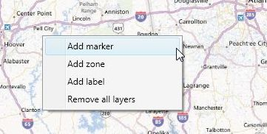
Figure 10.2: Basic Tools option
- Select a Style from the Style drop-down list for the marker. The style will determine the marker’s shape on the screen.
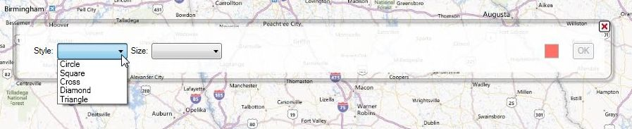
Figure 10.3: Marker styles
- Select the Size of the marker from the Size drop-down list.
- Select the Color of the marker by clicking on the red Point Color button to the right of the dialog box.
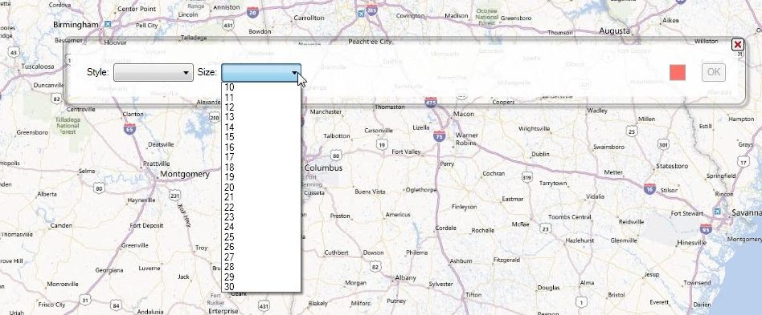
Figure 10.4: Marker size
- Click OK.
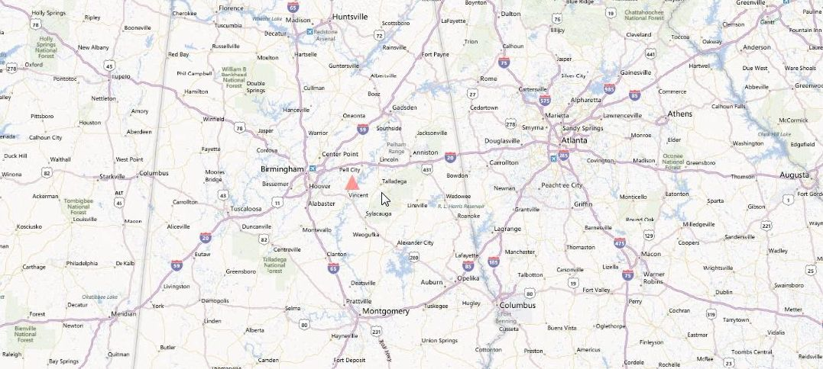
Figure 10.5: Marker displayed in Map window

Add Zone
A zone identifies a circular region on the map. This is useful when highlighting an area that centers on a point of interest or specifying an area with public health implications.
- Right click on the main map window in the location where you would like to place the center of the zone.
- Select Add zone.
- Enter the desired Radius, Units and Color. Zones can be of varied size and color but are limited to a circular shape.
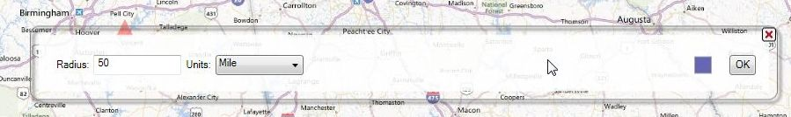
Figure 10.6: Zone settings
- Click OK.
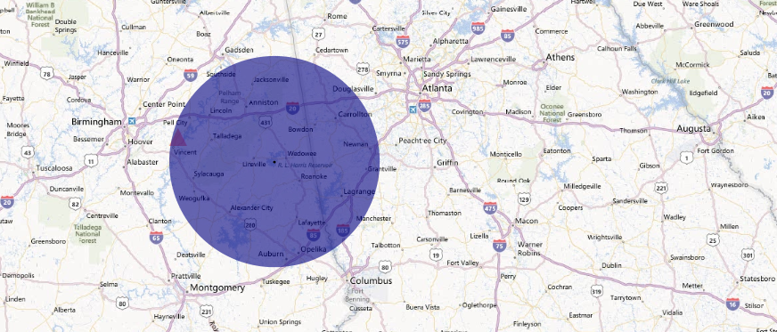
Figure 10.7: Zone displayed in map window
Note: Zones will appear distorted when placed closer to the north and south poles due to the area being re-projected from the globe onto a flat surface.

Add Label
- Right click on the main map window in the location where you would like to place the label.
- Select Add label.
- Enter the label you would like to display in the textbox. Click the ellipses next to the Font textbox to select the desired Font and Color.
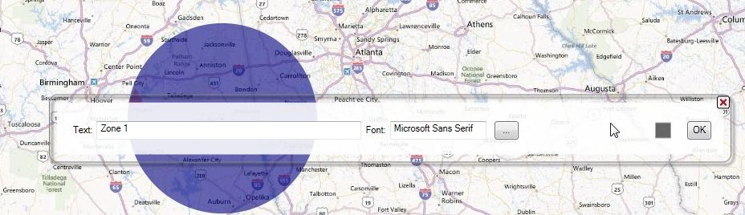
Figure 10.8: Label Settings
- Click OK.
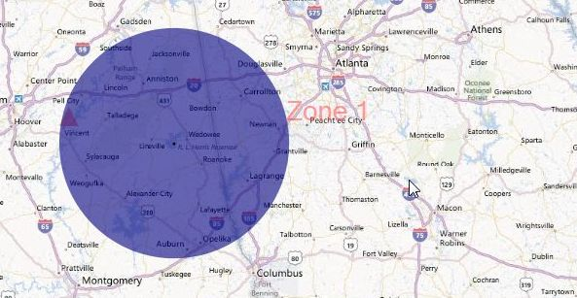
Figure 10.9: Label displayed in Map window

Remove All Layers
To clear the main map window of all layers, right click on the map and select Remove all layers.

Save Maps as Map File
Maps may be saved as either an image file (*.png) or an Epi Info™ 7 Map File (*.map7). The map file format saves the map along with the underlying data layers. The Epi Info™ 7 Map File can only be opened using the Epi Info™ 7 software. When opened, the map file will automatically update the map based on any changes to the dataset. Create and save the map file by clicking on the Save 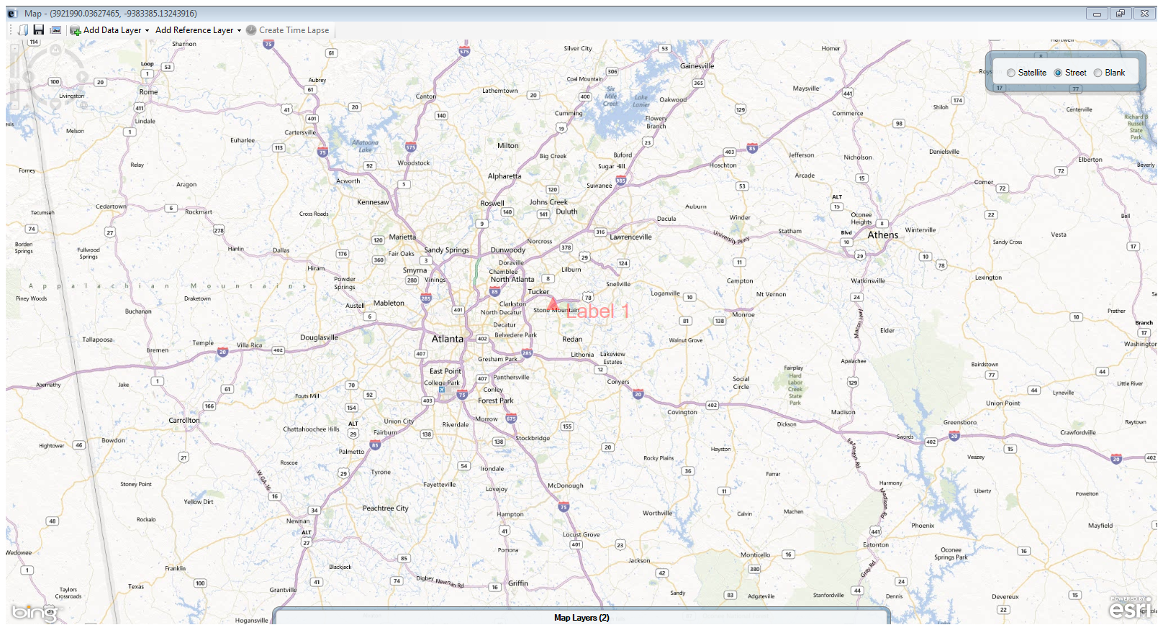 button in the Maps toolbar.
- Click the Save button. A Save As dialog box opens.
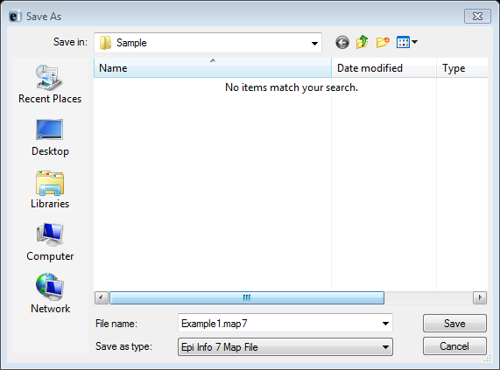
Figure 10.10: Save As dialog box
- Create a File name and choose a file destination from the Save in drop-down list. The map is saved in the *.map7 file format, which can be opened later by Epi Info™.
- Click the Save button. A Save Successful dialog box appears.
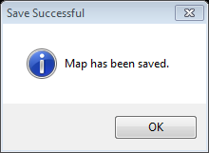
Figure 10.11: Save Successful
- Click OK to exit.

Save Maps as an Image
The image format saves only the map image in a *.png file format. This image file can be inserted into documents or opened with a multitude of software applications. Save the map as an image by clicking on the Save as Image 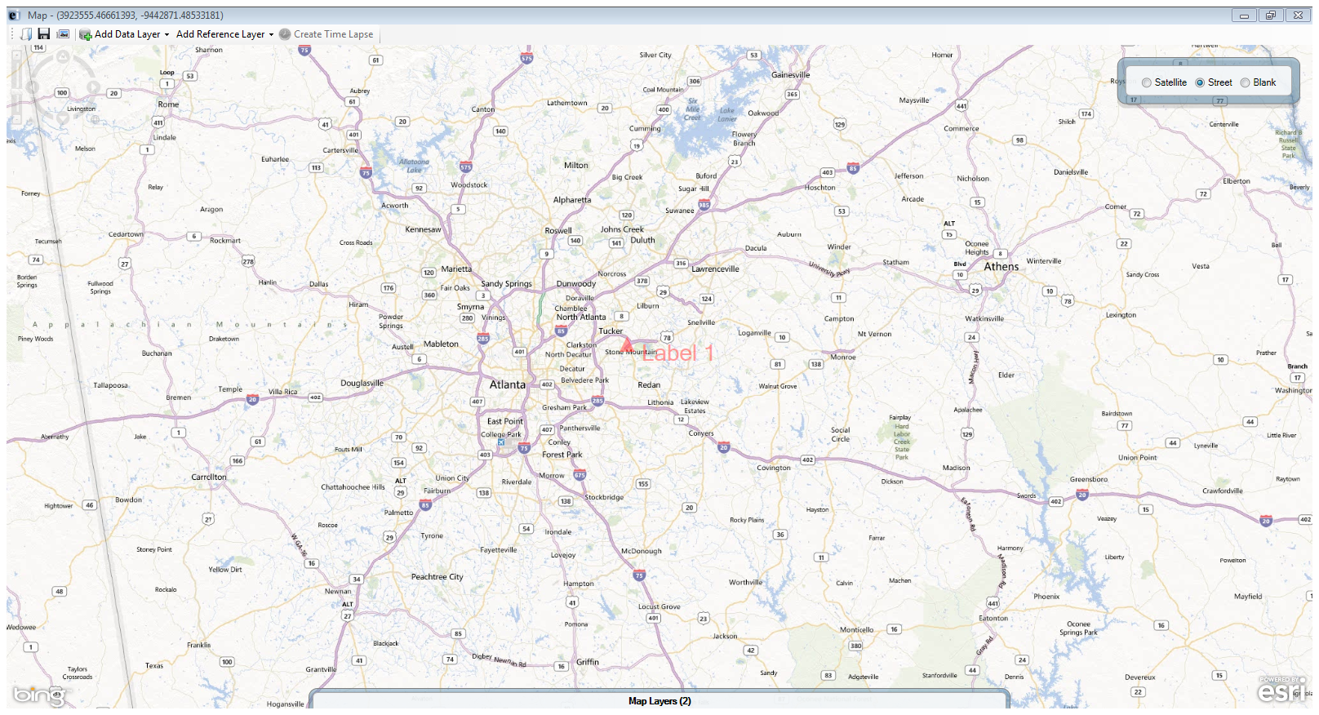button in the Maps toolbar.
Note: The Epi Info™ software will not open or edit a map saved in image format.
- Click the Save as Image button. A Save As dialog box appears.
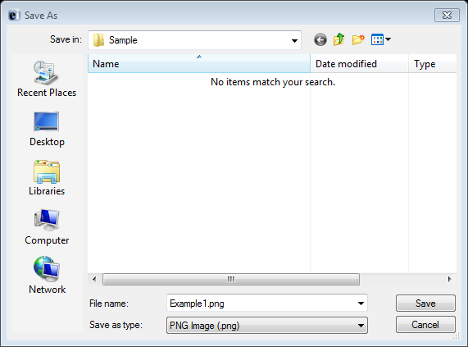
Figure 10.12: Save As dialog box
- Create a File name and choose a file destination from the Save in drop-down list. The map is saved in the *.png file format, which can be opened later with an image software application.
- Click the Save button. A Save Successful dialog box appears.
- Click OK to exit.

Open Maps
The Epi Info™ Maps tool will only open files in the Maps (*.map7) file format. To open a maps file, click the Open button in the Maps toolbar and select the desired file.
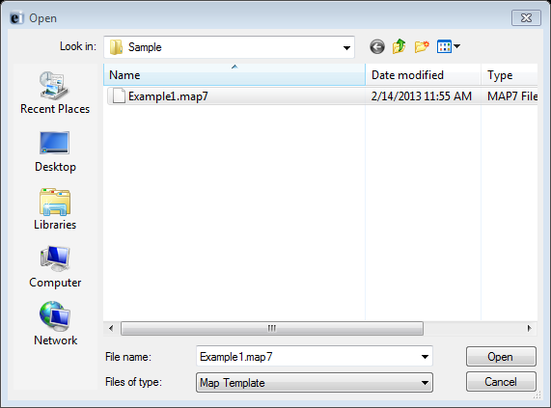
Figure 10.13: Open Map file dialog box
Click Open. The map file updates and displays in the main map window.

Adding a Data Layer

Case Clusters
Case Clusters display case locations on a map based on geographic coordinates. Each dataset used to create a case cluster must contain numeric fields that Maps can designate as latitude and longitude. The software has the capability of geocoding a street address into these coordinates. In cases where geocoding is not applied, a street address alone will not be sufficient to create a case cluster. For additional information on geocoding, refer to the Form Designer section of this user guide.
In the main map window, large clusters appear as bigger circles with the total case count contained inside of them. Individual cases appear as single dots without a case count designation. The example below demonstrates how to create a case cluster map in street view with the data included in the E. coli project folder.
- Select Add Data Layer from the navigation menu.
- Select Case Cluster from the drop-down list.
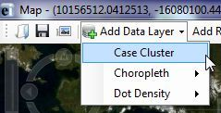
Figure 10.14: Case Cluster Data Layer
- The Data Source dialog box appears.
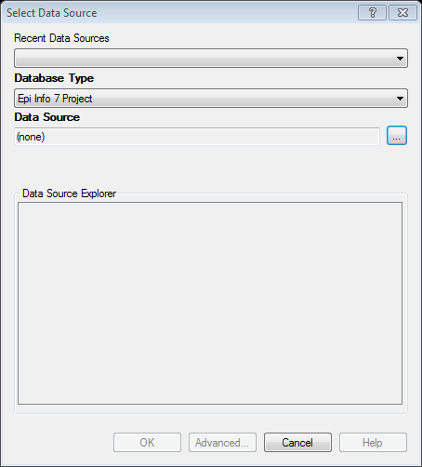
Figure 10.15: Select Data Source Dialog Box
- Select the appropriate database from the Database Type drop-down list. There are multiple databases available from the drop-down list and it is imperative that the database type matches the file format that you are adding to Maps. For this demonstration, the default Epi Info 7 Project option is used.
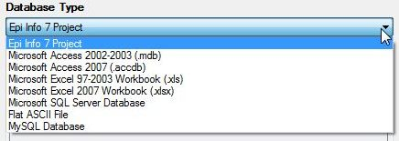
Figure 10.16: Database Type
- Click on the ellipses next to the Data Source field.
- Select the project data that you would like to map. For this demonstration, select the Ecoli project.
- Select the Food History form from the Data Source Explorer menu. Click OK.
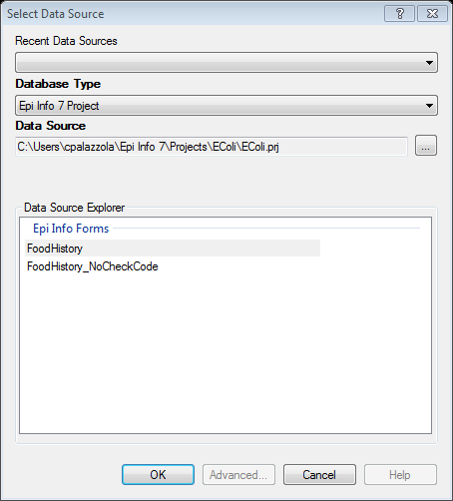
Figure 10.17: Data Source Explorer dialog box
- Select the field containing the Latitude coordinates (Latitude) from the Latitude drop-down list.
- Select the field containing the Longitude coordinates (Longitude) from the Longitude drop-down list.
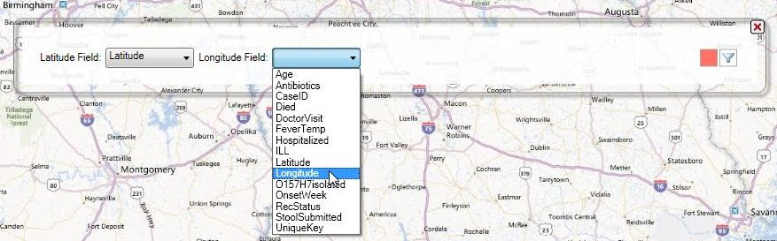
Figure 10.18: Latitude and Longitude drop-down list
- The Maps tool will display all clusters based on latitude and longitude coordinates in red by default. You can change the color by clicking the red Point Color button and selecting a different color.
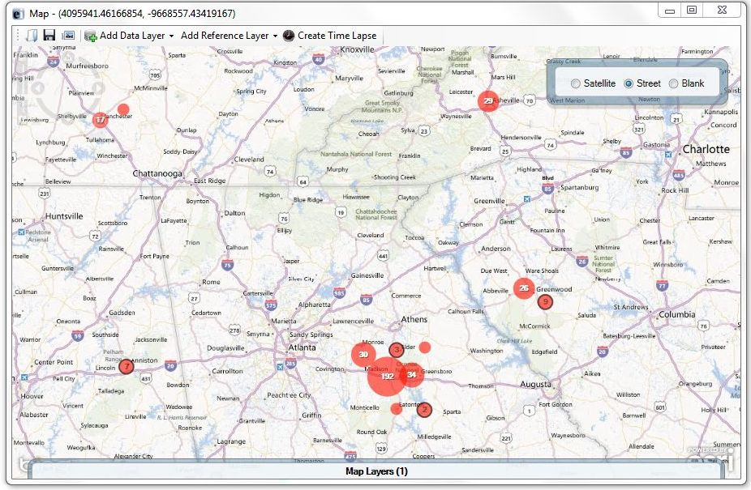
Figure 10.19: Case cluster map of E. coli cases
As the view zooms in, case clusters separate into smaller clusters and individual cases appear as single red dots.
Move the mouse over a small case cluster (less than 12 records) to flare the cluster outwards.
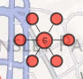
Figure 10.20: Expanded case cluster
The number six at the center of the cluster represents six different cases. When the mouse is over the case cluster, six smaller dots appear, each representing one of the six records inside of that cluster. This is useful if the same household contains multiple cases.

Data Filtering in Maps
Data filters in the Maps tool are used to select a subset of data by specifying and applying certain conditions. This allows the user to show the effect of a variable on the geographic distribution of cases. To access the data filter tool, move your cursor over the Map Layers gadget at the bottom of the main map window. Currently there is one case cluster layer in red with no filters.
Figure 10.21: Map Layers gadget
The following example demonstrates how to apply a filter to the Age variable from the data layer added in the previous example.
- Click the Data Filters button. The Data Filters gadget appears.
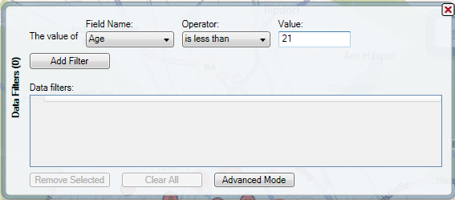
Figure 10.22: Data Filters dialog box
- From the Field Name drop-down list, select Age.
- From the Operator drop-down list, select Is Less Than.
- Enter 21 into the Value textbox.
- Click the Add Filter button. The Data Filter gadget displays one row in the Data filters table.
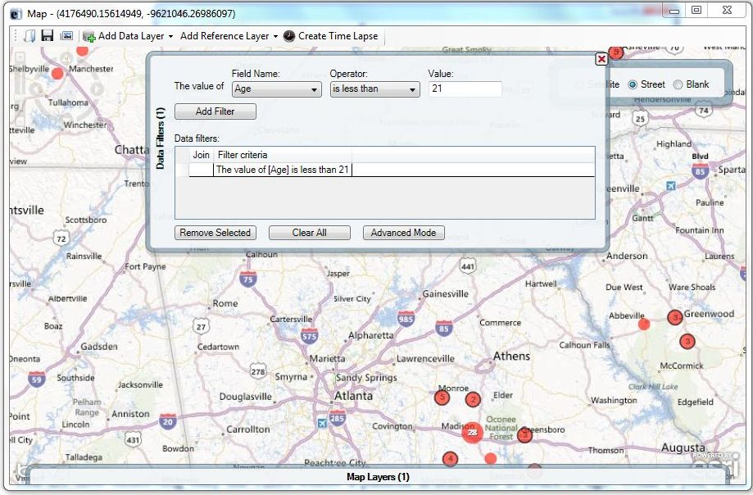
Figure 10.23: Map window with Data Filter
- To close the gadget, click the X button. The map displays only cases where the patient’s age is less than 21.

Stratifying Data
Filters are a powerful tool but in certain instances, it is best to display the full dataset in groupings. This requires stratifying the data. After completing the previous steps, the map displays the patient population that is less than 21 years of age. To create the stratified map, another layer is required to show an additional age group in the patient population. In the following example, a filter is applied to an additional layer based on the patient’s age. Blue clusters will represent the records that meet the specified condition.
- From the toolbar at the top of the map window, select Add Data Layer > Case Cluster.
- Select the Food History form in the E. coli project. A small gadget appears with Latitude and Longitude drop-down lists.
- Before selecting Latitude and Longitude, click the red Point Color button to change the layer’s color to blue.
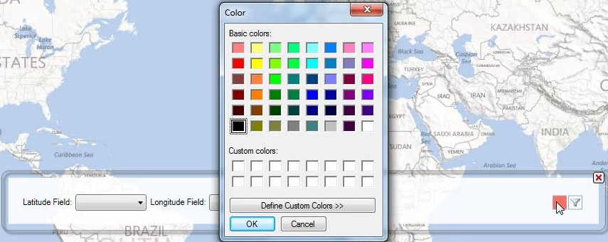
Figure 10.24: Point Color Menu
- Click the Data Filters button. The Data Filters gadget appears. From the Field Name drop-down list, select Age.
- From the Operator drop-down list, select Is Greater Than or Equal To.
- Enter 21 into the Value textbox.
- Click the Add Filter button.
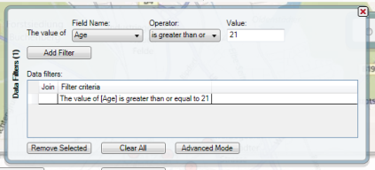
Figure 10.25: Stratified Data Filters gadget
- To close the Data Filters gadget, click the X in the top-right corner.
- From the Latitude drop-down list, select Latitude.
- From the Longitude drop-down list, select Longitude. The stratified map displays both age groups by color.
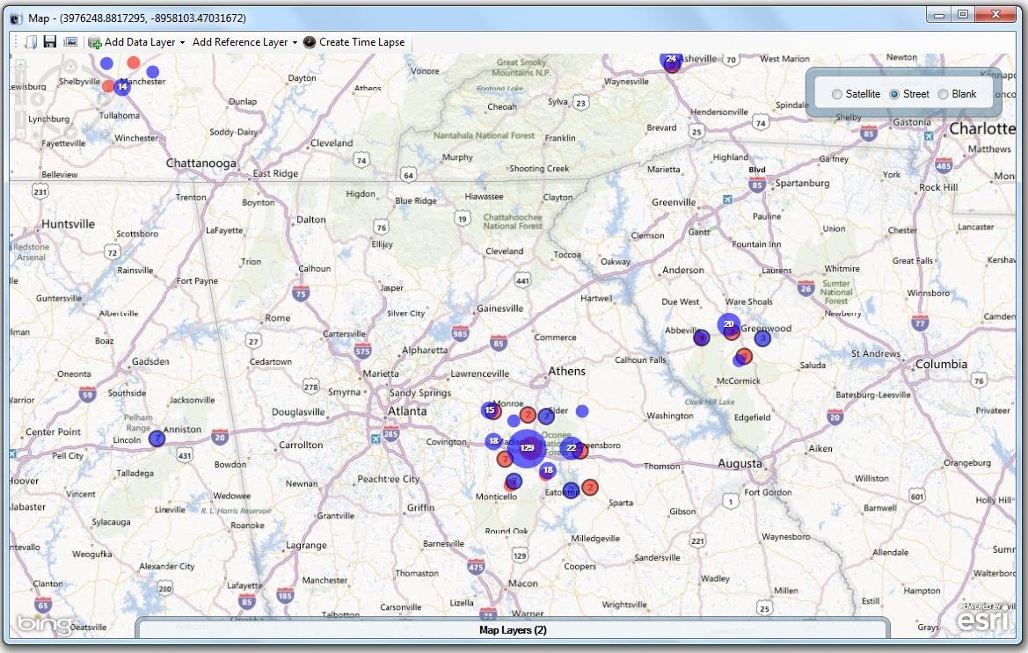
Figure 10.26: Stratified Map window
The blue clusters represent cases where the patient is 21 years of age or older, while the red clusters represent cases where the patient is less than 21. The Maps tool allows for multiple age groupings and can also stratify the dataset based on other variables (e.g., whether the patient is male or female, foods eaten, etc.).
Note that the Map Layers gadget at the bottom of the screen displays a (2) instead of a (1). This indicates that there are two different layers with corresponding filters.

Time Lapse
When a case cluster layer is added to Maps, the tool displays all cases contained in the dataset (If a filter is applied, Maps will display all cases that meet the selected filter criteria). The Time Lapse tool creates a dynamic environment to show how the dataset transforms over time. To enable this feature, load a data layer with a time variable.
- Add a Case Cluster data layer (See Adding a Data Layer). Use the Food History form in the E. coli project for the following example.
- Click Create Time Lapse.
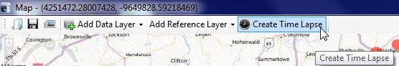
Figure 10.27: Create Time Lapse
- Select the OnsetDate from the Time Variable from the drop-down list. Click OK.
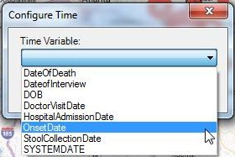
Figure 10.28: Configure Time dialog box
- To show the progression of the symptom onset date over time, click the Run 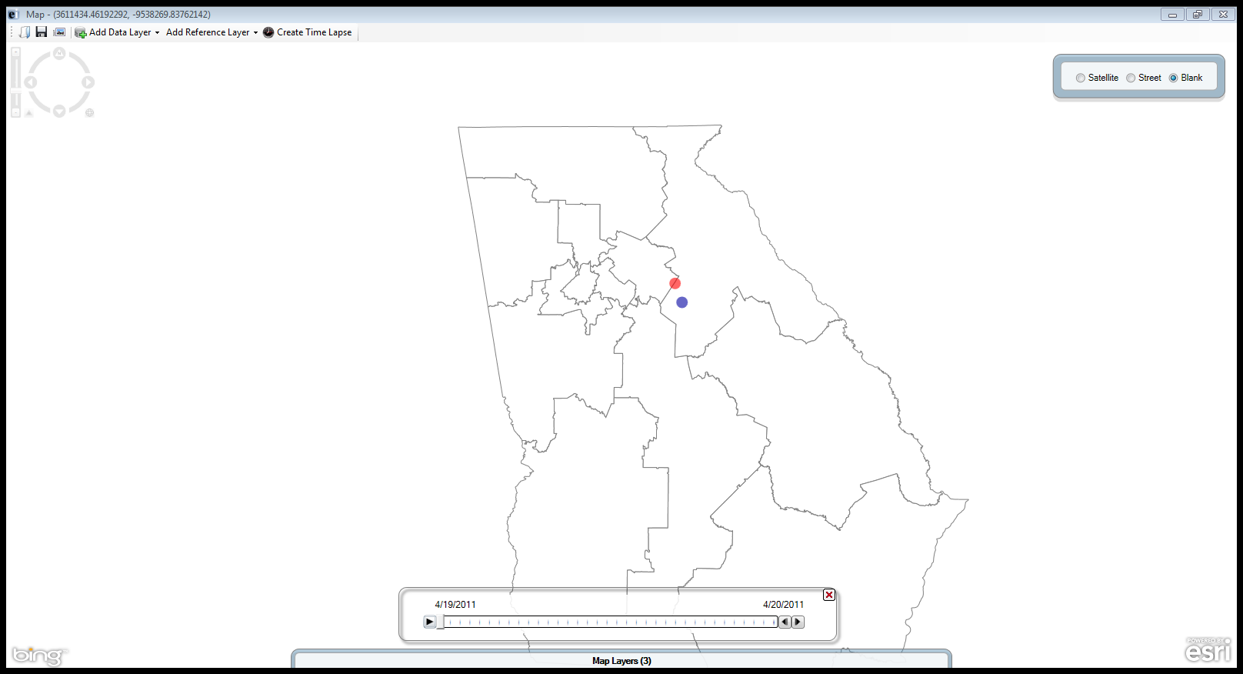 button to the left of the timeline.
Figure 10.29: Timeline
- The main map window clears and begins adding the cumulative number of cases in accordance with the timeline. The figure below displays the number of cases in the dataset from 4/19/2011 to 5/17/2011.
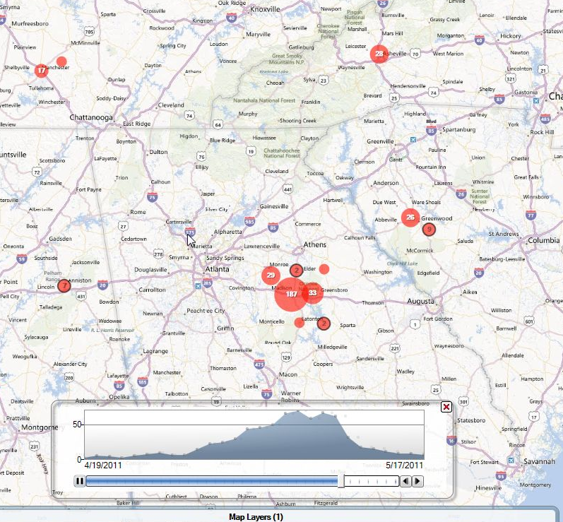
Figure 10.30: Time Lapse display
- It is important to note that the distribution of cases displays at the bottom of the screen. At any time, press pause to show the cumulative dataset at that time interval. The buttons to the right of the timeline move the time series forwards and backwards.
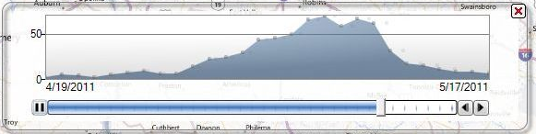
Figure 10.31: Time Series Distribution

Creating Choropleth and Dot Density Maps with Boundaries
Maps can create a choropleth or dot density map by combining a dataset with three boundary formats: shape file, map server, or KML (Keyhole Markup Language). See below for map/boundary format compatibility:
- Choropleth: Shape file
- Choropleth: Map server
- Choropleth: KML
- Dot density: Shape file
- Dot density: Map server
- Dot density: KML
The boundaries are independent of the dataset but are joined with database keys.
Note: The dataset and boundary file must contain the proper database keys and the user must designate the proper key from each drop-down list to create a choropleth or dot density map.
Key descriptions are as follows:
- Feature Key – designates the variable in the boundary set that will match a corresponding variable in the dataset.
- Data Key – designates the variable in the dataset that will match a corresponding variable in the boundary set.
- Value Field – designates the value being displayed.
Shape Files
A shape file stores non-topological geometric and spatial information in vector format. These files are simple to use but lack complex data elements. Various sources attach additional information or tables to shape files for more advanced analysis.
KML
KML is an open source specification for describing geographic data. Like shape files, KML files contain instructions used by mapping tools to draw boundaries, points, and other feature sets. A benefit to using KML files is that they can be edited using simple text editors.
Map Servers
Map server is a platform used to publish spatial and geographic data to the internet. One advantage of the map server format is the capability of creating a central repository for mapping data with relational database management systems.

Choropleth Map using Map Server Boundaries
A choropleth map uses graded differences in shading or color to display variations of a variable across a geographic area. The color gradient typically spans from one color to another or from light to dark.
The example below demonstrates how to combine a map server feature set for the state of New York with the Lyme data set included with Epi Info to create a choropleth map.
Note: This example uses case based data, where each row in the data set represents an individual case, rather than aggregate data.
- Select Add Data Layer from the navigation menu.
- Select Choropleth>With Map Server Boundaries from the drop-down list.
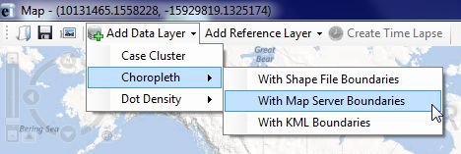
Figure 10.32: Choropleth using Map Server Boundaries
- The Data Source dialog box appears. Select Database Type from the drop-down list.
- Click on the ellipses next to the Data Source field. Select the Lyme project from the Epi Info™ 7 Projects folder.
- Select the Case Report form. Click OK.
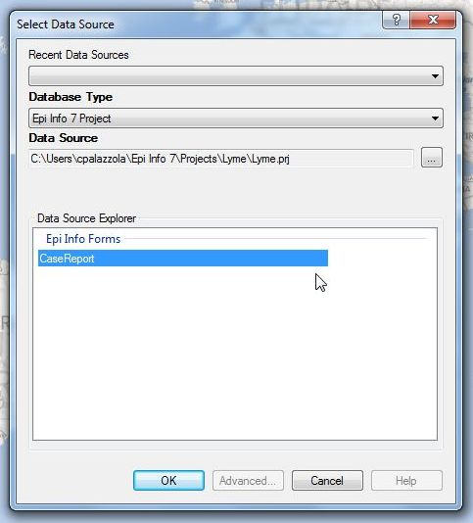
Figure 10.33: Choropleth Data Source dialog box
- Click on the Browse Map Server button.
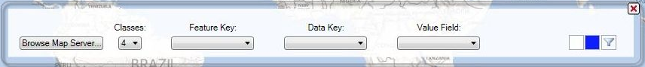
Figure 10.34: Browse Map Server
- Select NationalMap.gov – New York County Boundaries from the drop-down list. Click OK.
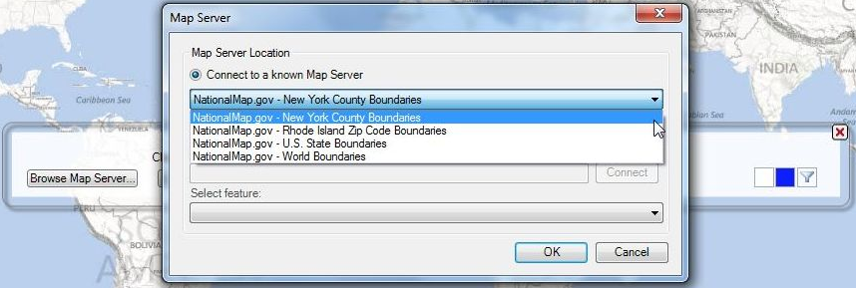
Figure 10.35: Map Server Location
- The New York county boundaries appear on the map.
- Select the number of Classes you want to display. By clicking on four from the drop-down list, the choropleth will designate values into quartiles.
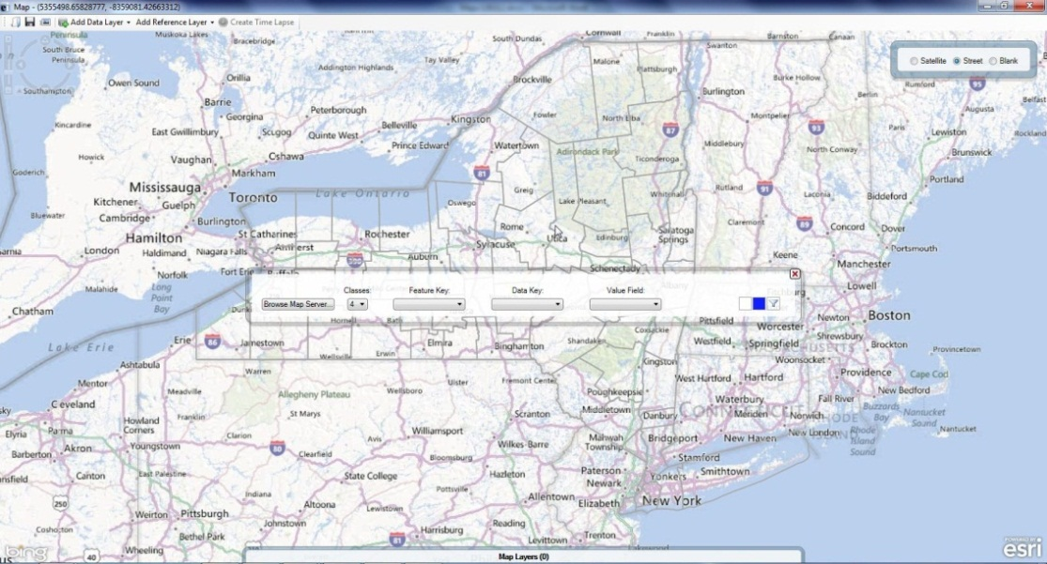
Figure 10.36: Map Server Boundaries
- Select COUNTY_NAME from the Feature Key drop-down list. The feature key connects County_Names in the map server file to the dataset.
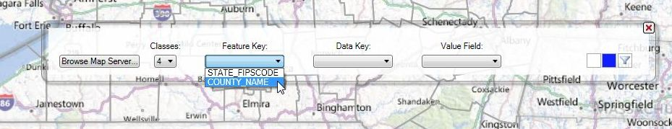
Figure 10.37: Map Server Feature Key
- Select County from the Data Key drop-down list. The data key connects the dataset field, County, to the map server feature key COUNTY_NAME.
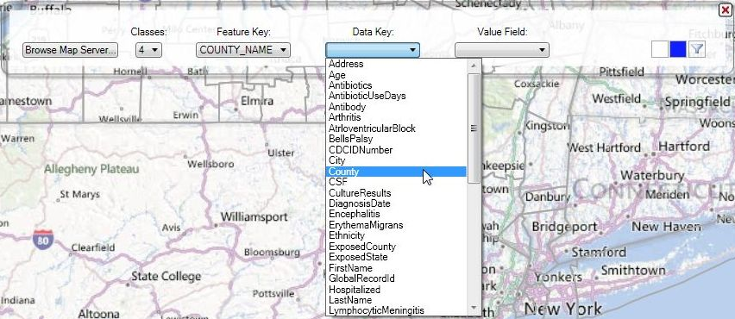
Figure 10.38: Map Server Data Key
- Select <Record Count> from the Value Field drop-down list. Record Count is a system variable that provides the totals for the number of records in each boundary. This action will populate the choropleth based on the record count value.
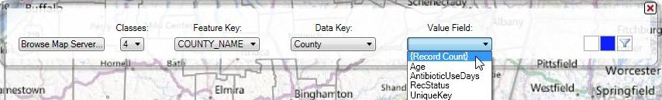
Figure 10.39: Map Server Value Field
The choropleth map appears showing the number of records in each New York County. Counties with the highest tier of records are dark blue while Counties containing the least amount of records are white.
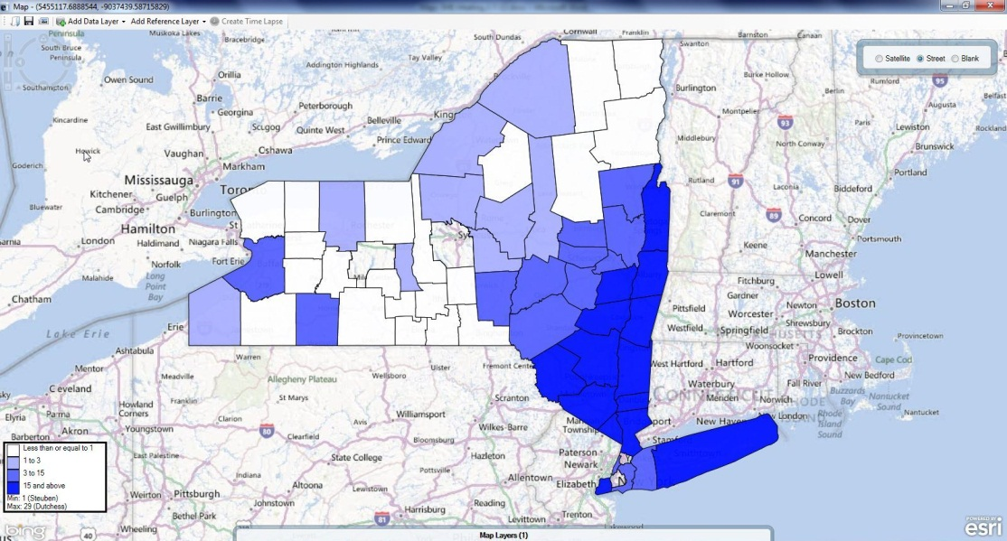
Figure 10.40: Choropleth in Street view
- Select Blank view to display the choropleth with a white background.
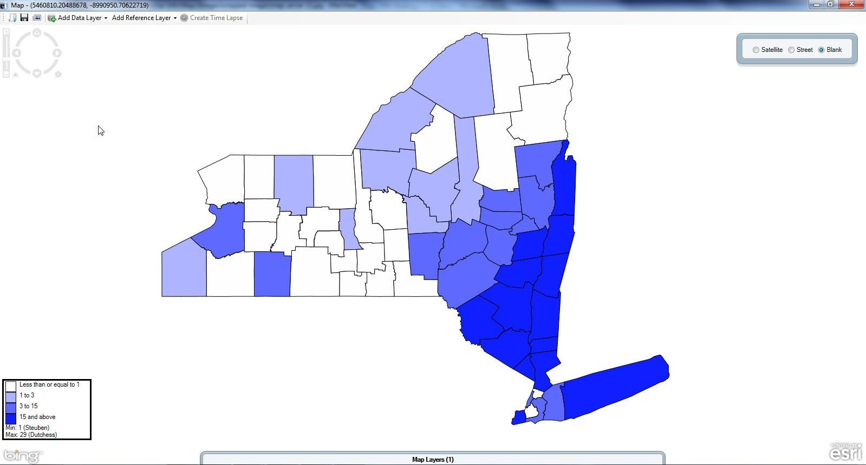
Figure 10.41: Choropleth in Blank view
- To edit the color scheme or to add a filter, place the mouse over the Map Layers gadget located at the bottom of the screen.
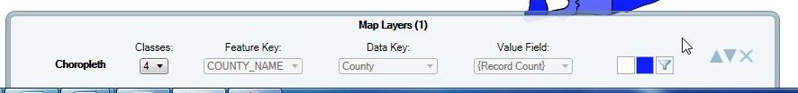
Figure 10.42: Map Layers Tab

Choropleth Map using KML Boundaries
The following demonstration uses aggregate data extracted from the 2011 U.S. Census’ American Community Survey to show the percentage of the population lacking health insurance in counties in Maryland.
Note: This example uses aggregate data, which lists each geographic area once and contains a column for the aggregate value.
- Select Add Data Layer from the navigation menu.
- Select Choropleth>With KML Boundaries from the drop-down list.
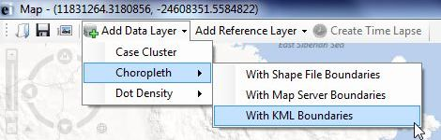
Figure 10.43: Choropleth using KML Boundaries
- The Data Source dialog box appears. Select Microsoft Excel 97-2003 Workbook from the Database Type drop-down list.
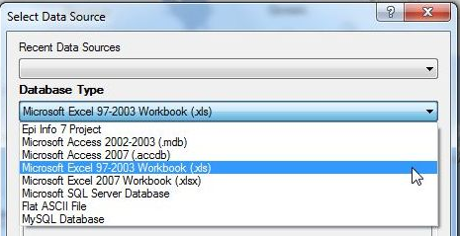
Figure 10.44: Database Type drop-down list
- Click the ellipses next to the Data Source field. The Open Existing File dialog box appears.
- Click the ellipses next to the Location textbox to browse for the KML file you would like to map. Select the KML_Example project.
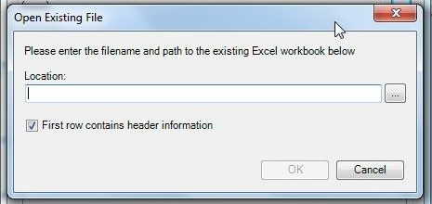
Figure 10.45: Open Existing File dialog box
- Select ACS_11_1YR_HealthInsurance. Click Open.
- Select the Pct Uninsured by County$ Form. Click OK.
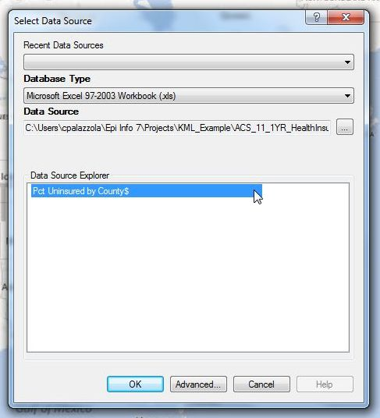
Figure 10.46: Choropleth Data Source dialog box
- Click the Specify KML button.
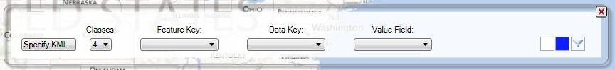
Figure 10.47: Specify KML
- Click the Browse button and select the Maryland_Counties.kml file under the KML_Example project folder. Click OK.
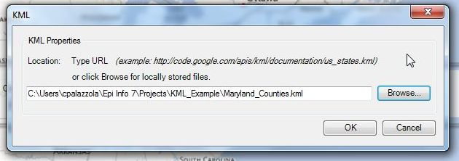
Figure 10.48: KML Location
- A blank Maryland state map appears.
- Select the number of Classes you want to display. By clicking on four from the drop-down list, the choropleth will designate values into quartiles.
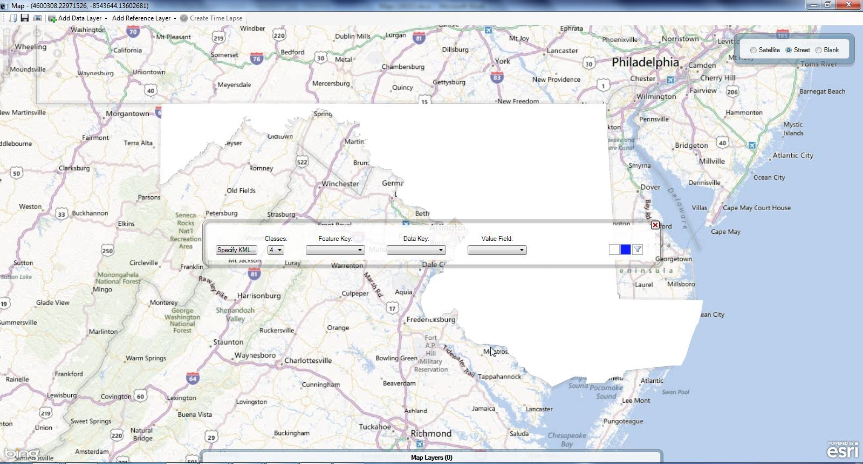
Figure 10.49: KML Boundaries
- Select County_Code from the Feature Key drop-down list. The feature key connects County_Code in the KML file to the dataset.
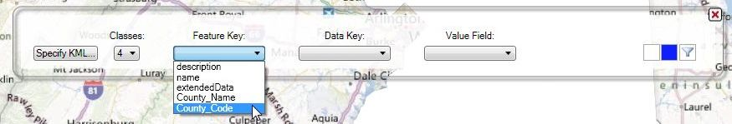
Figure 10.50: KML Feature Key
- Select Geo#id2 from the Data Key drop-down list. The data key connects the dataset field, Geo#id2, to the KML feature key County_Code.
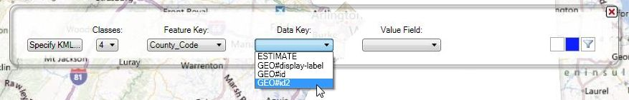
Figure 10.51: KML Data Key
- Select Estimate from the Value Field drop-down list. This action will populate the choropleth based on the Estimate value.
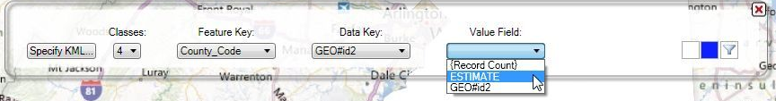
Figure 10.52: KML Value Field
The choropleth map appears showing the estimated percentage of the population lacking health insurance in each Maryland County.
Note: Territories that do not contain any data will remain uncolored.
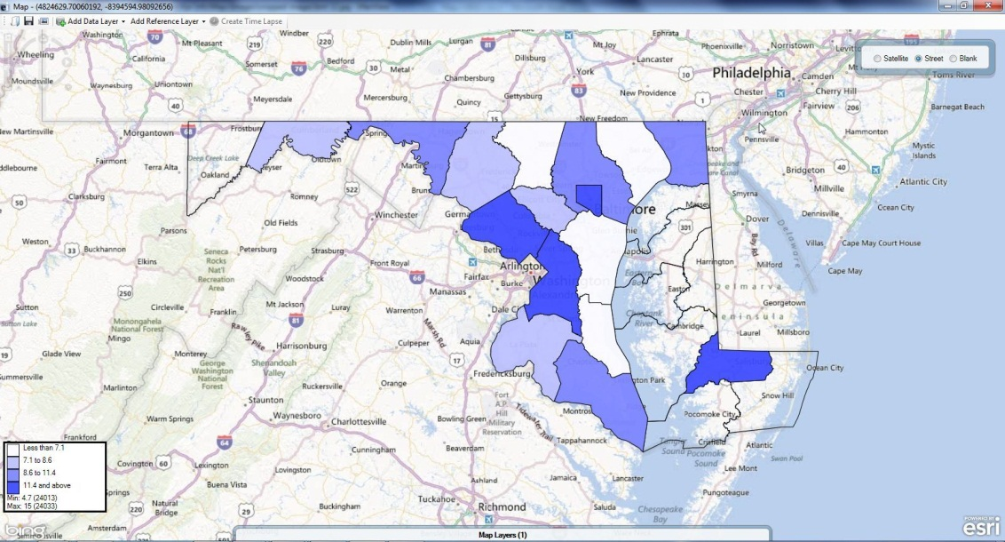
Figure 10.53: Choropleth in Street view
- Select Blank view to display the choropleth with a white background.
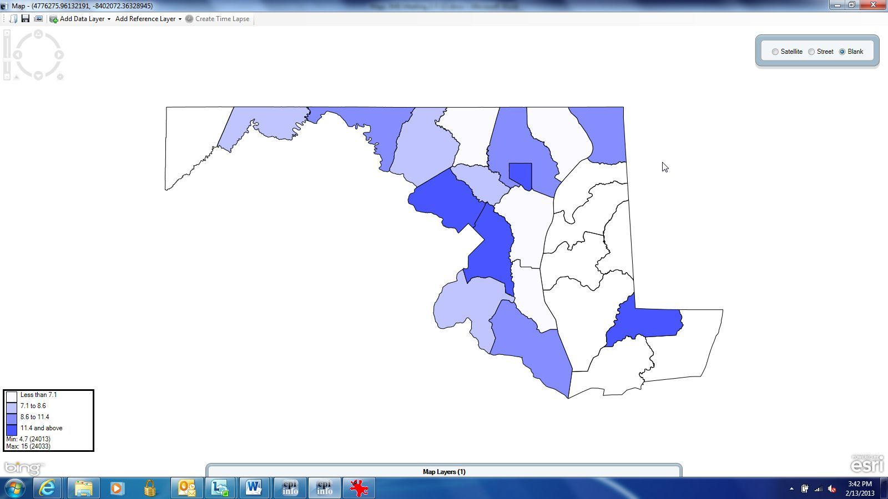
Figure 10.54: Choropleth in Blank view
- To edit the color scheme or to add a filter, place the mouse over the Map Layers gadget located at the bottom of the screen.

Dot Density Map using Shape File Boundaries
To display densities across geographic boundaries, select Dot Density from the data layers drop-down list. Maps will populate the dot density map according to the dot value selected in step eight. Increasing the dot value increases the value each dot represents. The dot density map populates each dot randomly within a set of boundaries to display the density. The example below demonstrates how to create a dot density map with data from a Vital Statistics report published by the Mexico Ministry of Health using a shape file.
- Select Add Data Layer from the navigation menu.
- Select Dot Density>With Shape File Boundaries from the drop-down list.
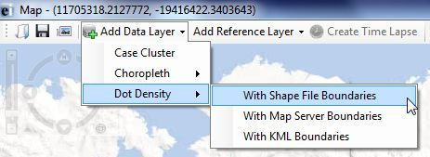
Figure 10.55: Dot Density with Shape File Boundaries
- The Data Source dialog box appears. Select Database Type from the drop-down list.
- Click on the ellipses next to the Data Source field. Select the project data that you would like to map. The following demonstration uses the Sample project.
- Select the MexMap95 form. Click OK.

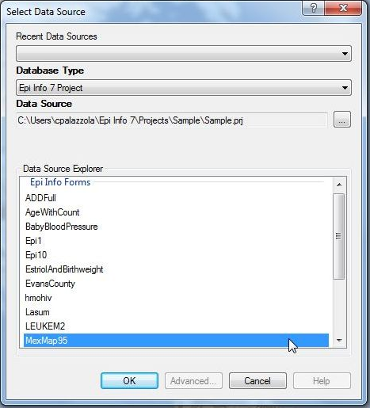
Figure 10.56: Shape File Data Source dialog box
- Click the Browse Shape File button.
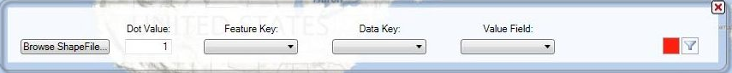
Figure 10.57: Browse Shape File
- Select MXState.shp under the Sample project folder. The MexMap95 shape file boundaries appear on the map.
- Enter the amount, as an integer, that each dot should count for under Dot Value. In this example, the dots are associated with the percentage of teen pregnancy in each state. By specifying “1”, each dot will represent a single teen birth percentage point.
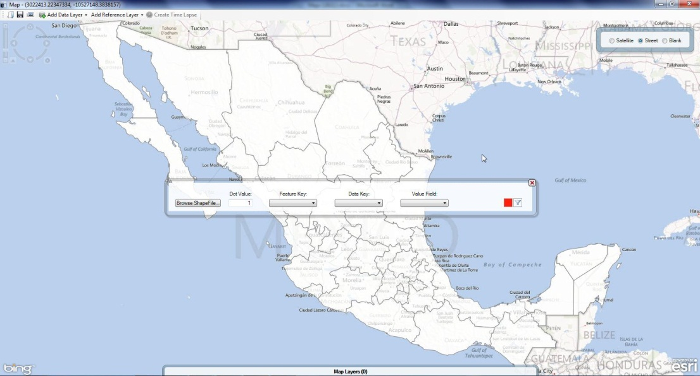
Figure 10.58: Shape File boundaries
- Select name from the Feature Key drop-down list. The feature key connects name in the shape file to the dataset.
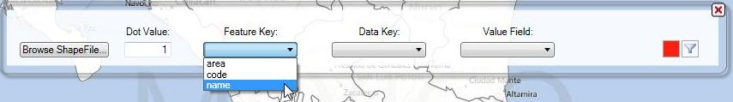
Figure 10.59: Shape File Feature Key
- Select STATE from the Data Key drop-down list. The data key connects the dataset field, STATE, to the shape file feature key name.
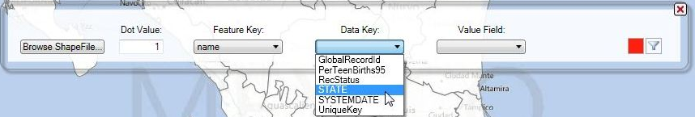
Figure 10.60: Shape File Data Key
- Select PerTeenBirths95 from the Value Field drop-down list. This populates the dot density map based on the percentage of teen births in that state.
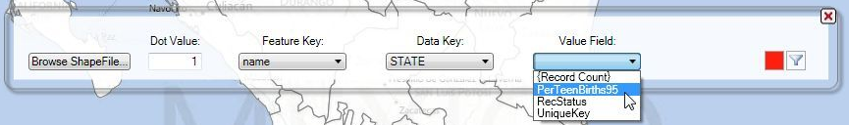
Figure 10.61: Shape File Value Field
Since one was selected as the dot value, each red dot that appears represents a single percentage point. Areas with a higher concentration of red dots represent a higher percentage of teen births.
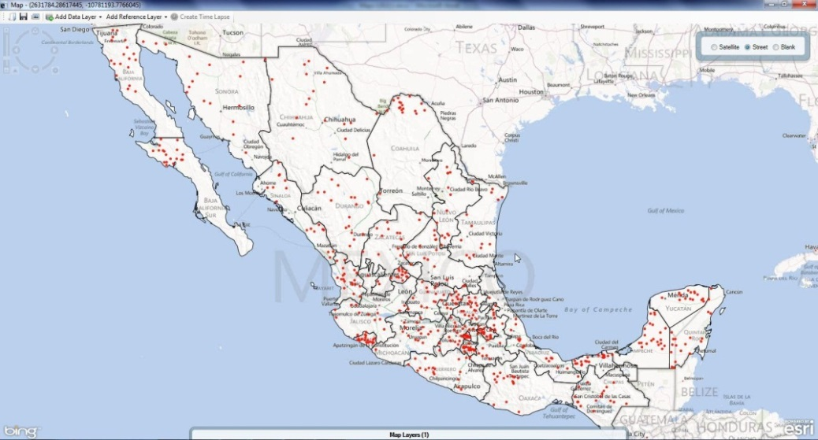
Figure 10.62: Dot Density Map in Street View
- Select Blank view to display the dot density map with a white background.
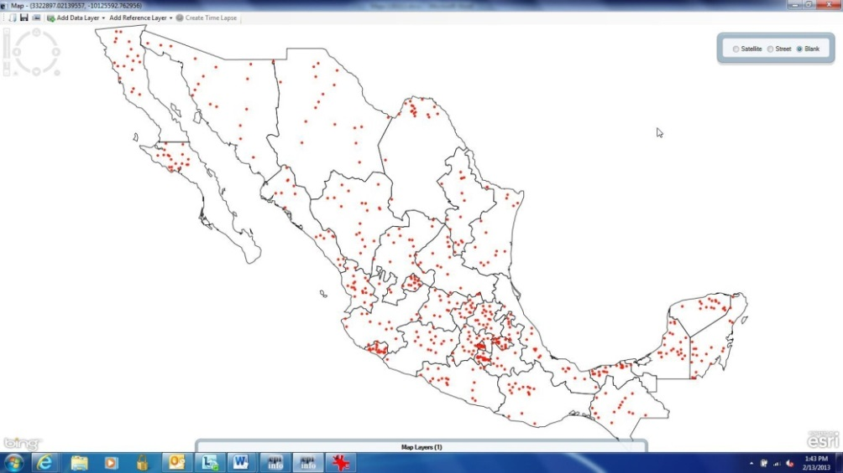
Figure 10.63: Dot Density in Blank View
- To edit the color scheme or add a filter, place the mouse over the Map Layers gadget located at the bottom of the screen.
The three examples shown in the Adding a Data Layer section do not represent every possible combination of map type, database type and boundary file. The Epi Info™ Maps tool is capable of mapping all combinations using similar processes.

Reference Layer
Reference layers are available to enhance the map with additional information outside of the project data. In the previous section, you combined information from shape files, KML files, and the map server with your dataset to create choropleth and dot density maps. However, additional layers may be necessary to highlight points of interest or boundaries that are not evident in the data layers.

Map Server
- From the toolbar at the top of the Map window, select Add Reference Layer > Map Server. The Map Server dialog box appears.
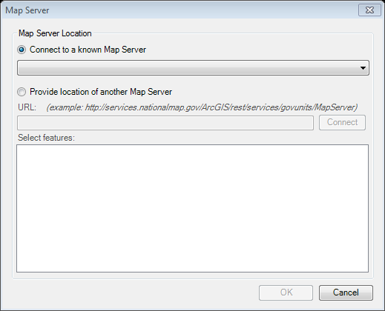
Figure 10.64: Map Server Location dialog box
- Select the desired reference layer from the Connect to a known Map Server drop-down list or Provide the location of another Map Server. For this example, select USGS.gov (National Hazards Support System) – Current Earthquakes from the drop-down list. Click OK.
- The map displays the location of all current earthquakes tracked in USGS’ map server.
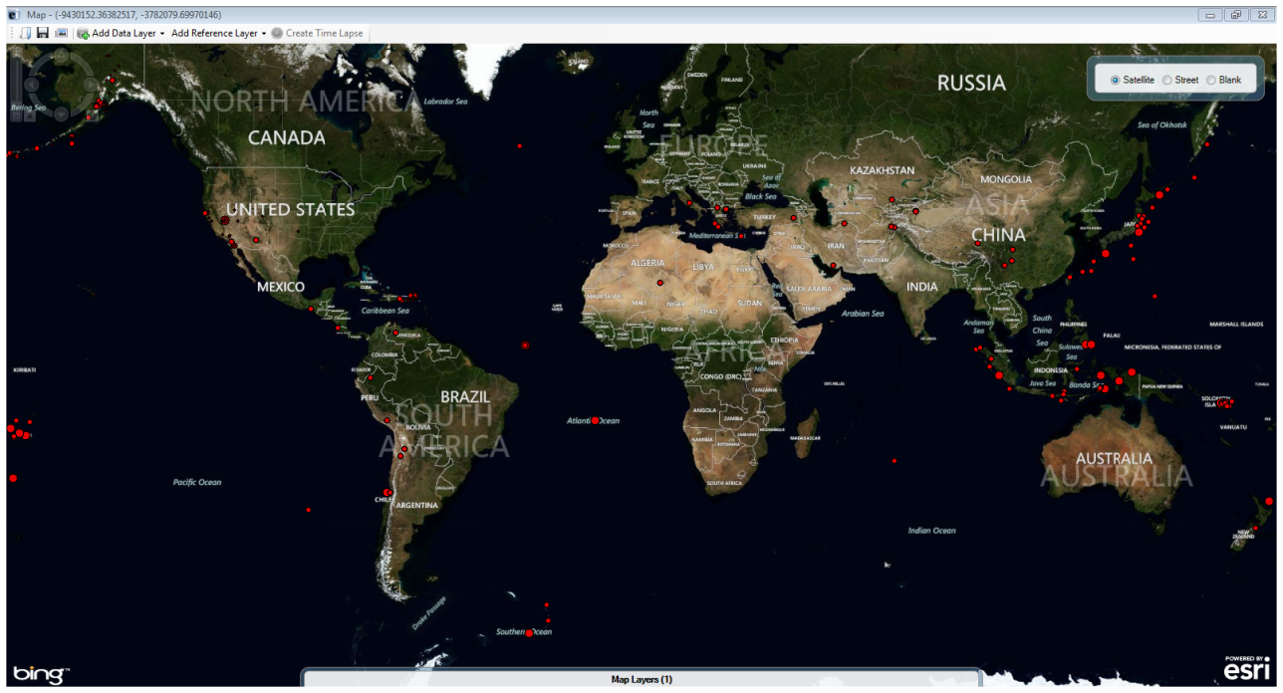
Figure 10.65: Map Server Reference Layer

Shape Files
The example below displays the Mexican state boundaries from the Sample project folder.
- From the toolbar at the top of the map window, select Add Reference Layer > Shape Files.
- Browse and select the desired shape file document, Sample>MXState.shp. The map appears displaying the shape file boundaries.
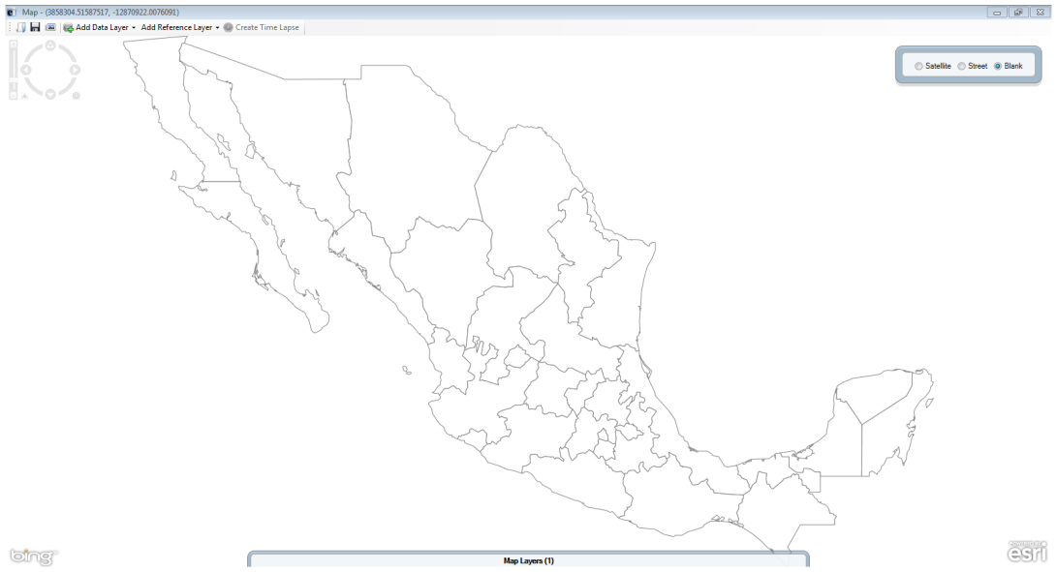
Figure 10.66: Shape file Reference Layer

KML
The example below displays the storm track taken by Hurricane Katrina.
- From the toolbar at the top of the Map window, select Add Reference Layer > KML.
- Type the following URL for NOAA’s Katrina tracker: http://ngs.woc.noaa.gov/storms/katrina/kml/katrina_track.kml. The map appears displaying Hurricane Katrina’s track.
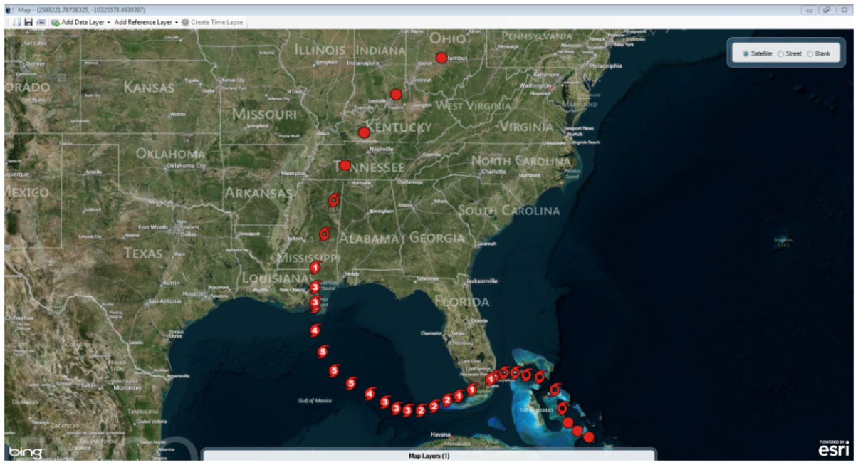
Figure 10.67: KML Reference Layer

THIS PAGE IS
INTENTIONALLY BLANK.
- Nutritional Anthropometry: Collecting and Analyzing Nutritional Data

Introduction

Epi Info™ 7 contains several nutritional anthropometry tools used to collect, analyze, and graph child growth data. Formerly referred to as the NutStat module, the Nutritional Anthropometry tools now include a data entry form that calculates z-scores and percentiles as data are entered, creates growth charts in Visual Dashboard, and has the ability to add z-scores and percentiles to existing datasets.
Four growth references are available for use: CDC 2000 Growth Reference, WHO Child Growth Standards, WHO Reference 2007, and CDC/WHO 1978. Except for the Nutrition project forms, all nutritional anthropometry tools in Epi Info™ 7 can easily select the required growth reference.

The Nutrition Project

The Nutrition Project is a specialized project that can be opened in the Enter tool or modified in Form Designer. The Nutrition form contains fields that collect a child’s age, height, weight, and other measurements for each clinic or doctor’s office visit. Based on these measurements, the appropriate z-scores and percentiles are automatically calculated and added to the dataset. The WHO Child Growth Standards are used to calculate z-scores for children 0 to 2 years of age and the CDC 2000 reference is used to calculate z-scores for children 2 years of age and older. For additional information, see the CDC Growth Charts Web page. (www.cdc.gov/growthcharts).

Opening the Nutrition Form
To open the Nutrition project:
- From the Epi Info™ 7 menu, click the Enter Data button or Tools > Enter Data. The Enter Data tool opens.
- From the toolbar, click the Open Form button. The Open Form dialog box appears.
- Click the ellipsis next to the Current Project text box. The Select a Project dialog box appears.
- Navigate to the Projects subfolder. A list of projects appears.
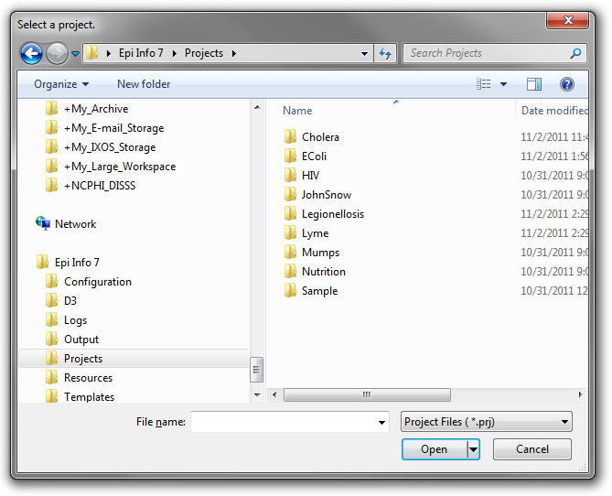
Figure 10.68: Project’s subfolder
- Select the Nutrition folder. Click Open.
- Select the Nutrition project file. Click Open. The Open Form dialog reappears with a list of available forms to select.
- From the list of forms, select Nutrition.
- Click OK. The Nutrition form appears in the Enter Data tool.
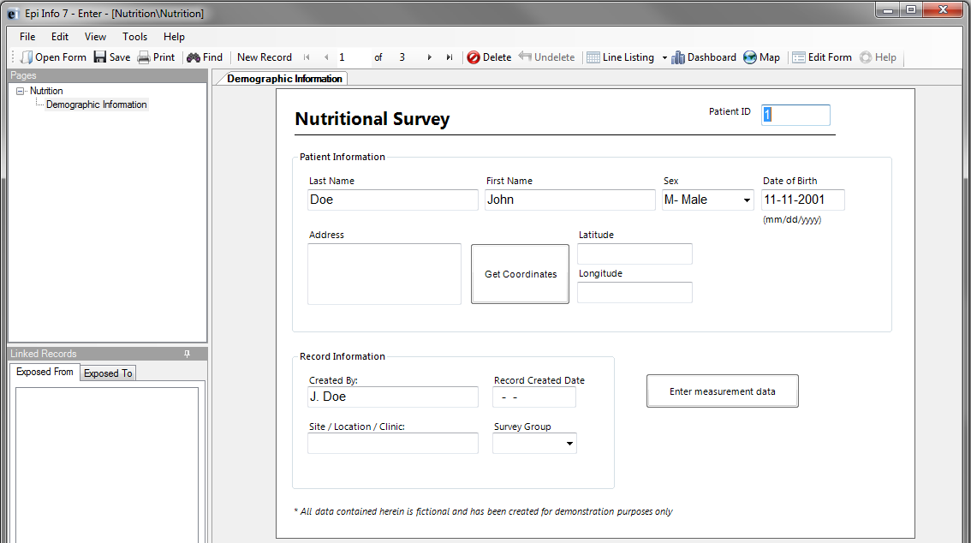
Figure 10.69: The Nutrition Form

Using the Nutrition Form
After the Nutrition Form is opened, data can be entered, modified, and deleted in the same manner as other Epi Info™ 7 forms. Each record in the Nutrition form represents a single child. The form contains the optional capability to geocode the child’s home address into latitude and longitude coordinates with the Get Coordinates button. Reference the Enter Data section of this user guide for additional information regarding the data entry process.
Although the data entry form contains only one record per child, each child may have been measured at multiple points in time. The Nutrition project has the ability to capture multiple measurements for each child, which is essential for calculating statistics and generating graphs. The Nutrition form has a related form called PatientVisits to store measurement information over time. The PatientVisits form may have one or more associated records. Clicking the Enter Measurement Data button will access the PatientVisits form.
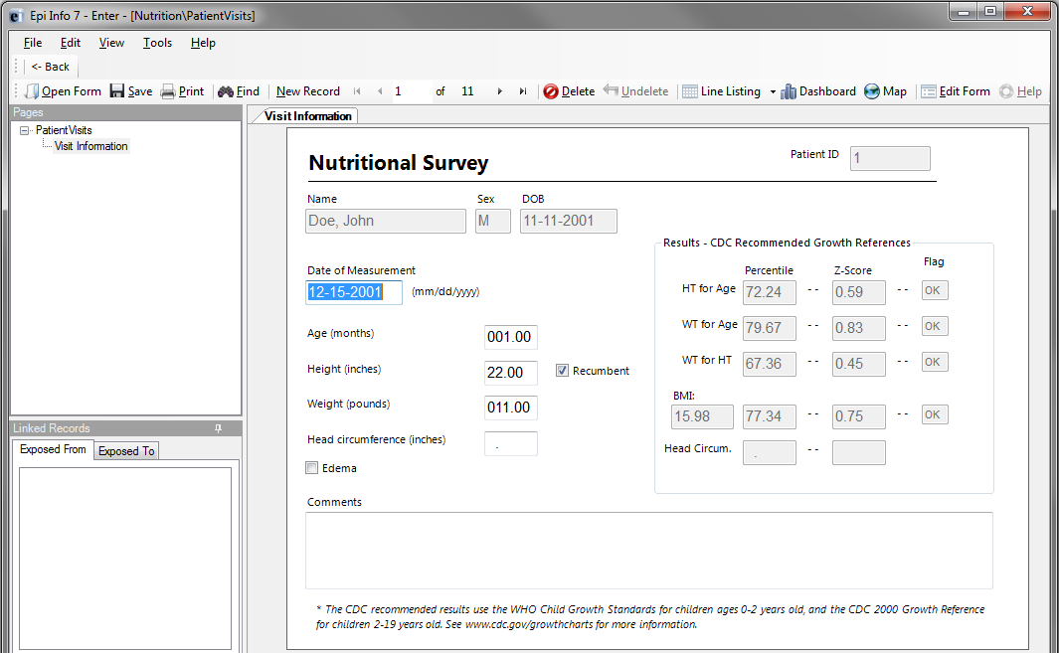
Figure 10.70: PatientVisits Form
The patient’s name, sex, date of birth, and ID number automatically appear in the form. These values link the records in this form to the child’s nutritional record in the Nutrition form. As you type values into the PatientVisits form (e.g., date of measurement, age in months, height, weight, etc.) the z-scores and percentiles are automatically calculated and appear in the form.
Add measurement records by clicking the New Record button on the toolbar. Clicking the <- Back button closes the PatientsVisits form and returns you to the Nutrition form.
The relationship between these two forms defines how information is stored and calculated. For each record in the Nutrition form, there may be one or more linked record(s) in the PatientVisits form. If the user is viewing record #1 in the Nutrition form, clicking the Enter Measurement Data button will take the user to all of the measurements associated with that particular child (and no others). See the following figure for a visual explanation of the relationship. Note that the blue squares represent records in the Nutrition form, and the red squares represent records in the PatientVisits form.
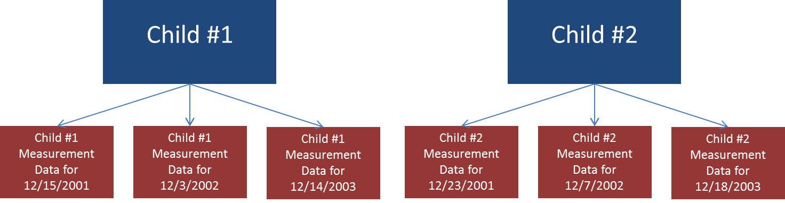
Figure 10.71: Nutrition (blue, top) and PatientVisits form (red, bottom) Relationship
To view Child #1’s measurement information on 12/15/2001, navigate to Child #1’s record in the Nutrition form. Click Enter Measurement Data and navigate to the record that has 12/15//2001 as the date of measurement.
Note: The data included in the Nutrition project may differ from that displayed in the figure above.

Customizing the Nutrition Forms
The Nutrition forms can be customized to include or exclude any field or check code in the form. For example, if geocoding the child’s address into latitude and longitude is not necessary, those fields can be deleted. The form’s title, Nutritional Survey, can also be changed.
Note: Removing fields or changing field names may disable the underlying z-score and percentile calculations.
For additional information regarding form editing, reference the Form Designer section of the user guide.

NutStat Growth Charts in Visual Dashboard

Based on a child’s measurements, a growth chart can be created in Visual Dashboard to track the progress of a particular child (Displaying multiple children on a single chart is not an available option). The NutStat growth charts can be accessed in Visual Dashboard by right clicking on the canvas and then selecting Add Nutstat growth chart.
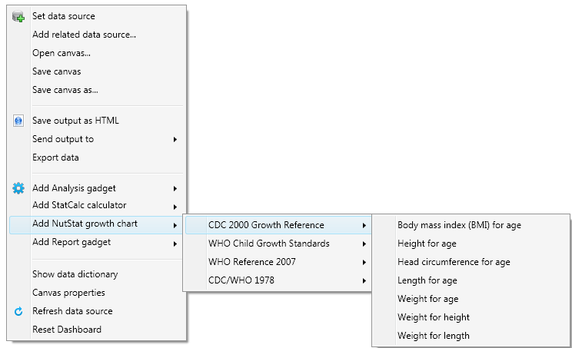
Figure 10.72: Growth Chart Types
There are four growth references available for use: CDC 2000 Growth Reference, WHO Child Growth Standards, WHO Reference 2007, and CDC/WHO 1978. Each growth reference contains different options for creating a growth chart and each chart requires the associated data.
Note: The Nutrition project does not contain example data to create all chart types.

Loading Nutritional Data
Prior to creating a growth chart, nutritional data must be loaded into the dashboard. Follow the steps below to load the data associated with the Nutrition project into the dashboard.
- From the Epi Info™ main menu, click the Visual Dashboard button or select Tools > Analyze Data > Visual Dashboard. The Dashboard tool appears.
- Right-click on the dashboard canvas. A context menu appears.
- Select Set Data Source from the context menu. The Select Data Source dialog box appears.
- Click the ellipses next to the Data Source text box. A file open dialog box appears.
- Navigate to the Epi Info™ projects folder.
- Open the Nutrition folder within the projects folder.
- Select the Nutrition project. Click Open.
- In the Select Data Source dialog box, select the PatientVisits form. Click OK. The data is loaded on the dashboard.
After the PatientVisits form is loaded, the dashboard will have cached the data in the computer’s memory. Based on the data, various types of statistical tools or gadgets can be added to the canvas to display useful information to the user. For information regarding the statistical tools and gadgets available, reference the Visual Dashboard section of this user guide.

Creating a Growth Chart
There are many growth charting options available under Add NutStat growth chart in Visual Dashboard. The available growth chart types are dependent on each growth reference and require the necessary project data.
Note: The Nutrition project does not contain example data for every growth chart type.
The following examples demonstrate how to create a growth chart with data contained in the Nutrition project. All growth charts created in Visual Dashboard use similar processes outlined in the examples below.

BMI for Age
The following example demonstrates how to create a BMI for Age growth chart using the CDC 2000 Growth Reference. The growth chart will demonstrate how the patient’s BMI compares to the CDC 2000 Growth Reference by age.
- Right-click on the dashboard canvas. A context menu appears.
- Select Add NutStat Growth Chart > CDC 2000 Growth Reference > Body Mass Index (BMI) for Age from the list of options in the context menu. A growth chart gadget appears on the canvas.
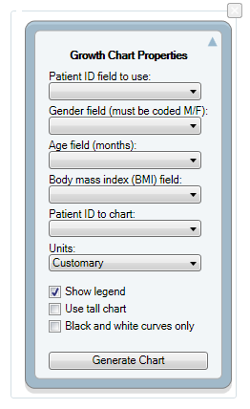
Figure 10.73: Growth Chart Gadget
The gadget must specify what fields to use for the Patient ID, Gender, Age, Body mass index (BMI), and the Patient ID to chart.

- Select VisitPatientID for Patient ID field to use.
- Select VisitSex for Gender field (must be coded M/F).
- Select AgeMonths for Age field (months).
- Select BMI for Body mass index (BMI) field.
- Select 1 for Patient ID to chart.
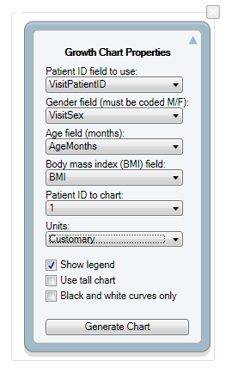
Figure 10.74: Completed Growth Chart Gadget
The checkboxes below the drop-down lists allow for customizing the appearance of the graph.
- Show legend – adds a legend to the graph (checked by default)
- Use tall chart – extends the vertical height of the growth chart
- Black and white curves only – all curves appear in black and white (color is removed)
- Click the Generate Chart button. The growth chart appears on the canvas.
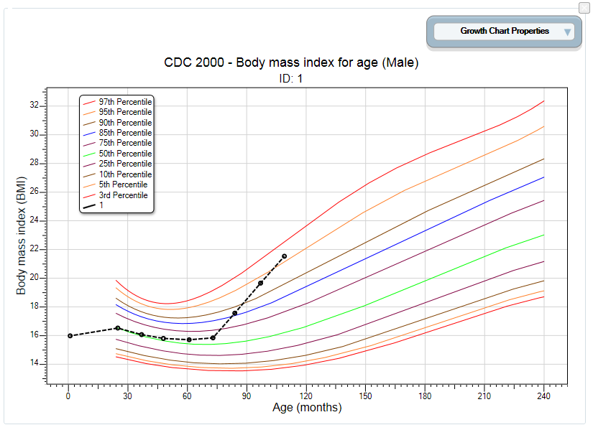
Figure 10.75: BMI for Age Growth Chart
- To collapse the panel and show only the chart, click the up arrow at the top right corner of the properties panel. Click the down arrow to expand the properties panel.

Height for Age
The following example demonstrates how to create a Height for Age growth chart using the CDC/WHO 1978 growth reference. The growth chart will demonstrate how the patient’s height compares to CDC/WHO 1978 standards by age.
- Right-click on the dashboard canvas. A context menu appears.
- Select Add NutStat Growth Chart > CDC/WHO 1978> Height for Age from the list of options in the context menu. A growth charting gadget appears on the canvas.
- Select VisitPatientID for Patient ID field to use.
- Select VisitSex for Gender field (must be coded M/F).
- Select AgeMonths for Age field (months).
- Select HeightInches for Height field.
- Select 1 for Patient ID to chart.
- Click the Generate Chart button. The chart appears as shown below.

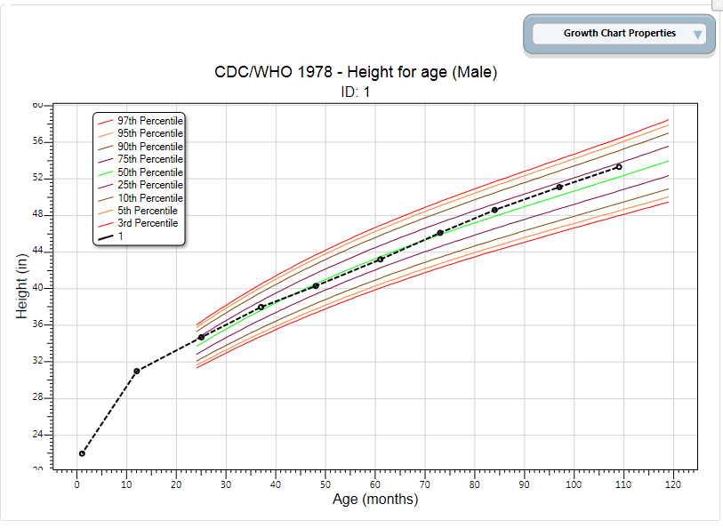
Figure 10.76: Height for Age Growth Chart
- To collapse the panel and show only the chart, click the up arrow at the top right corner of the properties panel. Click the down arrow to expand the properties panel.

Length for Age
The following example demonstrates how to create a Length for Age growth chart using the WHO Child Growth Standards. The growth chart will demonstrate how the patient’s length compares to WHO Child Growth Standards by age.
Note: The Length for Age chart requires similar inputs as the Height for Age chart but additionally requires the user to check the Recumbent check box in the PatientVisits form during data entry.
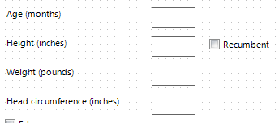
Figure 10.77: Recumbent checkbox in PatientsVisit form during data entry
- Right-click on the dashboard canvas. A context menu appears.
- Select Add NutStat Growth Chart > WHO Child Growth Standards > Length for Age from the list of options in the context menu. A growth charting gadget appears on the canvas.
- Select VisitPatientID for Patient ID field to use.
- Select VisitSex for Gender field (must be coded M/F).
- Select AgeMonths for Age field (months).
- Select HeightInches for Length field. (If recumbent was checked during data entry, the height field converts to length)
- Select 1 for Patient ID to chart.
- Click the Generate Chart button. The chart will appear as shown below.
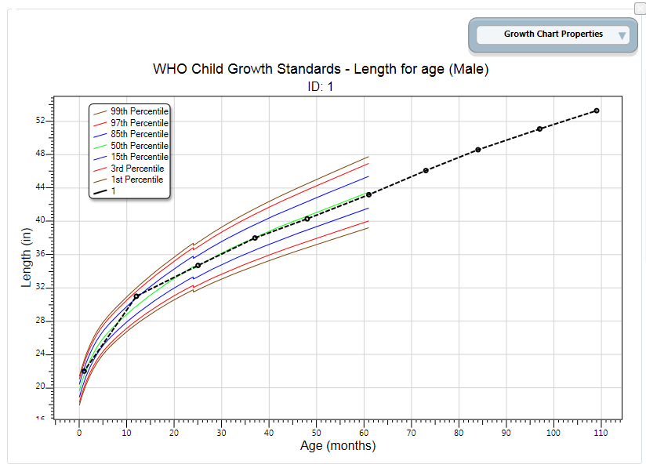
Figure 10.78: Length for Age Growth Chart
- To collapse the panel and show only the chart, click the up arrow at the top right corner of the properties panel. Click the down arrow to expand the properties panel.
It is important to note some aspects of the growth charting capabilities. First, there must be a patient ID field to identify a single person within the database. In the examples above, all of the records from the patient with an ID value of 1 were charted. Second, the field storing gender information must code that information as M and F. The dashboard has data recoding capabilities that can be used to change gender information to other formats. No matter what format represents male and female, it can be converted. In the examples above, no conversion was necessary. Third, the field storing the age values must be in months. Similar to gender, the dashboard can convert ages stored in days and years into months. Fourth, all properties can be changed in order to re-generate the chart. However, changing the chart inputs and growth references is subject to the data available and the available chart types. Finally, the growth charts can be used with non-Epi Info™ 7 projects, including projects that do not have the z-scores and percentiles already calculated.

Using the Nutrition Functions

There may be cases where nutritional data have already been collected in another program (e.g., Microsoft Excel) but the z-scores and percentiles are missing. Re-entering all of this data into the Epi Info™ 7 Nutrition project would be inefficient and time-consuming.
The Epi Info™ 7 Classic Analysis tool contains two specialized functions, ZSCORE and PFROMZ, that can add z-scores and percentiles to an existing set of data. For additional information on the Classic Analysis tool, reference the Classic Analysis section of this user guide.

The ZSCORE Function
The ZSCORE function takes a series of parameters and returns a z-score (z statistic) based on those parameters. The nutritional parameters include:
- Growth reference set (i.e., the CDC 2000 Growth Reference).
- Type of z-score (i.e., body mass index for age).
- Name of the column that stores the primary measurement (i.e., BMI).
- Name of the column that stores the secondary measurement (i.e., AgeMonths).
- Name of the column that stores the child’s gender, stored as 1’s and 2’s.
Note: The data available in the Nutrition project stores gender information as M and F and must be converted to 1’s and 2’s.
Each parameter is separated by a comma, and the entire series of parameters are enclosed in parenthesis. If you wish to calculate body mass index for age using the CDC 2000 Growth Reference, the function must reference the child’s raw BMI (column BMI), the child’s age in months (column AgeMonths), and the child’s gender (column Gender). The function will be similar to the following:
ZSCORE("CDC 2000", "BMI", BMI, AgeMonths, Gender)
The first parameter is “CDC 2000”. The quotes are required as the first two parameters are literal values (i.e. fixed values, the calculations will always refer to the exact CDC 2000 value). The full set of valid references that can be used for this parameter are listed below.
Parameter value | Reference
CDC 2000 | CDC 2000 Growth References
WHO CGS | WHO Child Growth Standards (0-5 years)
WHO 2007 | WHO Reference 2007 (5-19 years)
NCHS 1977 | CDC/WHO 1977 Growth Reference
Figure 10.79: Valid Values for First Parameter
The second parameter, “BMI”, tells the program to calculate a z-score for body mass index for age. The quotes for this second parameter are also required. The full set of valid z-score types that can be used for the second parameter are listed below. Not all growth references support all types of z-score calculations (i.e., “BMI” may be valid for CDC 2000, but it is not supported when using the NCHS 1977 growth reference).
Parameter value | Type of z-score
BMI | Body mass index-for-age
HtAge | Height-for-age
WtAge | Weight-for-age
WtHt | Weight-for-height
WtLgth | Weight-for-length
HeadCircum | Head circumference-for-age
LgthAge | Length-for-age
Ssf | Subscapular skinfold-for-age
Tsf | Triceps skinfold-for-age
Figure 10.80: Valid Values for Second Parameter
The third parameter is also BMI, but does not contain any quotes because this parameter is the name of the column (or field) in the current dataset that contains the child’s raw BMI calculation. For this example, it is assumed that the raw BMI score is stored in a column called BMI.
The fourth parameter is AgeMonths. It is critical to note that this parameter assumes the specified column is numeric and the numbers represent the child’s age in months.
The fifth parameter is Gender. It assumes the genders are stored in the database as 1’s (male), and 2’s (female).
Note: The data available in the Nutrition project stores gender information as M and F under the field VisitSex. To create the necessary Gender data, enter the following code into Classic Analysis.
DEFINE Gender

IF VisitSex = "M" THEN
ASSIGN Gender = "1"
END

IF VisitSex = "F" THEN
ASSIGN Gender = "2"
END

Database names and column names may differ from the example above. The final three parameters may vary considerably depending on the database. However, the first two parameters will only accept the limited set of inputs stated in the tables above.

To run this calculation, the ZSCORE function must be paired with an ASSIGN command. For example:
ASSIGN BMIZ = ZSCORE("CDC 2000", "BMI", BMI, AgeMonths, Gender)
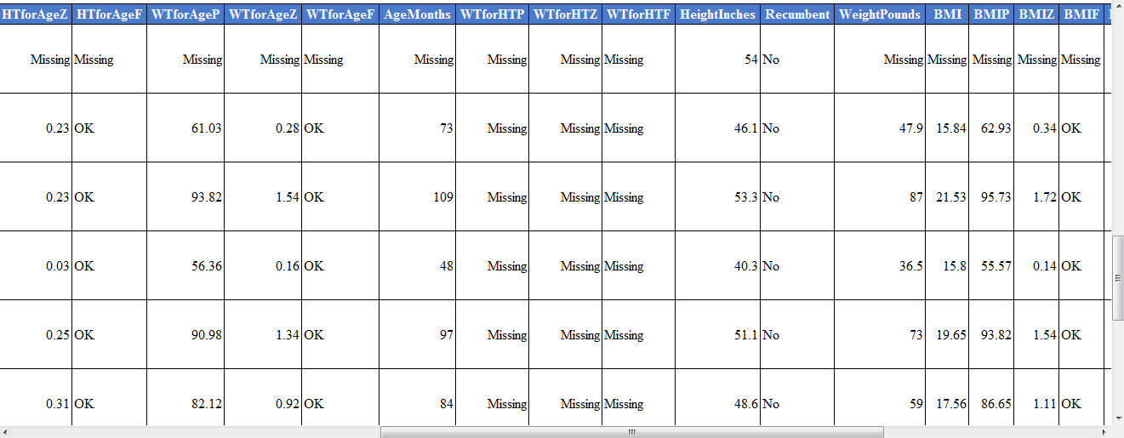
Figure 10.81: BMIZ Calculation
The code above instructs the program to assign the z-score for body mass index for age using the CDC 2000 Growth Reference to the BMIZ column. This will be done for every row in the current dataset.

The PFROMZ Function
The second Nutritional Anthropometry function included in Epi Info™ 7 is called PFROMZ, which converts a z-score into a percentile. To perform the percentile calculation, enter the column name that contains a z-score as a parameter, and the corresponding percentile is returned. For example:
PFROMZ(BMIZ)
The above code assumes the BMIZ column contains the z-scores for body mass index for age. Note that the PFROMZ function does not need to know the reference, z-score type, gender, etc., of the data. For example:
ASSIGN BMIP = PFROMZ(BMIZ)
The code above instructs the program to take the percentile associated with the z-score values stored in the BMIZ column and to assign that value to the BMIP column. This will be done for every row in the current dataset.

StatCalc

Introduction

StatCalc is an epidemiologic calculator that produces statistics from summary data. Three types of calculations are offered:
- Statistics from 2-by-2 to 2-by-9 tables similar to those produced in Analysis. Both single and stratified 2-by-2 tables can be analyzed to produce odds ratios and risk ratios (relative risks) with confidence limits, several types of chi square tests, Fisher exact tests, Mantel-Haenszel summary odds ratios and chi squares, and associated p-values.
- Sample size and power calculations include Population Survey, Cohort or Cross-Sectional, and Unmatched Case-Control Study.
- Chi-square for trend by the Mantel extension of the Mantel-Haenszel summary odds ratio and chi square. This tests for the presence of a trend in dose response or other case control studies where a series of increasing or decreasing exposures is being studied.

How to Use StatCalc

Opening StatCalc

- From the Epi Info 7 main menu, select StatCalc.
- Select one of the following calculations using the up and down arrow keys or click: Sample Size & Power, Chi Square for Trend, Tables (2X2, 2Xn), Poisson (rare event vs. std.) or Binomial (proportion vs. std.).
- You can also select calculations by pressing the corresponding key on the keyboard that matches the highlighted letter on the menu. If you select a calculation using the keyboard, the calculation appears immediately.
- If you select the Sample size and power calculation, the following calculation options appear: Population Survey, Cohort or Cross-Sectional, Unmatched Case-Control.
- Use the tab key or return key to move around the different cells available for data entry
- Enter data for each calculation type. Calculations are performed when you enter data...
- To modify values already entered, use the Tab key or click on the cell and enter the new information.
- Right click and select the Print option in order to print the results.
- Right click and select the Save as Image option to save a screen shot of your results as an image file.

Analysis of Single and Stratified Tables

These tables are similar to those produced in Classic Analysis. Both single and stratified 2-by-2 tables can be analyzed to produce odds ratios and risk ratios (relative risks) with confidence limits, several types of chi square tests, Fisher exact tests, Mantel-Haenszel summary odds ratios and chi squares, and associated p values
Assumptions
- The values in the cells must be counts representing the number of records meeting the specifications in the marginal and stratum labels.
- A case-control study is one in which the ill and well individuals are selected and the number of exposed and unexposed is subsequently ascertained. In a cohort study, the exposed and unexposed are selected and the number of ill in each group is subsequently ascertained. A cross-sectional study starts with neither illness nor exposure determined, and ascertains both during the study.
- In cohort studies, the relative risk may be calculated from the results. In case-control studies, the odds ratio may be used as an approximation of the relative risk if the disease is rare in the general population from which cases and controls are selected. Fewer than one case in 20 individuals might be taken as a starting point. Thus, in a foodborne outbreak, selecting cases and controls from those who ate at a particular restaurant in a given week, the odds ratio could not be used to approximate relative risk if half of the individuals became ill. The odds ratio would, however, be an indicator of the degree of association between illness and the consumption of a particular food.
- For the results to be valid, the outcomes in each record must be independent of those in other records. The values for one individual do not predict those for another. Confounding must be removed by stratifying on confounding variables.Single 2-by-2 Tables
Two-by-two tables are frequently used in epidemiology to explore associations between exposure to risk factors and disease or other outcomes. The table in StatCalc has Exposure on the left and Disease across the top. Not all textbooks and articles use the same conventions. Carefully observe the labels and transpose data items if necessary.
Given a yes-no or other two-choice question describing disease and another describing exposure to a risk factor, StatCalc produces several kinds of statistics that test for relationships between exposure and disease. Generally, an association is suggested by an odds ratio or relative risk larger or smaller than 1.0. The further the odds ratio or relative risk is from 1.0, the stronger the apparent association. Statistical significance can be assessed by p-values for the Chi square tests that are small <.05 if often used, Fisher exact test with a small p value; or confidence limits for the odds ratio that do not include 1.0.
The expected value of a cell is the product of the marginal totals for that cell divided by the grand total for the table. If any expected value is less than five, it is recommended you use the Fisher Exact test results and the Exact confidence limits. If the numbers in the table are all large, the other tests should indicate nearly the same result.

Stratified Analysis of 2-by-2 Tables
If confounding is present, associations between disease and exposure can be missed or falsely detected. A confounding factor is one that is associated with the disease and the exposure, but may not be of interest or observed. Age is a frequent confounder, although any factor other than the main exposure being considered can be treated as a confounder.
Stratification means making a separate table of disease by exposure for each possible confounder combinations. In the simplest case, this could mean separate male and female tables if sex is the potential confounder. If Age, Sex, and City are confounders, separate tables would be made for each possible combination of age group, sex, and city.
The Mantel-Haenszel weighted odds ratio, relative risk, summary Chi square, and p-value combine results from different strata to remove confounding caused by the variables used for stratification. If tables are entered for male and female, confounding by sex is removed. The degree of confounding can be judged by comparing the crude and weighted odds ratios; if they are identical, there was no confounding by sex.
The Approximate (Cornfield and Greenland/Robins) and Exact confidence limits provide additional measures. If the weighted odds ratio or relative risk (not for case-control studies) has confidence limits that do not include 1.0, there is a statistical association with 95% confidence between the disease and the exposure without confounding by the stratifying factor.
If the odds ratio or relative risks for strata in a series of stratified tables for the tests are not similar, then interaction between the stratifying factor and the risk factor are present. Logistic regression or other multivariate methods may be indicated (or the number of subjects is too small to draw definite conclusions). Alternatively, it may be advisable to present the stratum-specific estimates separately.
Experts in logistic regression recommend you thoroughly explore the data using stratified analysis before undertaking the regression analysis. If the number of confounding factors is fairly small and the odds ratios are homogeneous from stratum to stratum, stratified analysis may be all you need.

Example
A study of bladder cancers cases used randomly selected controls to explore the history of artificial sweetener use in the two groups.
 | Bladder Cancer
Sweetener | Yes | No
Ever Used | 1293 | 2455
Never Used | 1707 | 3321
- From the StatCalc application main page, select Tables <2 x 2, 2 x n>. A blank table opens in the StatCalc application window.
- Enter the data from the above sample table.
- Results will be generated as the different values in the cells are populated.
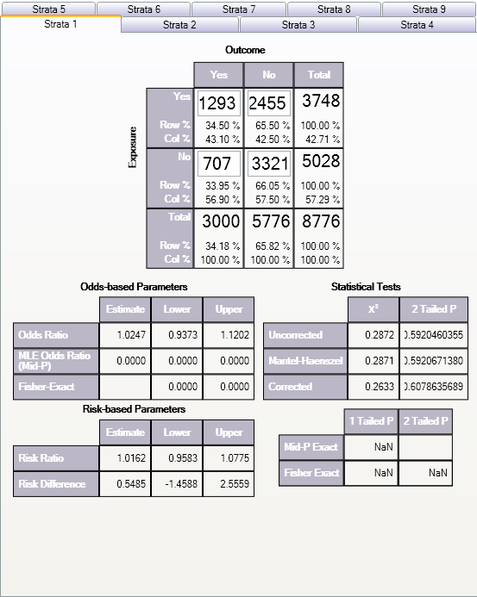
Figure 12.1: Results Table

The odds ratio of 1.02 and the confidence limits that include 1.0 fail to provide evidence of any association between sweetener use and bladder cancer (cited by Schlesselman, p. 38-39).
Example
Relationship Between Alcohol Consumption and Myocardial Infarction (MI): Confounding Due to Smoking Hypothetical Data from Schlesselman, p. 182
The following case-control study indicates an apparent association between alcohol consumption and MI with an odds ratio of 2.26.

 | MI
Alcohol | Yes | No
Yes | 71 | 52
No | 29 | 48
Smoking is known to be associated with MI and alcohol consumption. Stratifying the data by smoking status creates two tables, one for smokers, and one for nonsmokers.
Nonsmokers Smokers
 | MI |  |  |  | MI
Alcohol | Yes | No |  | Alcohol | Yes | No
Yes | 8 | 16 |  | Yes | 63 | 36
No | 22 | 44 |  | No | 7 | 4

The odds ratio for each table is 1.0, and the Mantel summary odds ratio is 1.0. The crude odds ratio and the Mantel summary odds ratio are quite different (4.0 and 1.0), concluding that smoking was a confounding factor and there appears (with this over simplified analysis) to be no association (odds ratio= 1.0) between alcohol and MI. Note that the odds ratio in the two strata are the same (1.0); there is no interaction or effect modification between smoking and alcohol. In other words, the effect of alcohol on MI is the same for smokers and nonsmokers. When the effect varies in the different strata (the odds ratios are different), interaction or effect modification is present.
To view and create a Stratified Analysis Summary of 2-by-2 Tables, take the following steps:
- From the StatCalc application main page, select Tables <2 x 2, 2 x n>. A blank table opens in the StatCalc application window.
- Enter the data from the above Nonsmokers sample table in the first Strata tab (Strata 1).
- Click on Strata 2
- Enter the data from the above Smokers sample table.
- The Stratified Analysis Summary of 2 Tables window gets populated as you enter data.
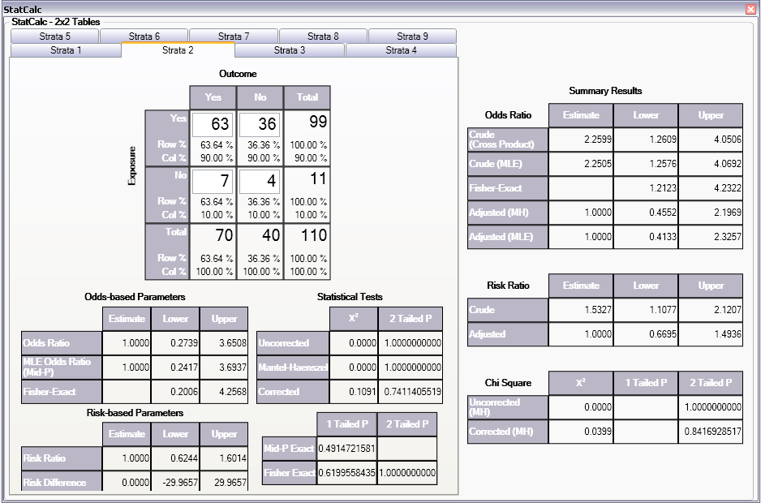
Figure 12.2: Multi-Strata 2x2 Results Table
Population Survey or Descriptive Study

Assumptions
- The sample to be taken must be a simple random or representative. A systematic sample (e.g., every fifth person on a list) is acceptable if the sample is representative. Choosing every other person from a list of couples, however, would not give a representative sample because it might select only males or only females.
- The question being asked must have a Yes-No or other two-choice answer, leading to a proportion of the population (those answering Yes) as the final result.

Example
Suppose you want to investigate whether the true prevalence of HIV antibody in a population is 10%. A random or systematic sample of the population is planned to estimate the prevalence. A 95% confidence that the true proportion in the entire population will fall within the confidence interval calculated from the sample is desired.
In StatCalc, enter the population size of 5,000, the estimate of the true prevalence 10%, and 10% as the Confidence Limit.Worst Acceptable value. The application will show the sample size for several different confidence levels including the desired 95%.
- From the StatCalc application main page, select Sample size & power. The following calculation options appear: Population survey, Cohort or cross-sectional, Unmatched case-control.
- Select Population Survey. The Population Survey or Descriptive Study Using Random (Not Cluster) Sampling window opens.
- Enter the Population Size of 5,000.
- Enter the Expected Frequency of 10%.
- Enter the Confidence Limits as 6%.
The results appear in the window.

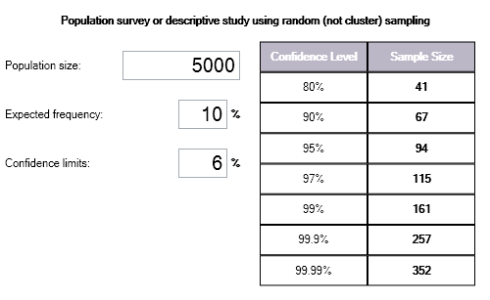
Figure 12.3: Population Survey or Descriptive Study Results Table

Notes
Sample size determination is only a rough guide, based on assuming a specific value for the true population proportion, the variability in the sample estimate and its confidence limit. Many other factors (i.e.,cost, number of available subjects, rate of nonresponse, and the accuracy of answers and data transcription) must be considered in study design.

THIS PAGE IS
INTENTIONALLY BLANK.

Command Reference

Introduction

Epi Info 7 is easy to operate in interactive mode, but complex or repeated operations require saving the steps as programs. Programs (similar to “scripts” in other software) can be used to set up menus, guide and limit the data entry process, restructure data, and do analyses.
In Form Designer and Classic Analysis, programming consists of interacting with a series of dialogs that produce the actual program statements. Experienced users may want to edit the statements or type them directly in the Program Editor. For this reason, the details of command syntax are provided and include a definition of each command and its operation because a single command (e.g., EXECUTE) may be found in Form Designer, Classic Analysis, and Visual Dashboard. Commands are in module based chapters with notation of differences that may exist between program implementation. Some commands are only available in one or two programs. Check Commands are saved in Form Designer and executed in Enter. Classic Analysis commands are generated, edited, executed, and may be saved with the Program Editor from Classic Analysis.
Functions and operators appear within commands and are used for common tasks (i.e., extracting a year from a date, combining two numeric values, calculating duration between two dates, or converting numbers to text and vice versa).

Check Code Commands

ASSIGN

Description
This command assigns the result of an arithmetic or string expression to a variable.
Syntax
ASSIGN <variable> = <expression>
ASSIGN <variable> = <defined DLLOBJECT>!<script function>({<parameters>})
- The <variable> represents a variable in a database or a defined variable created in a program.
- The <expression> represents any valid arithmetic or string expression.
- The <defined DLLOBJECT> represents any variable defined as a DLL object.
- The <script function> represents the name of a class or method inside the DLL or WSC that returns the desired value to be assigned.
- The <parameters> represent one or more optional function parameters to be passed into the DLL or WSC (do not include the {} or <> symbols in the code; parenthesis are required).
Comments
This command assigns the value of an expression to a variable. The variable may be a database variable in a form or Data Table, a user-defined variable created by the DEFINE command, or a system variable.
Examples
Example 1: The patient's age is calculated using the date of birth and the date the survey was last updated. The example assumes a form exists with the following fields: DOB (Date), SurveyDate (Date), and Age (Numeric). The code below would appear in the AFTER section of the second date field to be filled in by the user.
IF NOT BirthDate = (.) AND NOT SurveyDate = (.) THEN
ASSIGN Age = YEARS(BirthDate, SurveyDate)
END-IF
Example 2: The code below will automatically set the checkbox field 'Minor' to true when the value of the field 'Age' is below 18. The example assumes a form exists that has the following fields: Minor (Checkbox) and Age (Numeric). The code below would appear in the AFTER section of the Age field.
IF Age < 18 THEN
ASSIGN Minor = (+)
END
Example 3: A field is assigned the value of a mathematical expression that is used to calculate body mass index. The example assumes a form exists with the following fields: BMI (Numeric), Weight (Numeric), and Height (Numeric). The code below would appear in the AFTER section of the last field to be entered. Note that Weight and Height in this formula are being measured in pounds and inches, respectively.
ASSIGN BMI = (Weight / (Height * Height)) * 703
Example 4: A patient ID field is automatically generated using the patient's last name, gender, and middle initial. The example assumes a form exists with the following fields: ID (Text), LastName (Text), Sex (Text), and MI (Text). The code below would appear in the AFTER section of the last of the above fields to be entered.
ASSIGN ID = LastName & " - " & Sex & " (" & MI & ")"

AUTOSEARCH

Description
AUTOSEARCH causes Enter to search for records with values in the specified fields that match ones in the current record. If a match is found, it can be displayed, edited, or ignored, and the current record can continue to be entered.
Syntax
AUTOSEARCH [<field(s)>]
- The <field(s)> represents one or more fields to search.
Comments
The results are displayed as a spreadsheet. If you have more records than can be viewed in a single screen, a scroll bar appears to the right of the spreadsheet. Use the mouse to see the additional matched records.
To quickly navigate to one of the matched records returned, double-click the intended row. Alternatively, move the cursor to the desired row and press Enter or click OK. Navigating to a matched record will discard any data entered to the new record. All fields will show data from the selected record. The record number indicator at the lower left will show the record number of the selected record. To avoid selecting any of the matched records, press Esc or click Cancel to return to the current new record. Data entry will continue for the new record.
Fields displayed from a search are determined as follows:
- If a single field is the key field, it will be displayed with as many other fields as possible.
- Multiple key fields (if any) will be displayed before any others.

Example
The AUTOSEARCH command is used to find duplicate entries during data entry. In this example, duplicates are identified by a matching first and last name as in a name-based registry system. The example assumes a form exists with the following fields: FirstName (Text) and LastName (Text). The code below would appear in the AFTER section of the second field to be filled in by the user.
AUTOSEARCH FirstName LastName

Note: When searching on multiple fields, put the AUTOSEARCH command in Check Code for a field after all the key values have been entered. In the example above, both FirstName and LastName are key fields and LastName is the last of the key fields to be entered. The AUTOSEARCH command should appear in the Check Code for LastName.

BEEP

Description
This command causes the computer to generate a beep sound. It is often used to emphasize a customized message or warning dialog during data entry.
Syntax
BEEP
Comments
Command must be typed into the Program Editor since it is not available using the Command Tree.
Example
The computer emits a beep when invalid data is detected in the Age field. This code should appear in the AFTER section of the Age field.
IF Age > 5 THEN
BEEP
DIALOG "Do not include records for children over 5."
END-IF

CLEAR

Description
CLEAR sets the field named to the missing value, as if it had been left blank. The command is used to clear a previous entry when an error has been detected or a change occurs. More than one field may be specified. CLEAR is frequently followed by a GOTO command, which places the cursor in position for further entry after an error.
Note: More than one field can be used with the CLEAR command.
Syntax
CLEAR [<field(s)>]
- The <field> represents the name of a field on the form. If more than one field is specified, a space will separate them.
Comments
CLEAR will delete the value only for the current record. CLEAR cannot be used in grid tables. In Classic Analysis, you must clear a variable to use the ASSIGN command to assign it a value of null (.).
Examples
Example 1: The code below prevents invalid data from being saved to the current record by erasing it as soon as it is detected. The example assumes a form exists with the following field: Age (Numeric). The code below would appear in the AFTER section of the Age field.
IF Age >= 18 THEN
BEEP
DIALOG "Do not include records for adults."
CLEAR Age
END-IF
Example 2: The code below prevents an invalid date from being saved to the current record by erasing it as soon as it is detected. The example assumes a form exists with the following fields: DOB (Date) and SurveyDate (Date). The code below would appear in the AFTER section of the SurveyDate field.
IF (DOB > SurveyDate) OR (SurveyDate > SYSTEMDATE) THEN
CLEAR DOB SurveyDate
DIALOG "Invalid date detected. Please try again."
END-IF

Example 3: The code below prevents an invalid date from being saved to the current record by erasing it as soon as it is detected. By using a GOTO command to move the cursor back to the SurveyDate field, you are forced to keep entering data until valid data are detected. The example assumes a form exists with the following fields: DOB (Date) and SurveyDate (Date). The code below would appear in the AFTER section of the SurveyDate field.
IF DOB > SurveyDate THEN
CLEAR SurveyDate
GOTO SurveyDate
DIALOG "Survey date invalid. Please try again."
END-IF

COMMENTS (*)

Description
In Check Code and Classic Analysis, the combination of backslash and asterisk in the beginning of a line of code and an asterisk and backslash at the end, as shown in some code samples, indicates a comment. Commented lines are not executed. This allows you to enter user-defined comments to identify tasks, describe variable names or code blocks for documentation, and to assist with trouble-shooting or debugging.
Syntax
/* <text>
*/
- The <text> represents any alphanumeric text as a comment or a block of code slated to be ignored.
Comments
The /* character must be placed in the first column of a line to be recognized as comment mark. For comments longer than one line, the */ characters should be added at the end of the code. Use comments to disable commands.
Examples
Example 1: Comments are used to note the date of the code's generation date, purpose, and author.
/* Written by Jason D. Veloper, MPH – 06/30/2010
The block of code below uses the YEARS function
*/
ASSIGN AGE = YEARS(DOB, SYSTEMDATE)
Example 2: Comments are used to disable certain commands from executing.
/* The next few lines are incomplete and are commented for later
DEFINE PatientID Numeric – Note: need to determine ID should be a
Text type variable.
LIST – ToDo: need to add the variables to list
*/

DEFINE

Description
This command creates a new variable. In Check Code, all user defined variables are saved in the DEFINEDVARIABLES section.
Syntax
DEFINE <variable> {<scope>} {<type indicator>}
- <variable> represents the name of the variable to be created. The name of the newly defined variable cannot be a reserved word. For a list of reserved words, see the List of Reserved Words section.
- <scope> is optional and is the level of visibility and availability of the new variable. <scope> must be one of the reserved words: STANDARD, GLOBAL, or PERMANENT. If omitted, STANDARD is assumed and a type indicator cannot be used. For information on defining a variable as a DLL OBJECT, see the DEFINE DLLOBJECT command.
- <type indicator> is required and cannot be used if <scope> is omitted. <type indicator> is the data type of the new variable and must be one of the following reserved words: NUMERIC, TEXTINPUT, YN, or DATEFORMAT. If omitted, the variable type will be inferred based on the data type of the first value assigned to the variable. However, omitting field type is not recommended. Once field type is defined, the variable type cannot be changed. An error will occur if you attempt to assign data of a different type to the variable.
Comments
A custom variable defined in Epi Info 7 might not have a predefined data type if the <type indicator> is omitted when the variable is defined. If the variable does not have a predefined type and has not been used, the variable will accept a value in any of the four data types (Text, Number, Date, Yes/No [Boolean]) that is assigned to the variable the first time. Thereafter, the variable takes on the data type of the value assigned and it’s data type cannot be changed. However, omitting field type is not recommended. An error will occur if you attempt to assign data of a different data type. Various functions can be used to manipulate data, changing data type of values to match the data type of the variable. Some of these functions include FORMAT, TXTTONUM, TXTTODATE, and NUMTODATE.
Variable Scope
- STANDARD variables retain their value only within the current record and are reset when you load a new record. Standard variables are used as temporary variables behaving like other fields in the database. In Classic Analysis, Standard variables lose their values and definitions with each READ statement.
- GLOBAL variables retain values across related forms and when the program opens a new form, but are removed when you close the Enter program. Global variables persist while the program is executed. Global variables are also used in Classic Analysis to store values between changes of data source.
- PERMANENT variables are stored in the EpiInfo.Config.xml file and retain any value assigned until the value is changed by another assignment or the variable is undefined. They are shared among Epi Info programs (i.e., Enter, Classic Analysis, etc.) and persist even if the computer is shut down. Permanent variables in Classic Analysis may not have values that depend directly or indirectly on table fields. A <prompt/description> created for a permanent variable will exist for one session, and must be re-established each time it is used.
Type Indicators
- TEXTINPUT - Variables of this data type can receive any alpha-numeric characters including symbols and the output of functions (e.g., FORMAT).
- NUMERIC - Variables of this data type can receive numbers and the output of functions (e.g., TXTTONUM).
- DATEFORMAT - Variables of this data type can receive date values including the output of functions (e.g., TXTTODATE and NUMTODATE).
- YN - Variables of this data type can receive the Boolean values of (+) for Yes and (-) for No. Until an assignment is made, YN type variable values are (.) or missing.
Examples
Example 1: A variable is defined without <scope>, <type indicator>, and <prompt/description>. Standard scope thus becomes the default scope. As no type is specified, the variable can be assigned number, date, text, or Boolean data. However, once assigned a value, the data type of the variable becomes the data type of the value that has been assigned and may not be changed.
DEFINE BodyMassIndex NUMERIC
Example 2: A variable with standard scope and of type YN is defined.
DEFINE DoYouSmoke YN
IF DateSmokingStarted = (+) THEN
ASSIGN DoYouSmoke = (+)
ELSE
ASSIGN DoYouSmoke = (.)
END-IF
Example 3: A variable with standard scope and in date format is defined.
DEFINE DateOfBirth DATEFORMAT
Example 4: A variable with permanent scope is defined, but with no <type indicator>. As described in Example 1, the variable data type will be set with the first assignment of data and cannot be changed thereafter.
DEFINE StateID PERMANENT
Example 5: A variable with global scope and of type text is defined.
DEFINE PatientID GLOBAL TEXTINPUT

DEFINE DLLOBJECT

Description
This command creates a variable that represents an ActiveX object and a class within an ActiveX DLL (dynamic link library) file, ActiveX EXE (executable file), or a Windows Scripting Component (WSC) file.
Syntax
ActiveX DLL File
DEFINE <variable> DLLOBJECT "<ActiveX name>.<class>"
Windows Scripting Component (WSC) File
DEFINE <variable> DLLOBJECT "<filename>"
- The <variable> represents the name of the variable to be created. <variable> cannot be a reserved word.
- The <ActiveX name> represents the internal name of the ActiveX object that contains the class object for the DLL or EXE file.
- The <class> represents an internal class name that is defined within the ActiveX component.
- The <filename> represents the name of the Windows Scripting Component (WSC) file where the script component resides.
Comments
The ActiveX name may not be the same as the actual name of the dll (dynamic link library) or executable (exe) file. An ActiveX object is given a name when it’s developed. This name is required to create the object. The ActiveX object (executable or dll) must be registered before it can be used. Windows Scripting Component (WSC) objects can also be used.
Examples
Example 1: A variable is created that points to a class object within the Epiweek DLL file. This variable can subsequently be used to find the Epi Week for any given date.
DEFINE Week DLLOBJECT "EIEpiwk.Epiweek"
Example 2: A variable is created that points to a class object within the GetGlobalUniqueID.WSC file. You can use this variable to assign a field a unique ID.
DEFINE Global_ID DLLOBJECT "GetGlobalUniqueID.WSC"

AFTER and END-AFTER

Description
This command divides Check Commands to be executed after data entry. All commands in the AFTER and END-AFTER block are executed after entering data to the field, page, or form.
Syntax
AFTER
- AFTER and END-AFTER are only used in Check Code.
Comments
This command enables actions to occur after accessing a form, page, or field. The default time to execute commands associated with a variable is after entry.
AFTER must start in the first position of the line and end with END-AFTER.
Example
The following commands represent the Check Code for a variable called Demo1.
BEFORE
DIALOG ”This is Before entry”
END-BEFORE
AFTER
DIALOG ”This is After entry”
END-AFTER

BEFORE and END-BEFORE

Description
This command divides Check Commands to be executed before data entry from those executed after entry. All commands in the BEFORE and END-BEFORE block are executed before data entry to the field, page, or form.
Syntax
END-BEFORE
- ENDBEFORE is only used in Check Code. Command buttons will not take ENDBEFORE since all code inserted will be executed when you click the button.
Comments
This command enables actions to occur before accessing a form, page, or field. The default time to execute commands associated with a variable is before entry.
BEFORE must start in the first position of the line and end with END-BEFORE.

Example
The following commands represent the Check Code that raise a dialog before the cursor enters the field before data entry, and then after the cursor leaves the field following data entry.
BEFORE
DIALOG ”This is Before entry”
END-BEFORE
AFTER
DIALOG ”This is After entry”
END-AFTER

CLICK and END-CLICK

Description
This command block is for fields that have a click event such as Command Buttons, Checkboxes, Legal Values, and Comment Legal fields. Not all field types support the CLICK command. Check Commands in the Click block are executed immediately upon clicking the field or clicking an item in a drop-down list.
Syntax
CLICK
//Add commands here
END-CLICK
Comments
This command block enables actions to occur immediately upon clicking a field that supports the CLICK event.
CLICK must start in the first position of the line and end with END-CLICK.
Example
The following commands raise a dialog when the field is clicked.
CLICK
DIALOG ”The checkbox was just clicked.”
END-CLICK

EXECUTE
Description
Executes a Windows or DOS program - either one explicitly named in the command or one designated within the Windows registry as appropriate for a document with a named file extension. This provides a mechanism for bringing up the default word processor or browser on a computer without first knowing its name. The EXECUTE command accepts a series of paths, separated by semicolons:
EXECUTE c:\epi_info\myfile.exe;d:\myfile.exe
If the first is not found, the others are tried in succession. In Check Code, the EXECUTE command can be placed in any command block, but is often used with a button. A button does not have a Before Entry section.
Syntax
EXECUTE <filename>
EXECUTE "<filename> <command-line parameters>"
EXECUTE NOWAITFOREXIT <filename>
EXECUTE NOWAITFOREXIT '<filename>'
EXECUTE NOWAITFOREXIT "<filename>"
EXECUTE WAITFOREXIT <filename>
EXECUTE WAITFOREXIT '<filename>'
EXECUTE WAITFOREXIT "<filename>"
- The <filename> represents the path and program name for .exe (filename for registered Windows programs) and .com (filename for MS-DOS binary executable) files.
- The <command-line parameters> represent any additional command-line arguments that the program can accept.
- When Wait for Command to Execute (modal) is specified, the command should run and Enter should continue running. When Wait for Command to Execute is not specified (non-modal), Enter should wait until the executed program closes before continuing. When EXECUTE is run modally, permanent variables are written before the command is executed and reloaded after it is executed.
Comments
If the name of an executable program, (e.g., ENTER.EXE, MYBATCH.BAT, or MYWEB.HTM) is given, the program will be run in a separate window. The window closes when the program terminates.
If the name given is not a program, but a file with an extension (the three characters after the ".") registered by Windows for displaying the document, the correct program to display the file will be activated (i.e., WRITEUP.DOC might cause Microsoft Word© to run and load the file on one computer). Usually .TXT will run NOTEPAD.EXE© or WORDPAD.EXE©, and image files will appear in a browser or in a graphics program. An .HTM file will bring up the default browser.
You will not need to supply the location or even the name of the program that will be run. These details are stored in the Windows registry for common file extensions. The same concept applies to Internet addresses (URLs). Give a URL (Universal Resource Locator) that ends in .HTM or begins with HTTP:// “http://www.cdc.gov/epiinfo/” and Windows brings up the default browser, connects to the Internet (if possible), and goes directly to the site indicated.
Examples
Example 1: A text file on the C drive is opened. The operating system will select an application to open the file.
EXECUTE “C:\logfile.txt”
Example 2: An executable file is run.
EXECUTE "C:\Windows\Notepad.exe"
Example 3: Windows Internet Explorer is run and passed http://www.cdc.gov/epiinfo as a command-line parameter. Because WAITFOREXIT is specified, Enter will not allow you to continue entering data until the browser window is closed.
EXECUTE WAITFOREXIT "http://www.cdc.gov/epiinfo"

GOTO

Description
This command can be used alone or in an IF statement to transfer the cursor to a named variable field.
Syntax
GOTO <event>
- The <event> can be a +1, -1, page number, or a field name.
Event and Description
- +1 Automatically saves the current page if changes have been made, and goes to the next page.
- -1 Automatically saves the current page if changes have been made, and goes to the previous page.
- <page number> Automatically saves the current page if changes have been made, and goes to the page indicated by the number.
- <field name> Goes to the field indicated. Automatically saves the current page if changes have been made, if the field is on another page.
Comments
GOTO will be ignored if it is in the Before or After Record event. The GOTO command skips all the variables in between unavailable for data entry or Read Only.
Examples
Example 1: The form will skip directly from one field to another based on certain user input. The example assumes a form exists that has the following fields: DoYouSmoke (Yes/No), PacksPerDay (Numeric), and HeartDisease (Yes/No). The code below would appear in the AFTER section of the DoYouSmoke field.
IF DoYouSmoke = (+) THEN
GOTO HeartDisease
ELSE
GOTO PacksPerDay
END-IF
Example 2: You will be taken to the second page on the form based upon an answer provided to a question on lung disease. The example assumes a form exists that has two pages and the following fields: LungDisease (Yes/No). The code below would appear in the AFTER section of the LungDisease field.
IF LungDisease = (-) THEN
GOTO 2
END-IF
Example 3: You will be taken to the page immediately following the one they are on currently. The example assumes a form exists that has two pages and the following fields: DOB (Date) on page 1. The code below would appear in the AFTER section of the DOB field.
IF NOT DOB = (.) THEN
GOTO +1
END-IF

UNHIDE

Description
HIDE - This command hides a field from the form and prevents data entry.
UNHIDE - This command makes a field visible and returns it to the status before it was hidden.
Syntax
HIDE [<field(s)>]
UNHIDE [<field(s)>]
- The <field(s)> represents one or more valid field names.
Comments
If no field name is specified, the current field (the one to which the Check Code block pertains) is assumed. Text fields can be hidden or unhidden to position messages on the screen, and the display of alternate messages. Label/Title fields cannot be hidden.
Examples
Example 1: Questions relating to pregnancy will not be displayed if the patient is male. The ELSE section of the IF command allows the fields to be unhidden if you go back and change your answer in the Sex field. The example assumes a form exists with the following fields: Sex (Text), Pregnant (Yes/No), and ChildBirth (Yes/No). The code below would appear in the AFTER section of the Sex field.
IF Sex = "M" THEN
HIDE Pregnant
HIDE ChildBirth
ELSE
UNHIDE Pregnant
UNHIDE ChildBirth
END-IF
Example 2: The field that has the HIDE command will be hidden. The example assumes a form exists with two pages and the following fields: LungDisease (Yes/No). The code below would appear in the AFTER section of the LungDisease field.
IF LungDisease = (-) THEN
HIDE
END-IF
Example 3: Questions relating to pregnancy will not be displayed if the patient is a male. The example assumes a form exists with the following fields: Sex (Text), Pregnant (Yes/No), Complications (Yes/No), and ChildBirth (Yes/No). The code below would appear in the AFTER section of the Sex field.
IF Sex = "M" THEN
HIDE Pregnant ChildBirth Complications
END-IF

Note: When hiding a field, it is important that be unhidden (with an If…Then…Else…) if the value entered is changed.

IF THEN ELSE

Description
This command defines conditions and one or more consequences which occur when the conditions are met. An alternative consequence can be given after the ELSE statement to be realized if the first set of conditions is not true. The ELSE statement is optional.
Syntax
IF <expression> THEN
[command(s)]
END-IF
IF <expression> THEN
[command(s)]
ELSE
[command(s)]
END-IF
- The <expression> represents a condition that determines whether or not subsequent commands will be run. If the condition evaluates to true, the commands inside of the IF block will run. If the condition evaluates to false, the commands inside of the ELSE block will run instead. If no ELSE exists and the condition is false, then no commands inside of the IF block are run.
- The (command[s]) represents at least one valid command.
- The ELSE statement is optional and will run any code contained inside of it when the <expression> evaluates to false.
Comments
The IF statement is executed immediately if it does not refer to a database variable, any characteristic or attribute that can be measured, or if any defined variables have been assigned literal values.
Examples
Example 1: If you select "Male" for the patient's sex then the fields named Pregnancy and ChildBirth are hidden. The example assumes a form exists with the following fields all on the same page: Sex (Text), Pregnancy (Yes/No), and ChildBirth (Yes/No). The code below would appear in the AFTER section of the Sex field.
IF (Sex = "Male") THEN
HIDE Pregnancy Childbirth
END-IF
Example 2: If the date of birth supplied by the user occurs prior to January 1, 1900, the Enter module provides a warning beep and a warning dialog indicating invalid input. However, if the date of birth supplied is on or after January 1, 1900, the GOTO command is executed instead taking you to the following page. The example assumes a form exists with the following fields: DOB (Date). It also assumes a page exists following the page where DOB resides. The code below would appear in the AFTER section of the DOB field.
IF DOB < 01/01/1900 THEN
BEEP
DIALOG "Warning: Invalid date of birth detected"
ELSE
GOTO +1
END-IF

Example 3: The date of birth field is validated to ensure correct input. The date of birth field must not be less than January 1, 1900, must not be greater than the current time, and must not be greater than the date of the survey. If any of these conditions is not met, a warning dialog is displayed and the invalid input erased. The example assumes a form exists with that has the following fields: DOB (Date) and SurveyDate (Date). The code below would appear in the AFTER section of either DOB or SurveyDate, depending on whichever one will be filled in last.
IF (DOB < 01/01/1900) OR (DOB > SYSTEMDATE) OR (DOB > SurveyDate) THEN
BEEP
DIALOG "Warning: Invalid date of birth detected"
CLEAR DOB
END-IF

Example 4: An IF command is used to check if a field has been left blank. The example assumes a form exists with the following field: LastName (Text). The code below would appear in the AFTER section of the LastName field.
IF NOT LastName = (.) THEN
BEEP
DIALOG "Last name field should not be blank."
END-IF

Example 5: Multiple IF commands are used to generate more than two possible outcomes. The example assumes a form exists with the following fields: AgeType (Text), AgeYears (Numeric), and Age (Numeric). The code below would appear in the AFTER section of AgeType or Age, depending on which one will be filled in last.
IF AgeType = "Days" THEN
ASSIGN AgeYears = Age / 365.25
END-IF
IF AgeType = "Months" THEN
ASSIGN AgeYears = Age / 12
END-IF
IF AgeType = "Years" THEN
ASSIGN AgeYears = Age
END-IF
Example 6: The AND operator requires both Sex to be "F" and Pregnancy to be true in order for the GOTO command to be executed. The example assumes a form exists with the following fields: Sex (Text), Pregnancy (Yes/No), and ChildBirth (Yes/No). The code below would appear in the AFTER section of either Sex or Pregnancy, depending on which one is filled in last.
IF (Sex = "F") AND (Pregnancy = (+)) THEN
GOTO ChildBirth
END-IF

Example 7: Several IF commands are used to determine if a patient is ill. If any one of the symptoms listed in the form are true, the field ill is assigned true. The example assumes a form exists that has the following fields: Ill (Yes/No), Vomiting (Yes/No), Fever (Yes/No), and Diarrhea (Yes/No). The code below would appear in the AFTER section of the ill field.
ASSIGN Ill = (-)
IF Vomiting = (+) THEN
ASSIGN Ill = (+)
END-IF
IF Diarrhea = (+) THEN
ASSIGN Ill = (+)
END-IF
IF Fever = (+) THEN
ASSIGN Ill = (+)
END-IF

Example 8: Several IF commands are used to determine the number of symptoms a patient is presenting with. If the number of symptoms is greater than or equal to two, the Case variable is assigned true. If the number of symptoms is less than two, the Case variable is assigned false. The example assumes a form exists that has the following fields: MajorSymp (Numeric), Vomiting (Yes/No), Fever (Yes/No), Diarrhea (Yes/No), and Case (Yes/No).
ASSIGN MajorSymp = 0
IF Diarrhea = (+) THEN
ASSIGN MajorSymp = MajorSymp + 1
END-IF
IF Fever = (+) THEN
ASSIGN MajorSymp = MajorSymp + 1
END-IF
IF Vomiting = (+) THEN
ASSIGN MajorSymp = MajorSymp + 1
END-IF
IF MajorSymp >= 2 THEN
ASSIGN Case = (+)
ELSE
ASSIGN Case = (-)
END-IF

NEWRECORD

Description
This command saves the current records data and opens a new record for data entry.
Syntax
NEWRECORD
Example
DIALOG "This is the last field in my form."
NEWRECORD

Analysis Commands

ASSIGN

Description
This command assigns numeric or string expression results to a variable. It may be a database variable in a form or data table, or a user-defined variable created by the DEFINE command in a program.
Syntax
ASSIGN <variable> = <expression>
LET <variable> = <expression>
(ASSIGN and LET may be omitted)
<variable> = <expression>
- The <variable> represents a variable in a database or a defined variable created in a program.
- The <expression> represents any valid arithmetic or string expression.
Program Specific Feature
If the right side of the assignment does not contain a field variable (one in a database table), or a variable that depends on a field variable, the assignment is made immediately.
DEFINE YEAR NUMERIC
ASSIGN YEAR = 2000
The following code contains two view variables, ONSETDATE and EXPOSUREDATE.
DEFINE INCUBATION NUMERIC
ASSIGN INCUBATION = ONSETDATE-EXPOSUREDATE
In this example, INCUBATION is only calculated during current dataset processing. It is calculated for each record and may be used similar to a dataset variable in procedures (i.e., TABLES, FREQ, and GRAPH). Prior to and after processing a dataset, INCUBATION will have a "missing" value, although it could be assigned a value with another statement (e.g., INCUBATION = 999).
The value is calculated each time a record that meets the conditions of SELECT is read from the dataset. Any legal expression can be used that combines functions or literal values and operators (i.e., &, +, -, *, /, ^, and MOD). Boolean expressions are not supported in assign commands. Standard variables that depend on database fields must be saved to a table using WRITE before they can be edited using LIST UPDATE.

Comments
Temporary variables must be defined before being used and will accept any type of data (i.e., text, numeric, or date). Once they have been assigned a non-missing value or an expression, their type cannot change.
If an attempt is made to assign an invalid expression to a variable, it retains any previous assignment.
Examples
Example 1: The ASSIGN command is used to assign values to defined variables and database variables. Note that literal values (e.g., 42, other variables, and functions) can be used on the right side of the = operator.
READ {C:\Epi_Info_7\Projects\Sample\Sample.prj}:Surveillance
DEFINE State TEXTINPUT
ASSIGN City = "Atlanta"
ASSIGN State = "GA"
ASSIGN Address = City & ", " & State
DEFINE Now DATEFORMAT
ASSIGN Now = SYSTEMTIME
DEFINE Duration NUMERIC
ASSIGN Duration = YEARS(01/01/1998, ReportDate)
DEFINE Ill YN
ASSIGN Ill = (-)
ASSIGN Age = 42
ASSIGN Occupation = "Doctor"
LIST Address City State Duration Now Ill Occupation Age GRIDTABLE

BEEP

Description
This command generates a sound.
Syntax
BEEP

Example
If the number of records in the database is greater than 1,000, a beep is generated and a dialog box appears.
READ {C:\Epi_Info_7\Projects\Sample\Sample.prj}:Surveillance
IF RECORDCOUNT > 4 THEN
BEEP
DIALOG "Database greater than 4 records."
END

CANCEL SELECT or SORT

Description
This command cancels a previous SELECT or SORT command.
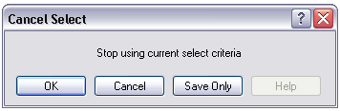
Syntax
SORT
SELECT

Comments
The Cancel Select and Cancel Sort commands automatically close the current output file.
Example
The commands below should be run one-by-one to better understand how the cancel sort and cancel select commands function.
READ {C:\Epi_Info_7\Projects\Sample\Sample.prj}:Oswego
SELECT Ill = (+)
LIST Age Ill Sex
SELECT
SORT Age
LIST Age Ill Sex
SORT

CLOSEOUT

Description
This command closes the current output file. It is normally used after a ROUTEOUT command when all the information to be included in the ROUTEOUT file has been produced.
Syntax
CLOSEOUT

Example
READ {C:\Epi_Info_7\Projects\Sample\Sample.prj}:Oswego
ROUTEOUT “C:\ My_Project_Folder \Outbreak1.htm” REPLACE
TABLES Vanilla Ill STRATAVAR=Sex
MEANS Age Ill
CLOSEOUT

COXPH

Description
This command performs Cox-Proportional Hazards and Extended Cox-Proportional Hazards survival analysis. This form of survival analysis relates covariates to failure through hazard ratios. A covariate with a hazard ratio greater than one causes failure. A covariate with a hazard ratio less than one improves survival. Some of the subjects may be unavailable prior to failure; the term "censored" is applied to them. COXPH is especially constructed to deal with this situation. Statistics showing the risk set by group and time can be written to an OUTTABLE for later formatting.
Syntax
COXPH <time variable>= <covariate(s)>[: <time function>:] * <censor variable> (<value>) [TIMEUNIT="<time unit>"] [OUTTABLE=<tablename>] [GRAPHTYPE="<graph type>"] [WEIGHTVAR=<weight variable>] [STRATAVAR=<strata variable(s)>] [GRAPH=<graph variable(s)>]

- The <time variable> represents a numeric or date variable, specifying when failure or censorship occurred.
- The <covariate(s)> represent a numeric variable, a non-numeric variable, or a variable specified as non-numeric by parenthesis. Any non-numeric variable, even a variable specified as non-numeric by surrounding with parenthesis, is automatically recoded into dummy variables. For all but one of the levels of a variable, a dummy variable will be created. It measures the contribution of its level to the excluded level. A covariate may be followed by a time function. This causes COXPH to run the Extended Cox procedure.
- The <time function> represents a numeric expression involving the time variable.
- The <censor variable> indicates whether the event is a failure or a censor.
- The <value> indicates which value of the CensorVar represents failure.
- The <strata variable(s)> represents a list of variables indicating the different levels of strata.
- The <weight variable> represents a variable to specify the contribution each data row has on the output.
- The <time unit> represents a value for labeling the time axis.
- The <tablename> represents a valid table name.

The <graph type> generates one of the indicated graphs:
  - Survival Probability shows the adjusted survival curves.
  - Observed shows the observed survival curves.
  - Survival-Observed shows the adjusted and observed survival curves.
  - Log-log Survival shows the logarithm of the negative of the logarithm of the adjusted survival curve.
  - Log-log Observed shows the logarithm of the negative of the logarithm of the observed survival curve.
  - Hazard Function shows the adjusted hazard function.
  - None
- The <graph variable(s)> represent a list of variables used to generate survival curves. Graph variables that are covariates or strata variables create curves adjusted by the covariates at all possible combinations of these graph variables. If a variable is numeric, it is plotted at its average value. Otherwise the graph variable splits the data into separate groups, each with its own curve.
Comments
COXPH uses the Breslow method to handle ties in the data.
Example
In this example, we will use the Anderson dataset from a clinical trial of leukemia patients to compare the treatment and placebo group survival.
READ {C:\Epi_Info_7\Projects\Sample\Sample.prj}:Anderson
COXPH STIME = (Rx) * Status ( 1 ) TIMEUNIT="Weeks" PVALUE=95% GRAPH=Rx GRAPHTYPE="Survival Probability"

DEFINE

Description
This command creates a new variable.
Syntax
DEFINE <variable> (<scope>) (<type indicator>)

- <variable> represents the name of the variable to be created.
- <scope> is the level of visibility and availability of the new variable and must be one of the reserved words STANDARD, GLOBAL, or PERMANENT. If omitted, STANDARD is assumed and a type indicator may not be used.
- <type indicator> is required and cannot be used if <scope> is omitted. <type indicator> is the data type of the new variable and must be one of the following reserved words: NUMERIC, TEXTINPUT, YN, or DATEFORMAT. If omitted, the variable type will be inferred based on the data type of the first value assigned to the variable. However, omitting field type is not recommended. Once field type is defined, the variable type cannot be changed. An error will occur if you attempt to assign data of a different type to the variable.
Comments
A custom variable defined in Epi Info 7 might not have a predefined data type if the <type indicator> is omitted when the variable is defined. If the variable does not have a predefined type and has not been used, the variable will accept a value in any of the four data types (Text, Number, Date, Yes/No [Boolean]) that is assigned to the variable the first time. Thereafter, the variable takes on the data type of the value assigned and it’s data type cannot be changed. However, omitting field type is not recommended. An error will occur if you attempt to assign data of a different data type. Various functions can be used to manipulate data, changing data type of values to match the data type of the variable. Some of these functions include FORMAT, TXTTONUM, TXTTODATE, and NUMTODATE.
Variable Scope
- STANDARD variables retain their value only within the current record and are reset when a new record is loaded. Standard variables are used temporarily behaving like other fields in the database. In Classic Analysis, Standard variables lose their values and definitions with each READ statement.
- GLOBAL variables retain values across related forms and when the program opens a new form, but are removed when the Classic Analysis program is closed. Global variables persist during program execution. Global variables are also used to store values between changes of data source (e.g., when the READ command is used). Global variables in Classic Analysis may not depend directly or indirectly on table fields.
- PERMANENT variables are stored in the EpiInfo.Config.xml file and retain any value assigned until the value is changed by another assignment or the variable is undefined. Permanent variables are shared among Epi Info 7 programs (i.e., Menu, Enter, Classic Analysis, etc.) and persist even if the computer shuts down. Permanent variables in Classic Analysis may not have values that depend directly or indirectly on table fields. A <prompt/description> created for a permanent variable will exist for one session and must be re-established each time it is used.
Type Indicators
- TEXTINPUT - Variables of this data type can receive any alpha-numeric characters including symbols and the output of functions (e.g., FORMAT).
- NUMERIC - Variables of this data type can receive numbers and the output of functions (e.g., TXTTONUM).
- DATEFORMAT - Variables of this data type can receive date values including the output of functions (e.g., TXTTODATE and NUMTODATE).
- YN - Variables of this data type can receive the Boolean values of (+) for Yes and (-) for No. Until an assignment is made, YN type variable values are (.) or missing.
Example
READ {C:\Epi_Info_7\Projects\Sample\Sample.prj}:Surveillance
DEFINE Birthday DATEFORMAT
ASSIGN Birthday = 01/01/2006
DEFINE HospitalCode NUMERIC
ASSIGN HospitalCode = 854
DEFINE Smoke YN
ASSIGN Smoke = (+)
LIST Birthday HospitalCode Smoke

DEFINE DLLOBJECT

Description
This command allows you to create an ActiveX (dynamic link library or executable) object.
Syntax
DLL File
DEFINE <variable> DLLOBJECT "<ActiveX name>.<class>"
WSC File
DEFINE <variable> DLLOBJECT "<filename>"

- The <variable> represents the name of the variable to be created.
- The <ActiveX name> represents the internal name of the ActiveX object that contains the class object for DLL files.
- The <class> represents a class name defined within the DLL.
- The <filename> represents the name of the WSC file where the script component resides.
Comments
The ActiveX name may not be the same as the actual name of the dll (dynamic link library) or executable. When an ActiveX object is developed, it is given a project name. This name is required to create the object. The ActiveX object (executable or dll) must be registered before it can be used. Windows Scripting Component (WSC) objects can also be used.
Example
DEFINE Week DLLOBJECT "EIEpiwk.Epiweek"

Define Group Command (Analysis Reference)

Description
This command allows you to create temporary group variables
Syntax
DEFINE <variable> GROUPVAR <variable 1> [<variable 1> ...]

- <variable> represents the new group variable being defined.
- <variable 1> ... represent the existing variables to which the new group variable will be equivalent.
Program Specific Feature
Field variables, not defined variables must be in the group. Variables in the group may be from different pages of the same or different forms, in any combination. They may themselves be group variables, but each variable will be represented in the new group only once no matter how many times it appears in the variable list or in group variables in the variable list.
If the group variable being defined exists and is not a group variable, an error message is displayed and the command is not processed. If it is a group variable, the new variable list replaces the existing variable list until the next READ or MERGE command or until it is redefined again. Group variables cannot be undefined.
Comments
This command is useful when there are many variables so that the use of * is impractical or invalid. Group variables can be used in the LIST and WRITE commands and in some statistical commands (e.g., FREQ, TABLES, and MEANS). Group variables cannot be used in Complex Sample commands.
Example
READ {C:\Epi_Info_7\Projects\Sample\Sample.prj}:Oswego
DEFINE Exposure GROUPVAR JELLO CAKES VANILLA CHOCOLATE
LIST Exposure

DELETE FILE/TABLES

Description
This command deletes files, tables, and forms.
Syntax
DELETE filename | wildcard {RUNSILENT}
DELETE TABLES tablename | filename:tablename {RUNSILENT | SAVEDATA}
Comments
Delete file specifies explicitly or implicitly (via wildcards) files to be deleted. If no files are specified, or if some of the specified files cannot be deleted, a message is produced unless RUNSILENT is specified. Wildcards are not permitted in the suffix.
Delete table specifies a table to be deleted. If the table does not exist or cannot be deleted, a message is produced unless RUNSILENT is specified. Unless RUNSILENT is specified, a confirmatory message is displayed prior to deletion.
To delete tables with spaces in their names, specify both the file and the table even if the table is in the current project. The table must be enclosed in single quotes. You can read a table with a space in its name, delete it, causing errors during subsequent procedures. To delete a table with space in its name, specify the database even if the table is in the current database.
DELETE TABLES will not delete, and produce a message if any of the specified tables are data, grid, or program. Code tables are deleted only if they are not referenced by any view.
SAVEDATA does not delete the data tables, but removes the RECStatus property from the table.
Space is not reclaimed until the Compact utility is run.
Analysis will not delete the current project MDB or any table in use by the current form.
Example
DELETE TABLES Backup2005

DELETE RECORDS

Description
This command deletes selected records.
Syntax
DELETE * {PERMANENT | RUNSILENT}
DELETE expression {PERMANENT | RUNSILENT}
Comments
All records in the current selection are set to deleted status, or if PERMANENT is specified, physically deleted. A confirmation message is displayed unless RUNSILENT is selected. This applies to Access tables and may not be used when using related tables. Use Epi Info 3.5.3 Compact Database utility to reclaim space after deleting tables.
Examples
Example 1: The code below will permanently erase all records in the current data source where the AgeInDays variable contains a value greater than five. Permanent deletions cannot be undone.
DELETE AgeInDays > 5 PERMANENT

Example 2: The code below will mark all records in an Epi Info 7 database for deletion. The UNDELETE Command can restore records that have been marked for deletion.
DELETE *

DIALOG

How to Use the DIALOG Command
Description
This command provides interaction with the user from within a program. Dialogs can display information, ask for and receive input, and offer lists for making choices.
Syntax
Simple Form
DIALOG "<prompt>" {TITLETEXT="<title>"}

- <prompt> represents the text to be displayed as message.
- <title> represents the text to be used as the caption for the dialog window. If <title> is omitted in the Dialog command, "Analysis" will be displayed on the dialog box's title bar.
Get Variable Form
DIALOG "<prompt>" <variable> <entry type> {TITLETEXT="<title>"}
DIALOG "<prompt>" <variable> "<value 1>", "<value 2>", "<value 3>", … ,"<value n>" {TITLETEXT="<title>"}
DIALOG "<file type selection>" <variable> READ {TITLETEXT="<title>"}
DIALOG "<file type selection>" <variable> WRITE {TITLETEXT="<title>"}

- <variable> represents the variable to store value entered.
- <entry type> represents a reserved word and/or mask that defines the type of input to be accepted and stored in the variable. The following are valid entry types:
  - TEXTINPUT specifies the input as text.
  - YN specifies the input as Boolean.
  - DATEFORMAT ("<date mask>") specifies the input as a date; if a date mask is not specified, the system short date is used.
  - "<numeric mask>" specifies the input as numeric. This option is identified as "Number Only". The numeric mask should be a text string (e.g., "####" or "##.###") that indicates the type of data to be entered. # indicates a digit.
  - If no <entry type> is specified, the input variable is interpreted as a number if possible. If the value is not a valid number, but is a valid date, it is interpreted as a date. Otherwise, an error occurs.
- <value> represents a value in a drop-down list of choices. Each value included in the command will be shown as a single item in the list.
- <file type selection> controls the type of files that are displayed for selection. It consists of alternating description and filter elements separated by vertical bars. The description is displayed for you to select. The corresponding filter element selects the files. If this element is left blank, all files can be selected. Syntax is created using the File Open and File Save options from the Dialog Format drop down menu.
List of Values Form
DIALOG "<prompt>" <variable> [<list type>] {TITLETEXT="<title>"}
DIALOG "<prompt>" <variable> DBVALUES <table name> {TITLETEXT="<title>"}

- The [<list type>] are DATABASES and DBVIEWS
Comments
The Simple form of DIALOG places a dialog box on the screen, using the text provided, with an OK button.
The Get Variable form of DIALOG displays the text prompt and provides a means for entering a value.
- If YN is specified, "Yes," "No" and "Cancel" buttons are presented and the specified variable is set to (+), (-), or (.).
- If TEXTINPUT or no entry type is specified, an entry field for user response is provided with OK and Cancel buttons. The variable is assigned the value of the input with a missing value if Cancel is chosen.
- The Get Variable form of the DIALOG command can also display a file selection dialog. If READ is used, only existing files are displayed. If WRITE is used and an existing file is selected, you will see the Overwrite? prompt.
- The Multiple Choice form of DIALOG displays the text prompt and provides a combo box for selecting among the values with OK and Cancel buttons. The variable is assigned the value of the input with a missing value if Cancel is chosen. Variable will text type.
- The Date form of the DIALOG command uses a special control for accepting input. Each section of the date (year, month, and day) can be increased or decreased independently using the drop down calendar. Using this control, it is impossible to select an invalid date.
The List of Values form of DIALOG displays a combo box of databases or form variables with OK and Cancel presented. The variable is assigned the value of your input with a missing value if Cancel is chosen. Variable will be text type. The VARIABLE VALUE form of DIALOG displays a combo box of distinct values of the specified variable in the specified database. The variable is assigned the value of input with a missing value if Cancel is chosen. The variable will be of the same type as the database variable.
 | Date Mask
* | System Time Format
! | System Long Date

 | Numeric Mask
# | Digit placeholder (Entry required).
. | Decimal placeholder. The actual character used is the one specified as the decimal placeholder in the computer's international settings.
, | Thousand separator. The actual character used is the one specified as the thousands placeholder in the computer's international settings.
9 | Digit placeholder. (Entry optional).
Punctuation | Included in the display.

 | Custom Formats
D | One- or two-digit day.
Dd | Two-digit day. Single-digit day values are preceded by a zero.
Ddd | Three-character weekday abbreviation.
dddd | Full weekday name.
H | One- or two-digit in a 12- hour format.
Hh | Two-digit hour in a 12-hour format. Single digit values are preceded by a zero.
H | One- or two-digit hour in 24-hour format.
HH | Two-digit hour in a 24-hour format. Single digit values are preceded by a zero.
M | One- or two-digit minute.
Mm | Two-digit minute. Single digit values are preceded by a zero.
M | One- or two-digit month number.
MM | Two-digit month number. Single digit values are preceded by a zero.
MMM | Three-character month abbreviation.
MMMM | Full month name.
S | One- or two-digit seconds.
Ss | Two-digit seconds. Single- digit day values are preceded by a zero.
T | One-letter AM/PM abbreviation. AM displays as A.
Tt | Two-letter AM/PM abbreviation. AM displays as AM.
Y | One-digit year. 1997 displays as 7.
Yy | Last two digits of the year. 1997 displays as 97.
Yyyy | Full year. 1997 displays as 1997.
Punctuation | Included in the display

Examples
Example 1: A prompt is displayed letting you know that the following commands may take several minutes to complete because of their complexity.
DIALOG "Warning: This script may take several minutes to complete" TITLETEXT="Warning"

Example 2: The DIALOG command is used to obtain a user-supplied date to calculate the patient's age. If you do not supply a date (press the Cancel button), the default ending date contained in the survey data source is used instead.
READ {C:\Epi_Info_7\Projects\Sample\Sample.prj}:Surveillance
DEFINE UpdateDate DATEFORMAT
DEFINE SubmitDate Dateformat
ASSIGN SubmitDate = EventDate
DIALOG "Enter a new ending date for survey data:" UpdateDate DATEFORMAT "MM-DD-YYYY"
DEFINE NewAge NUMERIC
ASSIGN NewAge = YEARS(SubmitDate, UpdateDate)
GRAPH NewAge GRAPHTYPE="Column"

Example 3: You will see a drop-down list of choices. The list contains part of the command; in this case, several counties in the state of Georgia. Your selection is temporarily assigned to all records in the form.
READ {C:\Epi_Info_7\Projects\Sample\Sample.prj}:Oswego
DEFINE NewCounty TEXTINPUT
DIALOG "Select a county" NewCounty "Fulton", "Baldwin", "DeKalb", "Cobb"
ASSIGN CountyName = NewCounty
LIST CountyName

Example 4: A drop-down list of choices is displayed. Each list item is retrieved from the X_COORD column of the SohoDead data table.
READ {C:\Epi_Info_7\Projects\Sample\Sample.prj}::SohoDead
DEFINE Coordinates TEXTINPUT
DIALOG "Select Coordinates" Coordinates DBVALUES SohoDead X_COORD TITLETEXT="Coordinates"

Example 5: A dialog box prompts you for an image file in JPG or bitmap format. Upon choosing the file, the full path and filename of the file are saved to the specified variable.
DEFINE FileName TEXTINPUT
DIALOG "Image files|*.bmp;*.jpg;|Allfiles|*.*" FileName READ TITLETEXT="Get image files"

Example 6: A dialog box is displayed that allows you to enter a number. An input mask is used to force your input to three whole digits and one decimal digit. Your input is temporarily assigned to each record in the form.
READ {C:\Epi_Info_7\Projects\Sample\Sample.prj}:Oswego
DEFINE NewAge NUMERIC
DIALOG "Enter patient age" NewAge "###.#"
ASSIGN Age = NewAge
LIST Age

Example 7: A dialog box is displayed that allows you to enter a number. An input mask is used in order to force your input to either one or two whole digits and one decimal digit. (The 9 represents an optional digit.) Your input is temporarily assigned to each record in the form.
READ {C:\Epi_Info_7\Projects\Sample\Sample.prj}:Oswego
DEFINE NewAge NUMERIC
DIALOG "Enter patient age" NewAge "9##.#"
ASSIGN Age = NewAge
LIST Age

DISPLAY

Command Generator
How to Use the DISPLAY Command
Description
This command displays table, form, and database information.
Syntax
DISPLAY <option> [<sub-option>] [OUTTABLE=<tablename>]

- The <option> determines the type and source of information displayed.
- The <tablename> represents the name of the data output table to receive results (optional).
- The [<sub-option>] refers to the type of displayed information.
  - Option DBVARIABLES - displays information about variables. Sub-option DEFINE displays only defined variables. Sub-option FIELDVAR displays only table/view variables for the current READ and RELATE tables. Sub-option LIST followed by a list of variable names displays only the specified variables.
  - Option DBVIEWS - displays information about forms and other Epi Info 7 specific tables in a database. The sub-option is the path of the database. Omitting the sub-option displays information for the current project database.
  - Option TABLES - displays information about tables in a database, whether Epi Info 7 specific or generic. The sub-option is the path of the database. Omitting the sub-option displays information for the current project database.
Examples
Example 1: The DISPLAY command is used to show the tables, forms, and variables from an existing data source.
READ {C:\Epi_Info_7\Projects\Sample\Sample.prj}:Oswego
DISPLAY TABLES
DISPLAY DBVIEWS
DISPLAY DBVARIABLES

Example 2: All forms in the Sample database are displayed.
DISPLAY DBVIEWS 'C:\Epi_Info_7\Projects\Sample\Sample.prj’

Example 3: All tables in the Sample database are displayed.
DISPLAY TABLES 'C:\Epi_Info_7\Projects\Sample\Sample.prj’

Example 4: All variables in Oswego are written to a new table in the Sample database called VarInfo.
READ {C:\Epi_Info_7\Projects\Sample\Sample.prj}:Oswego
DISPLAY DBVARIABLES OUTTABLE=VarInfo

EXECUTE

Description
This command executes a Windows program; one explicitly named in the command, or one designated within the Windows registry as appropriate for a document with a named file extension. This provides a mechanism for bringing up whatever word processor or browser is the default on a computer without first knowing its name.
If the pathname is a long filename, it must be surrounded in single quotes. If the command takes parameters, surround the command and the parameters with a single set of double quotes. Do not use single quotes.
Program Specific Feature
Link and Activate are not valid command names.
Syntax
EXECUTE <filename>
EXECUTE "<filename> <command-line parameters>"
EXECUTE NOWAITFOREXIT <filename>
EXECUTE NOWAITFOREXIT '<filename>'
EXECUTE NOWAITFOREXIT "<filename>"
EXECUTE WAITFOREXIT <filename>
EXECUTE WAITFOREXIT '<filename>'
EXECUTE WAITFOREXIT "<filename>"

- The <filename> represents the path and program name for .exe (filename for registered Windows programs) and .com (filename for MS-DOS binary executable) files.
- The <command-line parameters> represent any additional command-line arguments that the program can accept. When used, the entire string should be enclosed within double quotes.
- When Wait for Command to Execute (modal) is specified, the command and Analysis should run. When Wait for Command to Execute is not specified (non-modal), Classic Analysis should wait until the executed program closes before continuing. When EXECUTE is run modally, permanent variables are written before the command is executed, and reloaded after the command is executed.
Comments
If the name given is not a program, but a file with an extension (the three characters after the ".") registered by Windows for displaying the document, the correct program to display the file will be activated (i.e., WRITEUP.DOC might cause Microsoft Word © to run and load the file on one computer). On another machine, however, .DOC might correspond to Corel WordPerfect©. Usually .TXT will run NOTEPAD.EXE© or WORDPAD.EXE©, and image files will appear in a browser or in a graphics program. An .HTM file will bring up the default browser.
Examples
Example 1: The EXECUTE command is used to start the Enter module. The command-line parameter is used to load the Oswego Form from the Sample database.
EXECUTE "C:\Epi Info 7\
Epi Info 7\Enter.exe"

Example 2: The output file generated (in this case, Outbreak1.htm) is opened in the computer's default web browser.
READ {C:\Epi_Info_7\Projects\Sample\Sample.prj}:Oswego
ROUTEOUT “C:\Epi Info 7\Epi Info 7\Output\Outbreak1.htm' REPLACE
SET STATISTICS=COMPLETE
TABLES Vanilla Ill STRATAVAR=Sex
MEANS Chocolate Ill
CLOSEOUT
EXECUTE “C:\Epi Info 7\Epi Info 7\Outbreak1.htm”

FREQ

Description
FREQ produces a table from the table(s) specified in the last READ statement, showing how many records have each value of the variable. Exact Confidence limits for each proportion are included.
Syntax
FREQ [<variable(s)>] {<settings>}
FREQ * {EXCEPT [<variable(s)>]} {<settings>}
- <variable(s)> represents one or more variable names. Group variables may be used.
- <settings> represent clauses from the SET command indicating a value of a setting (except PROCESS and HYPERLINKS) which will be used for the duration of the statistical command only.
Comments
Records may be included or excluded from the count by using SELECT statements. Those marked as deleted in Enter will be handled according to the current setting for SET PROCESS. If more than one variable name is given, FREQ makes a separate table for each variable. Confidence limits for the binomial proportions are produced.
If a WEIGHTVAR is specified, the value of the WEIGHTVAR variable is treated as a count of instances of the variable being computed in the frequency (i.e., in the following command a record containing the value 30 for AGE and 15 for COUNT would give a result equivalent to 15 individuals of age 30).
FREQ AGE WEIGHTVAR = COUNT
If STRATUM is specified, a separate frequency is produced for each stratifying variable value.
FREQ ILL STRATAVAR=SEX, produces a table showing ILL (Yes/No/Unknown) for males and another for females. The same numbers can be obtained using TABLES ILL SEX, but the latter produces results in one table rather than in separate tables, and produces statistics to test for an association between ILL and SEX.
FREQ * makes a table for each variable in the current form other than unique identifiers. It is often used to begin analyses of a new data set.
To do frequencies of all variables except a few, use FREQ * EXCEPT VarName(s) followed by the names of the variables to be excluded.
Multiline (memo) variables cannot be used in Frequencies. To use a Multiline variable, define a new variable and assign to it the value SUBSTRING(<old variable>,1,255) and use it in the frequency.
Examples
Example 1: The number of ill and healthy people are displayed along with their percentages and the total.
READ {C:\Epi_Info_7\Projects\Sample\Sample.prj}:Oswego
FREQ Ill
Example 2: In this case, the variable 'Desserts' is a group variable containing the Yes/No variables Chocolate, Vanilla, and Cakes. Running a frequency on a group variable automatically runs a frequency on every variable contained in the group.
READ {C:\Epi_Info_7\Projects\Sample\Sample.prj}:Oswego
FREQ Desserts
Example 3: A frequency on two variables is produced. In this case, BakedHam and Milk.
READ {C:\Epi_Info_7\Projects\Sample\Sample.prj}:Oswego
FREQ BakedHam Milk
Example 4: A frequency on every variable in the current data source is produced.
READ {C:\Epi_Info_7\Projects\Sample\Sample.prj}:Oswego
FREQ *
Example 5: A frequency on every variable in the current data source (except Age, Code_RW, DateOnset, Name and TimeSupper) is produced.
READ {C:\Epi_Info_7\Projects\Sample\Sample.prj}:Oswego
FREQ * EXCEPT Age Code_RW DateOnset Name TimeSupper
Example 6: A frequency of ill people is produced, stratified by sex. Using the stratification option will produce two frequencies. In this case, males and females.
READ {C:\Epi_Info_7\Projects\Sample\Sample.prj}:Oswego
FREQ Ill STRATAVAR=Sex
Example 7: A weighted frequency is conducted. For each record, the value stored in Count is used to represent that record's weight.
READ {C:\Epi_Info_7\Projects\Sample\Sample.prj}:Lasum
FREQ Outcome WEIGHTVAR=Count
Example 8: A complex sample frequency is run using the Epi1 data set.
READ {C:\Epi_Info_7\Projects\Sample\Sample.prj}:Epi1
SET STATISTICS=COMPLETE
FREQ VAC PSUVAR=Cluster

GRAPH

Description
This command produces graphs from data in Classic Analysis.
Syntax
GRAPH [<variable(s)>] GRAPHTYPE="<graph type>" [<option name>=option value]
GRAPH [<variable(s)>] * <crosstab> GRAPHTYPE="<graph type>"
GRAPH [<variable(s)>] GRAPHTYPE="<graph type>" XTITLE="<string>" YTITLE="<string>"
- The <variable(s)> represents the (main) variable(s) to be graphed.
- The <crosstab> represents a variable to be used to classify the main variable(s).
- The <graph type> represents one of the graph types described below.
- STRATAVAR=<variable> generates a graph for each value of VarName. When saving a template, the template stores the current graph's background including the main title and the subtitle if it exists. However, if the sub-title is stratified (under "One Graph for Each Value of" in the dialog screen), it will be filtered out.
- WEIGHTVAR=<variable> weights each record by the value of <VarName>.
- WEIGHTVAR=<agg func>(<variable>) allows multiple records referring to the same values of the main variable, crosstab variable (if any), and strata variable (if any) are represented by the aggregate of VarName. Permissible AggFunc values are MIN (minimum), MAX (maximum), AVG (average), STDEV (standard deviation), SUM, SUMPCT (percent based on total of VarName), COUNT (number of records), or PERCENT (percent based on number of records).
- TITLETEXT="<string>" represents a title for each page of graphs. This title is in addition to the title for each graph, which is set by customization.
- DATEFORMAT="<format string>" is used when a main variable is a date variable to determine the format in which it will be displayed. Uses the same coding scheme as the FORMAT function.
- XTITLE="<string>", YTITLE="<string>" are used to pass X- and Y-axis labels from the GRAPH command.

Program Specific Feature
Multiline (memo) fields cannot be graphed. To use a Multiline variable, define a new variable, assign to it the value SUBSTRING(<old variable>,1,255), and use it in the graph.
The following are the graph types capable of being generated by the GRAPH command along with type-specific information ("series" refers to the values of a main variable for a specific value of any crosstab and strata variables):
- Line graphs connect X-Y points with lines. The main variables are the X and Y variables. Each series is represented by a different style of line. Both variables must be numeric. To generate a line graph with categorical data, generate a Bar graph and use customization.
- Column graphs use vertical bars to represent the count or weight for each value of the main variable(s). Each series results in an additional vertical bar at each point; the bars are distinguished by their style.
- Bar graphs use horizontal bars to represent the count or weight of each value of the main variable(s). Each series creates an additional horizontal bar at each point.
- Epi Curve use vertical bars to represent the count or weight for each value of the main variable. Each series creates an additional vertical bar at each point. The main variable must be numeric. This graph differs from the bar graph because adjacent bars represent equal ranges of the main variable.
- Pie in which each series is represented by a circle, and each value of the main variable has a slice of the circle proportional to the value associated with it.
- Area is similar to a line, except that the area below the line contains a solid fill.
- Scatter graphs display X-Y points as a scatter gram. The main variables are X and Y variables. Each series is represented by a different style of point.
- Bubble graphs are a variation of a Scatter chart in which the data points are replaced with bubbles. A Bubble chart can be used instead of a Scatter chart if your data has three data series.

Examples
Example 1: A graph showing the age of all survey respondents is displayed.
READ {C:\Epi_Info_7\Projects\Sample\Sample.prj}:Oswego
GRAPH Age GraphType="Column"
Example 2: A pie chart showing age categories is displayed.
READ {C:\Epi_Info_7\Projects\Sample\Sample.prj}:Oswego
DEFINE AgeCategory TEXTINPUT
RECODE Age TO AgeCategory
LOVALUE - 0 = "Unknown"
0 - 10 = "0 - 10"
10 - 20 = "11 - 20"
20 - 30 = "21 - 30"
30 - 50 = "31 - 50"
50 - 70 = "51 - 70"
70 - HIVALUE = ">70"
END
GRAPH AgeCategory GRAPHTYPE="Pie" TITLETEXT="Church Supper Attendees"
Example 3: A scatter graph is displayed showing age by time of supper.
READ {C:\Epi_Info_7\Projects\Sample\Sample.prj}:Oswego
GRAPH TimeSupper Age GRAPHTYPE="Scatter XY"
Example 4: A graph showing the number of ill persons and vanilla eaters is displayed using the form for the Oswego outbreak investigation.
READ {C:\Epi_Info_7\Projects\Sample\Sample.prj}:Oswego
FREQ Vanilla Ill STRATAVAR=Sex OUTTABLE=VanillaOut
READ {C:\Epi_Info_7\Projects\Sample\Sample.prj}:VanillaOut
SELECT Vanilla = (+) OR Ill = (+)
SET Missing = (-)
DEFINE Vanilla2 YN
DEFINE Ill2 YN
IF Ill = (+) THEN
ASSIGN Ill2 = Sex
END
IF Vanilla = (+) THEN
ASSIGN Vanilla2 = Sex
END
GRAPH Ill2 Vanilla2 GRAPHTYPE="Bar" TITLETEXT="Number of Ill Persons and Vanilla Eaters by Sex" WEIGHTVAR=Count
Example 5: An Epi Curve showing the incubation time for an unknown pathogen is displayed. Note that the DIALOG=(-) parameter ensures the graph window does not appear. Instead, the graph is generated and sent to the Analysis output window. This option can be useful when running automated scripts since it does not require user interaction to continue processing commands.
READ {C:\Epi_Info_7\Projects\Sample\Sample.prj}:Oswego
DEFINE Incubation NUMERIC
ASSIGN Incubation = MINUTES(TimeSupper, DateOnset) / 60
GRAPH Incubation GRAPHTYPE="Epi Curve" XTITLE="Incubation Period (Hours)" YTITLE="Number of Cases"

IF THEN ELSE

Description
This command defines conditions and one or more consequences which occur if the conditions are met. An alternative consequence can be given after the ELSE statement. The ELSE will be executed if the first set of conditions is not true. If the condition is true, the first statement is executed. If the statement is false, the statement is bypassed. If an ELSE statement exists, it is executed instead. THEN is part of the If Condition statement. It starts the section of code executed when the If condition is true.
Syntax
IF <expression> THEN
[command(s)]
END

IF <expression> THEN
[command(s)]
ELSE
[command(s)]
END
- The <expression> represents a condition that determines whether or not subsequent commands will be run. If the condition evaluates to true, the commands inside of the IF block will run. If the condition evaluates to false, the commands inside of the ELSE block will run instead. If no ELSE exists and the condition is false, then no commands inside of the IF block are run.
- The [command(s)] represents at least one valid command.
- The ELSE statement is optional and will run any code contained inside of it when the <expression> evaluates to false.
Comments
An IF statement is executed immediately if it does not refer to a database variable, if characteristic or attribute that can be measured, or if any defined variables have been assigned literal values. If the statement, YEAR = 97 has already occurred, then an IF statement dependent on it, such as IF YEAR = 97 then …., is executed immediately.
IF Age > 15 THEN
ASSIGN Group = "ADULT"
ELSE
ASSIGN Group = "CHILD"
END

It is important to cover all the conditions in IF statements to avoid gaps in the logic and results. Sometimes it is important to have an ELSE condition that covers conditions not included in other IF clauses. This effect is best achieved by setting the variable initially to something other than missing.
DEFINE ILL YN
ASSIGN ILL = (-)
IF Vomiting = (+) THEN
ASSIGN ILL = (+)
END
IF Diarrhea = (+) THEN
ASSIGN ILL = (+)
END
IF Fever = (+) THEN
ASSIGN ILL = (+)
END
Set Ill = (+) only if one or more symptoms are present.
The same result could be achieved with this code:
IF (Diarrhea = (+)) OR (Vomiting = (+)) OR (Fever = (+)) THEN
ASSIGN ILL = (+)
ELSE
ASSIGN ILL = (-)
END
Examples
Example 1: The Group variable for all records in the data set is assigned the value of "Young Adult" if the Age variable has a value between (but not including) 17 and 30. If the value in Age falls outside of this range, no value is assigned to Group.
READ {C:\Epi_Info_7\Projects\Sample\Sample.prj}:Oswego
DEFINE Group TEXTINPUT
IF Age < 30 AND Age > 17 THEN
ASSIGN Group = "Young Adult"
END
LIST Group
Example 2: Several different values are assigned to the Group variable depending on the value of the Age variable.
READ {C:\Epi_Info_7\Projects\Sample\Sample.prj}:Oswego
DEFINE Group TEXTINPUT
IF Age < 30 AND Age > 17 THEN
ASSIGN Group = "Young Adult"
END
IF Age <= 17 THEN
ASSIGN Group = "Minor"
END
IF Age >= 30 THEN
ASSIGN Group = "Adult"
END
LIST Group
Example 3: If the patient ate chocolate or vanilla ice cream, the variable IceCream is assigned a value of true. Otherwise, it is assigned a value of false.
READ {C:\Epi_Info_7\Projects\Sample\Sample.prj}:Oswego
DEFINE IceCream YN
IF Vanilla = (+) OR Chocolate = (+) THEN
ASSIGN IceCream = (+)
ELSE
ASSIGN IceCream = (-)
END
LIST Vanilla Chocolate IceCream

KMSURVIVAL

Description
This command performs the Kaplan-Meier Survival Analysis and produces graphs and statistics for one or several groups of subjects being followed in a clinical study. At any given time, some of the subjects may be "censored," not having information available on their status. KMSurvival is especially constructed to deal with this situation. Statistics showing the risk set by group and time can be written to an OUTTABLE for later formatting.
Syntax
KMSURVIVAL <time variable>=<group variable> * <censor variable> (<value>) [TIMEUNIT="<time unit>"] [OUTTABLE=<tablename>] [GRAPHTYPE="<graph type>"] [WEIGHTVAR=<weight variable>]
- The <time variable> represents the variable specifying the time of the event.
- The <group variable> represents the variable that indicates to which treatment or control group the subject belongs.
- The <censor variable> represents the variable to describe an event as failure or censored.
- The <value> represents the value of the censor variable indicating uncensored (failure).
- The <time unit> represents a value for labeling the time axis.
- The <graph type> represents the following:
  - Survival Probability is the observed survival over the different groups.
  - Log-Log Survival is the log of the negative log of the survival probability.
  - None does not produce a graph. If no graph type is specified, the default Survival Probability curve is plotted.
- The <weight variable> represents a variable in the database that specifies the contribution or each data row to the output.
Example
The commands below show a comparison between two groups.
READ {C:\Epi_Info_7\Projects\Sample\Sample.prj}:Addicts
KMSURVIVAL Survival_Time_Days = Clinic * Status ( 1 ) TIMEUNIT="Days"

LIST

Description
This command does a line listing of the current dataset. If variable names are given, LIST displays only these variables. LIST * displays all variables of all active records. LIST * EXCEPT displays all variables of all active records except those named.
Syntax
LIST {* EXCEPT} [<variable(s)>] LIST {* EXCEPT} [<variable(s)>] {GRIDTABLE}
- The * asterisk is used to represent all variables
- The <variable(s)> represents one or more variable names.
- The keyword GRIDTABLE specifies that data is displayed as a grid for viewing only, instead of HTML format.
Comments
Adding an EXCEPT Variable list excludes all the named variables from a LIST or LIST *.
If the dataset has been sorted with the SORT command, the records are listed in sorted order. Otherwise, they are listed in an order determined by the database.
Examples
Example 1: All variables are listed using the grid format.
READ {C:\Epi_Info_7\Projects\Sample\Sample.prj}:Oswego
LIST * GRIDTABLE
Example 2: The Age variable is listed using the web (HTML) format.
READ {C:\Epi_Info_7\Projects\Sample\Sample.prj}:Oswego
LIST Age
Example 3: The variables Sex, Vanilla, Chocolate, Ill, and Age are listed using the grid format.
READ {C:\Epi_Info_7\Projects\Sample\Sample.prj}:Oswego
LIST Sex Vanilla Chocolate Ill Age GRIDTABLE

LOGISTIC

Description
This command performs conditional or unconditional multivariate logistic regression with automatic dummy variables and support for multiple interactions.
Syntax
LOGISTIC <dependent variable> = <independent variable(s)> [MATCHVAR=<match variable>] [NOINTERCEPT] [OUTTABLE=<tablename>] [WEIGHTVAR=<weight variable>] [PVALUE=<PValue>]
- The <dependent variable> represents the dependent variable.
- The <independent variable(s)> represents an independent variable that can be a numeric variable, a non-numeric variable, or a variable surrounded by parenthesis. Any text or yes-no variable, or a variable surrounded with parenthesis, is automatically recoded into dummy variables. A dummy variable is created for all but one of the levels of a variable. The variable measures the contribution of its level relative to the excluded level. Interactions are specified by * between variables.
- The <weight variable> represents a variable to specify the contribution each data row has to the output.
- The <match variable> represents a variable to specify the different groups for a conditional analysis. If a match variable is specified, a conditional analysis will be performed
- The <tablename> represents a table where the residuals are stored. If no table name is present, no residuals are produced.
- The <PValue> represents the size of the confidence intervals; this may be specified as percent or decimal. If greater than .5, 1-PValue is used. The default is 95%.
Comments
LOGISTIC uses the Newton-Rhapson method for maximizing likelihood.
Example
To do an unconditional regression, run the following:
READ {C:\Epi_Info_7\Projects\Sample\Sample.prj}:Oswego
LOGISTIC Ill = BrownBread CabbageSal Water Milk Chocolate Vanilla

MEANS

Description
This command is used to compute descriptive statistics for a continuous (numeric) variable. When used with a cross-tabulation variable, it also computes statistics showing the likelihood that the means of the groups are equal. The mean of a yes-no variable is the proportion of respondents answering yes.
Syntax
MEANS <variable 1> {<variable 2>} {STRATAVAR=<variable(s)>} {WEIGHTVAR=<variable>} {OUTTABLE=<tablename>}
- <variable 1> represents a numeric variable to be used to calculate means (or * for all numeric variables).
- <variable 2> represents any variable used for cross-tabulation (optional).
- <variable(s)> represent variable(s) to be used for stratified analysis.
- <variable> represents a variable containing the frequency for the event.
- <tablename> represents a name for a table to be created.
Comments
The MEANS command has two formats. If only one variable is supplied, the program produces a table similar to one produced by FREQUENCIES, plus descriptive statistics. If two variables are supplied, the first is a numeric variable containing data to be analyzed and the second is a variable that indicates how groups will be distinguished. The output of this format is a table similar to one produced by TABLES, plus descriptive statistics of the numeric variable for each value of the group variable.
Multiline (memo) variables cannot be used in MEANS. To use a Multiline variable, define a new variable and assign to it the value SUBSTRING(<old variable>,1,255) and use it in the means.
The f-test which is generated from MEANS is a generalization of the t-test. The t-test only works with two groups while the f-test works with any number of groups.
MEANS produces the following statistical tests:
- Parametric
- ANOVA (for two or more samples)
- Student's t-test (for two samples)
- Non-parametric
- Kruskal-Wallis one-way analysis of variance (for two or more samples)
- Mann-Whitney U = Wilcoxon Rank Sum Test (for two samples)
Examples
Example 1: Descriptive statistics for the age variable are displayed, including the number of observations, the total, the mean, variance, standard deviation, 25%, median, 75%, maximum, minimum, and mode.
READ {C:\Epi_Info_7\Projects\Sample\Sample.prj}:Oswego
MEANS Age
Example 2: The MEANS command is used to compare two means. An independent t-test and one-way analysis of variance (ANOVA) is performed.
READ {C:\Epi_Info_7\Projects\Sample\Sample.prj}:EvansCounty
MEANS CHL CHD
Example 3: The average number of cigarettes smoked between males and females is determined.
READ {C:\Epi_Info_7\Projects\Sample\Sample.prj}:Smoke
MEANS NumCigar Sex STRATAVAR=Strata WEIGHTVAR=SampW PSUVAR=PSUID

MERGE

Description
This command merges records in one dataset with those in another the Global Record Identifier contained in every Epi Info 7 project to establish the match between records. Records in the second dataset that do not have matching keys can be appended to the end of a dataset. Records in the second dataset that do have matching keys can be used to update records in the main dataset. Records in the second dataset can be used as the parent in defining an Epi Info 7 parent-child relationship after records have been merged into the parent and child forms.
Syntax
MERGE <table specification> {LINKNAME=<text>} [<key(s)>] <type>
- The <table specification> represents the type and name of a data table to be read as the Merge file.
The <key(s)> represent the Global Record Identifier on which the match or relate will be performed. These are in the form: <ExpressionCurrntTable>::<ExpressionMergeTable>
- The <MergeType>, may be APPEND, UPDATE or RELATE. If no type is specified, APPEND and UPDATE are performed. For matching records, UPDATE replaces the value of any field in the READ table whose name matches in the MERGE table with the value from the MERGE table unless it has a missing value. For unmatched records, APPEND creates a new record in the READ table with values only for those fields which exist in the MERGE table.
- Currently, Merge is only supported when the READ and MERGE data source is an Epi Info 7 project.
Comments
APPEND adds unmatched records in the Merge table to the currently active dataset. Only fields found in both datasets are added.
UPDATE replaces fields of records in the active table with those in the Merge table if the key expressions match. Only fields found in both datasets with a non-empty value in the Merge table are replaced.
RELATE moves the unique key of the current table to the foreign key of the related table to make a permanent relationship. The related (Merge) table must be an Access/Epi2000 table. The READ table and the RELATE tables must be Epi Info forms. READ {C:\Epi_Info_7\Projects\Sample\Sample.prj}:

Example
MERGE {C:\Epi_Info_7\Projects\Sample\Sample.prj}:Surveillance GlobalRecordId :: GlobalRecordId

PRINTOUT

Description
This command sends the contents of the current output file (the one visible in the output window) or some other specified file to the default printer.
Syntax
PRINTOUT <filename>
Example
The output file Oswego.txt is sent to the printer.
READ {C:\Epi_Info_7\Projects\Sample\Sample.prj}:Oswego
WRITE REPLACE "Text" 'C:\Epi_Info\Oswego.txt' *
PRINTOUT 'C:\Epi_Info\Oswego.txt'

QUIT

Description
This command closes the current data files and terminates the current program, closing Classic Analysis.
Syntax
QUIT
Program Specific Features
Quit will stop the execution of a program and close Classic Analysis. If there is no QUIT at the end of a .PGM program, Classic Analysis continues to run and offer user-interaction.
Example
You are presented with a dialog box asking if you want to close Analysis. Selecting 'Yes' closes Classic Analysis.
DEFINE Results YN
DIALOG "Do you wish to close Analysis?" Results YN
IF Results = (+) THEN
QUIT
END

READ

Description
This command makes one or more forms the active dataset. It also removes any previously active datasets and associated defined variables and dataset-specific commands (e.g., RELATE, SORT, SELECT or IF statements).
Syntax
READ <table specification> FMT="<file format>" UID="<username>" PWD="<password>" END

The <table specification> and FILESPEC are referred to in the following paragraphs:
The READ, RELATE, and MERGE commands can operate on many different types of data. Each type requires a different table specification, and some types required additional information in a file specification. Table specifications usually consist of a data type (contained in double quotes), a space, a file path (which may be enclosed in single quotes, and must be if it includes a space), a colon, and a table name.
The various file types that can be used are:
- Epi Info 7 Forms and Tables
- Microsoft Access 97-2003 and MS Access 2007
- Microsoft Excel 97-2003 and Excel 2007
- SQL Server – Server name and Database name will be required when accessing tables within an SQL Server database.
- Text Files – There are two basically different forms of text files. Both forms have only one table per file, so there is no need to specify a table. Both forms put the data for one record on a single line. The difference is in how the fields are indicated. One form, called "delimited," uses designated characters to separate fields. The second form, shown in the fourth example, is called "fixed" because each field occupies the same positions in each line. All character positions through the last field must be accounted for even if they do not contain useful data (the command generator will automatically generate filler fields as required). Even if the first line of the file contains field names (HDR="YES"), the names specified in field definitions will be used. The text file driver actually reads the file into the database, so changes made to the file after the READ will not be saved and changes made through Epi Info will not be saved to the text file (unless it is rewritten with the WRITE REPLACE command, which is available only in CSV format).
Examples
Example 1: If the file/form was previously accessed, the Oswego Form is read
READ {config:Sample.prj}:Oswego

Example 2: The Oswego Form is read. Unlike in example 1, the full path to the database file is specified.
READ {C:\Epi Info 7\Epi Info 7\Projects\Sample\Sample.prj}:Oswego

Example 3: If a space appears in the table name in Access, it must be enclosed in square brackets.
READ {C:\Epi Info 7\Epi Info 7\MyData}:[Table Name with Spaces]

Example 4: An Excel spreadsheet is read.
READ {C:\Epi Info 7\Epi Info 7\PlagueData.xls}:[Plague$]

RECODE

Description
This command is used to change some or all the values of a variable. New values can be stored in the same variable or in a new one. It can also be used to convert a numeric variable into a character variable or the reverse, or to create a new variable based on recoded values of an existing variable.
Syntax
RECODE <variable1> TO <variable2>
value1 - value2 = <recoded value>
value1 – HIVALUE = <recoded value>
LOVALUE - value2 = <recoded value>
value3 = <recoded value>
ELSE = <recoded value>
END
- The <variable1> represents the donor variable (where the values are).
- The <variable2> represents the receiver variable (where recoded values will be).
Comments
Text values must be enclosed in quotation marks; numeric, date; yes/no values must not. All recoded values must be of the same type. Numeric ranges are separated by a space, hyphen, and space, as in 1 - 5. Negative values are permitted (i.e.,-10, -9, and -8). The words LOVALUE and HIVALUE may be used to indicate the smallest and largest values representable in the database. The word ELSE may be used to indicate all values not falling in the preceding ranges. Recodes take place in the order stated; if two ranges overlap, the first in order will apply. Analysis cannot RECODE more than about 12 levels of values. If this is a problem, do as many recodes as possible, write a new table, READ it, and do more recodes.
Examples
Example 1: The RECODE command is used to generate an age range.
READ {C:\Epi_Info_7\Projects\Sample\Sample.prj}:Oswego
DEFINE AgeRange TEXTINPUT
RECODE Age TO AgeRange LOVALUE - 0 = "<=0" 0 - 10 = ">0 - 10"= 10 - 20 = ">10 - 20" 20 - 30 = ">20 - 30" 30 - 40 = ">30 - 40"
40 - 50 = ">40 - 50"
50 - 60 = ">50 - 60"
60 - 70 = ">60 - 70"
70 - 80 = ">70 - 80"
80 - 90 = ">80 - 90"
90 - 99 = ">90 - 99"
99 - HIVALUE = ">99"
END
LIST Age AgeRange

Example 2: The RECODE command is used to generate an age range. The ELSE clause ensures that any values not captured in the recoding process are assigned a default value. In this case, any values greater than 60 are assigned "Senior."
READ {C:\Epi_Info_7\Projects\Sample\Sample.prj}:Oswego
DEFINE AgeRange TEXTINPUT
RECODE Age TO AgeRange
LOVALUE - 0 = "<=0"
0 - 10 = ">0 - 10"
10 - 20 = ">10 - 20"
20 - 30 = ">20 - 30"
30 - 50 = ">30 - 50"
50 - 65 = ">50 - 65"
ELSE = "Senior"
END
LIST Age AgeRange

Example 3: The RECODE command is used to generate a detailed age range from 0 to 70 in increments of three. Note that a single RECODE command is limited to approximately 12 conditions because of query size limitations inherent in the Access database format. The desired age categories would require more than 12 recodes. To work around this problem, only 10 recodes are done at a time and are separated by a series of SELECT, WRITE, and READ commands. The first WRITE command creates a new temporary table (or overwrites an existing one) that stores only records that contain recoded values. The remaining records are not written out because of the SELECT command. Each subsequent block of recoded values is written to the same file using the APPEND parameter. By the time the code is done executing, the table T1 contains all of the recoded data.
READ {C:\Epi_Info_7\Projects\Sample\Sample.prj}:Oswego
DEFINE AgeRange TEXTINPUT
RECODE AGE TO AgeRange
LOVALUE - 0 = "<=0"
0 - 3 = ">0 - 3"
3 - 6 = ">3 - 6"
6 - 9 = ">6 - 9"9 - 12 = ">9 - 12"
12 - 15 = ">12 - 15"
15 - 18 = ">15 - 18"
18 - 21 = ">18 - 21"
21 - 24 = ">21 - 24"
24 - 27 = ">24 - 27"
END
SELECT NOT AgeRange = (.)
WRITE APPEND "Epi7" {Provider=Microsoft.Jet.OLEDB.4.0;Data Source="{C:\Epi_Info_7\Projects\Sample\Sample.prj}: T1 *
READ {C:\Epi_Info_7\Projects\Sample\Sample.prj}:Oswego
DEFINE AgeRange TEXTINPUT
RECODE Age TO AgeRange
27 - 30 = ">27 - 30"
30 - 33 = ">30 - 33"
33 - 36 = ">33 - 36"
36 - 39 = ">36 - 39"
39 - 42 = ">39 - 42"
42 - 45 = ">42 - 45"
45 - 48 = ">45 - 48"
48 - 51 = ">48 - 51"
51 - 54 = ">51 - 54"
54 - 57 = ">54 - 57"
END
SELECT NOT AgeRange = (.)
WRITE APPEND "Epi7" {Provider=Microsoft.Jet.OLEDB.4.0;Data Source="{C:\Epi_Info_7\Projects\Sample\Sample.prj}: T1 *
READ {C:\Epi_Info_7\Projects\Sample\Sample.prj}:Oswego
DEFINE AgeRange TEXTINPUt
RECODE Age TO AgeRange
57 - 60 = ">57 - 60"
60 - 63 = ">60 - 63"
63 - 66 = ">63 - 66"
66 - 69 = ">66 - 69"
69 - 70 = ">69 - 70"
70 - HIVALUE = ">70"
END
SELECT NOT AgeRange = (.)
WRITE APPEND "Epi7" {Provider=Microsoft.Jet.OLEDB.4.0;Data Source="{C:\Epi_Info_7\Projects\Sample\Sample.prj}: T1 *
READ {C:\Epi_Info_7\Projects\Sample\Sample.prj}:T1
LIST Age AgeRange

REGRESS

Description
This command performs multivariate linear regression with support for automatic dummy variables and multiple interactions. If a variable has more than two values, it is automatically turned into a series of 'yes/no' variables called 'dummy variables', one for each extra value.
Syntax
REGRESS <dependent variable> = <independent variable(s)> [NOINTERCEPT] [OUTTABLE=<tablename>] [WEIGHTVAR=<weight variable>] [PVALUE=<PValue>]

- <dependent variable> represents the dependent variable.
- <independent variable(s)> is an independent variable that can be a numeric variable, a non-numeric variable, or a variable surrounded by parenthesis. Any text or yes-no variable, or a variable surrounded with parenthesis, is automatically recoded into dummy variables. A dummy variable is created for all but one of the levels of a variable. This dummy variable measures the contribution of its level relative to the excluded level. Interactions are specified by * between variables.
- <weight variable> represents a variable describing each data row's contribution to the regression
- <tablename> is the table to store the residuals. If no table name is present, no residuals are produced.
- <PValue> represents the size of the confidence intervals; may be specified as percent or decimal; if greater than .5, 1-PValue is used. The default is 95%.
Comments
REGRESS uses the least-squares method for determining coefficients.
Example
READ {C:\Epi_Info_7\Projects\Sample\Sample.prj}:BabyBloodPressure
REGRESS SystolicBlood = AgeInDays Birthweight

RELATE

Description
This command links one or more tables to the current dataset during analysis, using a common identifier to find matching records. The identifier may span several fields, in which case values in each of the fields must match.
Syntax
RELATE <table specification> [<key(s)>] {ALL}

- The <table specification> represents the type and name of a data table to be read as the Related file.
- The <key(s)> represent one or more expressions that designate keys on which the match or relate will be performed. When multiple expressions are used, they are connected with AND. These following are in the form:
<ExpressionCurrentTable> :: <ExpressionRelateTable>
- The ALL represents records in the table(s) already READ or related for which there is no corresponding record in the RELATE table will be included in the data with null values for variables in the RELATE table. If absent, only records with corresponding records in the RELATE table will be included in the data.
Program Specific Features
Analysis
If the relationship was created in Form Designer, Classic Analysis can relate the two tables without need of a key expression.
Form Designer
- Grid tables and relate buttons help create parent-child relationships.
- Grid tables have a prefix of recgrid table.
Comments
To use RELATE, at least one table must have been made active with the READ command. The table to be linked must have a key field that identifies related records in the other table. In Epi Info 7, the keys in the main and related tables or files might not have to have the same name.
The expressions in the key are the names of variables in the tables that will be used to determine which records match each other. More than one key pair ("multiple keys") can be designated, separated by AND.
After issuing the RELATE command, the variables in the related table may be used as if they were part of the main table. Where variable names are duplicated in the related tables, the variable names will be suffixed with a sequence number. In referring to a variable in a related table, you may (optionally) use the form HOUSE.AGE to represent the variable AGE in the form HOUSE. This will distinguish it from another variable AGE that might be in the main table.
Frequencies, cross-tabulations, and other operations involving data in both the main and related tables can be performed. To preserve the linked structure, the WRITE command may be used to create a new table. More than one table may be related to the main table or related table by using successive RELATE commands.
Example
The records from the RHepatitis data tables are related to the Surveillance data table.
READ {C:\Epi_Info_7\Projects\Sample\Sample.prj}:Surveillance
RELATE RHepatitis GlobalRecordId :: [FKEY]

ROUTEOUT

Description
This command directs output to the named file until the process is terminated by CLOSEOUT. Output from commands (e.g., FREQ and LIST) is appended to the same output file as it is produced.
Syntax
ROUTEOUT <filename> {REPLACE | APPEND}

- The <filename> represents an HTM document where the output will be stored. If no directory is specified, use the directory of the current project.
- The REPLACE | APPEND keyword controls what happens to an existing file with the same name. If REPLACE is specified, any existing file of the same name is deleted prior to writing. If APPEND is specified, new output is appended to any existing file with the same name.
Comments
Epi Info 7 sends output to an HTML document that any browser can be read. If no output is selected, Epi Info 7 creates a new file (typically called OUTXXX.HTM) where XXX is a sequential number. Output files are placed in the same directory as the current project. The prefix for output files and a starting sequence number can be changed from the Storing Output command located in the Output folder.
If no path is specified, or if the directory does not exist, the output file is created in the directory of the current project.
Example
The output generated by running the commands below is sent to the file Outbreak1.htm in the C:\Epi_Info_7\Projects\folder.
READ {C:\Epi_Info_7\Projects\Sample\Sample.prj}:Oswego
ROUTEOUT “C:\Epi_Info_7\Projects\Outbreak1.htm” REPLACE
SET STATISTICS=COMPLETE
TABLES Vanilla Ill STRATAVAR=Sex
MEANS Chocolate Ill
CLOSEOUT

RUNPGM

Description
This command runs a stored Classic Analysis program. This command is similar to an INCLUDE file or subroutine in other systems.
Syntax
RUNPGM '<file name>':"<program>"
RUNPGM '<file name>'

- The <file name> represents the path and filename for the MDB or PGM file where the program is stored. If the path or filename contains a space, it must be enclosed in single quotes. If the program to be run is in the current project, the path need not be supplied.
- The <program> represents the Program name. If the program name contains a space, it must be enclosed in double quotes. This is not used for text files.
Comments
Since the filename can include any path and database name, the program to be executed can be stored in a different database.
Examples
Example 1: The program editor code contained in the Statistics.pgm file is run.
RUNPGM "C:\MyProject_Folder\Sample\Sample.prj":Statistics

SELECT

Description
This command allows an expression to be specified that must be true to process a record. It can also be called a data filter. If the current selection is Age>35, then only those records with age greater than 35 are selected. SELECT used alone without an expression cancels all previous SELECT statements. SELECT statements are cumulative until canceled. Therefore, Select Age > 34, Select Sex = “Male" will choose males over the age of 34. Cancel Select before doing Select Sex = “Female" because you will get only records that are male and female, or none at all.
Syntax
SELECT <expression>

- The <expression> represents any valid Epi Info 7 expression.
Comments
SELECT expressions are cumulative so that the two expressions:
SELECT Age > 35
SELECT Sex = "F"
are equivalent to
SELECT (Age > 35) AND (Sex = "F")
Examples
Example 1: A subset of the data contained in the Food History table is selected. In this case, only records where the patient is female and interviewed after 04/15/2011, or where the patient is male and interviewed after 06/01/2011 are selected to be in the subset. Note the use of parentheses to show relationships.
READ {C:\Epi_Info_7\Projects\Ecoli\EColi.prj}:FoodHistory
SELECT ((DateofInterview > 04/15/2011) AND (Sex =”F-Female")) OR ((DateofInterview > 05/15/2011) AND (Sex = "M-Male"))
LIST * GRIDTABLE

Example 2: A subset of the data contained in the Food History data table is selected. In this case, only records where the patient's first name is "Pam" are selected to be in the subset. Note that "Huber" is not case sensitive, and the SELECT command would have also selected "HUBER" and "huber”.
READ {C:\Epi_Info_7\Projects\Ecoli\EColi.prj}:FoodHistory
SELECT LastName = "Huber"
LIST * GRIDTABLE
Example 3: A subset of the data contained in the Food History data table is selected. In this case, only records where the patient's last name starts with the letters "Sch" and ends with the letter "r" are selected to be in the subset.
READ 'C:\Epi_Info\Refugee.mdb':Patient
SELECT LastName LIKE "Sch*r"
LIST LastName

Example 4: A subset of the data contained in the Oswego data table is selected. In this case, only records where the patient is ill are selected to be in the subset.
READ {C:\Epi_Info_7\Projects\Sample\Sample.prj}:Oswego
SELECT Ill = (+)
LIST Name Age Ill

Example 5: A subset of the data contained in the Oswego data table is selected. In this case, all records except those that do not have a value for the TimeSupper variable (the field was left blank during data entry) will be selected to be in the subset.
READ {C:\Epi_Info_7\Projects\Sample\Sample.prj}:Oswego
SELECT NOT TimeSupper = (.)
LIST TimeSupper DateOnset Sex Ill

Example 6: A subset of the data contained in the Oswego data table is selected. Two SELECT commands have a cumulative effect so that the two expressions are equivalent to SELECT (Age > 30) AND (Sex = "Male"). Only records where the age is greater than 30 and the sex is male will be selected.
READ {C:\Epi_Info_7\Projects\Sample\Sample.prj}:Oswego
SELECT Age > 30
SELECT Sex = "Male"
LIST Age Sex

Example 7: A subset of the data contained in the Oswego data table is selected. Two SELECT commands have a cumulative effect making the two expressions equivalent to SELECT (Age > 30) AND (Age < 20). Only records where the age is greater than 30 and less than 20 are selected. Because these two conditions are mutually exclusive, the LIST command produces no output. A CANCEL SELECT command may be issued to clear the current selection criteria.
READ {C:\Epi_Info_7\Projects\Sample\Sample.prj}:Oswego
SELECT Age > 30
SELECT Age < 20
LIST Age Sex

SET

Description
This command provides various options that affect the performance and output of data in Classic Analysis. These settings are utilized whenever you use the Classic Analysis program.
Syntax
SET [<parameter> = <value>]
The <parameter> = <value> represents various elements on the form. Any number of elements may be used in a single SET statement.
Parameter | Values | Response
(-) | "<Text>" | In Boolean variables, NO will be represented as <Text>.
(.) | "<Text>" | Variables with missing values will be represented as <Text>.
(+) | "<Text>" | In Boolean variables, YES will be represented as <Text>.
YN | "<Text1>" | Sets displayed text for Yes, No, and Missing to Text1, Text2, and Text3 respectively.
PROCESS | NORMAL | Deleted records are not included.
 | DELETED | Only deleted records are included.
 | BOTH | Deleted records are included.
DELETED | YES or (+) | Deleted records are included.
 | NO or (-) | Deleted records are not included.
 | ONLY | Only deleted records are included.
MISSING | (+) or ON | Include missing values for analysis.
 | (-) or OFF | Do not include missing values for analysis.

Program Specific Feature
In the command generator, selecting Save All generates a SET command, which contains all current settings. Selecting Save Only or OK generates a SET command, which contains only changed settings. To force a SET command to be generated for a current value of a setting, change its value and change it back again.
Example
SET MISSING=(-)

SORT

Description
This command allows a sequence to be specified for records to appear in LIST, GRAPH, and WRITE commands. If no variable names are specified after the SORT command, the current sort is cleared, and subsequent record outputs will be in the order of the original data table. If one variable name is given, records are sorted using that variable as the "key". If more than one variable is specified, records will be put in order by the first variable, then within a group with the same value of variable 1, the ordering will be by variable 2, etc.
Syntax
SORT <variable> {DESCENDING}

- <variable> represents the variable to be sorted by.
- DESCENDING indicates that the sort order is descending; if not specified, ascending order will be used.
Comments
The parameter DESCENDING must be placed next to the variable to be sorted in descending order. Should several variables be sorted in descending order, one DESCENDING should be included for each of them.
Examples
Example 1: The data is sorted by Age in ascending order.
READ {C:\Epi_Info_7\Projects\Sample\Sample.prj}:Oswego
SORT Age
LIST Age Sex Ill GRIDTABLE

Example 2: The data is sorted by Age in descending order. If two or more records have the same value for Age, the records are sorted by Ill in descending order. If two or more records have the same value for Ill, the records are sorted by Sex in descending order.
READ {C:\Epi_Info_7\Projects\Sample\Sample.prj}:Oswego
SORT Age DESCENDING Ill DESCENDING Sex DESCENDING
LIST Age Sex Ill GRIDTABLE

SUMMARIZE

Description
This command creates a new table containing summary statistics for the current dataset or its strata.
Syntax
SUMMARIZE varname::aggregate(variable) [varname::aggregate(variable) ...] TO tablename STRATAVAR=variable list {WEIGHTVAR=variable}

- Available aggregates are COUNT, MIN, MAX, SUM, FIRST, LAST, AVG, VARiance and STandardDEViation (Sum, Avg, Var and StDev available only for numeric fields). COUNT may be used without a variable in parenthesis to indicate that a count of the number of records in the table or strata is desired. You can also use COUNT with a variable in parenthesis to indicate that the number of records in the table or strata with non-missing values of the specified group is desired. FIRST and LAST are based on the current sort order.
Comments
Classic Analysis creates a new table or appends to an existing table (tablename) containing variables (varname) which represent aggregates of variables in the current data source (aggregate[variable]). The aggregates are computed for each group of records, determined by the STRATAVARs, which are also included in the table. Available aggregates are COUNT, MIN, MAX, SUM, AVG, VARiance and STandardDEViation (Sum, Avg, Var and StDev available only for numeric fields). COUNT may be used without a variable in parenthesis to indicate that a count of the number of records in the group is desired, or with a variable in parenthesis to indicate that the number of records in the group with non-missing values of the specified group is desired.
This command solves some recurring problems for programmers. One is computing percents; it is difficult to get a denominator. Another is determining the earliest or latest date in a list of relevant dates, or the highest or lowest of a series of measurements. Many problems can be solved with the OUTTABLE from a TABLES or FREQ command, or with self-joins, but this provides a straightforward method to achieve these results.
Note: Multi-line (memo) fields are not permitted.
Example
READ {C:\Epi_Info_7\Projects\Sample\Sample.prj}:EvansCounty
SUMMARIZE Average_Age :: Avg(AGE) Average_DBP :: Avg(DBP) Number_Records :: Count(AGE) Std_Age :: StDev(AGE) Std_DBP :: StDev(DBP) TO SUMMARY_TABLE
READ {C:\Epi_Info_7\Projects\Sample\Sample.prj}:Summary_Table
LIST *

TABLES

Description
This command cross-tabulates specified variables in two or three dimensions. Values of the first variable appear across the top of the table while those of the second variable appear in the left margin of the table. Unique values of additional variables are represented as strata. Normally, cells contain counts of records matching the values in the corresponding marginal labels. If a WEIGHTVAR parameter is given, the cells represent sums of the weight variable. TABLES DISEASE COUNTY WEIGHTVAR=COUNT provide the same results as SUMTABLES COUNT DISEASE COUNTY in Epi6.
Syntax
TABLES <exposure> <outcome> {STRATAVAR=[<variable(s)>]} {WEIGHTVAR=<variable>} {PSUVAR=<variable>} {OUTTABLE=<table>}

- <exposure> represents the variable in the database to be considered the risk factor (or * for all variables).
- <outcome> represents the variable in the database considered disease of consequence (or * for all variables).
- <variable> represents the variable in the database.
- <table> represents a valid table name to be used to store output.
Comments
For every possible combination of values of the strata variables, a separate table (stratum) for variable 1 by variable 2 is produced. TABLES BAKEDHAM ILL STRATAVAR=SEX produces a table of BAKEDHAM by ILL for each value of sex-one for M and one for F. TABLES BAKEDHAM ILL STRATAVAR=SEX RACE produces a separate table of BAKEDHAM by ILL for each combination of SEX and RACE-female/black, female/white, male/black, male/white, etc.
If * is given instead of a variable name, each variable in the dataset is substituted for * in turn. To analyze each variable by illness status, use the command TABLES * ILL which produces tables of SEX by ILL, AGE by ILL, etc.
It is important to consider using * or requesting multidimensional tables if the dataset is large (thousands of records), since it may produce more tables than needed in terms of time, paper, and other costs. Press Ctrl-Break to exit from a lengthy procedure.
For 2x2 tables, the command produces odds and risk ratios. For these values to have their accepted epidemiological meanings, the value representing presence of the exposure and outcome conditions must appear in the first row and column of the table. Epi Info yes/no variables are automatically sorted properly. The STATISTICS setting controls the detail to which the statistics are reported. For tables other than 2x2, Chi-square statistics are computed. If an expected value is < 5, the message Chi-square not valid appears. The mid-p and Fisher exact are preferred, especially in this case.
Multiline (memo) variables cannot be used in tables. To use a Multiline variable, define a new variable and assign to it the value SUBSTRING(<old variable>,1,255) and use it in the table.
Examples
Example 1: A 2x2 table is generated showing coronary heart disease (CHD) by Catecholamine Level (CAT).
READ {C:\Epi_Info_7\Projects\Sample\Sample.prj}:EvansCounty
TABLES CAT CHD

Example 2: A 2x2 table is generated showing coronary heart disease (CHD) by Catecholamine Level (CAT), stratified by an age group variable of type yes/no.
READ {C:\Epi_Info_7\Projects\Sample\Sample.prj}:EvansCounty
TABLES CAT CHD STRATAVAR=AgeG1

Example 3: A 2x2 table is generated for every variable in the database using Ill as the outcome variable for table.
READ {C:\Epi_Info_7\Projects\Sample\Sample.prj}:Oswego
TABLES * Ill

Example 4: A 2x2 table is generated and saved to a separate table in the Sample database using the OUTTABLE parameter.
READ {C:\Epi_Info_7\Projects\Sample\Sample.prj}:Oswego
TABLES Vanilla Ill OUTTABLE = T1
READ {C:\Epi_Info_7\Projects\Sample\Sample.prj}:T1
LIST * GRIDTABLE
Example 5: A 2x2 table is generated showing obesity and disease outcome. The analysis is weighted by the value contained in the COUNT column.
READ {C:\Epi_Info_7\Projects\Sample\Sample.prj}:Lasum
TABLES OB OUTCOME WEIGHTVAR=COUNT

Example 6: A complex sample table is generated using a stratified cluster survey.
READ {C:\Epi_Info_7\Projects\Sample\Sample.prj}:Epi10
TABLES Prenatal VAC STRATAVAR=Location WEIGHTVAR=POPW PSUVAR=Cluster

TYPEOUT

Description
This command inserts text, a string or file contents, into the output. Typical uses might include comments or boilerplate.
Syntax
TYPEOUT "text" ([<font property>]) {TEXTFONT <color> <size>}

- <text> represents the text to be displayed.
- <font property> represents the properties Underline, Bold, or Italic separated by commas.
- <color> represents Aqua, Lime, Red, Black, Silver, Maroon, Blue, Navy, Teal, Fuchsia, Olive, White, Grey, Purple, Yellow, or Green. Color can also be represented by hexadecimal digits ###### with pairs of digits representing the amount of red, green, and blue on a scale of 0–255.
Comments
TYPEOUT with a text string is similar to TITLE except that TYPEOUT places the text once when the command is encountered. HEADER appears at the top of each segment of output until cleared.
If no text in quotation marks follows the TYPEOUT command, TYPEOUT sends the file contents specified to the current output. It can be in text or HTML.
Examples
Example 2: Displays the word "Confidential" underlined and in bold.
TYPEOUT "Confidential" (BOLD,UNDERLINE)

UNDEFINE

Description
This command removes a defined variable and any assigned values from the system.
Syntax
UNDEFINE <variable>

- The <variable> represents a defined variable.
Program Specific Feature
Permanent variables cannot be undefined from the Undefine dialog box. To undefine a permanent variable, type the syntax into the Program Editor and run the command.
Comments
A variable that already exists in the database cannot be undefined. To remove a database variable from the database, use the WRITE command with the EXCEPT modifier.
Example
UNDEFINE NewVar

UNDELETE

Description
This command will mark logically deleted records as normal.
Syntax
UNDELETE *
UNDELETE expression

Comments
Undelete * or expression causes all logically deleted records in the current selection matching the expression to be set to normal status. This applies only to Epi Info 7 forms and may not be used when using related tables.
Example
UNDELETE AgeInDays > 5

WRITE

Description
The WRITE command sends records to an output table or file in the specified format. Specifications include which variables are written, variable order, and the type of file to be written.
Syntax
WRITE <METHOD> {<output type>} {<project>:}table {[<variable(s)>]}
WRITE <METHOD> {<output type>} {<project>:}table * EXCEPT {[<variable(s)>]}

- <METHOD> represents either REPLACE or APPEND
- <project> represents the path and filename of the output.
- <variable(s)> represents one or more variable names.
- <output type> represents the following allowable outputs:
Database Type | Specifier | Element
Epi Info 7 | "Epi Info 7” | <path:<table>
MS Access 97-2003 | MS Access 97-2003 | <path>
MS Access 2007 | MS Access 2007 | <path>
Excel 97-2003 | MS Access 97-2003 | <path>
Excel 2007 | MS Access 2007 | <path>
SQL Server |  | Server Name & Database Name
Text (Delimited) | "Text" | <path>

Comments
Records deleted in Enter or selected in Classic Analysis are handled as in other Analysis commands. Defined variables may be written to allow you to create a new Epi Info 7 file to make permanent changes. Unless explicitly specified, global and permanent variables will not be written.
To write only selected variables, the word EXCEPT may be inserted to indicate all variables except those following EXCEPT.
If the output file specified does not exist, the WRITE command will attempt to create it.
Either APPEND or REPLACE must be specified to indicate that an existing file/table by the same name will be erased or records will be appended to the existing file/table. If not all of the fields being written match those in an existing file during an APPEND, the unmatched fields are added to the output table.

Examples
Example 1: The Oswego data table (75 records) from Sample.PRJ is written to a database called SampleOutput. The destination table name is called Oswego_1. The second READ command reads the newly-created data table.
READ {C:\Epi_Info_7\Projects\Sample\Sample.prj}:Oswego
WRITE REPLACE "Epi 2000" 'C:\Epi_Info\SampleOutput.mdb':Oswego_1 *
READ {C:\Epi_Info_7\Projects\Sample\Sample.prj}:Oswego_1

Example 2: The Oswego data table (75 records) from Sample.PRJ is written to a database called SampleOutput three times. The APPEND method ensures that each WRITE command appends the entire data set several times. After all three WRITE commands have been run, the Oswego_2 table inside SampleOutput.mdb will contain 225 records.
READ {C:\Epi_Info_7\Projects\Sample\Sample.prj}:Oswego
WRITE APPEND "Epi7" {Provider=Microsoft.Jet.OLEDB.4.0;Data Source="C:\Epi_Info_7\Projects\SampleOutput.mdb"} : OSWEGO_2 *
WRITE APPEND "Epi7" {Provider=Microsoft.Jet.OLEDB.4.0;Data Source="C:\Epi_Info_7\Projects\SampleOutput.mdb"} : OSWEGO_2 *
WRITE APPEND "Epi7" {Provider=Microsoft.Jet.OLEDB.4.0;Data Source="C:\Epi_Info_7\Projects\SampleOutput.mdb"} : OSWEGO_2 *
READ {C:\Epi_Info_7\Projects\SampleOutput.mdb”}:OSWEGO_2

Example 3: This example shows how to make defined variables into permanent database variables. The Oswego data table from Sample.PRJ is written to a database called SampleOutput. Notice that the defined variable IncubationTime does not exist in Sample.PRJ, but after the WRITE command has executed, it is now a part of the newly-created data table Oswego_3.
READ {C:\Epi_Info_7\Projects\Sample\Sample.prj}:Oswego
DEFINE IncubationTime NUMERIC
ASSIGN IncubationTime = HOURS(TimeSupper, DateOnset)
LIST IncubationTime
WRITE REPLACE "Epi7" {Provider=Microsoft.Jet.OLEDB.4.0;Data Source="C:\Epi_Info_7\Projects\SampleOutput.mdb"} : OSWEGO_3 *
READ {C:\Epi_Info_7\Projects\SampleOutput.mdb”}:OSWEGO_3
LIST * GRIDTABLE

Example 4: The records from the Oswego Form in the Sample database are exported to an Excel spreadsheet. By specifying age, sex, and incubation time in the WRITE command, only those variables will be exported. This example may not work if Microsoft Excel is not installed on the computer.
READ {C:\Epi_Info_7\Projects\Sample\Sample.prj}:Oswego
DEFINE IncubationTime
ASSIGN IncubationTime = HOURS(TimeSupper, DateOnset)
WRITE REPLACE "Epi7" {Provider=Microsoft.Jet.OLEDB.4.0;Data Source="C:\Epi_Info_7\Projects\Oswego.xls";Extended Properties="Excel 8.0;HDR=Yes;IMEX=1"} : OSWEGO_1 Age Sex IncubationTime*
READ {C:\Epi_Info_7\Projects\Oswego.xls}:[OSWEGO_1$]
LIST * GRIDTABLE

Example 5: The records from the Oswego Form in the Sample database are exported to a text file.
READ {C:\Epi_Info_7\Projects\Sample\Sample.prj}:Oswego
WRITE REPLACE "Epi7" {Provider=Microsoft.Jet.OLEDB.4.0;Data Source="C:\ My_Project_Folder ";Extended Properties="text;HDR=Yes;FMT=Delimited"} : [OSWEGO#txt] *

THIS PAGE IS
INTENTIONALLY BLANK.

Functions and Operators

Introduction
Functions modify the value of one or more variables to produce a result (i.e., ROUND(2.33333) produces the value 2). Operators are used to combine two items (i.e., the + operator combines Var1 and Var2 to produce a sum, as in Var3=Var1+Var2). Functions and operators appear within commands and are used for common tasks that include extracting a year from a date, combining two numeric values, or testing logical conditions. Almost all functions require arguments enclosed in parentheses and separated by commas. If arguments are required, do not place any spaces between the function name and the left parenthesis. Syntax rules must be followed. Quotes that must enclose text strings are displayed in question or prompt dialog boxes. Parentheses must enclose arithmetic expressions and can explicitly control the order of operations. Parentheses also enclose function arguments.

Syntax Notations
The following rules apply when reading this manual and using syntax:
Syntax | Explanation
ALL CAPITALS | Epi Info commands and reserved words are shown in all capital letters similar to the READ command.
<parameter> | A parameter is information to be supplied to the command. Parameters are enclosed with less-than and greater-than symbols or angle brackets < >. Each valid parameter is described following the statement of syntax for the command. Parameters are required by the command unless enclosed in braces { }. Do not include the < > symbols in the code.
[<variable 1>] | Brackets [ ] around a parameter indicates that there can potentially be more than one parameter.
{<parameter>} | Braces { } around a parameter indicate that the parameter is optional. Do not include the { } symbols in the code.
| | The pipe symbol ’|’ is used to denote a choice and is usually used with optional parameters. An example is in the LIST command. You can use the GRIDTABLE or the UPDATE option, but not both. The syntax appears as follows with the pipe symbol between the two options:  LIST {* EXCEPT} <VarNames> {GRIDTABLE | UPDATE}
/*  */ | The combination of backslash and asterisk in the beginning of a line of code and an asterisk and backslash, as shown in some code samples, indicates a comment. Comments are skipped when a program is run.
" " | Quotation marks must surround all text values as in:  DIALOG "Notice: Date of birth is invalid."

Operators
There are various types of operators discussed in this appendix. The following types are provided:
- Arithmetic Operators are used to perform mathematical calculations.
- Assignment Operators are used to assign a value to a property or variable. Assignment Operators can be numeric, date, system, time, or text.
- Comparison Operators are used to perform comparisons.
- Concatenation Operators are used to combine strings.
- Logical Operators are used to perform logical operations and include AND, OR, or NOT.
- Boolean Operators include AND, OR, XOR, or NOT and can have one of two values, true or false.

Operator Precedence
If several operations occur in an expression, each part is evaluated and resolved in a predetermined order called Operator Precedence. Parentheses can be used to override the order of precedence and evaluate some parts of an expression before others. Operations within parentheses are always performed before those outside. Within parentheses, however, normal Operator Precedence is maintained.
If expressions contain operators from more than one category, arithmetic operators are evaluated first, comparison operators next, and logical operators last. Comparison operators all have equal precedence; they are evaluated in the left-to-right order in which they appear. Arithmetic and logical operators are evaluated in the following order of precedence:

Arithmetic | Comparison | Logical
Negation (-) | Equality (=) | Not
Exponentiation (^) | Inequality (<>) | And
Multiplication and division (*, /) | Less than (<) | Or
Integer division (\) | Greater than (>) | Xor
Modulus arithmetic (Mod) | Less than or equal to (<=)
Addition and Subtraction (+, -) | Greater than or equal to (>=)
String concatenation (&) | Is
If addition and subtraction, multiplication and division, occur together respectively in an expression, each operation is evaluated as it occurs from left to right.
The string concatenation operator (&) is not an arithmetic operator, but in precedence, it does fall after all arithmetic operators and before all comparison operators. The Is operator is an object reference comparison operator. It does not compare objects or their values; it checks only to determine whether two object references refer to the same object.

& Ampersand
Description
This operator forces text string concatenation of two expressions. Text concatenation operator connects or concatenates two values to produce a continuous text value.
Syntax
<expression> & <expression>
- The <expression> represents any valid logical expression.

Whenever an expression is not a string, it is converted to a String subtype. If both expressions are Null, the result is Null. However, if only one expression is Null, that expression is treated as a zero-length string ("") when concatenated with the other expression. Any expression that is Empty is also treated as a zero-length string.
Example
READ {C:\My_Project_Folder\Sample\Sample.prj}:Oswego
DEFINE NameVar TEXTINPUT
ASSIGN NameVar=LastName&FirstName
LIST NameVar LastName FirstName

= Equal Sign
Description
This operator assigns a value to a variable or property. Comparison operator also used as an equal to; the result of comparison operators is usually a logical value, either true or false.
Syntax
<variable> <operator> <value>
- The <variable> represents any variable or any writable property.
- The <value> represents any numeric or string literal, constant, or expression.

Comments
The name on the left side of the equal sign can be a simple scalar variable or an element of an array. Properties on the left side of the equal sign can only be those writable properties at run time.
Example
READ {C:\My_Project_Folder\Sample\Sample.prj}:Oswego
DEFINE Newvar NUMERIC
ASSIGN Newvar =Age
LIST Newvar Age

Addition (+)
Description
This operator provides the sums of two numbers. Basic arithmetic operator used for addition; the result of an arithmetic operator is usually a numeric value.
Syntax
[expression1] <operator> [expression2]
Comments
Although the + operator can be used to concatenate two character strings, the & operator should be used for concatenation to eliminate ambiguity and provide self-documenting code. If + operator is used, there may be no way to determine whether addition or string concatenation will occur. The underlying subtype of the expressions determines the behavior of the + operator in the following way:

If | Then
Both expressions are numeric | Add
Both expressions are strings | Concatenate
One expression is numeric and the other is a string | Add

If one or both expressions are Null expressions, the result is Null. If both expressions are Empty, the result is an integer subtype. However, if only one expression is Empty, the other expression is returned unchanged as a result.

Example
READ {C:\My_Project_Folder\Sample\Sample.prj}:Oswego
DEFINE Newvar NUMERIC
ASSIGN Newvar = Age + 5
LIST Age Newvar

AND

Description
This operator performs logical conjunction on two Boolean expressions. If both expressions evaluate to True, the AND operator returns True. If either or both expressions evaluate to False, the AND operator returns False.

Syntax
[Logical Expression] AND [Logical Expression]

Comments
The expression is any valid logical expression in Epi Info.

Example
READ {C:\My_Project_Folder\Sample\Sample.prj}:Smoke
DEFINE Result TEXTINPUT
IF Age > 75 AND Sex = 2 THEN
ASSIGN Result="Senior"
END
SELECT Result = "Senior"
LIST Result Age Sex

In this case, the value of "Senior" is assigned to all records that meet both criteria Age>65 and Sex=2.

ARITHMETIC

Description
These basic arithmetic operators can be used in combination with other commands. The result is a numeric value.

Syntax
[Expression] <Operator> [Expression]
- [Expression] is a numeric value or a variable containing data in numeric format.

Comments
The results are expressed in numeric format. The basic mathematical operators that can be used in Epi Info are as follows:
  - Addition + Basic arithmetic operator used for addition; the result of an arithmetic operator is usually a numeric value (i.e., EX. 3 + 3).
  - Subtraction - (Used for subtraction or negation.) Basic arithmetic operator used for subtraction or negation; the result of an arithmetic operator is usually a numeric value (i.e., EX. 3 – 1).
  - Multiplication * (Asterisk) Basic arithmetic operator used for multiplication; the result of an arithmetic operator is usually a numeric value.
  - Division / Basic arithmetic operator used for division; the result of an arithmetic operator is usually a numeric value.
  - Exponentiation ^
  - Modulus or Remainder MOD
Arithmetic operators are shown in descending order of precedence. Parentheses can be used to control the order in which operators are evaluated. The default order, however, frequently achieves the correct result.
While it is possible to do date math with dates considered as a number of days (e.g., IncubationDays = SymptomDateTime - ExposureDateTime), the behavior of the database services underlying Epi Info makes it more efficient to use time interval functions (e.g., IncubationDays = MINUTES(ExposureDateTime, Symptom DateTime)/[24*60]). For doing date math, the following rules apply:
Date + Date produces Date
Date - Date produces Days
Date * Date not permitted
Date / Date not permitted
Date ^ Date not permitted
Date + Number produces Date
Number + Date produces Number
The last two rules apply as well to other math operations: -, *, /, ^
The "zero day" for date math is December 30, 1899.

Example
READ {C:\My_Project_Folder\Sample\Sample.prj}:Surveillance
DEFINE var1 NUMERIC
ASSIGN var1=1250 MOD 100
DEFINE var2 NUMERIC
ASSIGN var2=1+1
DEFINE var3 NUMERIC
ASSIGN var3=2-1
DEFINE var4 NUMERIC
ASSIGN var4=1*1
DEFINE var5 NUMERIC
ASSIGN var5=8/4
DEFINE var6 NUMERIC
ASSIGN var6=5^2
LIST var1 var2 var3 var4 var5 var6

COMPARISONS

Description
These comparison operators can be used in If, Then, and Select statements in Check Code and Analysis programs. Yes/No variables can only be tested for equality against other Yes/No constants (+), (-), and (.).
Operator | Description
= | Equal to Comparison operator used for equal to; the result of comparison operators is usually a logical value, either True or False. EX. A1 = B1
> | Greater than comparison operator. Compares a value greater than another value; the result of comparison operators is usually a logical value, either True or False. Comparison operator used for comparing a value greater than another value; the result of comparison operators is usually a logical value, either True or False. EX. A1 > B1.
< | Less than comparison operator. Compares a value less than another value; the result of comparison operators is usually a logical value, either True or False. Comparison operator used for comparing a value less than another value; the result of comparison operators is usually a logical value, either True or False. EX. A1< B1
>= | Greater than or equal to
<= | Less than or equal to
<> | Not equal to
LIKE | Left side variable matches right side pattern; in pattern, ’*’ matches any number of characters, ’?’ matches any one character.

Syntax
[Expression] <Operator> [Expression]
[Expression] is any valid expression.

Comments
Comparison operators are executed from left to right. There is no hierarchy of comparison operators. The <> operator can be used only with numeric variables. For non-numeric variables, use NOT.

Example
READ {C:\My_Project_Folder\Sample\Sample.prj}:Surveillance
SELECT Age>20
LIST Age Disease

READ {C:\My_Project_Folder\Sample\Sample.prj}:Surveillance
SELECT Age<45
LIST Age Disease

READ {C:\My_Project_Folder\Sample\Sample.prj}:Surveillance
SELECT Age>=38
LIST Age Disease

READ {C:\My_Project_Folder\Sample\Sample.prj}:Surveillance
SELECT Age<>77
LIST Age Disease

LIKE Operator

Description
This operator is used with the SELECT command to locate subsets of information using a wildcard search. LIKE can be used only to locate data in text variables and uses asterisks (*) to define the select value. It can also be used to create IF/THEN statements.

Syntax
SELECT <variable> LIKE "*value*"
SELECT <variable> LIKE "*val*"
SELECT <variable> LIKE "v*"
SELECT <variable> LIKE "*v"
- The select variable must be a text type. The value can be a whole or partial text value. Text variables must be enclosed in quotes.

Comments
The results appear in the Output window. Use LIST to view the selected records.

Examples
READ {C:\My_Project_Folder\Sample\Sample.prj}:Surveillance
DEFINE Sick NUMERIC
IF Disease LIKE "h*" THEN
ASSIGN Sick = 0
END
SELECT Disease LIKE "h*"
LIST Age Disease DateAdmitted Sick GRIDTABLE
NOT

Description
This operator reverses the True or False value of the logical expression that follows.

Syntax
NOT [Expression]
The expression represents any valid logical expression in Epi Info.

Comments
If the value of an expression is True, Not returns the value False. If the expression is False, Not <expression> is True.

Example
READ {C:\My_Project_Folder\Sample\Sample.prj}:Oswego
DEFINE NoVanilla YN
IF NOT Vanilla = (+) THEN
NoVanilla = (+)
ELSE
NoVanilla = (-)
END
FREQ NoVanilla Vanilla
VANILLA | NOVANILLA
Yes | No
No | Yes

OR

Description
This operator returns True if one or the other or both expressions are True. If either expression evaluates to True, Or returns True. If neither expression evaluates to True, Or returns False.

Syntax
[Logical Expression] OR [Logical Expression]
[Logical Expression] represents any valid logical expression in Epi Info.

Example
READ {C:\My_Project_Folder\Sample\Sample.prj}:Oswego
DEFINE IceCream YN
IF VANILLA=(+) OR CHOCOLATE=(+) THEN
IceCream=(+)
ELSE
IceCream=(-)
END
FREQ IceCream
VANILLA | CHOCOLATE | ICE CREAM
Yes | Yes | Yes
No | Yes | Yes
Yes | No | Yes
No | No | No
Yes | Yes | Yes

XOR (eXclusive OR)

Description
This operator performs a logical exclusion on two expressions.

Syntax
[Logical Expression] XOR [Logical Expression]
The [Logical Expression] represents any valid logical expression in Epi Info 7 for Windows.

Comments
If one, and only one, of the expressions evaluates to True, the result is True. However, if either expression is Null, the result is also Null. When neither expression is Null, the result is determined according to the following table:
If  expression1 is | And  expression2  is | Then result is
True | True | False
True | False | True
False | True | True
False | False | False

Example
READ {C:\My_Project_Folder\Sample\Sample.prj}:Oswego
DEFINE Oneicecream YN
IF Vanilla = (+) XOR Chocolate = (+) THEN
Oneicecream = (+)
ELSE
Oneicecream = (-)
END
LIST Vanilla Chocolate Oneicecream GRIDTABLE

Functions
Do not put a space before the first parenthesis. Functions take the value of one or more variables and return the result of a calculation or transformation.

ABS Function

Description
The ABS function returns the absolute value of a variable by removing the negative sign, if any.

Syntax
ABS<variable>
- The <variable> can be an existing numeric variable, a defined variable containing numbers, or a numeric constant.

Comments
Results will be numeric.
Value | ABS Function
-2 | 2
1 | 1
0 | 0
-0.0025 | 0.0025

Example
READ {C:\My_Project_Folder\Sample\Sample.prj}:Oswego
DEFINE Age2 NUMERIC
DEFINE Age3 NUMERIC
ASSIGN Age2 = Age * -1
ASSIGN Age3 = ABS(Age2)
LIST Age Age2 Age3

DAY

Description
The DAY function extracts the day from the date.

Syntax
DAY (<variable>)
The <variable> is in date format.

Comments
If the date is stored in a text variable, the function will not be processed, and will be null.

Example
READ {C:\My_Project_Folder\Sample\Sample.prj}:Oswego
DEFINE CurrentDay NUMERIC
ASSIGN CurrentDay = DAY(01/15/2007)
LIST CurrentDay

DAYS

Description
The DAYS function returns the number of days between <var2> and <var1>. If any of the variables or values included in the formula is not a date, the result will be null.

Syntax
DAYS(<var1>, <var2>)
The <variable> is in a date format.

Comments
If the date stored in <var1> is more recent than that in <var2>, the result is the difference in days expressed as a negative number.

Example
READ {C:\My_Project_Folder\Sample\Sample.prj}:Oswego
DEFINE SickDays NUMERIC
ASSIGN SickDays = DAYS(04/18/1940, DateOnset)
LIST SickDays GRIDTABLE

EXISTS

Description
This function returns True if a file exists. Otherwise, it returns False.

Syntax
EXISTS(<variable>)
<variable> represents the complete file path and name in text format.

Comments
If you do not have permission to access the file, a False may be returned.

Example
READ {C:\My_Project_Folder\Sample\Sample.prj}:Oswego
DEFINE var1 TEXTINPUT
ASSIGN var1="C:\epi_info\epimap.exe"
IF EXISTS(Var1) =(+) then
DIALOG "Hello"
END
IF Exists("C:\Epi_Info\EpiInfo.mnu")=(+) then
DIALOG "File epiInfo.mnu exists"
END

EXP

Description
This function raises the base of the natural logarithm (e) to the power specified.

Syntax
EXP(<variable>)

Comments
This variable can be an existing numeric variable, a defined variable containing numbers, or a numeric constant.

Example
READ {C:\My_Project_Folder\Sample\Sample.prj}:Oswego
DEFINE ExpA NUMERIC
ASSIGN ExpA=EXP(Age)
LIST ExpA Age

FILEDATE
Description
This function returns the date a file was last modified or created. If FILEDATE is specified with a file path that lacks a directory, the current directory is used. If FILEDATE is specified without a file, or with a file that does not exist, the function returns missing.

Syntax
FILEDATE(<variable>)
The <variable> represents the complete file path and the name is text format.

Comments
This function is useful when several users are updating a large database.

Example
READ {C:\My_Project_Folder\Sample\Sample.prj}:RHepatitis
DEFINE NewUpdate DATEFORMAT
ASSIGN NewUpdate=FILEDATE("C:\epi_info\Sample.mdb")
IF FILEDATE("C:\epi_info\Sample.mdb") > NewUpdate THEN
DIALOG "This information may be out of date. Please check the source." TITLETEXT="Warning"
END
LIST NewUpdate

FINDTEXT

Description
This function returns the position in a variable in which the string is located.

Syntax
FINDTEXT(<variable1>,<variable2>)
The <variable1> represents the string of characters to be found. The <variable2> represents the string to be searched.

Comments
If the sting is not found, the result is 0; otherwise it is a number corresponding to the position of the string starting from the left. The first character is 1. If the result is 0, the test was not found.

Example
READ {C:\My_Project_Folder\Sample\Sample.prj}:Surveillance
DEFINE Var11 NUMERIC
VAR11=FINDTEXT("M",LASTNAME)
LIST LASTNAME Var11

FORMAT
Description
This function changes the format of one variable type to text in a specified format. If no format is specified it returns text and converts a number to text.

Syntax
FORMAT(<variable>,["Format Specification"])
The <variable> represents a variable in any format and the [Format Specification] can represent any of the following:

Format Specification | Description
Date Formats
General Date | 11/11/1999 05:34
Long Date | System's long date format
Medium Date | System's medium date format
Short Date | System's short date format
Long Time | System's long time format
Medium Time | System's medium time format
Short Time | System's short time format
Number Formats
General Number | No thousand separator
Currency | Thousand separator plus two decimal places (based on system settings)
Fixed | At least #.##
Standard | #,###.##
Percent | Number multiplied by 100 plus a percent sign
Scientific | Standard scientific notation
Yes/No | Displays NO if number = 0, else displays Yes
True/False | False if number = 0
On/Off | True if number <> 0  Displays 0 if number = 0, else displays 1
Custom Format | Allows for the creation of customized formats

Comments
Output may vary based on the specific configuration settings of the local computer.
Format(Time, "Long Time")
MyStr = Format(Date,"Long Date")
MyStr = Format(MyTime,"h:m:s")
Returns "17:4:23"
MyStr = Format(MyTime,"hh:mm:ssAMPM")
Returns "05:04:23 PM"
MyStr = Format(MyDate,"dddd, mmm yyyy")
Returns "Wednesday, ' Jan 27 1993". If format is not supplied, a string is returned.
MyStr = Format(23)
Returns "23".

User-defined formats
MyStr = Format(5459.4, "##,##0.00")
Returns "5,459.40"
MyStr = Format(334.9, "###0.00")
Returns "334.90"
MyStr = Format(5, "0.00%")
Returns "500.00%"
MyStr = Format("HELLO", "<")
Returns "hello"
MyStr = Format("This is it", ">")
Returns "THIS IS IT"
MyStr = Format("This is it", ">;*")
Returns "THIS IS IT"

Examples
READ 'C:\Epi_Info\Refugee.MDB':Patient
DEFINE var2 NUMERIC
DEFINE var3 NUMERIC
DEFINE var4 NUMERIC
DEFINE var5 NUMERIC
DEFINE var6 NUMERIC
DEFINE var7 YN
DEFINE var8 Boolean
DEFINE var9
DEFINE var10
var2=FORMAT(BOH, "Currency")
var3=FORMAT(BOH, "fixed")
var4=FORMAT(BOH, "Standard")
var5=FORMAT(BOH, "Percent")
var6=FORMAT(BOH, "Scientific")
var7=FORMAT(BOH, "Yes/No")
var8=FORMAT(BOH, "True/false")
var9=FORMAT(BOH, "On/Off")
var10=FORMAT(BOH, "VB\s #,###.##")
LIST dob var2 var3 var4 var5 var6 var7 var8 var9 var10

HOUR

Description
This function returns a numeric value that corresponds to the hour recorded in a date/time or time variable.

Syntax
HOUR(<variable>)
The <variable> represents a variable in date format.

Comments
If the time is stored in a text variable, the function will not be processed, and the result will be null.

Example
READ {C:\My_Project_Folder\Sample\Sample.prj}:Oswego
DEFINE Local DATEFORMAT
ASSIGN Local = SYSTEMTIME
LIST Local
DEFINE hour1 NUMERIC
ASSIGN hour1=hour(local)
LIST Local hour1

HOURS

Description
This function returns the number of hours between <var1> and <var2> in numeric format.

Syntax
HOURS(<var1>, <var2>)
<var1> and <var2> represent variables in time or date/time format.

Comments
If the date stored in <var1> is older than that in <var2>, the result will be the difference in hours expressed as a negative number. Both variables must contain data in date, time, or date/time format. If any of the variables or values included in the formula is not a date, the result will be null.

Example
READ {C:\My_Project_Folder\Sample\Sample.prj}:Oswego
DEFINE hour1 NUMERIC
ASSIGN hour1=HOURS(Timesupper,Dateonset)
LIST hour1
LIST hour1 Timesupper Dateonset

LN

Description
The function LN returns the natural logarithm (logarithm in base e) of a numeric value or variable. If the value is zero or null, it returns a null value.

Syntax
LN(<variable>)
The <variable> can be an existing numeric variable, a defined variable containing numbers, or a numeric constant.

Example
READ {C:\My_Project_Folder\Sample\Sample.prj}:Oswego
DEFINE Natlogofage NUMERIC
ASSIGN Natlogofage = LN(AGE)
LIST Age Natlogofage

LOG

Description
This function returns the base 10 logarithm (decimal logarithm) of a numeric value or variable. If the value is 0 or null it returns a null value.

Syntax
LOG(<variable>)
The <variable> can be an existing numeric variable, a defined variable containing numbers, or a numeric constant.

Comments
The results will be numeric.

Example
READ {C:\My_Project_Folder\Sample\Sample.prj}:Oswego
DEFINE Declog NUMERIC
ASSIGN Declog = LOG(Age)
LIST Age Declog

MINUTES

Description
This function returns the number of minutes between <var1> and <var2> in numeric format.

Syntax
MINUTES(<var1>, <var2>)
<var1> and <var2> represent variables in time or date/time format.

Comments
If the date stored in <var1> is older the one in <var2>, the result will be the difference in minutes expressed as a negative number. Both variables must contain data in date, time, or date/time format. If any of the variables or values included in the formula is not a date, the result will be null.

Example
READ {C:\My_Project_Folder\Sample\Sample.prj}:Oswego
DEFINE Min1 NUMERIC
ASSIGN Min1=MINUTES(timesupper,dateonset)
LIST Min1

MONTH

Description
This function extracts the month from the date.

Syntax
MONTH(<variable>)
The <variable> represents a variable in date format.

Comments
If the date is stored in a text variable, the function will not be processed, and the result will be null.

Example
READ {C:\My_Project_Folder\Sample\Sample.prj}:Oswego
DEFINE CurrMonth NUMERIC
ASSIGN CurrMonth = MONTH(01/01/2005)
LIST CurrMonth

MONTHS

Description
This function returns the number of months between <var1> and <var2>. If any of the variables or values included in the formula is not a date, the result will be null.

Syntax
MONTHS(<var1>, <var2>)
<var1> and <var2> represent variables in date format.

Comments
If the date stored in <var1> is older than that in <var2>, the result will be the difference in months expressed as a negative number.

Example
READ {C:\My_Project_Folder\Sample\Sample.prj}:Surveillance
DEFINE AgeMonths NUMERIC
ASSIGN AgeMonths = MONTHS(BirthDate,01/01/2000)
LIST AgeMonths

NUMTODATE

Description
This function transforms three numbers into a date format.

Syntax
NUMTODATE(<year>, <month>, <day>)
- <year> represents a numeric variable or a number representing the year.
- <month> represents a numeric variable or a number representing the month.
- <day> represents a numeric variable or a number representing the day.

Comments
If the date resulting from the conversion is not valid (e.g., December 41, 2000), the date is recalculated to the corresponding valid value (e.g., January 10, 2001). When <Year> ranges between 0 and 29, it is represented as the respective year between 2000 and 2029. Values from 30 to 99 are represented as the respective year between 1930 and 1999. The earliest date that can be recorded is Jan 01, 100.
Day | Month | Year | Date Created
02 | 02 | 1999 | 02/02/1999
60 | 01 | 1999 | 03/01/1999
15 | 18 | 2000 | 03/18/2001
99 | 99 | 99 | 06/07/0107
20 | 74 | 74 | 08/20/1974

Example
READ {C:\My_Project_Folder\Sample\Sample.prj}:Surveillance
DEFINE day1 NUMERIC
DEFINE month1 NUMERIC
DEFINE year1 NUMERIC
ASSIGN day1= day(BirthDate)
ASSIGN month1 = month(BirthDate)
ASSIGN year1 = year(BirthDate)
define date2 DATEFORMAT
ASSIGN date2= NUMTODATE(year1,month1,day1)
LIST month1 day1 year1 date2 BirthDate GRIDTABLE

NUMTOTIME

Description
This function transforms three numbers into a time or date/time format.

Syntax
NUMTOTIME(<hour>, <minute>, <second>)
- <hour> represents a numeric constant or variable representing hours.
- <minute> represents a numeric constant or variable representing minutes.
- <second> represents a numeric constant or variable representing seconds.

Comments
Time must be entered in 24-hour format. Invalid dates will be recalculated to the respective valid time. If the number of the hour exceeds 24, the resulting variable will have a date/time format and the default day 1 will be December 31, 1899.
Hour | Minute | Second | Time Created
00 | 00 | 00 | 12:00:00 AM
00 | 00 | 90 | 12:01:30 AM
15 | 84 | 126 | 04:26:06 PM
25 | 00 | 00 | 12/31/1899 1:00:00 AM
150 | 250 | 305 | 01/05/1900 10:15:05 AM
15999 | 7500 | 8954 | 09/21/1901 07:29:14 AM

Example
READ {C:\My_Project_Folder\Sample\Sample.prj}:Surveillance
DEFINE Var3 DATEFORMAT
ASSIGN Var3=SYSTEMTIME
DEFINE Hour1 NUMERIC
DEFINE Minute1 NUMERIC
DEFINE Second1 NUMERIC
ASSIGN Hour1=HOUR(VAR3)
ASSIGN Minute1=MINUTE(VAR3)
ASSIGN Second1=SECOND(VAR3)
DEFINE Time2 DATEFORMAT
ASSIGN Time2=NUMTOTIME(HOUR1,MINUTE1,SECOND1)
LIST Var3 Hour1 Minute1 Second1 Time2

RECORDCOUNT

Description
This function returns the number of records in the current View. In Analysis, this takes into account any SELECT statement and value of the Process (Deleted) setting.

Syntax
RECORDCOUNT

Example
READ {C:\My_Project_Folder\Sample\Sample.prj}:Oswego
IF RECORDCOUNT=0 THEN
DIALOG "No records found."
QUIT
END

RND

Description
This function generates a random number between <var1> and <var2>.

Syntax
RND(<min>, <max>)
- The <min> represents a number or numeric variable that corresponds to the lowest value of the random number to be generated.
- The <max> represents a number or numeric variable that corresponds to the highest possible value for the random number to be generated.

Example
READ {C:\My_Project_Folder\Sample\Sample.prj}:Oswego
DEFINE Random1 NUMERIC
DEFINE Random2 NUMERIC
DEFINE Random3 NUMERIC
ASSIGN Random1=RND(1,100)
ASSIGN Random2=RND(1,100)
ASSIGN Random3=RND(1,100)
LIST Random1 Random2 Random3
ROUND

Description
This function rounds the number stored in the variable to the closest integer. Positive numbers are rounded up to the next higher integer if the fractional part is greater than or equal to 0.5. Negative numbers are rounded down to the next lower integer if the fractional part is greater than or equal to 0.5.

Syntax
ROUND(<variable>)
The <variable> can be an existing numeric variable, a defined variable containing numbers, or a numeric constant.

Comments
The results are returned in numeric format.
Differences Between TRUNC and ROUND
Value | TRUNC | ROUND
0.123456 | 0 | 0
7.99999999 | 7 | 8
45.545 | 45 | 46

Example
READ {C:\My_Project_Folder\Sample\Sample.prj}:Oswego
FREQ AGE
DEFINE Decade NUMERIC
ASSIGN Decade=ROUND(AGE/10)+1
LIST AGE Decade

SECONDS

Description
This function returns the number of seconds between <var1> and <var2> in numeric format.

Syntax
SECONDS(<var1>, <var2>)
<var1> and <var2> represent variables in time or date/time format.

Comments
If the date stored in <var1> is older than that in <var2>, the result will be the difference in seconds expressed as a negative number. Both variables must contain data in date, time or date/time format. If any of the variables or values included in the formula is not a date, the result is null.

Example
READ {C:\My_Project_Folder\Sample\Sample.prj}:Oswego
DEFINE Sec1 NUMERIC
ASSIGN Sec1=SECONDS(Timesupper,DateOnset)
LIST Timesupper DateOnset Sec1

SIN, COS, TAN

Description
These functions return the respective trigonometric value for the specified variable.

Syntax
SIN(<variable>)
The <variable> can be an existing numeric variable, a defined variable containing numbers, or a numeric constant.

Comments
The variable is interpreted as the angle in radians. To convert degrees to radians, multiply by pi (3.1415926535897932) divided by 180.

Example
READ {C:\My_Project_Folder\Sample\Sample.prj}:Oswego

DEFINE SinA NUMERIC
DEFINE SinB NUMERIC
DEFINE CosA NUMERIC
DEFINE TanA NUMERIC
ASSIGN SinA=SIN(AGE)
ASSIGN SinB=SIN(AGE)*3.14/180
ASSIGN CosA=COS(AGE)
ASSIGN TanA=TAN(AGE)
LIST SinA CosA TanA SinB

SUBSTRING

Description
This function returns a string that is a specified part of the value in the string parameter.

Syntax
SUBSTRING(<variable>, [First], [Length])
- The <variable> represents a variable in text format.
- The [First] represents the position of the first character to extract from the file.
- The [Length] represents the number of characters to extract.

Comments
This function cannot be used with non-string variables.

Example
READ {C:\My_Project_Folder\Sample\Sample.prj}:Oswego
DEFINE Text1 TEXTINPUT
ASSIGN Text1 ="James Smith"
DEFINE LName TEXTINPUT
ASSIGN LName = SUBSTRING(Text1,7,5)
LIST Text1 LName

SYSTEMDATE

Description
This function returns the date stored in the computer's clock.

Syntax
SYSTEMDATE

Comments
The SYSTEMDATE cannot be changed (assigned) from Classic Analysis. To use the SYSTEMDATE for computations, a new variable must be defined.

Example
To calculate next week's date:
READ {C:\My_Project_Folder\Sample\Sample.prj}:Surveillance
DEFINE TodayDate DATEFORMAT
ASSIGN TodayDate =SYSTEMDATE + 7
LIST TodayDate

SYSTEMTIME

Description
This function returns the time stored in the computer’s clock at the time the command is executed.

Syntax
SYSTEMTIME

Comments
The SYSTEMTIME cannot be changed from Classic Analysis (assigned). To use the system time for computations, a new variable must be defined.

Example
To calculate a time two hours after the current time:
READ {C:\My_Project_Folder\Sample\Sample.prj}:Surveillance
DEFINE Later DATEFORMAT
ASSIGN Later =SYSTEMTIME
LIST Later
ASSIGN Later =SYSTEMTIME+(120)
LIST Later

TRUNC

Description
This function removes decimals from a numeric variable, returning the integer part of the number. This follows the same logic as rounding toward zero.

Syntax
TRUNC(<variable>)
The <variable> can be an existing numeric variable, a defined variable containing numbers, or a numeric constant.

Comments
The result will be returned in numeric format.

Example
READ {C:\My_Project_Folder\Sample\Sample.prj}:ADDFull
DEFINE Trc1 Numeric
ASSIGN Trc1 = TRUNC(ADDSC)

LIST Trc1 ADDSC

TXTTODATE

Description
This function returns a date value that corresponds to the string.

Syntax
TXTTODATE(<variable>)
The <variable> represents a variable in text format.

Comments
The text variable can be in any format that can be recognized as a date (e.g., "Jan 1, 2000", "1/1/2000").

Example
READ {C:\My_Project_Folder\Sample\Sample.prj}:Surveillance
DEFINE Var1 TEXTINPUT
ASSIGN Var1="05/20/2006"
DEFINE Var2 DATEFORMAT
ASSIGN Var2=TXTTODATE(Var1)
DISPLAY DBVARIABLES
LIST Var1 Var2

TXTTONUM

Description
This function returns a numeric value that corresponds to the string.

Syntax
TXTTONUM(<variable>)
The <variable> represents a variable in text format.

Example
READ {C:\My_Project_Folder\Sample\Sample.prj}:Oswego
DEFINE Var1 TEXTINPUT
ASSIGN Var1="12345"
DEFINE Var2 NUMERIC
ASSIGN Var2=TXTTONUM(Var1)
LIST Var1 Var2
DISPLAY DBVARIABLES

UPPERCASE

Description
This function returns a string (text) variable that has been converted to uppercase.

Syntax
UPPERCASE(<variable>)
The <variable> represents a variable in text format.

Comments
Only lowercase letters are converted to uppercase; all uppercase letters and non-letter characters remain unchanged.

Example
READ {C:\My_Project_Folder\Sample\Sample.prj}:Surveillance
DEFINE LastName2 TEXTINPUT
ASSIGN LastName2 = UPPERCASE(LASTNAME)
LIST LastName2 LASTNAME

YEAR

Description
This function extracts the year from a date.

Syntax
YEAR(<variable>)
The <variable> represents a variable in date format.

Comments
The date argument is any expression that can represent a date. If the date variable contains null, null is returned.

Example
READ {C:\My_Project_Folder\Sample\Sample.prj}:Surveillance
DEFINE CurrentYear NUMERIC
ASSIGN CurrentYear =YEAR(01/01/2006)
LIST CurrentYear

YEARS

Description
This function returns the number of years from <var1> to <var2> in numeric format. If any of the variables or values included in the formula is not a date, the result will be null.

Syntax
YEARS(<var1>, <var2>)
<var1> and <var2> are represented in date format.

Comments
If the date stored in <var1> is more recent than that in <var2>, the result will be the difference in years expressed as a negative number.

Example
READ {C:\My_Project_Folder\Sample\Sample.prj}:Surveillance
DEFINE SurveyDate DATEFORMAT
ASSIGN SurveyDate=05/15/2001
DEFINE AgeYears NUMERIC
ASSIGN AgeYears =YEARS(BirthDate,SurveyDate)
MEANS AgeYears
LIST AgeYears BirthDate SurveyDate

Glossary
#
.CHK: EpiData was developed for data entry as an update of the principles used in the DOSprogram Epi Info v6. It is an all-in-one program (one exe file) for Windows (95/98/NT/2000) and Macintosh (with RealPc emulation). EpiData uses Epi Info v6 format for files (Qes, Rec, and Chk). Data can be exported to CSV, (comma separated data), dBase, Exceland Stata v4-6. Simple (range, legal, date) and enhanced control of logical consistency across variables, jumps based on the value of entry, and calculations during data entry is easy to define. Lists of data and overall frequency tables can be produced. Compare two files and get a list of differences in data (validate).
.QES: EpiData was developed for data entry as an update of the principles used in the DOSprogram Epi Info v6. It is an all-in-one program (one exe file) for Windows (95/98/NT/2000) and Macintosh (with RealPc emulation). EpiData uses Epi Info v6 format for files(Qes, Rec, and Chk). Data can be exported to CSV, (comma separated data), dBase, Exceland Stata v4-6. Simple (range, legal, date) and enhanced control of logical consistency across variables, jumps based on the value of entry, and calculations during data entry is easy to define. Lists of data and overall frequency tables can be produced. Compare two files and get a list of differences in data (validate).
.REC: EpiData was developed for data entry as an update of the principles used in the DOSprogram Epi Info v6. It is an all-in-one program (one exe file) for Windows (95/98/NT/2000) and Macintosh (with RealPc emulation). EpiData uses Epi Info v6 format for files (Qes, Rec and Chk). Data can be exported to CSV, (comma separated data), dBase, Exceland Stata v4-6. Simple (range, legal, date) and enhanced control of logical consistency across variables, jumps based on the value of entry, and calculations during data entry is easy to define. Lists of data and overall frequency tables can be produced. Compare two files and get a list of differences in data (validate).
95% Confidence Limits: A range of values for a variable that indicates the likely location of the true value of a measure.
A
Association: Statistical relationship between two or more events, characteristics, or other variables.
Average: Average of the values in the numeric expression.
C
Case: In epidemiology, a countable instance in the population or study group of a particular disease, health disorder, or condition under investigation. Sometimes, an individual with the particular disease.
Case Based: An advanced display process that allows users to show different symbols based on levels of classification (e.g., Confirmed, Probable, Discarded, Suspected).
Chi Square: A test of statistical significance used to determine how likely an observed association between an exposure and a disease could have occurred because of chance alone, if the exposure was not actually related to the disease. Tests for the presence of a trend in dose response or other case control studies where a series of increasing or decreasing exposures is being studied.
Conditional Probability: Estimate of the probability of survival of a defined group at a designated time interval.
Control: In a case-control study, comparison group of persons without disease.
Count: Number of values in the expression or number of selected rows.
D
Date Literals: A specific date used in functions or commands in Check Code or in Classic Analysis.
DLL: Dynamic Link Library
E
Elementary outcomes: All possible results of a random experiment.
Epi Info: Epi Info for Windows
Epidemic: The occurrence of more cases of disease than expected in a given area or among a specific group of people over a particular period of time.
Epidemiology: The study of the distribution and determinants of health-related states or events in specified populations, and the application of this study to the control of health problems.
Evaluation: A process that attempts to determine as systematically and objectively as possible the relevance, effectiveness, and impact of activities in the light of their objectives.
F
Frequency: The count in any given interval. The relative frequency is the proportion of weights in each interval.
G
GIS: Geographic Information System
H
Histogram: A graphical representation of the frequency of data values within small data ranges which are created by dividing the total range of data into 5 to 20 equal subintervals. The most common histogram form is the Bell Curve, also known as a Normal Distribution.
I
Interaction: The odds ratio (OR) for a variable varies with the value of another variable.
M
Maximum: Highest value in the expression.
Mean: Equal to the average of the data. Add all data together and divide by the number of observations.
Median: The measure of central location which divides a set of data into two equal parts. A center or mid-point of the data. Order the data from the smallest to the largest and the center point is the median. For odd numbers, it is the center number. For even numbers, it is the average of the center numbers.
Minimum: Lowest value in the expression.
O
ODBC: Open Database Connectivity
Odds Ratio: A measure of association that quantifies the relationship between an exposure and health outcome from a comparative study. Also known as the cross-product ratio.
Outbreak: Synonymous with epidemic. Sometimes the preferred word because it may escape sensationalism. Alternatively, a localized as opposed to generalized epidemic.
Outliers: The number of data values that are much smaller or larger than the rest of the data values.
P
P-Value: The probability that an observed association between an exposure and a disease could have occurred because of chance alone, if the exposure was not actually related to the disease.
PGM Files: Commands entered into Classic Analysis generate lines of code in the Program Editor and can be stored in the current PRJ file. Programs can be saved internally within the project or externally as a text file with a .pgm7 file extension. This makes a neat package of data and programs that can be copied to another system or sent by email for use elsewhere.
R
Random experiment: The process of observing the outcome of a chance event.
Ratio: The value obtained by dividing one quantity by another.
Risk: The probability that an event will occur (e.g., an individual will become ill or die within a stated period of time or age).
Risk Ratio: A comparison of the risk of some health-related event (e.g., disease or death in two groups).
S
Sample space: The set or collection of all elementary outcomes.
Standard Deviation: A statistical summary of how dispersed the values of a variable are around its mean. The average of all distances of each data point from the mean.
Standard Error: (of the mean) The standard deviation of a theoretical distribution of sample means of a variable around the true population mean of that variable.
Strata: A population subgroup defined by any number of demographic characteristics (e.g., age, gender, race, etc.).
Sum: Total of the values in the numeric expression.
V
Variable: Any characteristic or attribute that can be measured.
Variance: A measure of the dispersion shown by a set of observations.

Appendix

Data Quality Check

Date Validation
The Date field is an alphanumeric field with pre-set date patterns selected from the pattern drop-down list. It cannot be altered.
The date field offers Range property, which can be applied to Date variable types. Range allows for a specified value between one setting and another. Values falling outside a specified range will prompt you with a warning message in the Enter module. Unless the field is designated Required, missing values are accepted.
How To:
- Use Form Designer to open the data entry form.
- Select Oswego from “C:\Epi Info 7\Projects\Sample\Sample.prj\Oswego”.
- Right click on the Date Onset field.
- Select Properties option from the popup menu.
- Click on Range option.
- Enter the Lower and Upper date.

Numeric Data Validation – Lower and Upper Bound
The Number field is a numeric field that has six predefined value patterns (e.g., xxx.xx). A new pattern can be created by simply typing the pattern into the Pattern field.
The Number field offers Range property. The Range property can be applied to Number or Numeric types. The Range allows for a specified value between one setting and another. Values falling outside a specified range will prompt the user with a warning message in the Enter module. Missing values are accepted unless the field is also designated Required.
How to:
Use Form Designer to open the data entry form:
- Select Oswego from “C:\Epi Info 7\Projects\Sample\Sample.prj\Oswego”.
- Right click on the Age field.
- Select Properties option from the popup menu.
- Click on Range option.
- Enter the Lower and Upper values.

Legal Values
A Legal Values field is a drop-down list of choices on the questionnaire. These items cannot be altered by the person entering data. The only values legal for entry are the ones in the list.
How to:
- See the Legal Value section

Comment Legal Values
Comment Legal variables are similar to Legal Values. Comment Legal fields are text fields with a code typed in front of text (with a hyphen) so that in populating fields, the code is entered instead of the text. In the Classic Analysis module, the statistics are displayed with the codes only.
How To
- See the Comment Legal section

Auto Search
During data entry, fields with Autosearch Check Code are automatically searched for one or more matching records. If found, a match can be displayed and edited or be ignored and data entry can continue on the current record. Autosearch is used as an alert to potential duplicate records. However, the Autosearch command does not restrict users from entering duplicate records.
How To
- See the AutoSearch section

Skip Logic/Patterns
Skip patterns can be created by changing the tab order and setting a new cursor sequence through a questionnaire, or by creating Check Code using the GOTO command. Skip patterns can also be created based on the answers to questions using an IF/THEN statement.
How To
- See the Skip section.

Update Data
This technique allows users to search for existing records and re-enter or update data.
How To
- See the Data Entry sections.

Must Enter
A Must Enter/Required field is a mandatory field. Since the properties are mutually exclusive, Required cannot be used in combination with Read Only. If a page contains a Required variable, the Enter module will prevent further page navigation until a value has been entered. Use this property sparingly to avoid gridlock.
How To
- See the Must Enter section.

Calculated Age
If possible, always use the Years command to calculate from the birth and the data entry date.
How To
- See the YEARS function

Analysis

Check for Duplicate Records
Using Frequency, check for duplicate records.
How to:
- READ {C:\Epi Info 7\Projects\Sample\Sample.prj}:Oswego
- FREQ CODE
- SELECT CODE = "P55"
- LIST * GRIDTABLE

Delete Duplicate Records
- Helps you delete or remove duplicate records.
How To:
- READ {C:\Epi Info 7\Projects\Sample\Sample.prj}:Oswego
- FREQ CODE
- SELECT CODE = "P55"
- LIST * GRIDTABLE
- DELETE UNIQUEKEY = 1 PERMANENT

Missing Data
Using the SELECT command, this technique allows you to find missing records for specific fields or variables.
How To:
- READ {C:\Epi Info 7\Projects\Sample\Sample.prj}:Oswego
- SELECT DATEONSET = (.)
- LIST * GRIDTABLE

